ZEBRA-TAILED LIZARD TRANSLOCATION AND MONITORING
PEACH SPRINGS CANYON AND DIAMOND CREEK ON THE HUALAPAI RESERVATION

SECOND ANNUAL REPORT

Submitted to:

Bureau of Reclamation
Upper Colorado Region
125 State St., Rm 6107
Salt Lake City, UT 84138

Prepared by:

Hualapai Department of Natural Resources
P.O. Box 300
Peach Springs, AZ 86434

And

Stevens Ecological Consulting, LLC
P.O. Box 1315
Flagstaff, AZ 86002

January, 2014

Introduction

The zebra-tailed lizard (ZTL; Callisaurus draconoides) is a characteristic, relatively common Mohave and Sonoran Desert species that occurs throughout the lower elevation deserts of the Southwest (Brennon and Holycross 2006). ZTL is a medium-sized, insectivorous iguanoid lizard (Figure 1) that prefers sandy desert habitats, which are often dominated by creosote-bush (Larrea tridentata; Figure 2). Female ZTL lay 2-8 eggs in summer in sandy, friable soils; however, this species may be multivoltine. Although widespread, isolated populations may occur in sand dune refugia. Prior to 1983, zebra-tailed lizards were persistent residents of the sand dune area along the Colorado River in Grand Canyon at the Diamond Creek confluence on the Hualapai Indian Reservation (Tomko 1976; Miller et al. 1981; Figure 3). With the flooding that occurred (approximately 100,000 cfs) on the Colorado River in Grand Canyon in 1983-4 due to unexpectedly high runoff from the Rocky Mountains, river access at Diamond Creek for river rafters was restricted to the dune area and river traffic drove over the dunes. Off-road vehicular impacts are well-known to negatively affect diurnal reptile species, such as desert tortoise and ZTL (Busack and Bury 1974; Webb and Wilshire 1983). Repeated censuses for ZTL at the mouth of Diamond Creek from the late 1980’s through 2010 consistently failed to reveal any of these conspicuous, diurnal lizards, and the population was extirpated there (Stevens et al. 2011; Stevens 2012). However, ZTL, are still extant in the middle and upper Peach Springs Canyon, several miles south of the Diamond Creek dunes.

Analysis of missing and at-risk species in the Colorado River ecosystem downstream from Glen Canyon Dam identified ZTL as having high potential for restoration (Stevens et al. 2011). In an effort to re-establish ZTL on the dunes at Diamond Creek, the Bureau of Reclamation, Upper Colorado Region, working through the Glen Canyon Dam Adaptive Management Program, funded a translocation effort working with the Hualapai Tribe and Stevens Ecological Consulting, LLC.

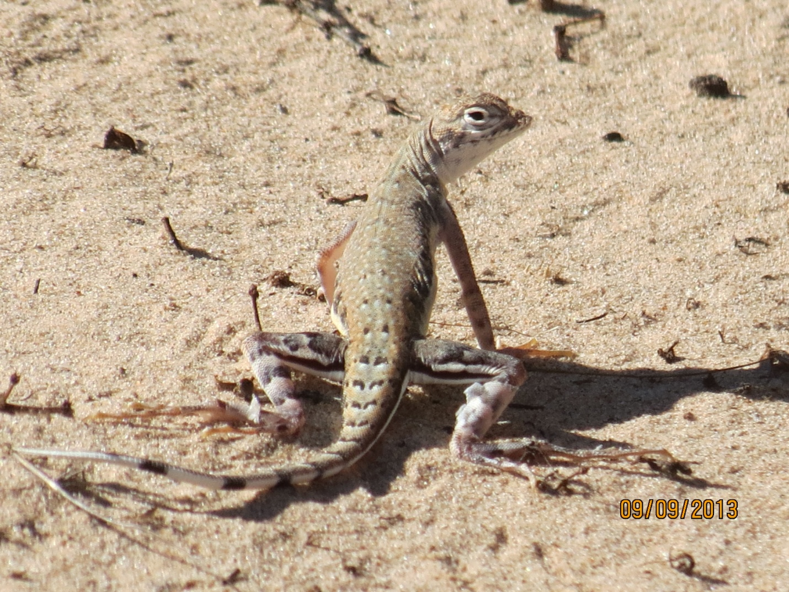

Figure 1. Zebra-tailed lizard at the Diamond Creek dunes in 2013 ( Photo by D. Dupree).

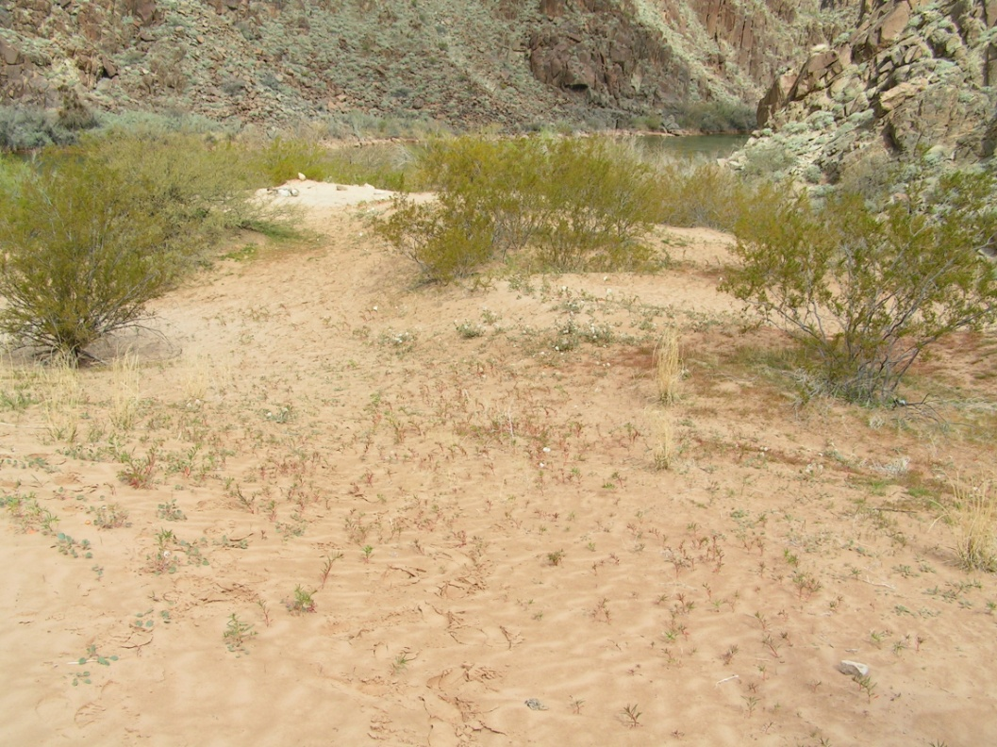

Fig. 2: Diamond Creek mouth dunes, oblique view, 8 March 2012 (Photo by L.E. Stevens).

Figure 3. Aerial photograph of the Diamond Creek area of the Hualapai
Reservation where the zebra-tailed lizards were released.

Methods

Dr. Larry Stevens and Dr. Kerry Christensen conducted an initial habitat analysis at the mouth of Diamond Creek dunes on 8 March 2012 , and evaluated potential capture sites in the middle and upper reaches of Peach Springs Canyon. They evaluated dune habitat structure (substrate and vegetation cover; Figure 3) and discussed appropriate stocking numbers for the translocation effort, concluding that 3-4 pairs of ZTL would be an appropriate starting number for the translocation effort. Plans by the Tribe to develop a small camping area near the translocation site also were discussed within the Tribe and were considered to be compatible with translocation.

On April 23, 2012, Dr. Larry Stevens,. Dr. Geoffrey Carpenter and Dr. Kerry Christensen used 12 foot-long cane poles fitted with fishing line nooses to capture five male and five female ZTL at two locations in middle-upper reaches of Peach Springs Canyon, approximately 10 miles south of the Diamond Creek dunes. One of the male lizards was a juvenile. Captured ZTL were examined for age, sex and health. ZTL capture required approximately 5 hr. The lizards were kept cool, transported to the dunes and released at three locations.

At approximately monthly intervals, staff of the Hualapai Department of Natural Resources performed surveys for the zebra-tailed lizards at the Diamond Creek dunes by walking around and through the dune area on foot (Table 1). The surveys lasted from 40 to 60 minutes each. Locations of contacted zebra-tailed lizards were plotted on a aerial photograph of the dune area. We recorded information on behavior, distance to vegetation and vegetation type.

Surveys were performed from May to September in 2012 and from April to October in 2013. Surveys were not performed in August of 2012 and August of 2013 due to monsoon activity at Diamond Creek.

Results

A good number of zebra-tailed lizards were observed during the 2013 Diamond Creek lizard surveys (Table 1). From three to six individuals were observed during each of the 2013 surveys, including at least two juvenile lizards born in 2013 (Figure 4; Table 1). A total of 21 individuals were observed across all the surveys in 2013 while 20 were observed in 2012 suggesting a somewhat stable population. No zebra tails were observed during the October 16, 2013 surveys, however, suggesting that they had already gone into wintertime dormancy underground by that time.

Aerial photographs with lizard locations (including zebra-tailed lizards, tree lizards and whiptail lizards) from the 2013 surveys are provided in Fig. 5.

Table 1. Summary of Diamond Creek zebra-tailed lizard monitoring results (2012- 2013).

Date | # of observers | # of ztl located | # juveniles | Mean dist. To veg. | Vegetation type(s)
05/01/12 | 1 | 2 | 1 | 0.5m | Creosote bush
05/15/12 | 1 | 3 | 1 | 0.7m | Arroweed, rabbit brush
06/26/12 | 2 | 6 | 1 | 2.5m | Creosote, mesquite, Baccharis
07/24/12 | 2 | 2 | 0 | 1.3m | Mesquite, creosote bush
09/04/12 | 2 | 7 | 0 | 1.0m | Mesquite, four-o’clock, Baccharis, salt bush, creosote
04/02/13 | 2 | 4 | 2 | 1.7 | Brittle bush
05/09/13 | 2 | 6 | 1 | 1.9 | Creosote, brittle bush, catclaw
06/12/13 | 2 | 5 | 2 | 1.2 | Creosote, mesquite, seep Baccharis
07/31/13 | 2 | 3 | 1 | 1.2 | Creosote, brittle bush
09/09/13 | 2 | 3 | 1 | 1.3 | Creosote
10/16/13 | 2 | 0 | 0 | N/A | N/A

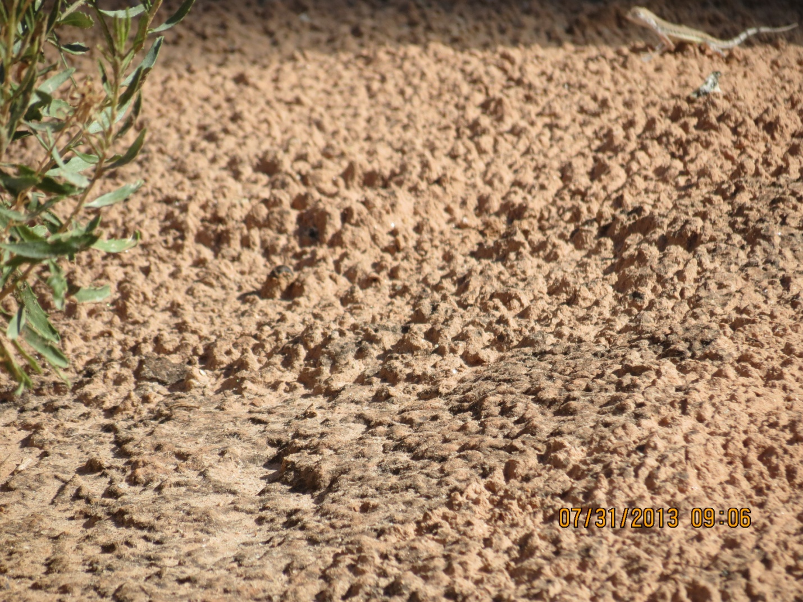
Figure 4. A photograph of a baby zebra-tail lizard (upper right corner) from the July 31, 2013 monitoring survey (Photo by D. Dupree).

Fig. 5: Lizard locations on the five monitoring surveys. Z= zebra-tailed lizard, ZA= adult ztl, ZJ=juvenile ztl, T= tree lizard (Urosaurus ornatus) W= whiptail lizard (Cnemidophorus tigris) and SM= desert spiny lizard (Sceloporus magister).

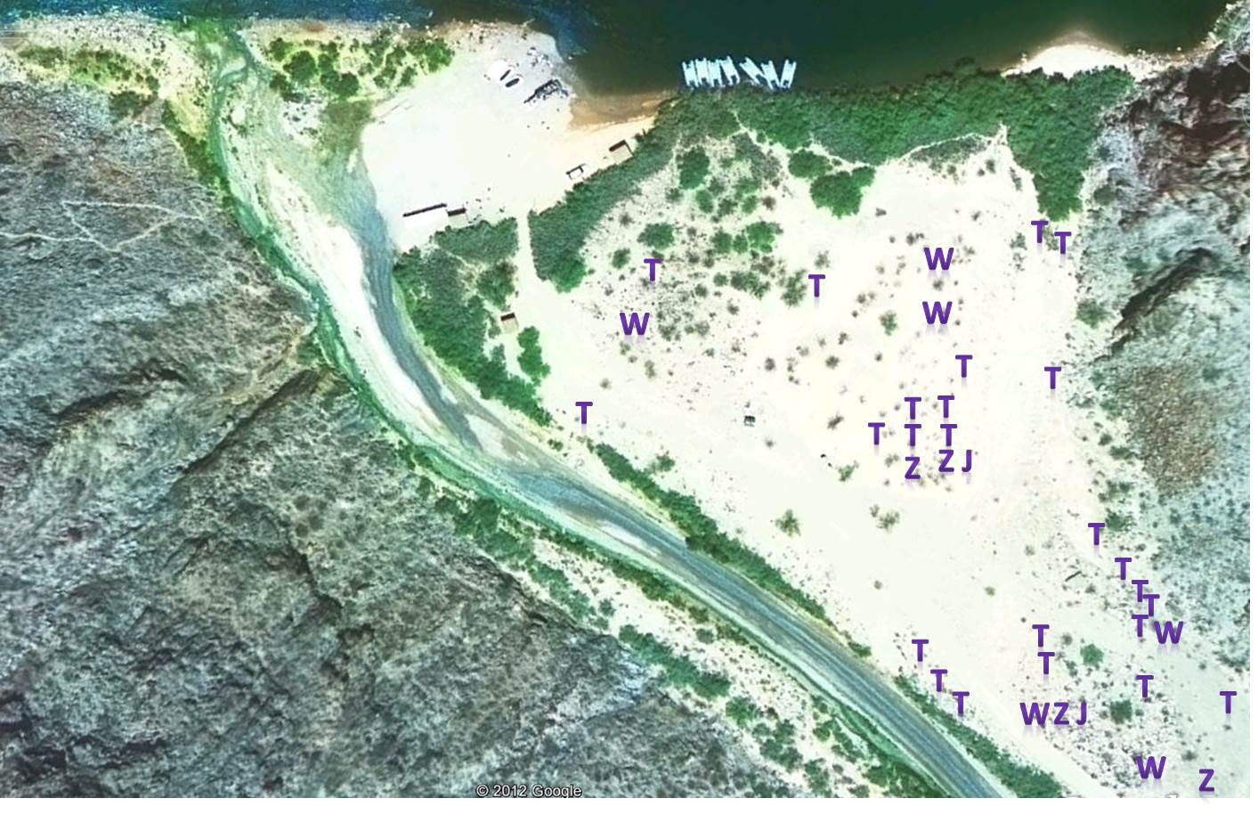
04/02/13

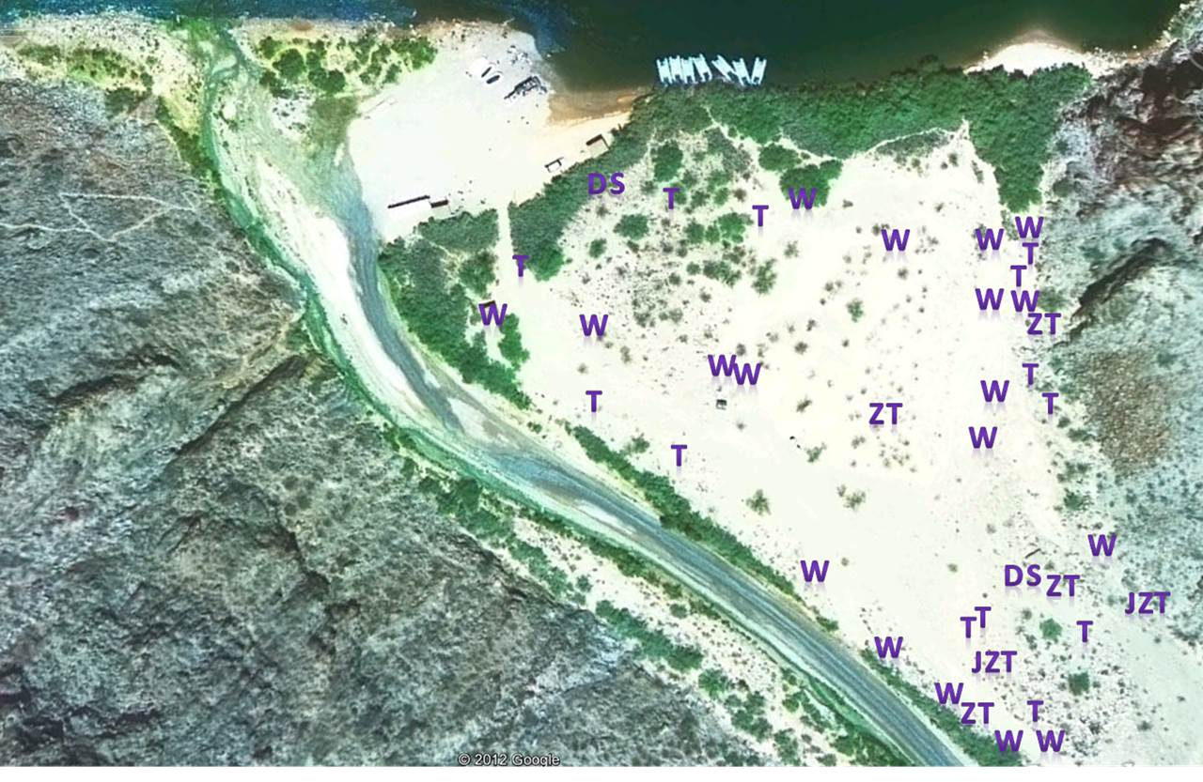
05/09/13

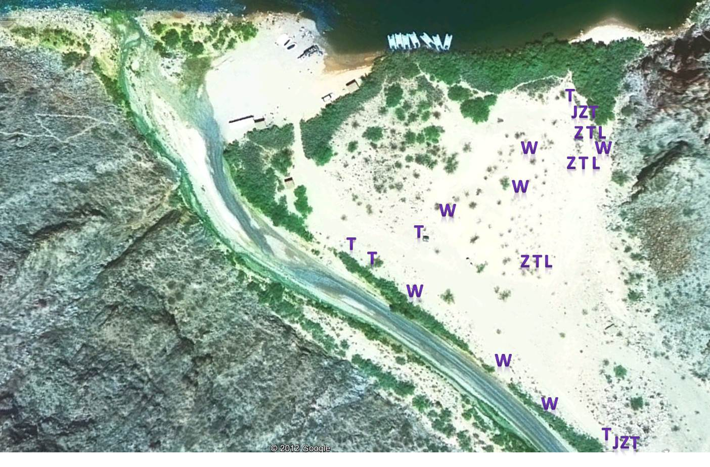
06/12/13

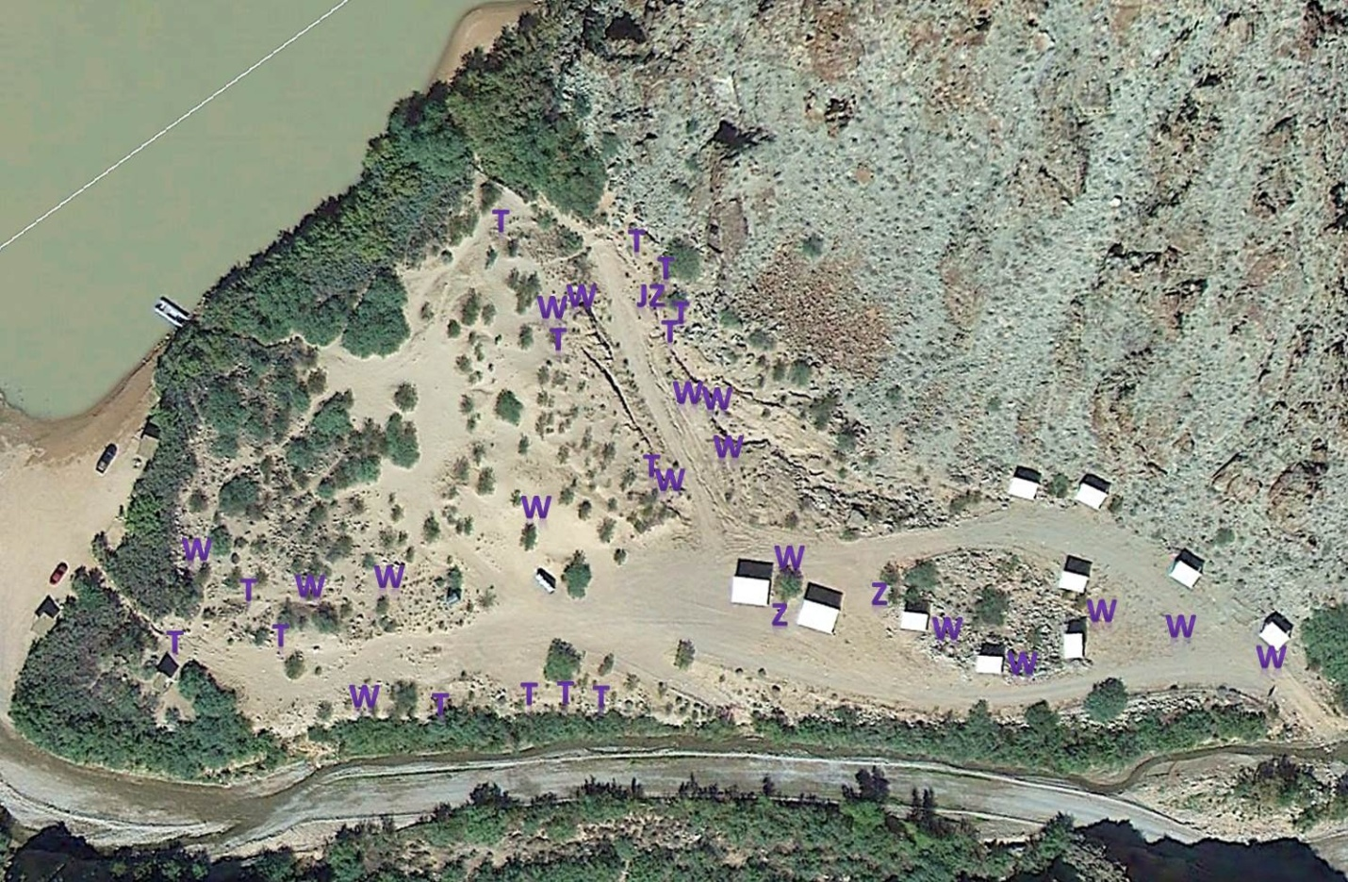

07/31/13

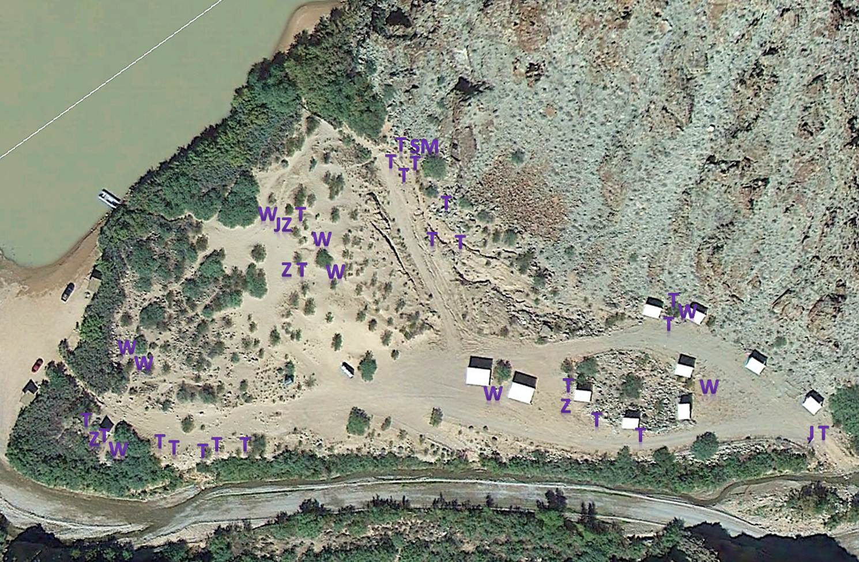

09/09/13

Discussion and Recommendations

From the results of the 2013 monitoring surveys, it appears that many of the zebra-tailed lizards that were translocated from Peach Springs Canyon to the Diamond Creek dune area on the Hualapai Reservation have survived and are in good health.
Concrete evidence of young-of-year juveniles indicates that some reproduction has occurred.

Human foot traffic on and around the dunes can be a nuisance to the lizards, but they seem to have adapted to that human activity. Continued monitoring will allow us to better understand visitor impacts to the lizards.

Detection success during monitoring increased when two observers were present. Occasionally, one observer would disturb a lizard but not see it, while the second observer was able to see the animal. We may add an additional observer in future monitoring runs.

Further translocation is being discussed by the ZTL translocation team (the Tribe, Reclamation, and advisors). Given the high survival rates of translocated ZTL through the 2012 and 2013 growing seasons, it may be advisable to defer additional translocations until we determine whether additional reproduction occurs in 2014. We propose to again monitor lizards beginning in April 2014.

References Cited
Brennon, T.C. and A.T. Holycross. 2005. A Field Guide to Amphibians and Reptiles of Maricopa County. Arizona Game and Fish Department, Phoenix.
Busack, S. D. and R. B. Bury. 1974. Some effects of off-road vehicles and sheep grazing on lizard populations in the Mojave Desert. Biological Conservation 6:179–183.
Miller, D.W., R.A Young, T.W. Gatlin, and J.A. Richardson 1982 Amphibians and Reptiles of the Grand Canyon Monograph Number 4, Grand Canyon Natural History Association, Grand Canyon.
Stevens, L.E. et al.. 2011. Assessment of taxa of management concern in the Colorado River ecosystem, Glen and Grand Canyons, Arizona, USA: habitat needs, availability and ecosystem roles, final report 8 July 2011. Report to the Bureau of Reclamation Glen Canyon Dam Adaptive Management Program, Salt Lake City.
Stevens, L.E.2012. The biogeographic significance of a large, deep canyon: Grand Canyon of the Colorado River, Southwestern USA. Pp. 169-208 in Stevens, L.E., editor. Global Advances in Biogeography. InTech Publications, Rijeka. ISBN: 978-953-51-0454-4 .
Tomko, D. 1976. Reptiles and amphibians of the Colorado River corridor, Grand Canyon. Museum of Northern Arizona, Flagstaff.
Webb, R. H. and H. G. Wilshire, editors. 1983. Environmental Effects of Off-Road Vehicles. Impacts and Management in Arid Regions. Springer-Verlag, Inc., New York.

