ZEBRA-TAILED LIZARD TRANSLOCATION AND MONITORING
PEACH SPRINGS CANYON AND DIAMOND CREEK ON THE HUALAPAI RESERVATION

FIRST ANNUAL REPORT

Submitted to:

Bureau of Reclamation
Upper Colorado Region
125 State St., Rm 6107
Salt Lake City, UT 84138

Prepared by:

Hualapai Department of Natural Resources
P.O. Box 300
Peach Springs, AZ 86434

And

Stevens Ecological Consulting, LLC
P.O. Box 1315
Flagstaff, AZ 86002

September, 2012

Introduction
The zebra-tailed lizard (ZTL; Callisaurus draconoides) is a characteristic, relatively common Mohave and Sonoran Desert species throughout the lower elevation deserts of the Southwest (Brennon and Holycross 2006). ZTL is a medium-sized, insectivorous iguanoid lizard that prefers sandy desert habitats, which are often dominated by creosote-bush (Larrea tridentate; Fig. 1). Female ZTL lay 2-8 eggs in summer in sandy, friable soils; however, this species may be multivoltine. Although widespread, isolated populations may occur in sand dune refugia. Prior to 1983, zebra-tailed lizards were persistent residents of the sand dune area along the Colorado River in Grand Canyon at the Diamond Creek confluence on the Hualapai Reservation (Tomko 1976; Miller et al. 1981). With the flooding that occurred (approximately 100,000 cubic feet per second) on the Colorado River in Grand Canyon in 1983-4 due to unexpected high runoffs from the Rocky Mountains, river access at Diamond Creek for river rafters was restricted to the dune area and river traffic drove over the dunes. Off-road vehicular impacts are well-known to negatively affect diurnal reptile species, such as desert tortoise and ZTL (Busack and Bury 1974; Webb and Wilshire 1983). Repeated censuses for ZTL at the mouth of Diamond Creek from the late 1980’s through 2010 consistently failed to reveal any of these conspicuous, diurnal lizards, and the population has been extirpated there (Stevens et al. 2011; Stevens 2012). However, ZTL, are still extant in the middle and upper Peach Springs Canyon, several miles south of the Diamond Creek dunes.
Analysis of missing and at-risk species in the Colorado River ecosystem downstream from Glen Canyon Dam identified ZTL as having high potential for restoration (Stevens et al. 2011). In an effort to re-establish ZTL on the dunes at Diamond Creek, the Bureau of Reclamation, Upper Colorado Region, working through the Glen Canyon Dam Adaptive Management Program, funded a translocation effort working with the Hualapai Tribe and Stevens Ecological Consulting, LLC.

Fig. 1: Zebra-tailed lizard from middle Peach Springs Wash, 23 April 2012 (photo by L.E. Stevens).
Methods
Dr. Larry Stevens and Dr. Kerry Christensen conducted an initial habitat analysis at the mouth of Diamond Creek dunes on 8 March 2012 (Fig. 2), and evaluated potential capture sites in the middle and upper reaches of Peach Springs Canyon. They evaluated dune habitat structure (substrate and vegetation cover) and discussed appropriate stocking numbers for the translocation effort, concluding that 3-4 pairs of ZTL would be an appropriate starting number for the translocation effort. Plans by the Tribe to develop a small camping area near the translocation site also were discussed within the Tribe and were considered to be compatible with translocation.

On April 23, 2012, Dr. Larry Stevens,. Dr. Geoffrey Carpenter and Dr. Kerry Christensen used 12 foot-long cane poles fitted with fishing line nooses to capture five male and five female ZTL at two locations in middle-upper reaches of Peach Springs Canyon, approximately 10 miles south of the Diamond Creek dunes. One of the male lizards was a juvenile. Captured ZTL were examined for age, sex and health. ZTL capture required approximately 5 hr. The lizards were kept cool, transported to the dunes and released at three locations.

At approximately monthly intervals, staff of the Hualapai Department of Natural Resources performed surveys for the zebra-tailed lizards at the Diamond Creek dunes by walking around and through the dune area on foot (Table 1). The surveys lasted from 40 to 60 minutes each. Locations of contacted zebra-tailed lizards were plotted on a aerial photograph of the dune area. We recorded information on behavior, distance to vegetation and vegetation type.

Results
Monitoring results are presented in Table 1. An aerial photograph with lizard locations (including zebra-tailed lizards, tree lizards and whiptail lizards) from all the surveys is provided in Fig. 4.

Table 1. Summary of Diamond dune zebra-tailed lizard monitoring results.
Date | # of observers | # of ztl located | Mean dist. To veg. | Vegetation type(s)
05/01/12 | 1 | 2 | 0.5m | Creosote bush
05/15/12 | 1 | 3 | 0.7m | Arroweed, rabbit brush
06/26/12 | 2 | 6 | 2.5m | Creososte, mesquite, Baccharis
07/24/12 | 2 | 2 | 1.3m | Mesquite, creosote bush
09/04/12 | 2 | 7 | 1.0m | Mesquite, four-o’clock, Baccharis, salt bush, creosote

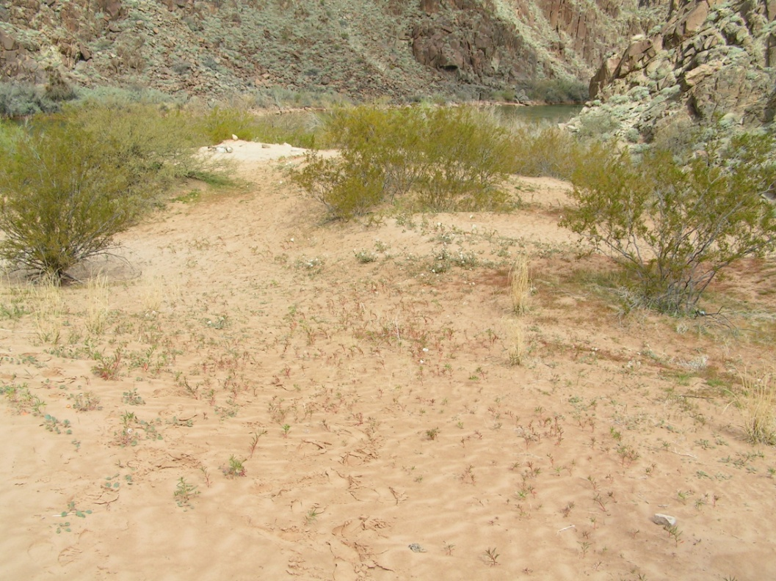

Fig. 2: Diamond Creek mouth dunes, oblique view, 8 March 2012.

Fig. 4: Lizard locations on the five monitoring surveys. Z= zebra-tailed lizard, ZA= adult ztl, ZJ=juvenile ztl, T= tree lizard (Urosaurus ornatus) and W= whiptail lizard (Cnemidophorus tigris).
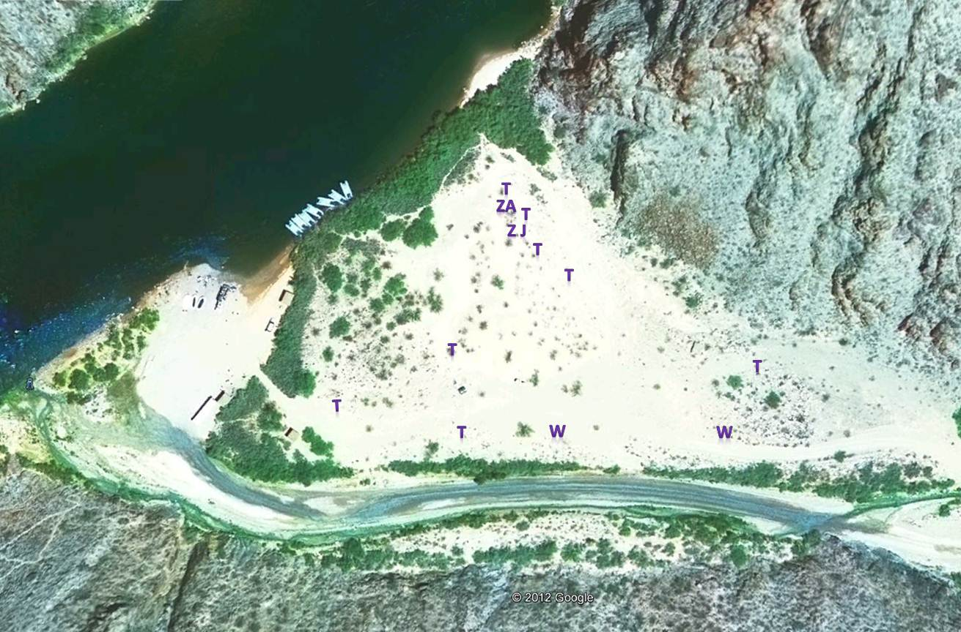

05/01/2012

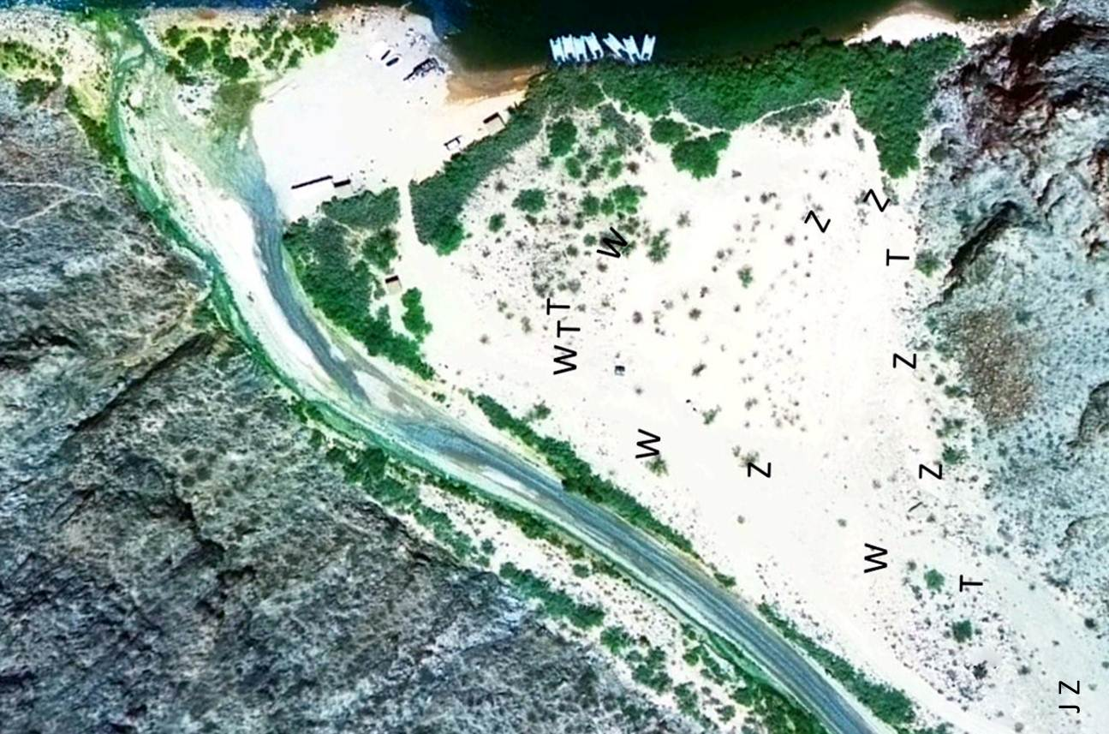
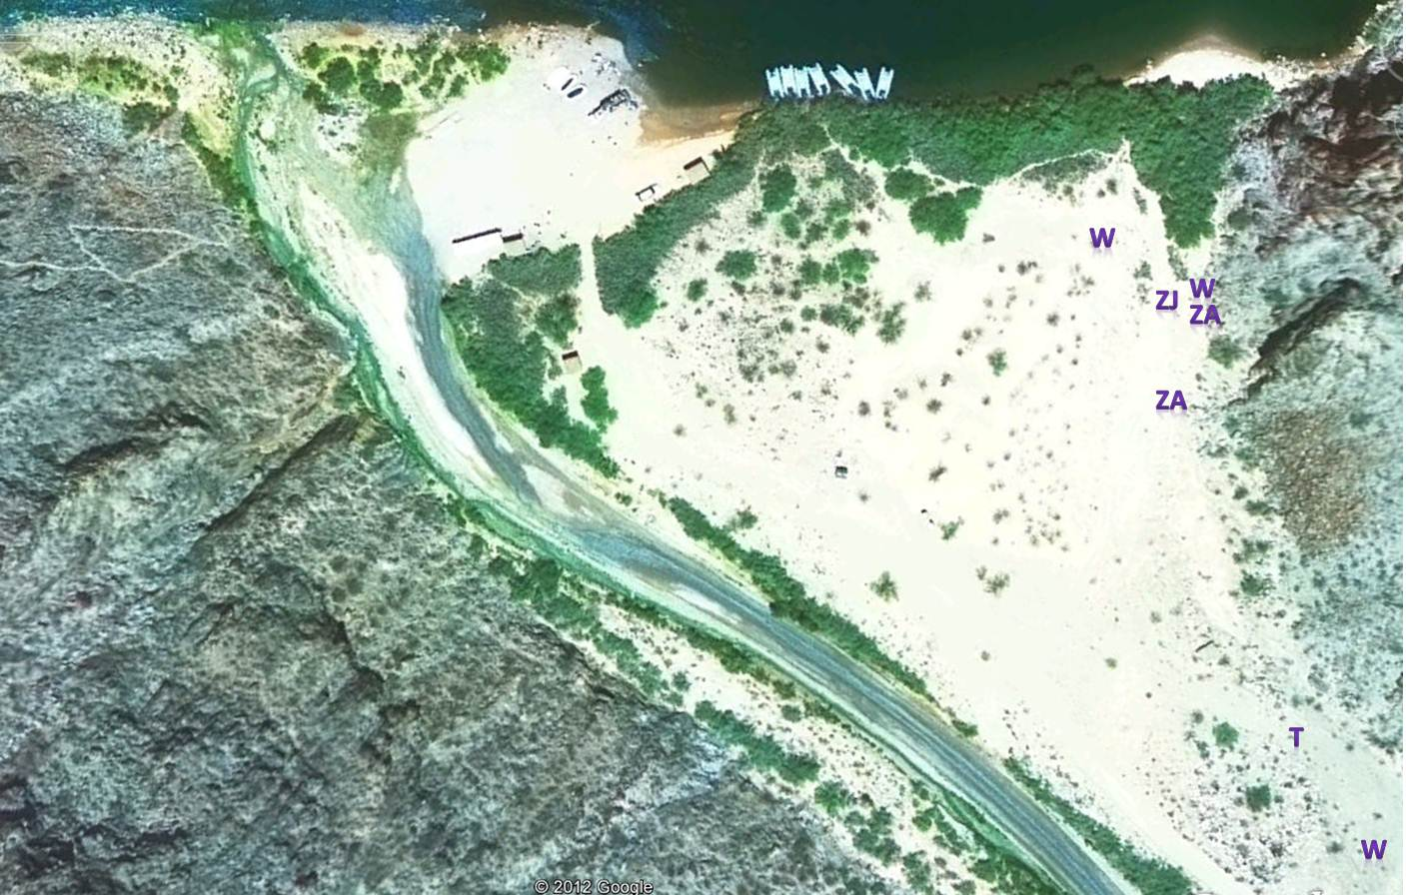
05/15/2012

06/2012

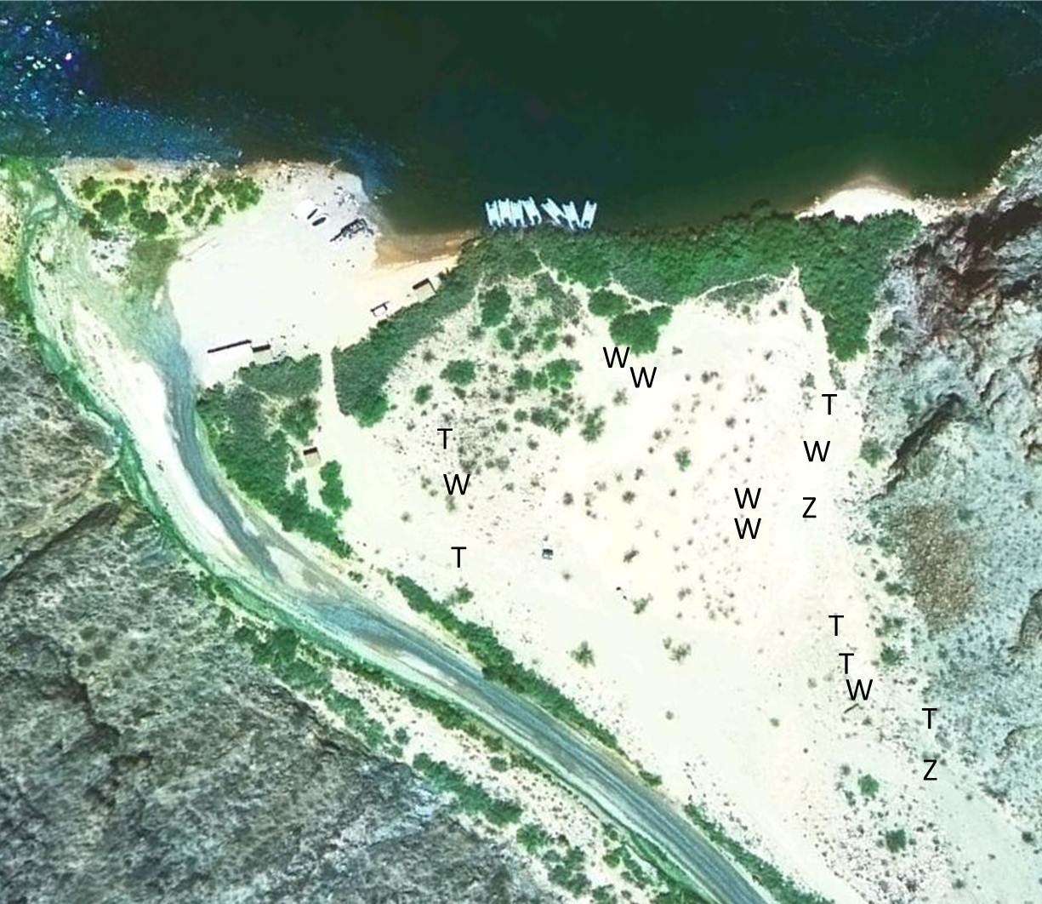

07/24/12
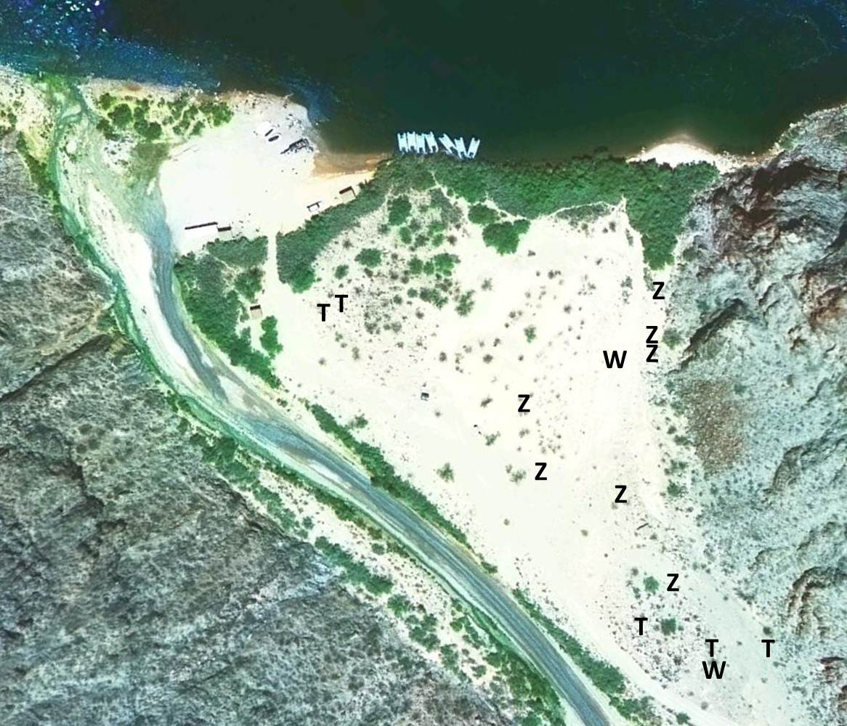

09/04/2012
Discussion and Recommendations
From the results of the monitoring surveys, it appears that the majority (if not all) zebra-tailed lizards that were translocated from Peach Springs Canyon to the Diamond dune area on the Hualapai Reservation have survived and are in good health. However, we have not detected evidence of reproduction at the translocation site.

Human foot traffic on and around the dunes can be a nuisance to the lizards, but they seem to have adapted to that human activity. Continued monitoring will allow us to better understand visitor impacts to the lizards.

Detection success during monitoring increased when two observers were present. Occasionally, one observer would disturb a lizard but not see it, while the second observer was able to see the animal. We may add an additional observer in future monitoring runs. On the July survey, the survey was cut short by monsoonal rain and flooding in Peach Springs canyon. This may explain the number of animals sighted on that survey.

Further translocation is being discussed by the ZTL translocation team (the Tribe, Reclamation, and advisors). Given the high survival rates of translocated ZTL through the 2012 growing season, it may be advisable to defer additional translocations until we determine whether reproduction occurs in 2013. We propose to re-initiate monitoring in April 2013, and we will attempt to capture, sex, weigh, and assess the health of surviving ZTL in the Diamond Creek mouth dunes. We will continue to monitor for evidence of reproduction success until mid-summer. If no reproduction is detected, the translocation team may opt to pursue additional translocation.

References Cited
Brennon, T.C. and A.T. Holycross. 2005. A Field Guide to Amphibians and Reptiles of Maricopa County. Arizona Game and Fish Department, Phoenix.
Busack, S. D. and R. B. Bury. 1974. Some effects of off-road vehicles and sheep grazing on lizard populations in the Mojave Desert. Biological Conservation 6:179–183.
Miller, D.W., R.A Young, T.W. Gatlin, and J.A. Richardson 1982 Amphibians and Reptiles of the Grand Canyon Monograph Number 4, Grand Canyon Natural History Association, Grand Canyon.
Stevens, L.E. et al.. 2011. Assessment of taxa of management concern in the Colorado River ecosystem, Glen and Grand Canyons, Arizona, USA: habitat needs, availability and ecosystem roles, final report 8 July 2011. Report to the Bureau of Reclamation Glen Canyon Dam Adaptive Management Program, Salt Lake City.
Stevens, L.E.2012. The biogeographic significance of a large, deep canyon: Grand Canyon of the Colorado River, Southwestern USA. Pp. 169-208 in Stevens, L.E., editor. Global Advances in Biogeography. InTech Publications, Rijeka. ISBN: 978-953-51-0454-4 .
Tomko, D. 1976. Reptiles and amphibians of the Colorado River corridor, Grand Canyon. Museum of Northern Arizona, Flagstaff.
Webb, R. H. and H. G. Wilshire, editors. 1983. Environmental Effects of Off-Road Vehicles. Impacts and Management in Arid Regions. Springer-Verlag, Inc., New York.

