BAHG Call #5 Notes
- Project B: Sandbar and Sediment Storage Monitoring and Research ($1,010,030) (Paul Grams and David Topping)
  - The purposes of this project are to: 1) track the effects of individual HFEs on sandbars and campsites), 2) monitor the cumulative effect of successive HFEs and intervening dam operations on sandbars and sand conservation, 3) investigate the interactions between dam operations, sand transport, and channel dynamics, and 4) develop and apply predictive models for streamflow and sandbar changes that can be used for evaluating dam operations scenarios. It directly relates to the LTEMP Record of Decision (ROD; LTEMP) to “increase and retain fine sediment volume, area, and distribution...for ecological, cultural, and recreational purposes." Full Description on page 106 of the FY21-23 TWP.
  - 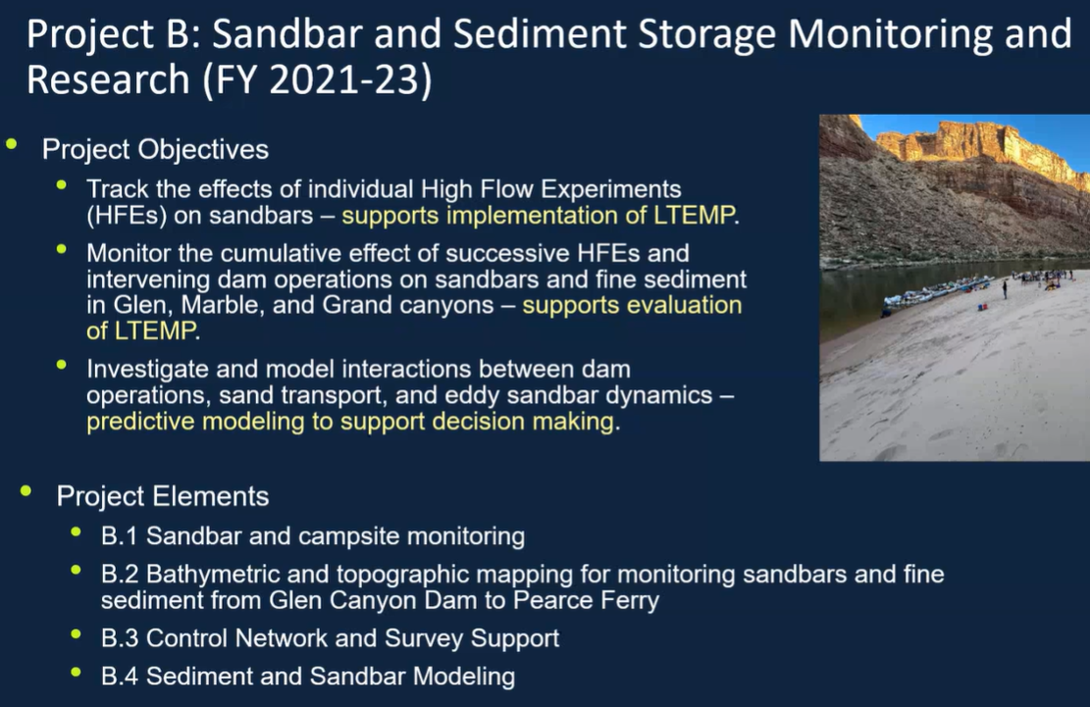
    - Sandbar and campsite monitoring with topographic surveys and remote cameras ($573,964)
    - 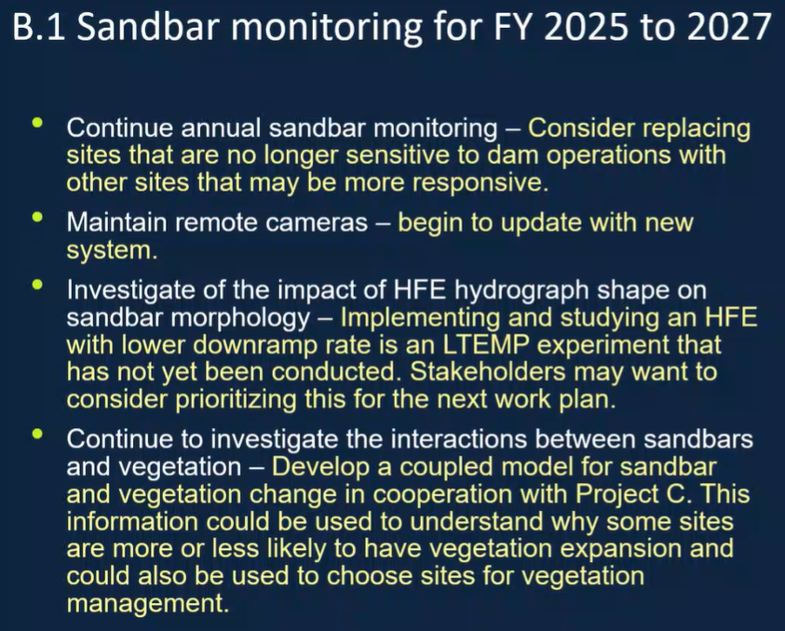
    - Bathymetric and topographic mapping for monitoring long-term trends in sediment storage ($333,831)
    - 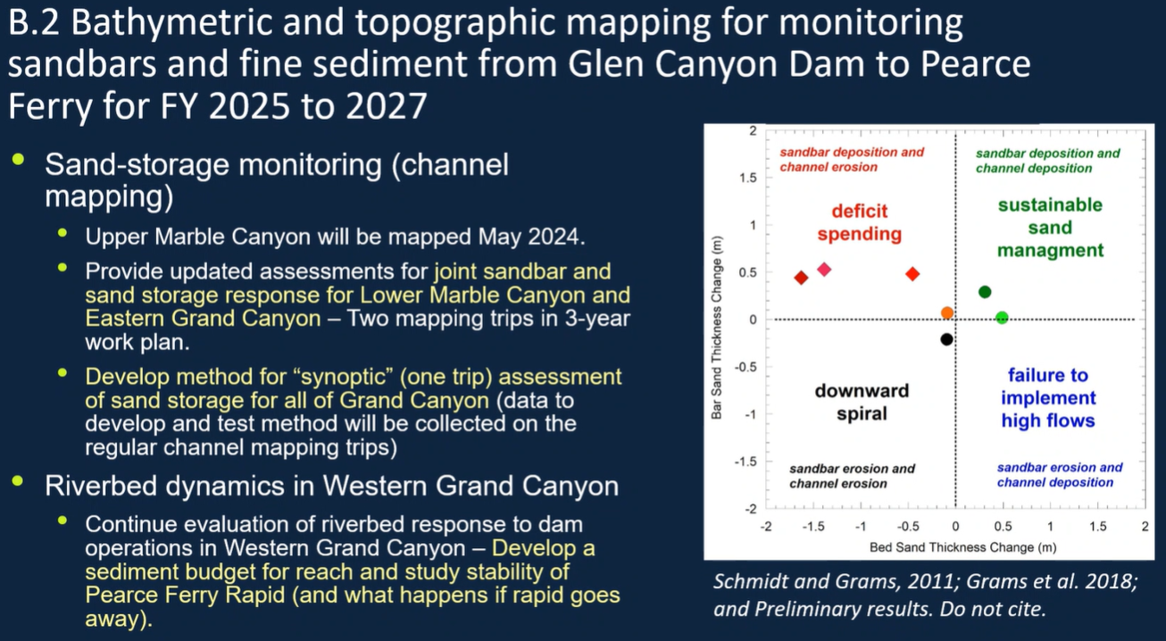
    - Control network and survey support ($102,235)
    - 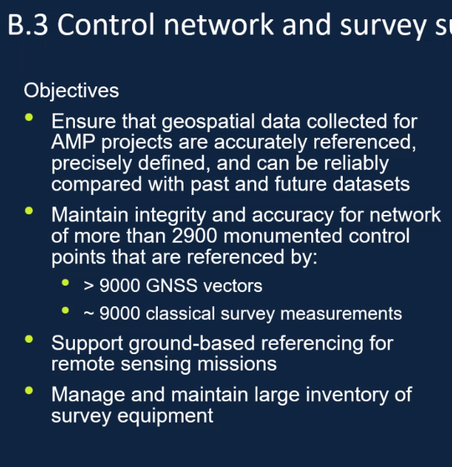
    - 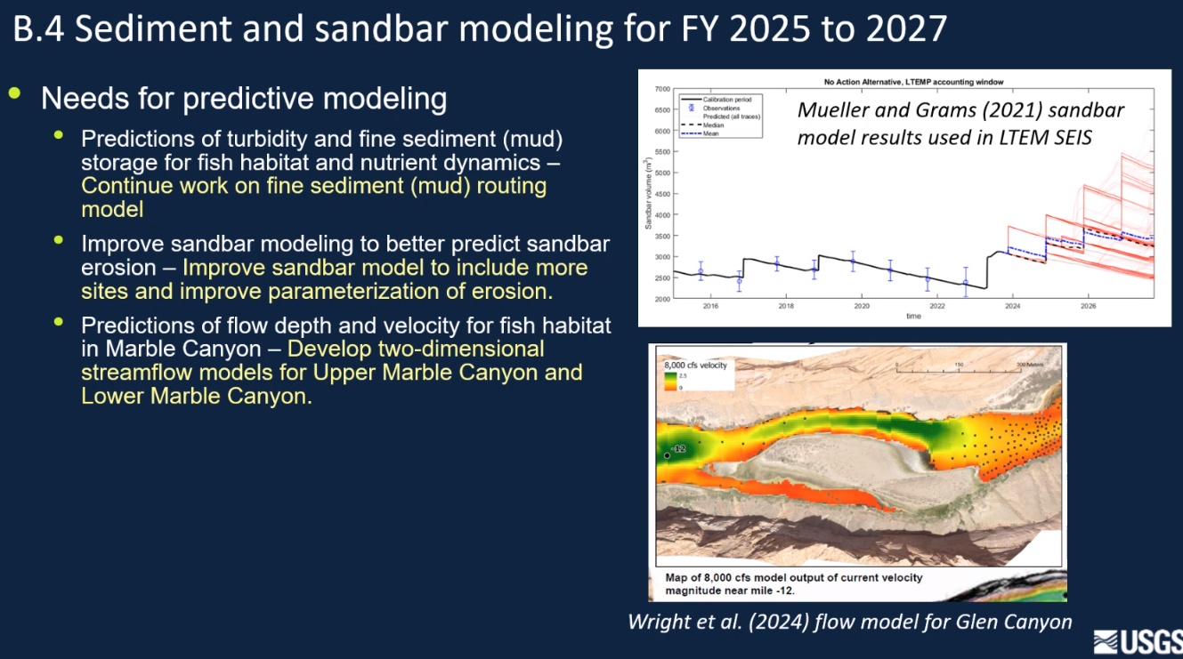

  - Discussion:
    - Craig Ellsworth: is anyone tracking how pearce ferry rapid is changing over time?
      - PG: we have started doing that, just as a casual add-on with a remote camera
        - Proposed to include in element B.2
        - Monitoring effect of rapid on water surface elevation
        - Looking at river bed above and below rapid as well
      - CE: thinking of it in terms of fish passage/barrier
        - AZGFD monitoring fish movement directly (funded through NPS at Meade and USFWS)
          - Looking at extending that effort through BOR
    - Rob Billerbeck: NPS Support for both
      - Note that revising downslope of HFE is supported
      - Worthwhile and within intent of maximizing benefits of HFEs
    - Larry Stevens: work is critical to program
- Project A: Streamflow, Water Quality, and Sediment Transport and Budgeting in the Colorado River Ecosystem ($1,249,606)
  - This project collects the physical data that directly link dam operations to the downstream Colorado River; all other GCDAMP-funded projects use these data to link dam operations to their resources of interest. The data collected by this project are used to implement the High-Flow Experiment (HFE) Protocol (i.e., trigger and design HFE hydrographs), to evaluate the reach-scale sand mass-balance response to the HFE Protocol, and to evaluate the downstream effects of releases conducted under the Long-Term Experimental and Management Plan (LTEMP) Environmental Impact Statement (EIS; LTEMP). Full Description on page 80 of the FY21-23 TWP.
    - A.3 Sediment transport and budgeting ($711,314)
  - Discussion:
    - Larry Stevens: have we looked at duration and extent of clearwater flows?
      - DT: we did publish an analysis in 2014 showing duration, haven’t done anything more recent, but do show turbidity on their sediment website
      - LS: is longer duration Clearwater flows more common, and what are the consequences of that?
        - DT: we have seen longer duration
    - Andrew Schultz: the web tool is incredibly important to the program, and it is cost effective and more efficient to internalize this position
      - Need to show we have financial support for it
      - Data work load has increased since those
- Project J: Socioeconomic Research ($217,529) (Lucas Bair)
  - Project J contains research elements that collect and integrate socioeconomic information with data and predictive models from ongoing long-term physical and biological monitoring and research led by the USGS GCMRC. The project elements improve the ability of GCDAMP resource managers and stakeholders to evaluate management actions and prioritize monitoring and research. The proposed project elements address the LTEMP ROD resource goals related to humpback chub, sediment, invasive fish, and hydropower, as specified in Section 4. Full Description on page 291 of the FY21-23 TWP.
  - 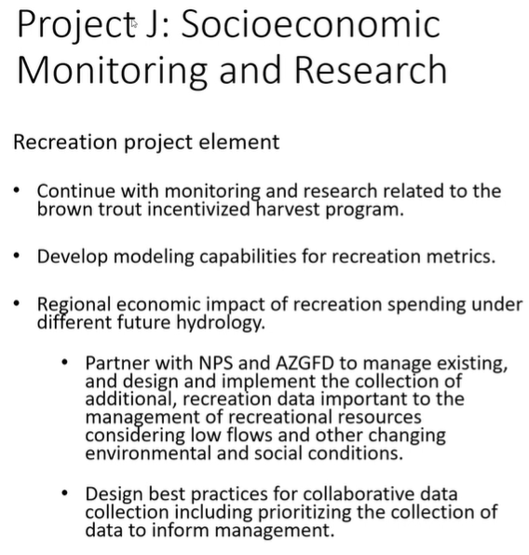
    - Predictive models for adaptive management
    - Brown trout incentivized harvest
    - 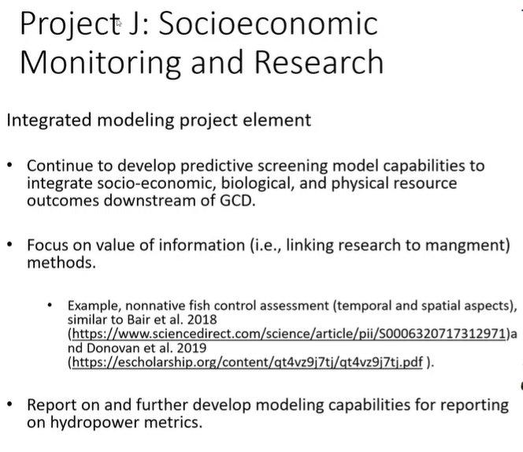
    - 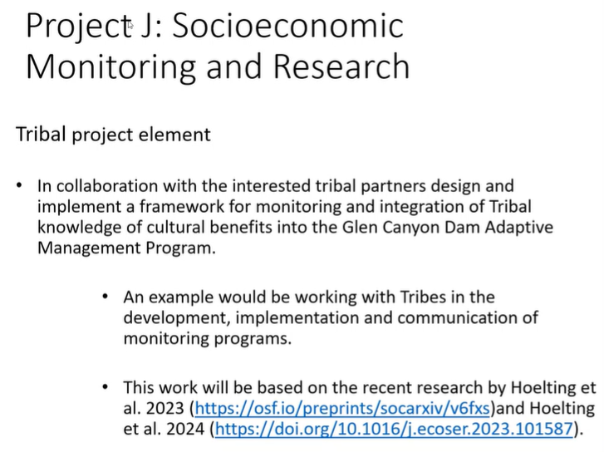
  - Discussion:
    - Larry Stevens: is it your plan to get to a statement of overall economic tradeoffs from dam
      - LB: slowly moving towards that, but getting to that end point will be difficult
        - Some of that is being addressed in the integrated modeling, so making progress
    - Craig Ellsworth: have concerns w/ GCMRC developing hydropower metrics, non-starter for WAPA as a stakeholder
    - Leslie James: same as Craig
      - Can’t approve w/ hydropower piece
    - Rob Billerbeck: NPS supports
    - Erik Stanfield: echo what Rob just said, specifically support for tribal component
      - Navajo feel strongly about exploring how to work together
      - Economics are best methods we have to do this

- Project K: Geospatial Science, Data Management, and Technology ($503,453) (Thomas Gushue)
  - This project provides high-level support to GCDAMP-funded science efforts in the disciplines of geospatial science, data management, database administration, and emerging information technologies. Full Description on page 326 of the FY21-23 TWP.
    - Enterprise GIS, geospatial analysis, and processing ($236,424)
    - 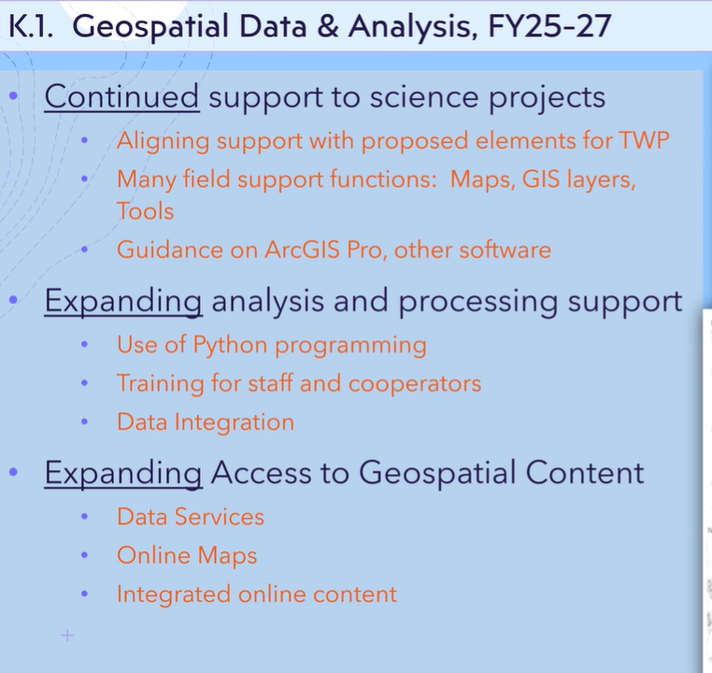
    - Data management and database administration ($206,180)
    - 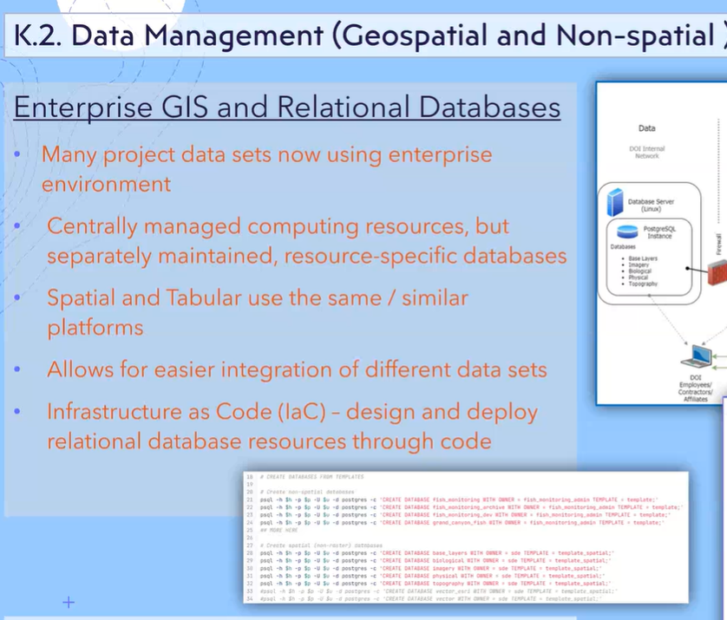
    - 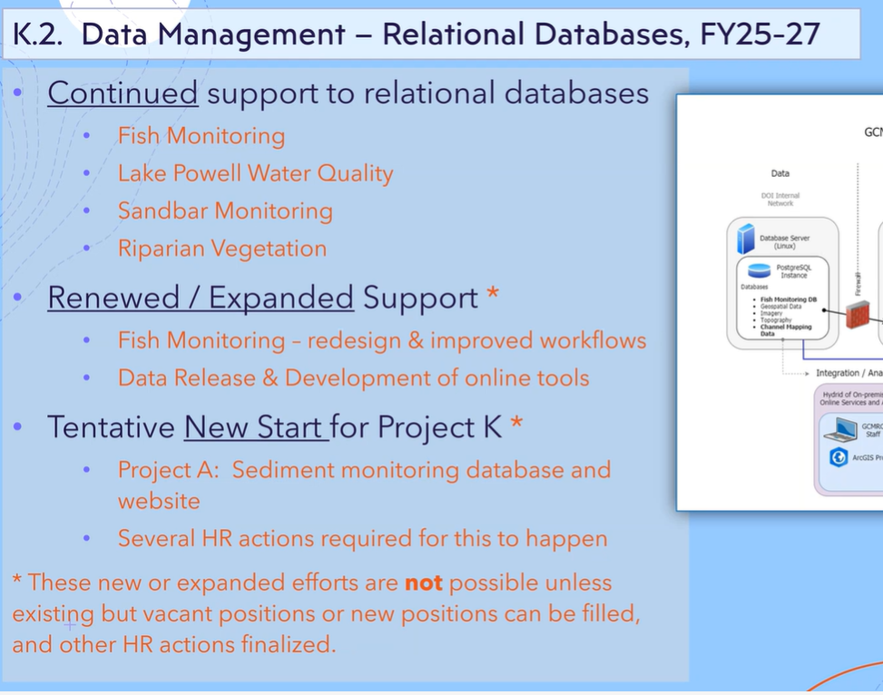
    - Remote monitoring and advanced technology support ($60,849)
    - 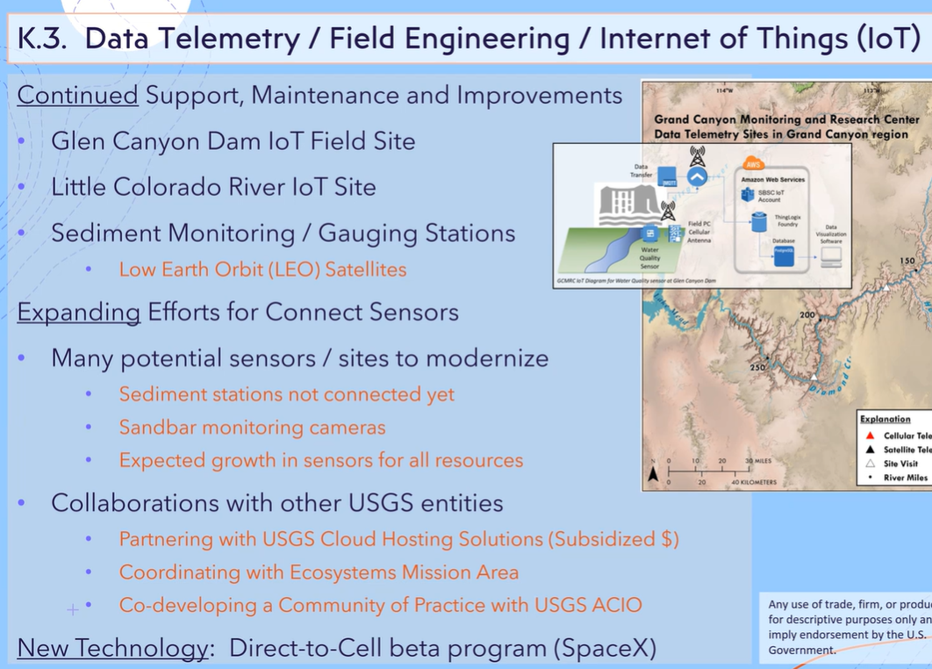

  - Discussion:
    - Erik Stanfield: conversation about doing large veg project on LCR
      - Is there a possibility to extend some of that geospatial data up the LCR?
      - TG: would love to be involved, if it’s a huge lift
- Project M: Leadership, Management, and Support ($1,337,333) (Mark Anderson/Andrew Schultz)
  - The Leadership, Management, and Support budget covers salaries for a budget analyst, librarian, a part-time library assistant, three members of the logistics support staff, as well as leadership and management personnel for GCMRC. Full Description on page 359 of the FY21-23 TWP.
    - Leadership, management, and support ($900,014)
    - Logistics staff ($360,619)
    - IT ($76,700)
  - Haven’t had both deputy and Chief on in a while, anticipating increase to logistics budget
  - Discussion

- Project N: Hydropower Monitoring and Research ($29,574) Lucas Bair
  - The LTEMP states that the objective of the hydropower and energy resource goal is to, “maintain or increase GCD electric energy generation, load following capability, and ramp rate capability, and minimize emissions and costs to the greatest extent practicable, consistent with improvement and long-term sustainability of downstream resources.” Project N will identify, coordinate, and collaborate with external partners on monitoring and research opportunities associated with operational experiments at GCD designed to meet hydropower and energy resource objectives, as stated in the LTEMP EIS and its ROD, and guided by the memorandum (Guidance Memo) from the Secretary's Designee, dated August 14, 2019. Full Description on page 360 of the FY21-23 TWP.
    - Hydropower monitoring and research
  - Move Project N as written in previous TWP to BOR side
    - Craig Ellsworth: work as written was not completed, thinks it’s a good fit for BOR power office.
      - Open to working w/ GCMRC and show them in person how the models work and run
      - WAPA wants to be at table while model is being run
  - Discussion:
    - Andrew Schultz: elaborate on SEIS reference
      - CE: not sure if that is a topic for this call
        - Think there is some inaccuracy in data analysis
    - Christina Nofstker: NM support moving N to BOR side, and still support Lucas’ work in recreation and tribal
    - Helen Fairley: before any decision is made history of Project N should be examined
    - Leslie James: don’t want comments interpreted as denigrating/reducing socioeconomics in this program
      - Recommendation would help make the program more robust as a whole by providing wider collaborative net
- General:
  - Craig Ellsworth: need some help on how this program needs to prioritize
    - Need to talk amongst ourselves and identify those priorities
    - Have BOR run their priorities exercise again
    - Have Stakeholder Priorities as well
      - LS: strongly second
        - How do we do that? Easy to rank in terms of our perspective

