BAHG Call #2: Foodbase, Nutrients, Water Quality
- Project E: Controls on Ecosystem Productivity: Nutrients, Flow, and Temperature (FY24 $293,152)
  - This project aims to disentangle some of these drivers by combining the highly resolved long-term information about riverine turbidity, silt and clay concentrations, solar inputs, discharge, and gross primary productivity via continuous oxygen and temperature measurements– data that are collected as parts of the Interagency Lake Powell Water Quality Monitoring project. Project E is designed to capture and link changes in productivity to changes in bottom-up drivers such as light, flow, and nutrients and to further develop links between these bottom-up drivers and higher trophic levels. Full Description on page 189 of the FY21-23 TWP.
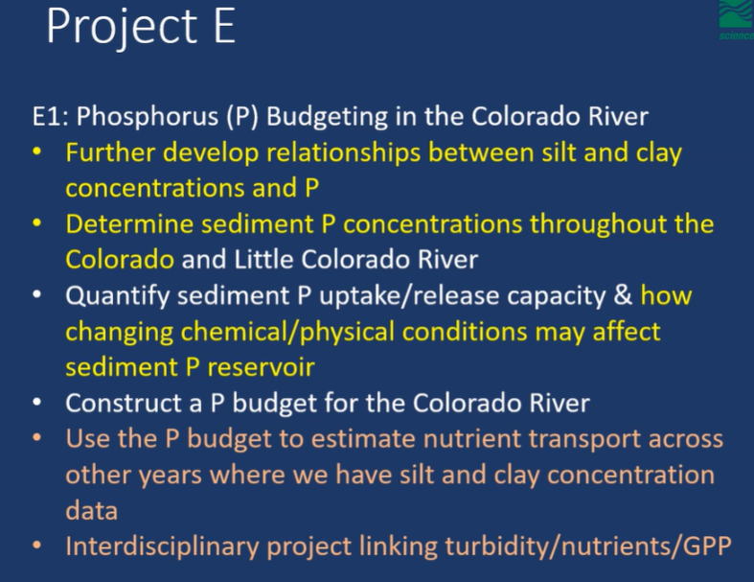
    - E.1 Phosphorus budgeting in the Colorado River (FY24 $106,169)
      - Construct phosphorus (P) budget
        - Extending that to GPP model
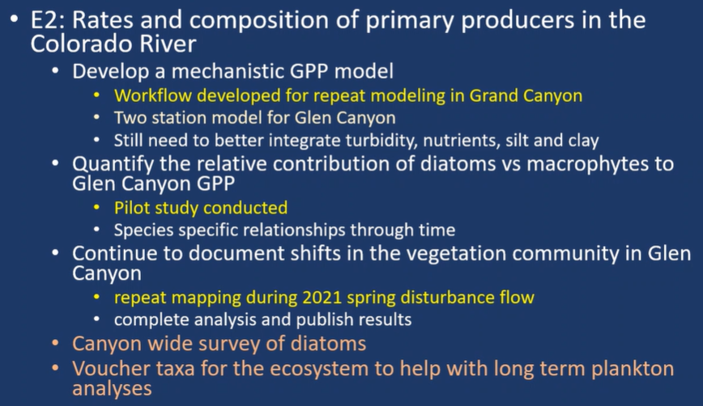
    - E.2 Rates and composition of primary producers in the Colorado River (FY24 $94,945)

    - E.3 Productivity at higher trophic levels (FY24 $92,038)
      - 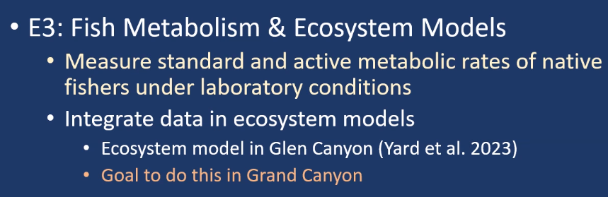
        - Need new equipment to measure metabolism of fish
        - Basis of fish model (bioenergetics)
        - A lot of fish biomass in Western Grand Canyon
          - Expect that food will become the limiting factor
        - Building on food web work that was done in the past
  - Discussion:
  - Project E Started from thinking of how things related to WQ and the ecosystem
    - Jim Strogen: are you at the point to say that P is too low and might require supplementing, or would further research be needed?
      - Charles Yackulic: P is often limiting
        - Downstream P becomes less a factor, that’s why we want to go downstream
        - Limits productivity in Lees Ferry
        - GCMRC focuses more on finding out what is happening in the trends and why, as opposed to management action
        - Have evidence to show that it is limiting and low
        - If you were to add P, big question of how to get it to stay available as sediment lowers P availability
      - Bridget Deemer: incubations collected sediment from Pearce Ferry and Paria, both incubations show P limitations
        - There will be questions about how much P would be needed below the dam
    - Chrsitina Noftsker: E.2, when you mentioned you want to do mapping, was a repeat of something, or are you proposing to do more?
      - Kim Dibble: started in 2016 matching TRGD segments to make links to RBT abundance and growth
        - Idea is to generate deep learning model w/ imagery
        - Do Glen Canyon for now, moving downstream won’t happen until solid progress has been made upstream
        - Repeat sampling every 3-5 years (if not included in this Work Plan, it should be in the next one)
      - CY: one thing to note is that the field work doesn’t take long, analysis is the hiccup
    - Craig Ellsworth: there might be openness to have experimental area downstream of dam
      - BD: tried two work plans ago to have experimental stream
        - Looking at warming water on macrophytes
          - Water was warmed too much through pipeline, so they couldn’t run the experiments
          - If there is an opportunity now to run experiments at banks or below dam it would be ideal
      - Bill Persons: tried to set up experimental streams below dam but had time maintaining water due to sump pumps, streams would sometimes go dry
    - Rob Billerbeck: For NPS definitely concerns about P fertilizing. For bioenergetics, I guess I'm wondering how the bioenergetics will help us with the big problems of the day - would it help us answer how well HBC and other natives will survive the warm water fish onslaught? Is that a necessary part of the models or what actionable info would be get from it?
      - CY: Bioenergetics of warmwater nonnative fish could help us understand how piscivorous they might be an what the impact of warmwater nonnatives populations of different sizes on native fish populations. Most of the information for warmwater nonnatives is well known. When it comes to questions of competition between native and nonnative species bioenergetics is a really useful tool.
- Project F: Aquatic Invertebrate Ecology (FY24 $686,647)
  - The primary focus of Project F is continuation of long-term food base monitoring needed to track ecosystem response to “Bug Flows” and other LTEMP experiments. Additionally, this project supports other projects within the TWP such as: Project E, Project G, and Project H. Full Description on page 214 of the FY21-23 TWP.
    - F.1 Aquatic invertebrate monitoring in Marble and Grand Canyons (FY 24 $358,497)
    - F.2 Aquatic invertebrate monitoring in Glen Canyon (FY 24 $270,068)
      - Drift is the best way to model trout growth
    - F.3 invertebrate monitoring in tributaries (not funded since 2021)
    - F.4 Fish diet studies (FY 24 $58,082)
    - 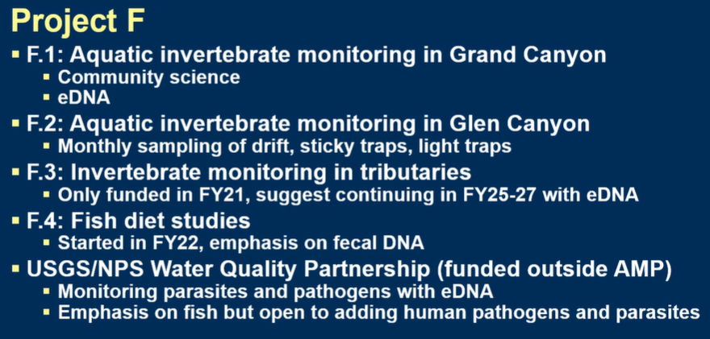

  - Discussion:
    - Larry Stevens: is it possible to move from individual resource to habitat basis in the next couple of funding cycles
      - Ted Kennedy: haven’t thought much about that, would be interested in meeting to discuss further
        - Two work plans ago had a student looking at importance of aquatic vs. land fauna
        - Papers have not been published yet
      - LS: long time since we heard about birds in the canyon
    - CN: would it be possible to look for eDNA related to the human "toelio" outbreaks in the canyon?
      - TK: possibly, does anyone know what order or phylum it’s from?
        - Viruses don’t have DNA, they have RNA, so it might be possible to monitor norovirus using water sample collections
        - Will reach out to grad student
    - CE: is there additional bug flow experimenting you would like to see done, what’s the next big thing?
      - TK: abundance of midges correlates strongly
        - Haven’t made a link w/ chub growth and survival
          - Can see role for additional replicates of bug flows to see if that connection exists

- Project A: Streamflow, Water Quality, and Sediment Transport and Budgeting in the Colorado River Ecosystem (FY24 $1,249,606)
  - This project collects the physical data that directly link dam operations to the downstream Colorado River; all other GCDAMP-funded projects use these data to link dam operations to their resources of interest. The data collected by this project are used to implement the High-Flow Experiment (HFE) Protocol (i.e., trigger and design HFE hydrographs), to evaluate the reach-scale sand mass-balance response to the HFE Protocol, and to evaluate the downstream effects of releases conducted under the Long-Term Experimental and Management Plan (LTEMP) Environmental Impact Statement (EIS; LTEMP). Full Description on page 80 of the FY21-23 TWP.
    - A.1 Stream gaging and hydrologic analyses ($400,958)
    - A.2 Continuous water-quality parameters ($137,334)

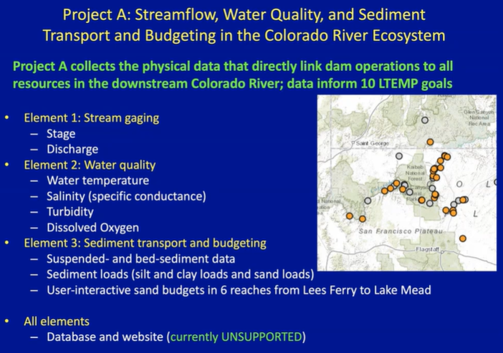
- This project is salary heavy
  - Only two river trips to maintain remote gaging stations in the canyon
  - HFE might have additional logistics to collect more data

  - Discussion:
    - CN: would temp in the slough fit in A, or different project area?
      - DT: deciding whether or not slough fits in Project A or not
        - Had hallway conversations about how to streamline some of the data collection so it’s not add on for other projects
        - DO sensor for GPP work halfway b/w dam and lees ferry that could become part of project A
          - Need to QA/QC data back to June 2023
          - In 25 this person might be able to take on more
    - Jim Strogen: is vandalism an issue on these sites?
      - David Topping: many years ago we had vandalism at LCR above the mouth
        - A couple others at outlying sites, but not a big problem here as with other sites
    - Betsy Morgan: how does the database/website effort differ from Project K?
      - Project K does not have an employee at the moment, looking for support
      - Data goes back to the 1990s
        - Hope in next TWP is to have someone in Project K take this on
        - Have to bring expertise in house w/ new position in Project K
      - Thomas Gushue (Project K): workflow for Project A data has followed a different path to other projects
        - Didn’t have capacity back then, but with new hire we would have a lot of crossover
      - Bridget Deemer: having a database manager would help a lot of projects
        - David Topping: incredibly important to bring this expertise in-house
        - Could distribute cost of funding this position across a lot of different projects

