The effects of High Flow Events (HFEs) on dissolved oxygen concentrations and temperature below Glen Canyon Dam

This paper investigates how HFEs and other types of operations affect water quality parameters such as dissolved oxygen (DO) and temperature below Glen Canyon Dam. A review of water chemistry parameters collected at the Lees Ferry gage during the 2014 HFE shows that DO and temperature is primarily determined by the stratification characteristics of Lake Powell. Release temperature and DO did change after the opening of the bypass tubes but these changes were most likely related to the lower intake elevations and increased aeration of releases from using the bypass tubes and not as a function of increasing the volume of water being release by the dam.

The following is a scaled diagram of the intake levels and an approximation of the water quality profile of Lake Powell in the forebay of Glen Canyon Dam during the 2014 HFE. Stratification in Lake Powell is often a complex interaction of layers of water with different temperatures and densities (cold water is denser than warm water and more saline water is denser than fresher water) but for this discussion we will just assume warmer, less saline water is located nearer the surface and colder, more saline water is located near the bottom. In the diagram below I tried to construct a water profile based on releases and water quality measurements made at Lees Ferry during the 2014 HFE.

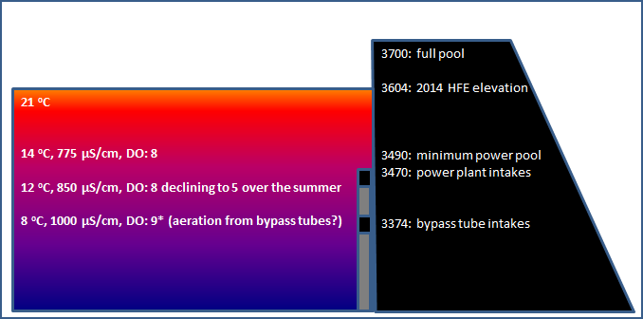

In looking at DO concentrations taken at Lees Ferry at the beginning of the 2014 HFE (following figure: a), one can see that DO concentrations did not begin to increase until after the bypass tubes were opened. This shows that increasing flows from near minimum releases of 7,000 cfs to powerplant capacity did not increase DO concentrations in the tailwater. The increase in DO after the opening of the bypass tubes was most likely caused by either the increased aeration of water as it was released through the jet tubes or the increased depth at which the bypass tubes were drawing water from Lake Powell. A look at measurements of temperature and specific conductance (salinity) also shows an abrupt change once the bypass tubes were opened (the figure: b and c). This provides an additional indication that water being released through the bypass tubes had a very different physical and chemical makeup than the water being released through the power plant with the bypass release being colder and with a higher specific conductance than the power plant release.

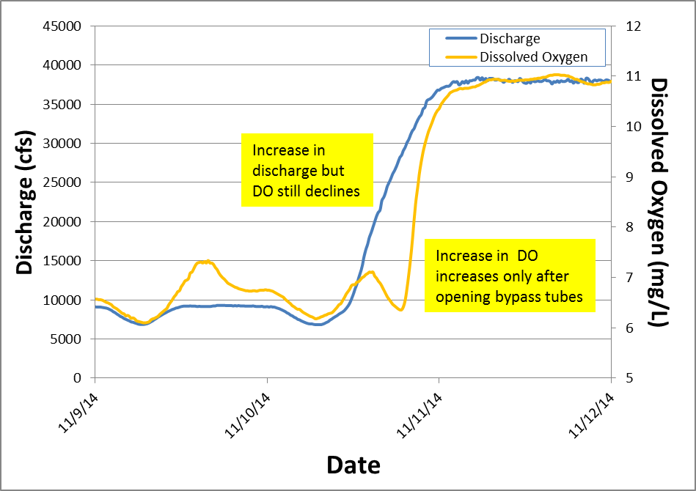

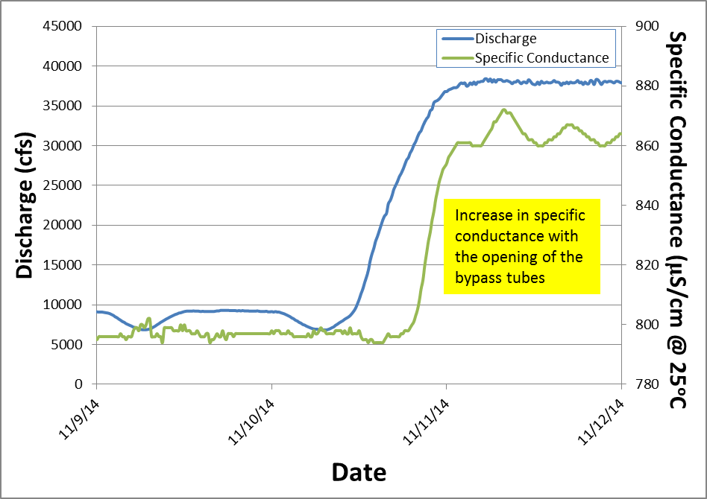

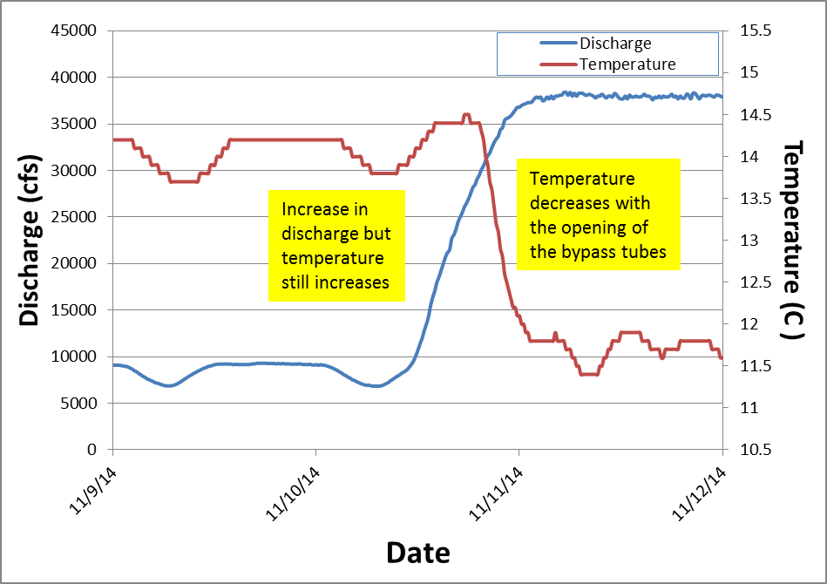

Temperature measurements prior to the HFE indicate there was about a 0.5ºC diel change in temperature at Lees Ferry. Temperatures in the Lees Ferry reach also appear to be primarily driven by release temperature instead of by volume. The figure above and to the right shows that temperatures continued to increase even as releases increased up to power plant capacity. Temperatures only began to decrease when the bypass tubes were opened. Additionally, fluctuations of 0.5ºC still occurred even at the peak flow for the HFE. This is an indication that these diel temperature fluctuations were likely due to temperature fluctuations in Lake Powell and not from instream warming in the Lees Ferry reach.

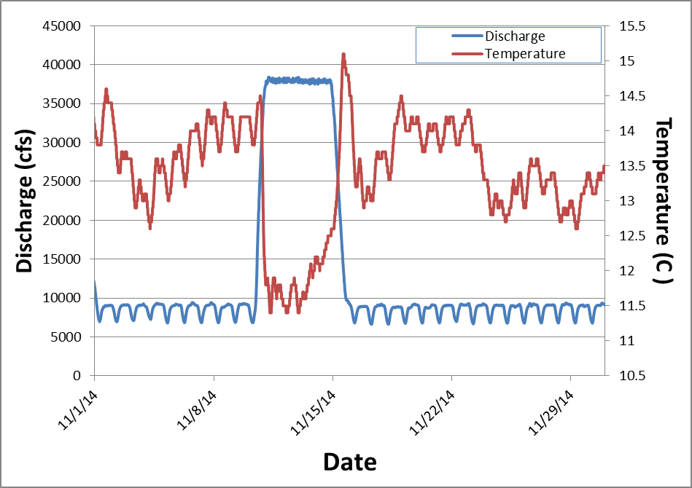

Several people have pointed out that it appeared that the 2014 HFE reversed a long decline in DO in the Lees Ferry reach. This trend began in June and continued through the beginning of November. Dissolved oxygen concentrations typically decline over the summer in hypolimnetic releases because the thermocline reduces the mixing of deeper water in the reservoir and oxygen demand in the hypolimnion typically increases during the summer. A closer look at when the decline in DO concentrations reversed shows that DO concentrations in the releases form Glen Canyon Dam actually began to increase the beginning of November prior to the HFE (following figure).

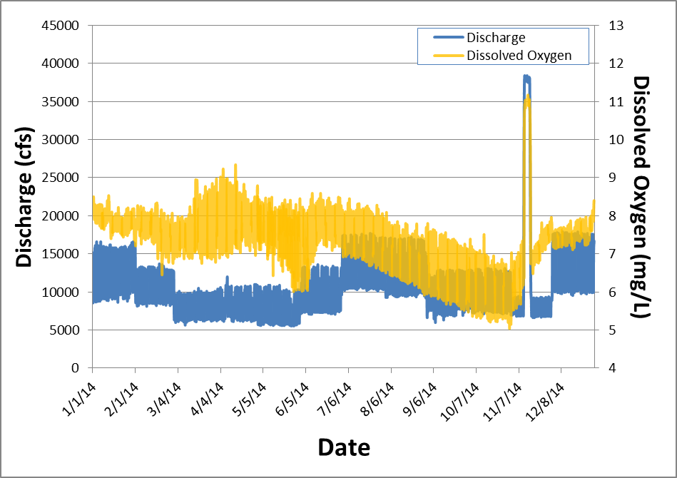

Additionally, a truncation in the daytime spikes in DO in the Glen Canyon tailwater can be seen after the 2014 HFE (following figure). As noted above, the daily cycle in DO concentrations below Glen Canyon Dam is not a function of water volume. The low nighttime DO is not a result of lower nighttime releases but a function of reduced photosynthetic activity from algae and macrophytes below the dam at night. Conversely, the daytime peaks are a result of increased photosynthetic activity during the day. After the HFE, daily fluctuations in DO are more truncated than before the HFE indicating a reduction in photosynthetic activity below the dam after the HFE (following figure on the right). This is probably because much of the algae and macrophytes were either scoured by the high flow or buried by sediment redistribution in the Glen Canyon reach. There also appears to be a difference in the rate of the DO recovery before and after the HFE. The slope of the pre-HFE DO measurements appears to be greater than the slope of the post-HFE measurements (following figure). This may be due to a difference in DO concentrations in the releases from the dam due to a lower lake elevation or it may be related to the apparent reduction in photosynthetic activity mentioned above.

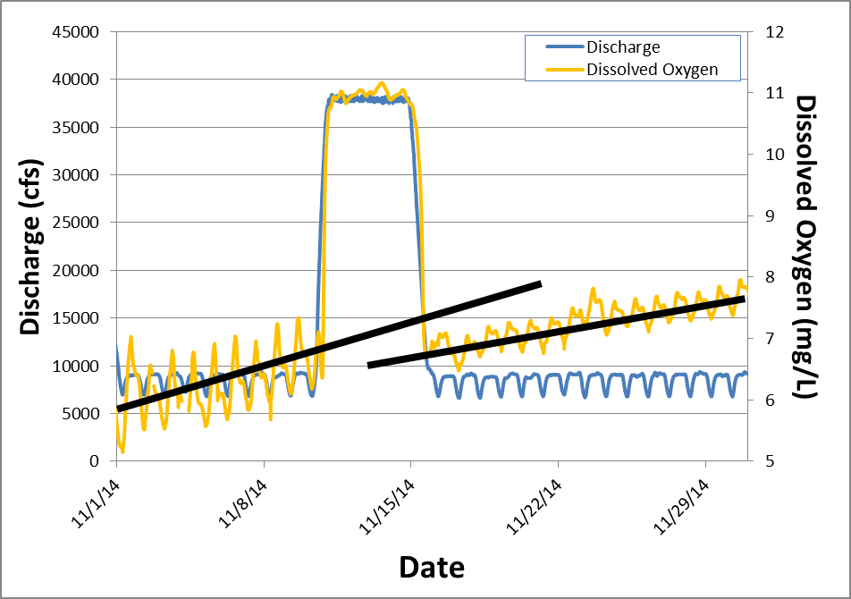

In summary, maintaining an elevated release does not appear to increase DO concentrations or decrease water temperatures in the Lees Ferry reach when those releases are at or below powerplant capacity. Increases in DO and decreases in water temperature can be achieved using releases from the bypass tubes. This is most likely due to the lower intake elevations and increased aeration of the bypass tubes. HFEs appear to suppress photosynthetic contributions to daily increases in DO below the dam. This is probably due to the scouring or burial of algae and macrophytes in the Lees Ferry reach. Reversal of the low DO trend in the summer and fall of 2014 occurred prior to the 2014 HFE and was probably hindered by the HFE scouring algae and macrophytes below the dam.

