BAHG Call #4
- Project L: Overflight Remote Sensing in Support of GCDAMP and LTEMP ($312,349) (Joel Sankey, Thomas Gushue)
  - This project seeks to acquire and analyze high-resolution multispectral imagery and digital surface models (DSM) of the Colorado River and riparian area from the forebay of Glen Canyon Dam downstream to Lake Mead, and along the major tributaries to the Colorado River. Data derived from the 2021 and previous overflights are used either directly or indirectly by every science project to address every resource goal of the LTEMP. Full Description on page 346 of the FY21-23 TWP.
    - Overflight remote sensing ($312,349)
  - 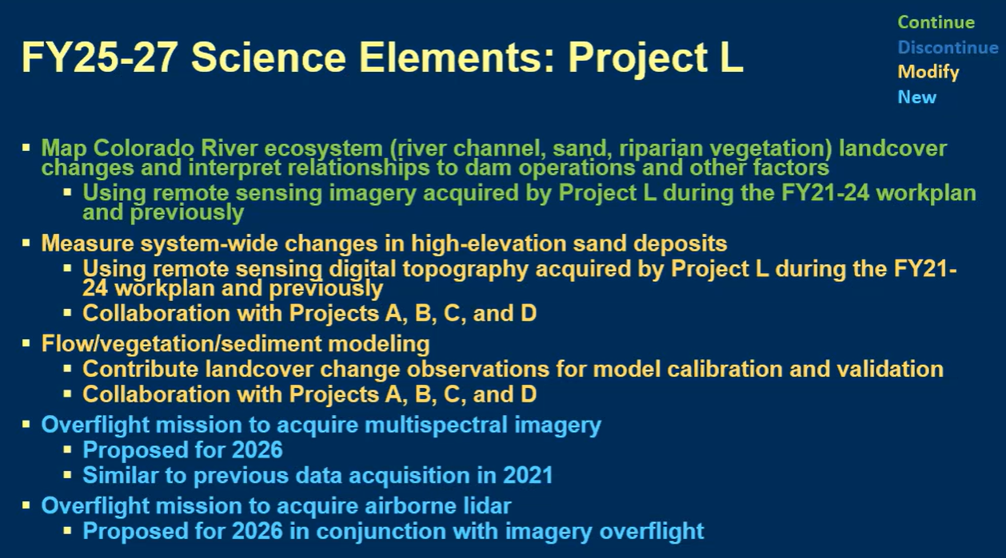
      - LiDAR would be very helpful for hydrologic modeling
  - Discussion:
    - Seth Shanahan: could we get a sense of what the budget might look like for regular flight vs. w/ LiDAR? Are there ways to save on the budget?
      - Joel Sankey: preliminary conversations w/ contractor price is similar to previous years w/o LiDAR. Don’t have a number right now on LiDAR, but will get back to you
      - Thomas Gushue: USGS 3DEP program, mission is to collect high resolution LiDAR, would try to coordinate w/ them and offset cost
      - SS: Imagery about $500k, how or if we could save money? What information do we lose or gain by doing it this workplan or not?
        - JS: people use this imagery and map data in the field to collect their data, there were significant enough changes @ 8,000cfs that another imagery run would be worthwhile
        - TG: only data collection that spans the entire system
          - 2026 would give us a change detection from spring HFE
            - Cost gets spread out across every project every year
        - JS: pushing the project off risks having those funds getting picked up by other projects
    - Betsy Morgan: how does the program distinguish which project bears costs since there is collaboration?
      - JS: try to make sure there is not a waste of money being spent by having redundant data collection across projects
    - Larry Stevens: probably the most important record of how the ecosystem changes
      - Running at 4-8 intervals is essential to many different resources
    - Christina Noftsker: 3DEP, does the program pay for the LiDAR if it can be dovetailed w/ 3DEP?
      - JS: Depends on the program, but idea is multiple partners come together to provide funding towards it
      - CN: in prior years, did other branches of the program pay for the imagery?
        - JS: a lot of work put into other ways to collect that imagery. Have settled on overflights due to advancement of sensors.
          - Save money on 2021 overflight
- Project D: Effects of Dam Operations and Vegetation Management for Archaeological Sites ($331,622) (Joel Sankey, Helen Fairley)
  - The LTEMP goal for Archaeological and Cultural Resources is to maintain the integrity of potentially affected National Register of Historic Places (NRHP)-eligible or listed historic properties in place, where possible, with preservation methods employed on a site- specific basis. Project D monitors and quantifies changes in the physical condition of river corridor archaeological sites in Grand Canyon as a function of ongoing and experimental dam operations and vegetation management actions of the LTEMP ROD (LTEMP), in keeping with the mandates of the Grand Canyon Protection Act (GCPA) and consistent with the monitoring plan developed in 2015 and Reclamation’s 2017 Historic Preservation Plan. Description on page 164 of the FY21-23 TWP.
  - 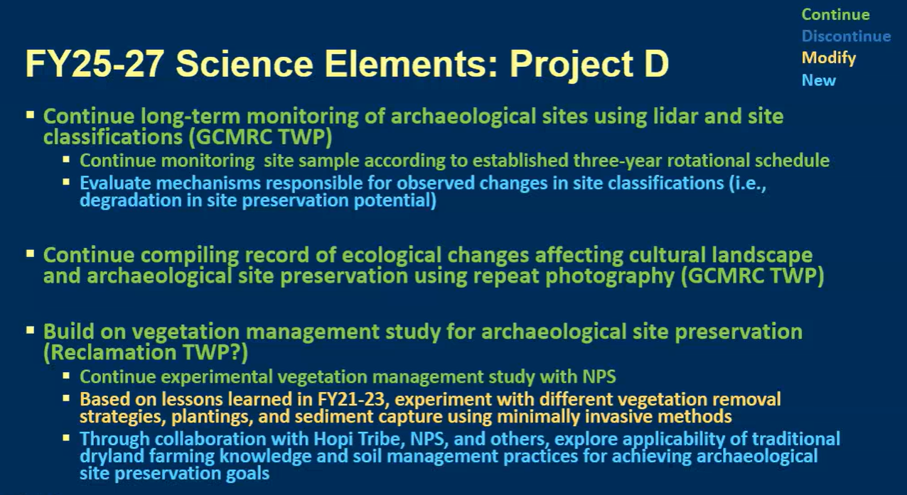
  - 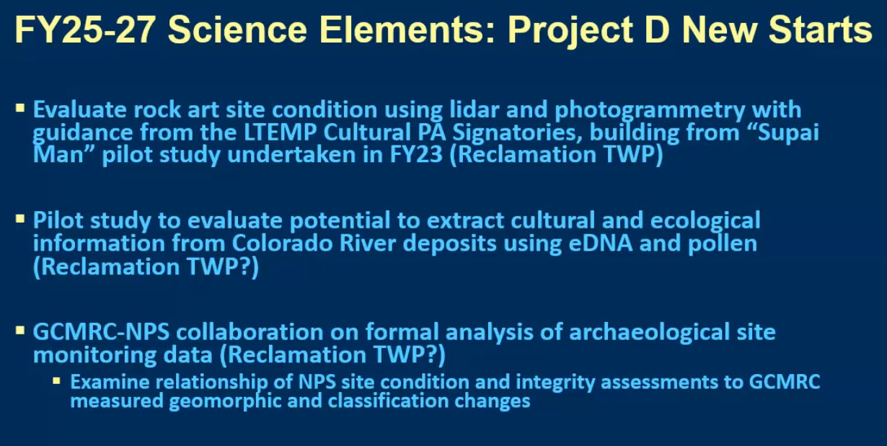
  - 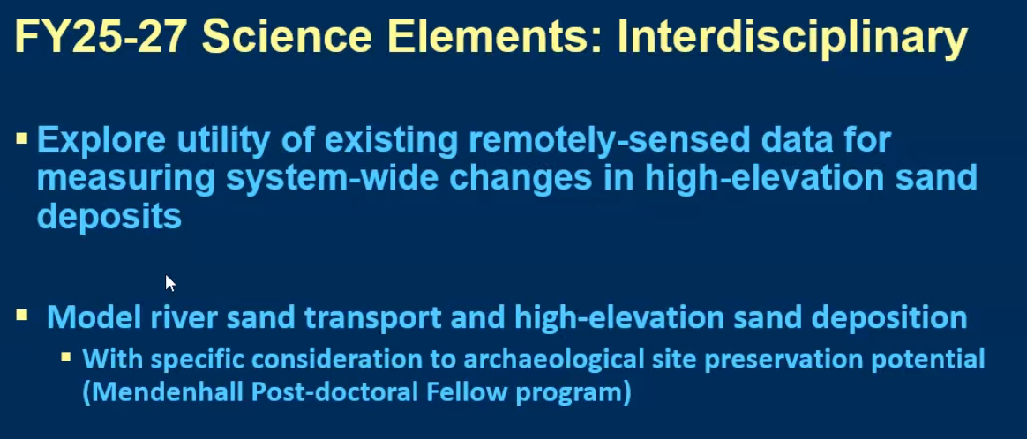
    - Dam operations, vegetation management, archaeological sites ($294,846)
    - Monitoring landscape-scale ecosystem change with repeat photography ($36,776)
    - Cultural Program History ($0)

  - Discussion:
    - Would Project L LiDAR allow for cost saving in the year it is collected?
    - Leslie James: What is the practical effect of moving some of this work over to Reclamation, what does that really mean? Moving some of GCMRC funds back to BOR?
      - Helen Fairley: some of these projects (like rock art) is more suited to PA as it has a broader scope than Dam Effects
        - Pilot study is one that had back and forth, part of PA but there has not been much effort to understand it
      - LJ: understand that, but why is some of this work still considered experimental as opposed to more management actions?
        - If management actions, where should the responsibility lie?
      - JS: Last work plan the Veg management had parallel projects w/ NPS, last TWP fit the work to evaluate those management actions
      - HF: in terms of veg management, looked at effects of veg management and how quickly it comes back and how sediment management actions effect sandbars
    - Rob Billerbeck: LiDAR stuff, we haven’t had a lot of NPS discussion, yet
      - Looks useful at getting at how sites are changing
      - Knowing how much veg and how many sites are experiencing that encroachment was significant for NPS action
        - Learned we didn’t have to remove as much veg as initially thought
    - Larry Stevens: think as big as possible at this point in the program
      - Why not spend some time in the next three years using historical photos to focus in on micro habitats to develop ecological understanding of vegetation states through time
        - HF: potential there, one of the challenges we face is “habitat for who?” and being more explicit about what we’re talking about
          - Maybe some of these changes are benefiting some and not others
          - Repeat photography records haven’t been used to their full potential
            - Potential for understanding sediment supply availability
    - LS: not suggesting fullscale habitat search, but would love to see the conversation to develop a plan for it
      - Would like to see planning to get at that broader perspective
      - Word “enhance” in GCPA difficult term for NPS, what do we want to the river corridor to look like?
    - Kurt Dongoske: are you doing any assessment of how wind blown sand on archeological sites is being stabilized (if at all)?
      - HF: sand doesn’t need to be compacted to have preservation value
        - Can withstand fair amount of traffic and still preserve site
        - Trying to take this to the next step of how we can manage sand to hold that sediment where it needs to be held
      - KD: what is the end game for this entire project? When will you have enough info to make findings, or will it be ongoing monitoring that should potentially be taken over by NPS?
        - HF: a bit of both research and long term monitoring
          - Thought there would be more HFEs
          - Need longer term data stream to understand that interconnection of sand supply
          - Can’t get a hold of decadal changes doing a short term study, so that’s why this is designed as long term
      - KD: concern that burying sites with wind blown sites does have affect as it does not allow Zuni to receive message from ancestors
        - Turned arch sites into geomorph landscape situations
        - Cultural landscape study within park, it is important to note BOR resistance to appreciating Zuni relationship to Grand Canyon
        - HF: burying sites out of view is an unlikely outcome as it would take a lot of sand to bury these sites
          - Trying to find a way to ensure that these sites aren’t erased from the landscape as a result of humans
          - Seeing if this can work in the long run if there is even enough sand to make a difference
        - KD: original EIS issue of historic floods no longer occurring was something that couldn’t be considered in EIS, only operations of the dam
          - Sediment behind the dam helped secure sites in place
          - concerned with interaction b/w NPS archeologists and Zuni
    - Rob Billerbeck: appreciated comments from Kurt and Helen
      - Trouble trying to maintain natural aeolian processes, not aware of sites w/ too much building of sediment
      - NPS looking at maintaining and struggling to do so, not aware of too much sediment
- Project I: Warm‐Water Native and Non‐Native Fish Monitoring and Research ($655,278) (Charles Yackulic, Drew Eppehimer, Kim Dibble)
  - Maintaining self-sustaining native fish populations within the Colorado River and minimizing the presence and expansion of aquatic invasive species are two specific resource goals outlined in the LTEMP and associated 2016 Biological Opinion for the operation of Glen Canyon Dam. These two resource goals are closely linked together in that introduced warm-water fish are largely incompatible with Colorado River native fish and pose a direct risk to native species like the Humpback Chub. This project will help to monitor those risks. Full Description on page 291 of the FY21-23 TWP.
  - 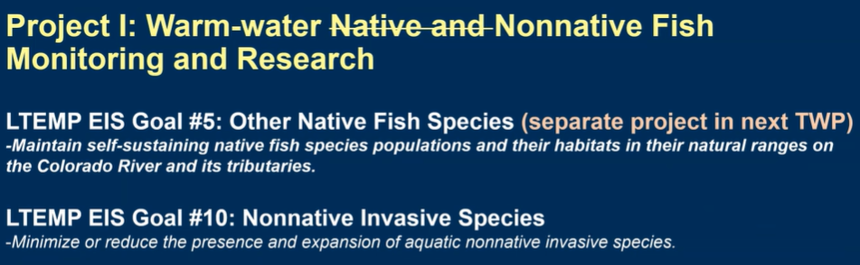
  - 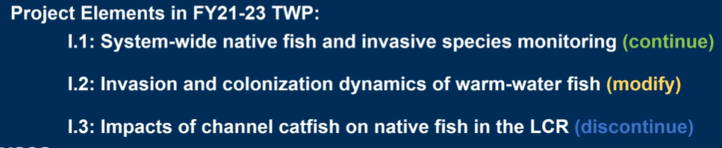
    - System-wide native fish and invasive aquatic species monitoring ($357,743)
    - Invasion and colonization dynamics of warm-water invasive fish ($168,365)
    - Impacts of channel catfish on native fish in the LCR ($129,170)
  - 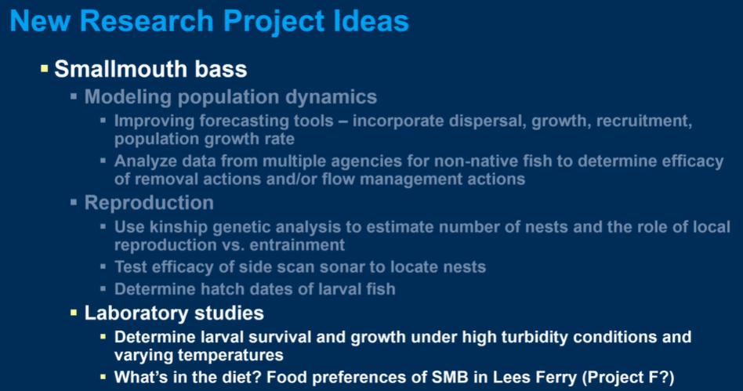
    - Diet studies happening under Project F, not sure if it go under project I or not
  - 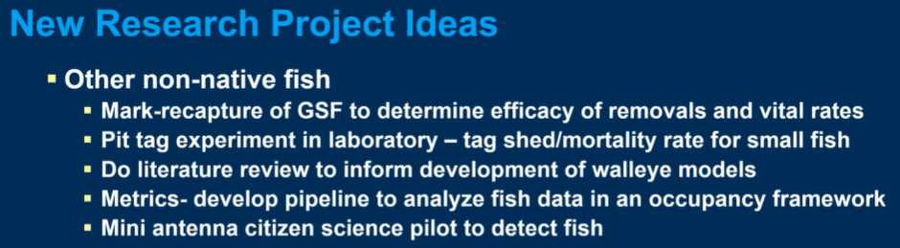
  - 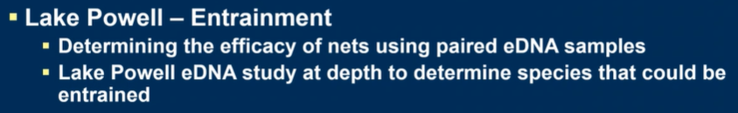
  - 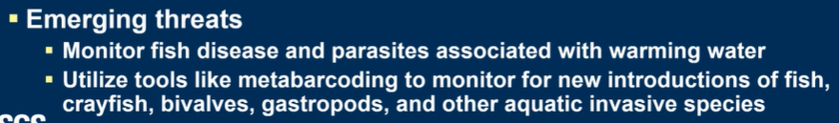
    - Would that fit more under project G?
  - Discussion:
    - Jim Strogen: parasites, is there ultimately a management action that could mitigate, or is this just a study?
      - System-wide the parasites are coming in due to warming waters
        - Need to monitor as it’s in the BO
        - If due to warming, there is potential management action to cool the water
      - JS: knowing about the parasites is all well and good, but can’t think of management action for us
      - KD: management action would be related to temps
    - Larry Stevens: how do we get to the big picture of fisheries? Maybe get bibliography of all information?
      - Is there strategy of life history model for these fish species?
        - KD: would be a huge effort to get all of that data and information together on a resolution necessary for life history
          - Would need to think about it more
      - LS: Want to make sure there is a clear plan to move forward in the next TWP
    - Craig Ellsworth: modeling population dynamics, would hope entrainment would be included in that model
      - Hope that there is temp monitoring being done in areas like the slough and other easily accessible areas to get idea of what’s going on
      - Tucker trough (2nd bullet on “New Research Ideas” is a good idea
      - KD: Jeff Arnold putting out two loggers in the slough next week, talked about temp and DO loggers, concern of losing those loggers due to activity in the slough
        - Looking at temps in vegetation beds
    - Seth Shanahan: ideas from the non-native fish strategic plan. One idea is a discussion and review of fish actions on how they are at controlling non-natives, and any opportunities for off-ramping
      - Add project element that would allow GCMRC participation
      - KD: will touch base later to see what would work
    - Shana Rapoport: could you give us detail on how the budget pertains to presenting the results, how do we aggregate all the information coming in from difference agencies?
      - Do we need to devote more funding to that kind of activity, or would another agency be more suited to being the data clearing house?
      - KD: use the ARM to relay science to stakeholders, are opportunities to present to TWG and AMWG periodically
      - Bill Stewart: a lot going on, and it’s a mix of TWP and NPS actions
        - Glad to hear having some space in the TWP to better communicate these efforts
        - There is technical team focused just on folks doing the work in the river
      - KD: quantifying where we are in the invasion curve could be difficult, have been trying to figure out how to answer that question
        - Do have a web map for non-native fish mapping
          - BS: not available publicly yet
    - Emily Young: since we’re considering SMB flow options, does additionally monitoring need to be included in this work plan, or would it be experimental fund?
      - Any additional research we want to see if we aren’t able to have those flow options?
      - KD: modeling that was mentioned earlier might encompass some of that effort
        - As far as adding additional monitoring, we are monitoring Lee’s Ferry a lot already (TRGD, NPS monitoring, AZGFD, etc.).
    - Rob Billerbeck: relevant projects to what we’re going through right now, appreciate Emily’s comments on the LTEMP SEIS options
      - Maybe something b/w Lee’s Ferry and LCR would be appropriate

