LTEMP SEIS Cool Mix Flow Summary Report

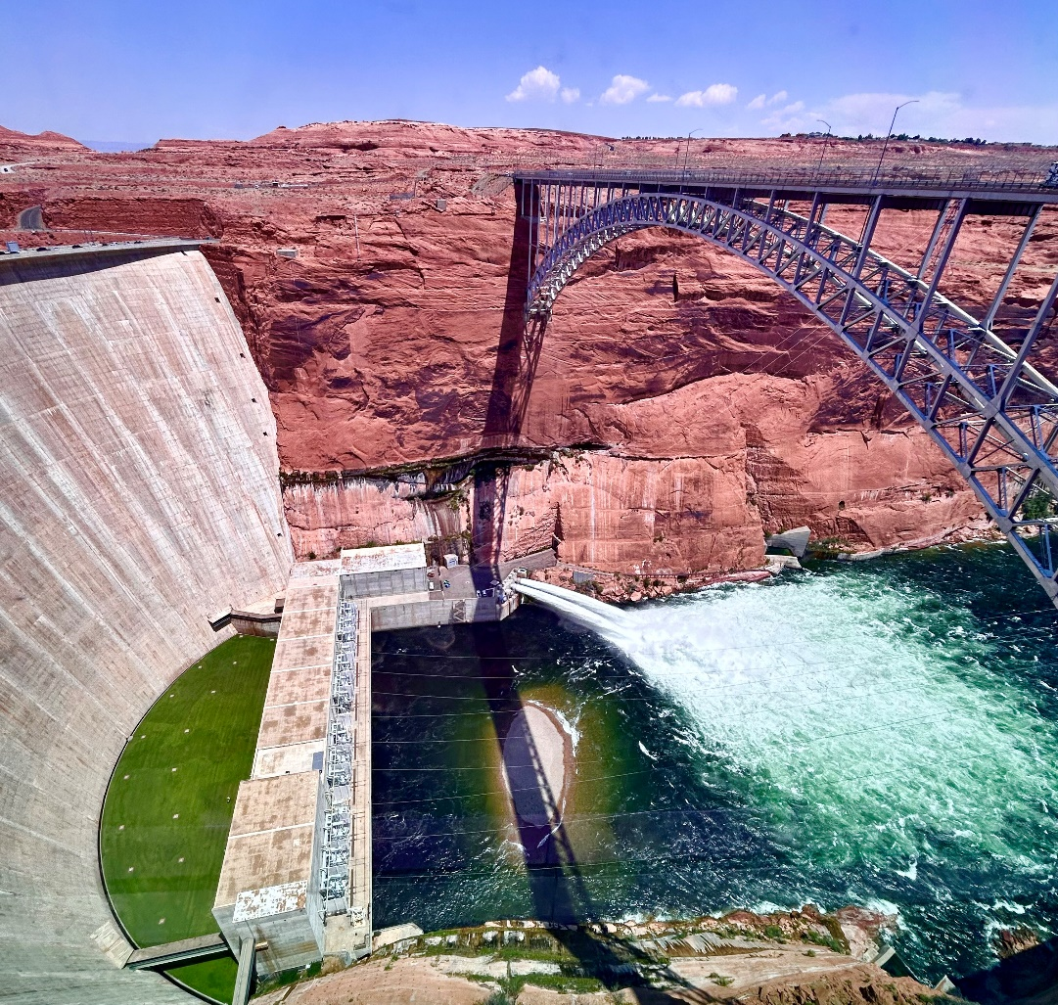

Fiscal Year 2024

Introduction
Smallmouth bass, introduced to the upper Colorado River basin in the late 1960s, have historically had limited, if any, reproduction downstream from Glen Canyon Dam (GCD) through Grand Canyon, due to presumably unfavorable cold water conditions. Smallmouth bass were periodically captured immediately downstream from GCD since 2003. In July 2022, a single juvenile smallmouth bass was captured in the slough at -12 mile. The capture of this smallmouth bass as well as green sunfish (another warm water invasive species), which had recently established populations in the area, set off alarm bells for natural resource managers. These captures coincided with the warmest recorded GCD release temperatures to date (21 °C), which represents a 6.5 ° C increase from the maximum release temperatures averaged over the previous 10 years. Warmer temperatures driven by record low reservoir levels enabled successful reproduction of smallmouth bass downstream of GCD. Monitoring efforts in 2022 and 2023, respectively, found 362 individuals between GCD and Lees Ferry, and 1,113 individuals between GCD and RM 16. The highest densities of smallmouth bass were in the first 15 miles between GCD and Lees Ferry, which is known as the Lees Ferry reach (Figure 1). This significant increase in smallmouth bass reproduction raised concerns about their potential impact on native fish populations, including the largest federally protected humpback chub population which resides downstream from Lees Ferry in the Grand Canyon.
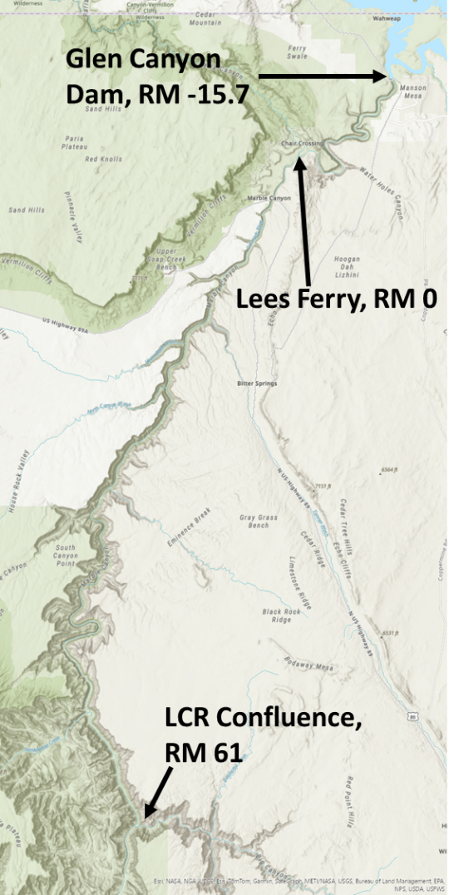
Figure 1. The action area discussed here, showing key locations such as Glen Canyon Dam (river mile –15.9), Lees Ferry (RM 0), and the Colorado River’s confluence with the Little Colorado River (RM 61).
In response to these changing conditions, the Secretary of the Interior’s acting designee (Acting Designee) for the Glen Canyon Dam Adaptive Management Work Group (AMWG) provided a directive to develop a strategic plan to prevent, detect, and respond to cool and warmwater invasive fish establishment below GCD (GCDAMP 2023). Additionally, the Acting Designee directed Reclamation to identify and analyze operational alternatives at GCD to disrupt the spawning of smallmouth bass and other warmwater nonnative fish that pass through the dam (termed ‘entrainment’).
Reclamation published the Final Glen Canyon Dam Long-Term Experimental and Management Plan Supplemental Environmental Impact Statement (LTEMP SEIS) and Record of Decision (ROD) in July 2024 (USBR 2024). The LTEMP SEIS analyzed six alternatives, and the “Cool Mix ” flow (a method for releasing cold water through the dam from deep within the reservoir through the River Outlet Works (ROW), or bypass tubes, to cool river temperatures) was chosen for implementation in 2024. In 2024, the ROD provided guidance for Cool Mix flow operations, stating that a Cool Mix flow would be triggered when the average daily temperature at river mile (RM) 61 exceeded 15.5 °C (60 °F) for three consecutive days. River mile 61 was chosen to ensure unfavorable conditions for smallmouth bass in the first 75 river miles below GCD which constitute critical habitat for humpback chub. The threshold temperature of 15.5 °C was chosen based on scientific literature that indicated smallmouth bass start to spawn after temperatures reach and maintain 16.0 °C for several days. A weekly adaptive decision-making process was used in coordination with Western Area Power Administration (WAPA) to most effectively balance hydropower production and bypass flow volumes to meet downstream temperature targets. Temperature data was expected to use real-time stream gage readings at the dam and Lees Ferry along with existing downstream models (e.g., Dibble et al., 2020 and Mihalevich et al., 2022). The Cool Mix flow was planned to remain in effect until the mean daily water temperature (without bypass) at RM 61 fell below 15.5 °C. The ROD also stated that the planning and implementation process described in LTEMP would be used to assess monitoring results, including effectiveness of experimental flows and potential off-ramps (see below).
A monitoring plan (LTEMP SEIS ROD attachment B) was developed by the U.S. Geological Survey’s (USGS) Grand Canyon Monitoring and Research Center (GCMRC) to evaluate the effectiveness of the Cool Mix flow in 2024. The monitoring plan outlines a comprehensive approach to assess various smallmouth bass population metrics, including abundance and catch, distribution and dispersal patterns, growth, diet, and genetic kinship analysis to assess entrainment (Figure 2).

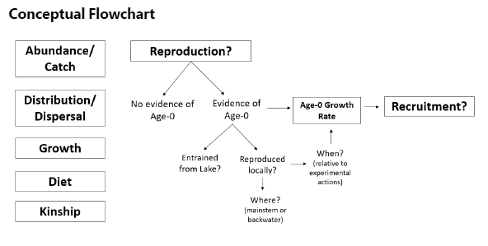
Figure 2. Conceptual model of the monitoring approach taken to determine the effectiveness of Cool Mix flows in 2024 (LTEMP SEIS ROD attachment B).
This report summarizes the actions and outcomes of implementing the Cool Mix flow in 2024 including monitoring done by the National Park Service (NPS), the USGS Grand Canyon Monitoring and Research Center (GCMRC), the Arizona Game and Fish Department (AZGFD), and the Bureau of Reclamation. We thank each of these agencies and their staff for their efforts in this intense summer, and we particularly highlight the efforts of the Reclamation and WAPA staff who turned the Cool Mix flow from a paper exercise into reality.

Implementation

General Overview
During normal operations, GCD releases water through penstocks (water intakes) that direct water to the dam’s generators that create power. Declining Lake Powell levels mean the penstocks draw from warm surface water, resulting in the river temperature warming and a higher likelihood of fish utilizing warm surface waters (e.g., smallmouth bass) being entrained through the penstocks of the dam and released into a warming river below GCD and smallmouth bass concerns. To cool the river water, Reclamation proposed alternative flows that release water through the ROW, which are four large tubes through the dam that are deeper in the water than the penstocks but do not power the generators. The water released through the ROW is known as bypass because it bypasses the generators and thus does not create power. To determine what the temperature of the river immediately below the dam will be when the ROW are operating, scientists need to know the volume of the penstock (warm) and ROW (cold) water releases and how those waters mix. Furthermore, the river will warm or cool as the water flows through the canyon downstream depending on the season. To calculate what the river’s temperature will be at a given distance from the dam, scientists must determine the dam’s release temperature (the mix of warm penstock and cold bypass water) and apply corrections to that based on how long the water is moving and how the predicted weather will change water temperature. Cooling the river may have ecological impacts that require monitoring, and bypassing the generators reduces power output and thus reduces revenue for WAPA.

Pre-implementation
In April 2024, in anticipation of a decision to run a smallmouth bass flow option, Reclamation focused on data availability and collection, as well as the specifications for bypass releases. Reclamation concluded that for the Cool Mix flow experiment, two of the four ROWs— specifically ROWs 3 and 4 — would be sufficient, providing a combined release capacity of 7,500 ft³/s. This arrangement enabled the concurrent relining project for ROWs 1 and 2. To streamline operations during the initial implementation phase, a limit of four changes per day to the bypass release volumes was established.
Water temperature data to be used for determining bypass volumes included monthly forebay profiles and GCMRC’s continuous sensor located immediately downstream from the dam. Further downstream, multiple water temperature sensors were available for monitoring the experiment. This included locations at Lees Ferry (river mile (RM) 0), RM 30 and RM 61. For RM 30 and RM 61, GCMRC staff had to manually download this information. In late May, discussions between Reclamation and GCMRC resulted in an agreement for bi-monthly data updates at RM 61, which transitioned to weekly updates by late June. By the end of June, Reclamation acknowledged the need for real-time continuous data at RM 61 and initiated plans to upgrade the gage during a mid-August, river trip.
Reclamation used the process-based 1D model described in Mihalevich et al. (2022) and the statistical model reported in Dibble et al. (2020) for predicting river temperatures. The first estimate of bypass water volumes needed for Cool Mix flows was conducted using the Colorado River Mid-term Modeling System (CRMMS) April 24-month study hydrologic forecasts. The Dibble model was used to back-calculate optimal release water temperatures to meet the 15.5 °C target temperature at RM 61, while the selective withdrawal algorithm in the CE-QUAL-W2 model for Lake Powell estimated the necessary weekly bypass flow under the calculated release temperatures. In May, WAPA informed Reclamation of the development of an optimization tool in collaboration with Argonne National Lab, aimed at maximizing power purchase costs during Cool Mix flow implementation by optimizing penstock release hours. This prompted Reclamation to create a river temperature delta lookup table, generated by running the 1D model with observed inputs from 1990 to 2023, varying GCD release temperatures from 10 °C to 18 °C in 0.5 °C increments. This lookup table, compiled as an Excel workbook, included hourly temperature deltas for locations RM 0 (Lees Ferry), RM 15, RM 30, and RM 61 within the Grand Canyon, and was shared with WAPA.

On-Ramp
In June 2024, Reclamation initiated a series of internal weekly calls with Reclamation staff from the Adaptive Management Group, Water Quality and River Operations groups (BOR Group) and WAPA staff from the Scheduling, Environmental and Modeling groups (WAPA Group) to facilitate the implementation and coordination of smallmouth bass flow management. These calls focused on reviewing the latest data from RM 61, analyzing river temperature model forecasts, discussing the daily allowed changes to bypass flows, and addressing the maximum permissible temperature change per hour in the river. On June 28, data from RM 61 was available only up to June 18, as GCMRC staff were still manually downloading this information weekly. The 14-day model forecast at that time indicated a single-day exceedance of the temperature threshold of 15.5 °C on June 29 and a three-day exceedance beginning on July 6. Therefore, it was anticipated that RM 61 would exceed the 3-day average temperature limit within 1-2 weeks, however the ROD was still pending signature.
By the week of July 1, 2024, a subsequent data download from GCMRC revealed temperature exceedances at RM 61 had already occurred for three consecutive days. All river temperature models utilized—including the 1D model (Mihalevich et al., 2022), statistical model (Dibble et al., 2020), and lookup table model—forecasted continuous exceedances of the temperature threshold under current operations as analyzed by BOR Group. During this week, WAPA Modeling provided Reclamation Water Quality with three hydrographs for testing that included weekly average bypass flows of 1,766 ft³/s, 2,095 ft³/s, and 3,280 ft³/s, all with bypass durations of 16 hours from 10 PM to 2 PM. Analysis of the river temperature forecast models indicated that a weekly average bypass of 3,280 ft³/s would be required to keep temperatures within acceptable limits. The ROD was signed on July 3rd, and the first Glen Canyon directive authorizing the release of Cool Mix flows was issued by the Reclamation River Operations shortly thereafter on July 5th. This directive specified the initiation of Cool Mix flows starting July 9 at midnight with a hydrograph featuring a 5,000 ft³/s peak bypass flow for 16 hours (Table 1).
Table 1. Hourly GCD release schedule issued under the first directive of LTEMP SEIS Cool Mix flows.
Hour System Time (MST) | Bypass Release (ft³/s) | Penstock Release (ft³/s) | Total Release (ft³/s)
0:00 | 5,000 | 4,480 | 9,480
1:00 | 5,000 | 4,480 | 9,480
2:00 | 5,000 | 4,480 | 9,480
3:00 | 5,000 | 4,480 | 9,480
4:00 | 5,000 | 4,480 | 9,480
5:00 | 5,000 | 4,480 | 9,480
6:00 | 5,000 | 4,480 | 9,480
7:00 | 5,000 | 4,480 | 9,480
8:00 | 5,000 | 4,480 | 9,480
9:00 | 5,000 | 4,480 | 9,480
10:00 | 5,000 | 4,480 | 9,480
11:00 | 5,000 | 4,480 | 9,480
12:00 | 5,000 | 6,086 | 11,086
13:00 | 5,000 | 10,086 | 15,086
14:00 | 0 | 15,086 | 15,086
15:00 | 0 | 15,086 | 15,086
16:00 | 0 | 15,086 | 15,086
17:00 | 0 | 15,086 | 15,086
18:00 | 0 | 15,086 | 15,086
19:00 | 0 | 15,086 | 15,086
20:00 | 0 | 15,086 | 15,086
21:00 | 0 | 14,480 | 14,480
22:00 | 5,000 | 6,980 | 11,980
23:00 | 5,000 | 4,480 | 9,480

Implementation
The amount of bypass flow needed to cool the river down below 15.5 °C at RM 61 was determined through collaborative modeling efforts by Reclamation and WAPA. This process began with Reclamation Water Quality sending WAPA Modeling the latest estimates of penstock and bypass release temperatures. The WAPA Modeling group used a modeling tool developed by Argonne that incorporated the daily scheduled water release, discharge ramp rates, temperature deltas from the lookup table (described above), energy load pattern, and the purchase power price curves. WAPA Modeling created multiple hydrographs with varying amounts of bypass flow release patterns aimed at meeting the downstream temperature criteria. Reclamation Water Quality evaluated whether WAPA Modeling’s hydrograph(s) would maintain < 15.5 °C temperatures at RM 61 using the river temperature models discussed above (e.g., Mihalevich et al., 2022, Dibble et at., 2020, and the lookup table). River temperature model forecasts included 16-day weather forecasts from the Global Forecast System (GFS) model (NCEP 2015). Due to the uncertainty in meteorological forecasts used in the river temperature models, Reclamation Water Quality evaluated forecasted river temperatures on a 3-day rolling average. Depending on model results, the BOR Group would either accept one of the hydrographs or request a modified pattern from WAPA Modeling if none of the proposed patterns met downstream temperature criteria. Once a pattern met temperature threshold limits, a directive confirming the release pattern was issued by Reclamation River Operations. This weekly collaborative cycle was repeated throughout the implementation of Cool Mix flows (Table 2).
Table 2. Weekly process of implementation for the smallmouth bass flow experiment.
Day of the Week | Activity
Monday | Reclamation Water Quality updated WAPA Modeling on current release penstock and bypass temperatures  WAPA Modeling developed 2-4 weekly hydrographs using the river temperature lookup table and the penstock and bypass temps
Tuesday | WAPA hydrographs tested in river temp models by Reclamation Water Quality  BOR Group meeting to discuss model outputs and determine hydrograph(s) that meet objectives for further discussions with WAPA Group
Wednesday | Coordination meeting between BOR Group and WAPA Group to discuss model outputs and hydrograph(s) for a final hourly release pattern determination
Thursday | Reclamation River Operations issued a directive confirming the release pattern
Friday | LTEMP Planning and Implementation Technical Team meeting to discuss experiment updates (every other Friday)
Saturday | New hydrograph implemented by Reclamation and WAPA

Throughout the experiment, Planning/Implementation (PI) Leadership and Technical Teams, as defined in the LTEMP ROD, met to discuss status of the smallmouth bass flows with regards to smallmouth bass captures, instream temperatures, and other issues. These meetings occurred every other Friday during implementation.

Off-Ramp
The LTEMP SEIS and ROD stated that the PI process would be used to assess monitoring results, including effectiveness of experimental flows and potential off-ramps. Off ramp discussions began in late-October when modeling results forecasted river temperatures could fall below 15.5 °C at RM 61 without Cool Mix flows. However, releases from GCD penstocks were still warmer than 18 °C for most of October, which could have provided favorable spawning conditions for smallmouth bass in the Lee’s Ferry reach if the experiment were to conclude. On November 5, 2024, the PI Leadership and Technical teams discussed moving the targeted river mile for maintaining 15.5 °C temperatures from RM 61 to the releases out of GCD (RM-15.7). A five member panel of expert biologists from GCMRC, US Fish and Wildlife Service, National Park Service (NPS), WAPA, and the Arizona Game and Fish Department assessed the risks of off ramping while release temperatures were above 15.5 °C. Experts from four out of the five agencies expressed concern regarding the potential for smallmouth bass to spawn and overwinter in the Lees Ferry reach and suggested maintaining Cool Mix flows until dam release temperatures were below 15.5 °C. In a memo issued by the Designee to the AMWG on November 6, 2024, the target location for maintaining a 15.5 °C threshold was adjusted so cool water would be maintained from GCD to Lees Ferry. The experiment concluded on November 19, 2024, when penstock release temperatures from GCD fell below 15.5 °C.

Results

Hydrology
During the 133 days of Cool Mix flow releases, 893,919 acre-ft of water was bypassed, which consisted of 32.5% of the total flow below GCD (Table 3). Glen Canyon Dam releases during the Cool Mix flows maintained the monthly planned volume, and the volume necessary to meet the 2024 water year volume of 7.48 million acre-feet. To reduce experimental costs, Reclamation coordinated with WAPA to preserve on-peak hours for hydropower generation (typically 3pm to 10pm) and time Cool Mix flow releases during off-peak hours (Figure 3). Release data from GCD between July and November 2024 is provided in Appendix A.
Table 3. Total and bypass release volumes and percentage of flow that was bypassed for months during Cool Mix flow implementation in 2024.
Dates | Total Release [KAF] | Bypass Release [KAF] | Volume Bypassed  [%]
9 – 31, July | 554,542 | 167,416 | 30%
1 – 31, August | 759,780 | 257,447 | 34%
1 – 30, September | 568,347 | 253,624 | 45%
1 – 31, October | 482,582 | 168,301 | 35%
1 – 18, November | 388,196 | 47,130 | 12%

Figure 3. Boxplots of total, penstock, and bypass release discharge from Glen Canyon Dam for each hour of the day between July 9, 2024, and November 18, 2024. Colored boxes represent the 25th and 75th inner quartile range with the black dash indicating the 50th quantile. All data points are marked by black dots. Outliers are marked by black stars. Dashed lines connect median values between each hour of the day.

Water Quality

Temperature
River temperatures in the Lees Ferry reach and further downstream in Marble and Grand Canyon reaches are largely driven by release temperatures from GCD but are also influenced by additional factors such as local meteorology and seasonal canyon shading (Mihalevich et at., 2020). Release temperatures from GCD historically reach an annual maximum in October or November, depending on water storage conditions. Over the summer months (June through August) release temperatures are relatively cold with river temperatures warming as they move downstream. When GCD release temperatures peak in October or November, river temperatures are typically cooling as they flow downstream.
Water temperatures at the USGS Lees Ferry (RM 0) gage averaged 14.1 °C during Cool Mix flow implementation (Figure 4). The warmest temperatures in Lees Ferry occurred in late October, with a maximum daily average of 16.22 °C. At that time, river temperatures were generally cooling as they moved downstream, so the 15.5 °C temperature target was still being met at RM 61.
Mean daily river temperatures at RM 61 hovered around 15.5 °C throughout implementation of the Cool Mix flow experiment (Figure 5). Efforts to minimize bypass volumes combined with unexpected meteorological conditions resulted in temporary exceedances of 15.5 °C at RM 61 throughout the summer. Exceedances were often remedied by the following week’s modeling and implementation strategy. Reclamation reserved the ability to issue within week changes to bypass volumes throughout the experiment. On September 27, 2024, in response to exceedances observed at RM 61, a within week directive was issued to increase planned weekly average bypass volumes from 3,283 ft³/s to 3,889 ft³/s. This directive came the day before an existing directive was to go into effect. Overall, river temperatures at RM 61 exceeded 15.5 °C for 29 days in 2024 (14 exceedance days occurred after Cool Mix flow implementation). In contrast, 2022 and 2023 had 156 and 152 days above 15.5 °C at RM 61, respectively.
A post-hoc modeling analyses conducted for this report using the Mihalevich et al. (2022) model with observed penstock release temperatures suggests that RM 61 would have experienced approximately 135 (±5) days of temperatures over 15.5 °C in 2024 had Cool Mix flow not occurred (Figure 5). River temperature predictions at RM 61 have a root mean squared error (RMSE) of 0.45 °C over the 2024 Cool Mix flow period.
Figure 4. Daily average river temperatures measured at Lees Ferry (NWIS: 09380000). Dotted horizontal line demarcates 15.5 °C. Shaded yellow band indicates the temporal duration of the Cool Mix flow experiment.
Figure 5. Post-hoc modeling analysis showing observed temperatures from at GCD, RM 0, RM 30, and RM 61 and model predictions with (orange line) and without cool-mix (red line) at downstream river locations from July-December in 2024.

Specific Conductivity
Specific conductivity concentrations, a surrogate for total dissolved solids (TDS), below GCD increased during the cool-mix implementation due to bypass release, which drew from the deeper more saline hypolimnion in Lake Powell (Figure 6). There is no limit on TDS concentrations released from GCD, however higher exports of TDS from GCD are a concern to the Colorado River Basin Salinity Control Forum, as elevated levels could impact TDS concentrations in releases from downstream Hoover Dam, Parker Dam, and Imperial Dam.

Soluble reactive phosphorus
Soluble reactive phosphorus (SRP) is a form of phosphorus that is dissolved in the water and is immediately available for biological uptake. Typically, high levels of SRP can be harmful to aquatic environments causing degraded water quality and eutrophication (Wilhelm et al 2018), whereas very low SRP can limit food web production (Elser et al 2007). Worldwide, among unpolluted rivers, average SRP is ~10 µg/L (Meybeck 1982, 1993). Over the past ~30 years, concentrations of SRP at Lees Ferry have averaged 4 µg/L (Andrews and Deemer 2024). During the 2024 Cool Mix flow experiment, SRP in the dam draft tubes was <1µg/L, but concentrations of SRP at the depth of the bypass intake were higher, resulting in tailwater SRP concentrations of about 3 µg/L (Bridget Deemer per comm). Although there was an increase in SRP during the Cool Mix flow experiment, the value (3 µg/L) is well below the average for unpolluted rivers (10 µg/L) and is still below the long-term average SRP for Lees Ferry (Andrews and Deemer 2024).

Figure 6. Daily average specific conductance measured at Lees Ferry (NWIS: 09380000). Shaded yellow band indicates the temporal duration of the Cool Mix flow experiment.

Dissolved Oxygen
Dissolved oxygen concentrations in the river increased during Cool Mix flow implementation due to the aeration of bypass water as it is ejected from the hollow jet valves (Figure 7). Measurements of dissolved oxygen ~1 km below the dam indicated periods of 118% of saturation during bypass releases (Deemer per comm). This level of saturation is consistent with high dissolved oxygen concentrations measured below the dam during High Flow Experiments (Hueftle and Stevens 2001, Vernieu 2010).
High dissolved oxygen concentrations during Cool Mix flows raised concerns about gas bubble trauma in fish below the dam. Researchers from GCMRC collected water samples August 15 - 16, 2024, to characterize total dissolved gas pressure during Cool Mix flow implementation. Spot measurements of total dissolved gas recorded a maximum of 114% of saturation at RM -10.2 at 10:55 am on August 16, 2024 (Bridget Deemer per comm). The EPA limit on total dissolved gas is 110% for fresh water uses while more generous limits of 125% of saturation exist in the Columbia River Basin during fish passage spill operations for ESA-listed juvenile salmonids (USACE 2025). Despite elevated levels of total dissolved gas pressure in the Lees Ferry reach during the Cool Mix flows, there were no confirmed cases of gas bubble trauma.

Figure 7. Daily average dissolved oxygen measured at Lees Ferry (NWIS: 09380000). Shaded yellow band indicates the temporal duration of the Cool Mix flow experiment.

Turbidity
Turbidity, a relative measure of water clarity, in the Lees Ferry reach was unaffected by the Cool Mix flows (Figure 8). Spikes in turbidity observed at Lees Ferry can be associated with turbid release from GCD following rainfall-runoff events, or from rainfall-runoff events in the Lees Ferry reach itself that result in suspended sediment entering the river. Research on the effects of water clarity on native Grand Canyon fishes suggests that relatively small increases in turbidity (as low as 25 FNU) in the Colorado River may be sufficient to increase survival of juvenile humpback chub by reducing predation mortality from rainbow and brown trout (Ward et al. 2016).
Figure 8. Daily average turbidity measured at Lees Ferry (NWIS: 09380000). Shaded yellow band indicates the temporal duration of the Cool Mix flow experiment.

Biology

Monitoring Effort
GCMRC developed a conceptual monitoring approach to guide efforts to evaluate the effectiveness of the Cool Mix flows on smallmouth bass reproduction and recruitment (Figure 1). The conceptual approach addressed abundance/catch, distribution, growth, diet and genetic kinship (relatedness among individuals captured in Lake Powell and downstream from GCD). In 2024, significant resources were dedicated to monitoring the effects of water flows on the smallmouth bass population while also addressing the need to remove smallmouth bass from the ecosystem as part of an ongoing rapid response effort. To achieve these dual objectives, GCMRC collaborated with the NPS and other organizations to establish methods for systematically analyzing presence-absence data, alongside capturing fish for removal through a well-structured experimental design.
A multi-agency effort employed a multitude of sampling techniques, including boat and backpack electrofishing, seine and hoop netting, environmental DNA surveys, sonar surveys, snorkel surveys, artificial bass nests, and visual scanning for nests.

Table 4 . Multi-agency sampling efforts in the Colorado River between Glen Canyon Dam and the Little Colorado River confluence in 2024. Reach acronyms are: Lees Ferry (LF), Paria River to Badger Creek (PBR), Lees Ferry to Little Colorado River confluence (LF to LCR) and the Little Colorado River (LCR).
 |  |  | Reaches Surveyed:
Event | Agency | Date | LF | PBR | LF to LCR | LCR
Lees Ferry electrofishing | GLCA | 5-Mar | X
Lees Ferry fish population monitoring | AGFD | 11-Mar | X
Lees Ferry electrofishing | GLCA | 1-Apr | X
Mainstem Fish, Monitoring | AGFD | 3-Apr |  | X | X
Lees Ferry trout population monitoring | AGFD | 4-Apr | X
Lees Ferry Netting | GLCA | 8-Apr | X
Paria to Badger backwater sampling | GRCA | 9-Apr |  | X
Lees Ferry electrofishing | GLCA | 15-Apr | X
Little Colorado River chub monitoring | FWS/USGS | 16-Apr |  |  |  | X
Lees Ferry Netting | GLCA | 22-Apr | X
Juvenile HBC monitoring | USGS | 23-Apr |  |  | X
Lees Ferry electrofishing | GLCA | 29-Apr | X
Lees Ferry Netting | GLCA | 6-May | X
Paria to Badger backwater sampling | GRCA | 7-May |  | X
Lees Ferry electrofishing | GLCA | 13-May | X
Mainstem Fish, Monitoring | AGFD | 17-May |  | X | X
Lees Ferry Netting and Slough Block Net Installation | GLCA | 20-May | X
Paria to Badger electrofishing | GRCA | 20-May |  | X
Little Colorado River chub monitoring | FWS/USGS | 21-May |  |  |  | X
Lees Ferry electrofishing | GLCA | 27-May | X
Sonar Survey | BOR | 28-May | X
Lees Ferry electrofishing | GLCA | 3-Jun | X
Paria to Badger backwater sampling | GRCA | 4-Jun |  | X
Lees Ferry Netting | GLCA | 10-Jun | X
Paria to Badger electrofishing | GRCA | 10-Jun |  | X
Trout Recruitment, Growth and Population Dynamics | USGS/AGFD | 13-Jun | X
Lees Ferry Netting | GLCA | 17-Jun | X
HBC AGG/NN Surveillance Downstream | GRCA | 19-Jun |  | X | X
Lees Ferry Electrofishing/Maybe only one boat | GLCA | 24-Jun | X
LCR Juvenile HBC monitoring (3 camps) | FWS/USGS | 27-Jun |  |  |  | X
Lees Ferry Electrofishing | GLCA | 1-Jul | X
Juvenile HBC monitoring | USGS | 5-Jul |  |  | X
Lees Ferry Netting | GLCA | 8-Jul | X
Lees Ferry trout population monitoring | AGFD | 8-Jul | X
Paria to Badger electrofishing | GRCA | 8-Jul |  | X
Lees Ferry Electrofishing | GLCA | 15-Jul | X
Mainstem fish survey, HBC-Seining | USGS | 18-Jul |  | X | X
Lees Ferry Electrofishing/Maybe only one boat | GLCA | 22-Jul | X
Paria to Badger backwater sampling | GRCA | 23-Jul |  | X
Lees Ferry Netting | GLCA | 29-Jul | X
Paria to Badger electrofishing | GRCA | 29-Jul |  | X
Lees Ferry Electrofishing | GLCA | 5-Aug | X
BOR Sonar/snorkel/seining Survey | BOR | 6-Aug | X
Lees Ferry Electrofishing/maybe only one boat | GLCA | 12-Aug | X
Paria to Badger backwater sampling | GRCA | 13-Aug |  | X
Lees Ferry Netting | GLCA | 19-Aug | X
Paria to Badger electrofishing | GRCA | 19-Aug |  | X
Lees Ferry Netting | GLCA | 26-Aug | X
Non-native fish surveillance | Biowest | 27-Aug |  | X | X
Mainstem Fish, HBC-aggregations (netting) | FWS | 28-Aug |  | X | X
Lees Ferry Electrofishing | GLCA | 3-Sep | X
Lees Ferry Netting | GLCA | 9-Sep | X
Paria to Badger electrofishing | GRCA | 9-Sep |  | X
Lees Ferry Electrofishing | GLCA | 16-Sep | X
Lees Ferry Netting | GLCA | 23-Sep | X
Non-native fish surveillance/eDNA survey | GRCA | 23-Sep |  | X | X
Lees Ferry Electrofishing | GLCA | 30-Sep | X
Paria to Badger electrofishing | GRCA | 7-Oct |  | X
Mainstem Fish Monitoring | AGFD | 9-Oct |  |  | X
Lees Ferry Electrofishing | GLCA | 15-Oct | X
Non-native fish surveillance Downstream Electrofishing | GRCA | 21-Oct |  | X | X
Lees Ferry Electrofishing | GLCA | 28-Oct | X
Trout Recruitment, Growth and Population Dynamics | USGS/AGFD |  | X
Paria to Badger electrofishing | GRCA | 11-Nov |  | X
Lees Ferry Electrofishing | GLCA | 18-Nov | X

In total, 37 surveys were conducted in the Lees Ferry reach of Glen Canyon National Recreation Area (NRA), 21 surveys in the section from the Paria River confluence to Badger Rapids in Grand Canyon National Park (NP), 10 trips covering the area from Lees Ferry to the confluence with the Little Colorado River, and 3 trips into the Little Colorado River itself.

Smallmouth Bass
As anticipated, the Cool Mix flows negatively impacted smallmouth bass in Glen Canyon and Grand Canyon, leading to reduced growth (as inferred from modal progression: Charles Yackulic, pers comm), a decline in relative abundance, and no confirmed recruitment or spawning observed (Shollenberger et al., 2025, Yackulic 2025).

Abundance/Catch
In 2023, the mean daily catch per unit effort (CPUE) of smallmouth bass between GCD and Lees Ferry increased from May to July. The highest CPUE in 2023 occurred in October when young of the year smallmouth bass grew to catchable sizes (Figure 9). In 2024, SMB relative abundance remained stable throughout the year, indicating that no new fish were growing to catchable size and suggesting that no reproduction occurred. Both juvenile and large adults (i.e., >200 mm), were more abundant in 2023 compared to 2024 (Shollenberger et al 2025). Due to low capture rates in 2023-2024, relative abundance estimates for smallmouth bass below Lees Ferry were not calculated (Shollenberger et al., 2025).
Length-frequency data (Figure 10) revealed the presence of a new year class of smallmouth bass in 2023, shown by the larger proportion and abundance of juvenile smallmouth bass (20–30 mm) in June-August (Figure 10b) and growing larger into the fall (Figure 10c). In 2024, we did not see fish within this size class (20-30 mm) supporting a lack of bass reproduction below the dam in 2024.
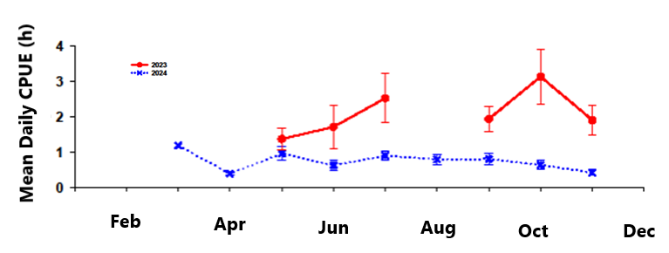
Figure 9. Mean daily catch per unit effort (CPUE) of smallmouth bass residing in the Colorado River between GCD and Lees Ferry from March through November 2024. Error bars represent standard error (SE).

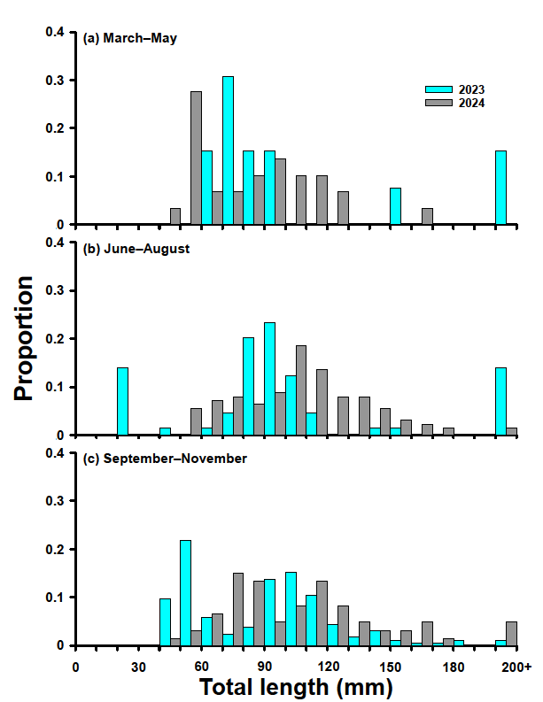
Figure 10. Total length (TL) frequency histograms for smallmouth bass during (a) March–May, (b) June–August, and (c) September–November between GCD and Lees Ferry in 2023 and 2024.

Distribution
From 2022-2024, the furthest downstream smallmouth bass were captured was at RM 16.38R in November 2023. The furthest downstream adult smallmouth bass (>200mm) was captured within the slough at RM -12.19L in July 2023. Distribution of smallmouth bass in 2024 was similar to that observed in 2023 with the exception that bass were largely absent from the -12 mi slough (Figure 11; Shollenberger et al 2025). A total of 252 smallmouth bass were captured across all projects (Drew Eppehimer per comm), with 191 of those fish captured in the Glen Canyon reach (RM –15.71 to RM 0). Bass captures in the PBR reach (RM 0 to RM 8) increased slightly in 2024 (13 individuals captured vs 8 in 2023), suggesting that large-scale migration downstream is not yet occurring.

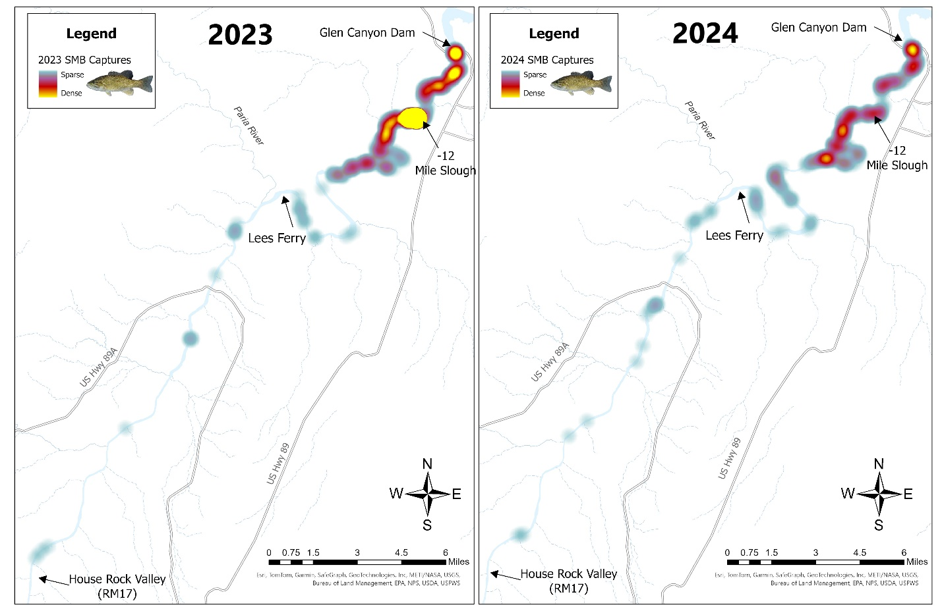
Figure 11. Relative density heat map for smallmouth bass captures in GRCA and GLCA between GCD and Badger Rapid in 2023 (left) and 2024 (right).

Growth
Length frequency histograms for smallmouth bass between GCD and Lees Ferry in 2023 and 2024 (Sept-Dec) suggest two cohorts in each year (Figure 10). The average total length of these cohorts can be compared between years to estimate average growth. The 2023 length frequency histogram has a younger cohort with a mean length of ~54 mm (fish likely born in 2023) and another with a mean length of ~109 mm (fish likely born in 2022, Charles Yackulic per comm). The 2024 length frequency histogram has one cohort with a mean length of 63 mm, fish likely born in 2023, and another with a mean length of 117 mm, fish likely born in 2022 (Charles Yackulic per comm). The difference between these average lengths suggests that the 2022 year class grew an estimated average of 8 mm and 2023 year class grew 9 mm between Fall of 2023 and 2024. In the previous year, smallmouth bass grew an estimated average of 25 mm from Fall 2022 to Fall 2023 (Charles Yackulic per comm). Assuming the birth year of fish were categorized accurately, these data indicate that the bass growth rate was about 1/3 in the Cool Mix flow temperatures of 2024 compared with warmer dam releases in 2023. Otoliths from smallmouth bass were collected in 2024 to confirm cohort assignments, but these data are not yet available.

Diet
GCMRC is currently analyzing the stomach contents of the smallmouth bass collected in Colorado River in 2024. Sixty smallmouth bass stomachs have been processed (Drew Eppehimer per comm).

Kinship
A kinship genetic analysis project is currently underway at GCMRC, in collaboration with outside partners. This work will identify genetic relationships among smallmouth bass captured in Lake Powell and downstream from GCD to evaluate the relatedness of smallmouth bass in different cohorts and from different capture locations. With sufficient sampling in both Lake Powell and downstream from GCD, this information can be used to make inferences on whether individual smallmouth bass were spawned locally or if they originated from Lake Powell. Other objectives of this work are to estimate the number of adult breeders (Nb) over a single reproductive year, any changes to effective population/breeding size (Ne) over time and identify geographic areas of reproductive hotspots.
Preliminary, unpublished results using microsatellite data from juvenile smallmouth bass captured in Lees Ferry in 2022 and a few samples from Lake Powell indicate the number of breeding adults during the initial phase of this invasion was large, with at least 94 parental pairs contributing to the juveniles collected in the initial year of sampling and an effective population size (Ne) of 214 (95% CI: 171-267; assuming monogamous mating). The juvenile progeny collected were dispersed widely throughout Glen Canyon (Osborne et al. 2024). The small sample size from Lake Powell precluded a definitive assessment of spawning origin (i.e., local reproduction in Lees Ferry or entrainment of juveniles from Lake Powell) for individuals collected in 2022 at the start of the invasion. Understanding this nuance may alter management strategies to reduce the likelihood of successful recruitment. Additional tissue samples collected from 2023-2024, along with 2022 samples, will be sent to a different laboratory to complete the work associated with this project.

Other Observations
In addition to traditional sampling, several new or non-traditional methods were implemented to help determine whether smallmouth bass were spawning. This work includes artificial spawning beds (NPS), side scan sonar identification of bass nests (USGS/BOR/NPS), environmental DNA (eDNA) sampling, and snorkel surveys (NPS/USGS/BOR).
Beginning in early June 2024, Glen Canyon NRA personnel deployed artificial spawning beds (ASBs) in pairs (one commercially made and one self-fabricated, Figure 12) at four locations along the river at depths of approximately 1–2 meters. These beds provide optimal spawning substrate and overhead cover and aim to lure bass to spawn there rather than in harder to access, less visible sites. HOBO temperature loggers were installed alongside these beds to monitor water temperature conditions. These nests were visually monitored weekly and snorkel surveys were conducted in August in the lower -12 Mile Slough as well as in the -11.82R and -11.55R backwaters in the vicinity of the ASBs. These surveys employed a double-pass method to assess the presence and abundance of target species and to evaluate the efficacy of snorkel survey techniques in the Glen Canyon section of the Colorado River. No bass were detected using the ASBs.

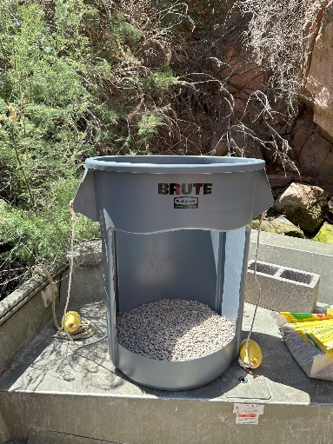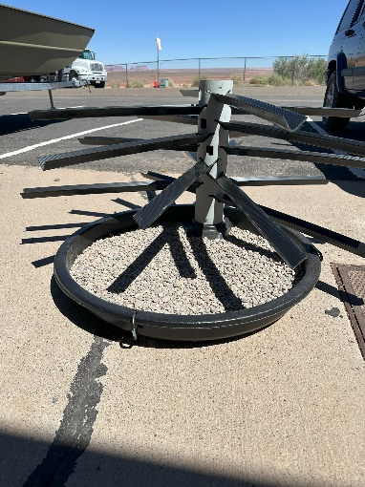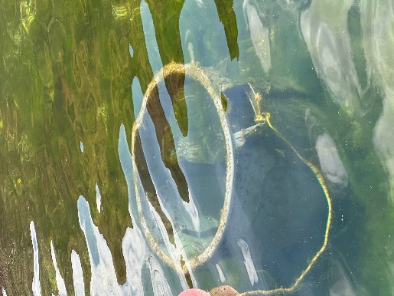
Figure 12. Fabricated (left) and commercial (center) artificial spawning beds. Right image shows a fabricated bed deployed.
Side-scan sonar (SSS) has been used in other systems to identify smallmouth bass spawning beds. This technique was used in conjunction with USGS flow modeling (Wright et al 2024) to identify sites in the Glen Canyon reach with optimal bass spawning habitat requirements (never dries out, is <0.1m/s for at least some portion of the day, water velocity never > 0.3m/s during typical GCD releases, course substrate, reasonably flat terrain, depth around 1 to 1.5m; USBR 2024). In May, Cameron Bodine (with Northern Arizona University at the time) with NPS and BOR assistance used SSS to map substrate types in the Lees Ferry reach and identified two sites (Figure 12) as optimal for bass nest detection. USGS and BOR biologists conducted a second survey scanning for nests in August (Figure 13). Snorkel surveys were also conducted during this trip in backwaters and shallow areas. No bass or nests were detected by either method, but SSS techniques are ready for use in 2025.
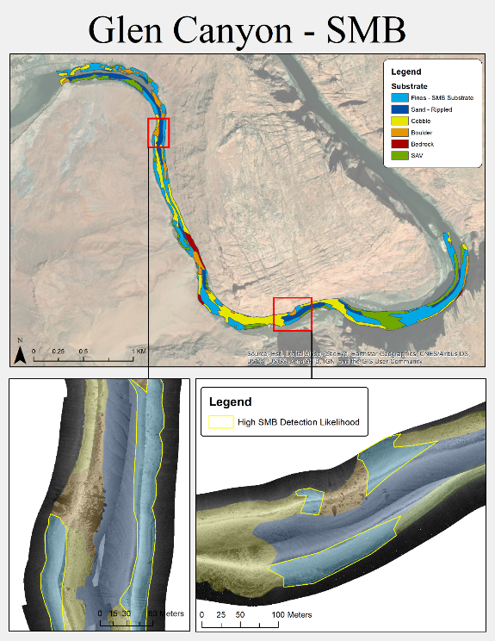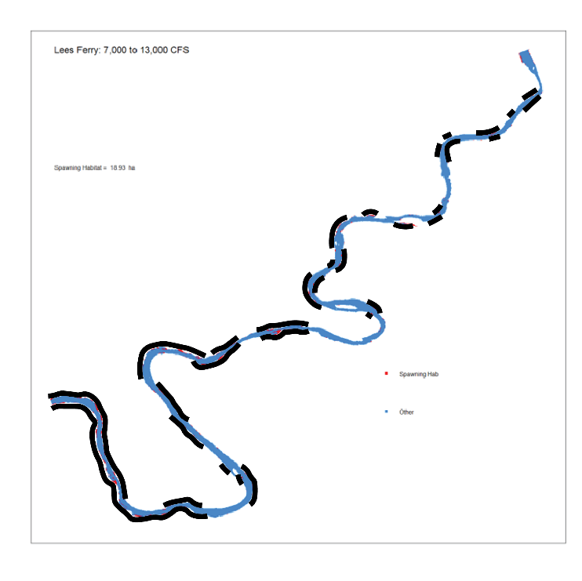
Figure 13. Substrate identification and two optimal bass nest survey sites (left) identified near Lees Ferry using side-scan sonar. Sonar was again used in August (right panel) to search for bass nests (black segments represent scanned area).

Grand Canyon National Park personnel collected environmental DNA samples in September 2024 to identify the distribution of smallmouth bass below Lees Ferry. This technique attempts to find and amplify smallmouth bass DNA present in 5L water samples and is typically effective at determining the presence/absence of rare species in aquatic systems (Carim et al. 2016). Standard curves can be used to determine the relative concentration of DNA in the water column by providing an estimate of the # of copies/L. Water filtration associated with eDNA sampling can be difficult in the Colorado River, below the Paria River, due to high turbidity loads, which clogs filters and reduces the amount of water that can be used per sample to detect the DNA of target species. Samples were collected from both sides of the river every mile from RM 0.0 to RM 30.0 and then were collected every 2.5 miles until RM 65.0, resulting in 273 samples collected from 91 sites. Grand Canyon’s sampling detected smallmouth bass DNA in four samples with the furthest downstream positive sample at RM 37.5 (Figure 14). Samples with positive detections were re-analyzed in the lab to confirm initial results. While DNA degrades over time due to solar radiation, high temperatures, and biological activity, it is currently unknown the rate at which DNA degrades and disperses in the Colorado River for rare species. Studies from other systems indicate DNA can travel hundreds of meters or more from the source location.

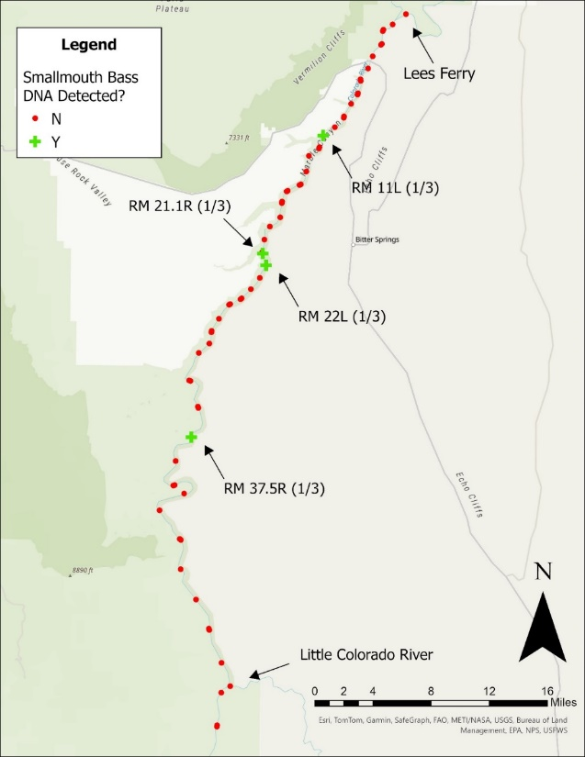
Figure 14. Map of positive and negative eDNA sampling sites within GRCA from September 2024. Numbers in parentheses denote # of replicates at each respective site that were positive for smallmouth bass DNA.

Green Sunfish
The 2024 Cool Mix flows appeared to have had a negative effect on green sunfish in Glen and Grand Canyons with reduced growth, recruitment, and relative abundance (Shollenberger et al 2025). The highest concentrations of green sunfish occurred just below GCD and at the -12 mile slough (Figure 15). Although green sunfish was the most abundant nonnative fish present above Lees Ferry in 2024, with a total of 11,740 captured, NPS’ electrofishing catch per unit effort remained stable (March through November) through Glen Canyon compared to 2023, which suggests limited reproduction occurred in 2024 (Figure 16 and 17; Shollenberger et al 2025). Reproduction of green sunfish occurred in 2023 and the increase in relative abundance during the fall can in part be attributed to YOY fish growing into a catchable size; this was not observed in 2024 (Figure 16 and 17). In both Lees Ferry and the PBR reach catch rates increased in the fall in 2023 indicating reproduction and successful recruitment; this increase was not observed in 2024 indicating limited reproduction. One caveat to this is Arizona Game and Fish Department’s (AZGFD) standardized monitoring data. Their data has shown an increasing number of green sunfish, with CPUE of green sunfish increasing at a rapid rate since 2022 (D. Rowgowski per comm).
Sizes of green sunfish in 2024 were larger than in 2023 (Figures 18 and 19, Shollenberger et al 2025). Recruitment of green sunfish appeared to be limited above RM 61 compared to 2023 with the captures of young of the year green sunfish only being observed in a few locations (RM 209, Shollenberger et al 2025; -12 mile upper slough, Shollenberger et al 2025; -15.19 Dam Slough Clancy per comm, and Hidden Slough, Hines per comm). When the average size is on the smaller side (i.e. 40- 80 mm) the population is likely dominated by small young of year fish. Likewise, if the average size is greater the following year (i.e. 2023 compared to 2024) then that would suggest a reduction of young of the year fish and the population is dominated by 1-2 year old fish.
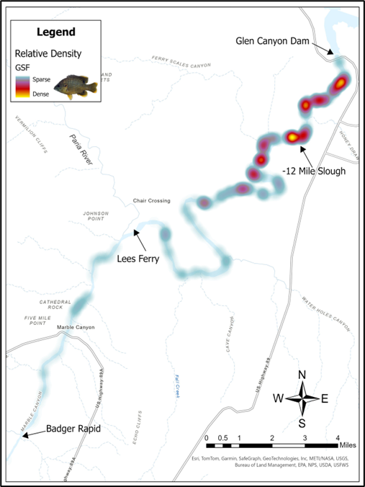
Figure 15. Relative density heat map for green sunfish captures in GRCA and GLCA between GCD and Badger Rapid in 2024.

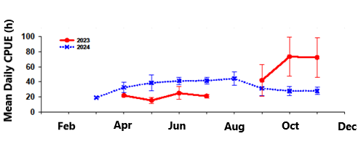
Figure 16. Mean daily catch per unit effort (CPUE) of green sunfish residing in the Colorado River between GCD and Lees Ferry from March through November 2024. Error bars represent standard error (SE).
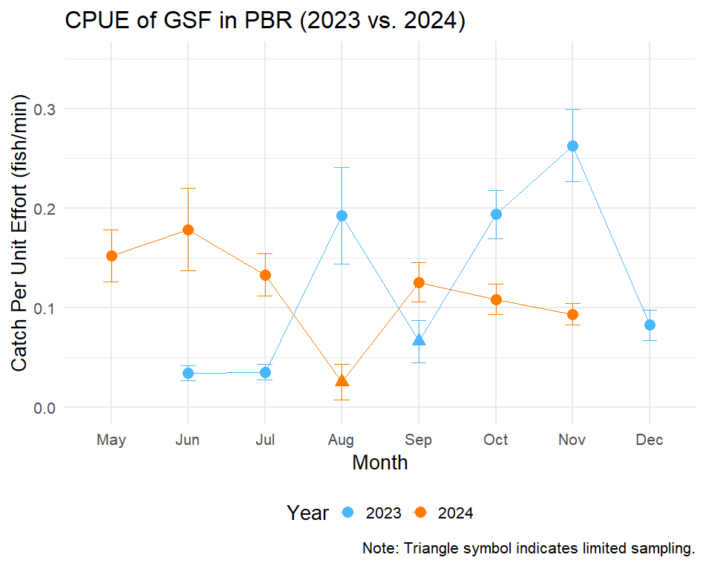
Figure 17. CPUE for green sunfish from electrofishing efforts in the Paria to Badger reach in Grand Canyon in 2024 vs. 2023.

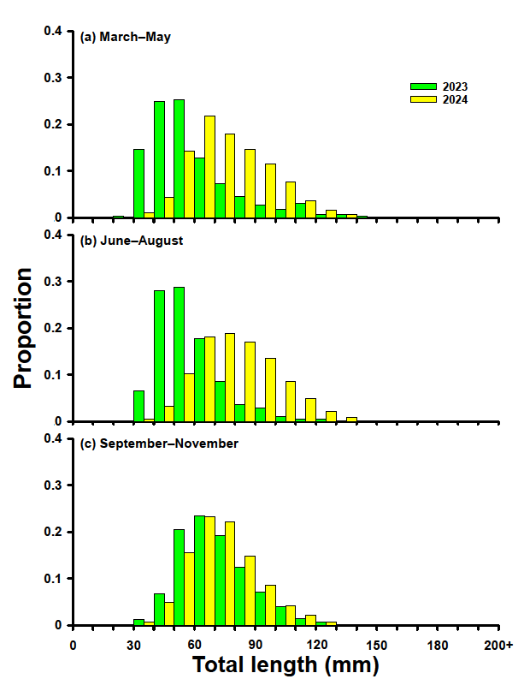
Figure 18. Total length (TL) frequency histograms for green sunfish during (a) March–May, (b) June–August, and (c) September–November between GCD and Lees Ferry in 2023 and 2024.

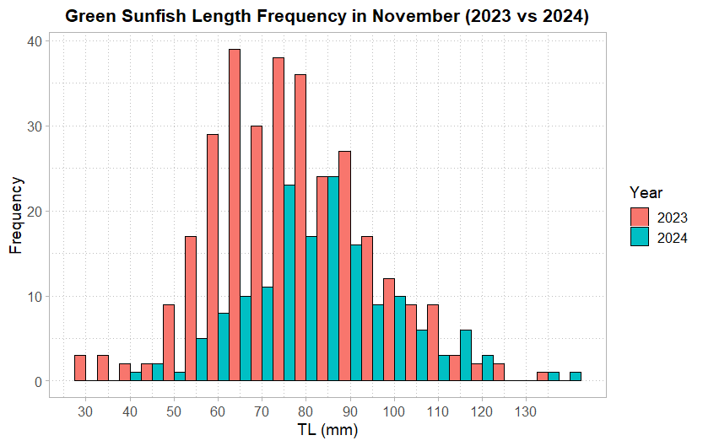
Figure 19. Length Frequency of green sunfish captured in the Paria to Badger reach in November 2023 compared to November 2024.

Humpback Chub
Growth and condition are the two available parameters to best assess the effects of Cool Mix flows on humpback chub in the Grand Canyon. Observed growth for humpback chub from JCM east (100-150 mm) in 2024 from July to October was 7.6 (standard error of +/- 0.5) mm/month, matching the predicted growth of 8mm/month (Figure 20, Charles Yackulic per comm). If the Cool Mix flow experiment had not occured in 2024, predicted average river temperature would have been ~17.2 °C (Charles Yackulic per comm). Comparing the predicted river temperature from Charles Yackulic’s modeling with Figure 20, humpback growth would have ~4 mm/month more without the Cool Mix flow releases.
Condition is another parameter available to assess the effect of Cool Mix flows on humpback chub. Relative condition of humpback chub from JCM data in 2024 is very similar to (≥ 1) previous years for juvenile and adult humpback chub around RM 61 (Ben Miller per comm). One exception was condition for adult humpback chub around RM 61 during the summer season, which fell below 1(1 is the value of an expected weight for a fish given its length (Maria Dzul per comm).
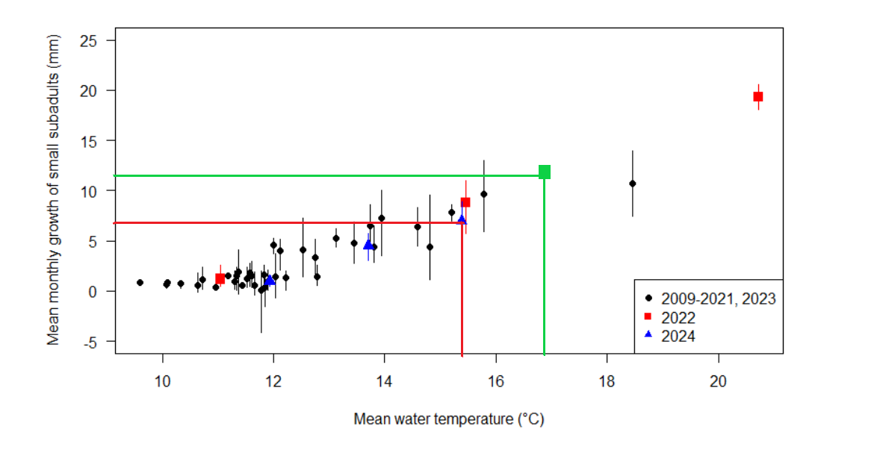
Figure 20. This figure from Maria Dzul’s presentation on humpback chub monitoring from the Annual Reporting meeting in April 2025. Mean monthly growth of subadult (100-149 mm) humpback in JCM east in relation to mean river temperature during 2024. Red line shows 2024 growth at 15.5°C (during Cool Mix flow) and the green line shows predicted growth at ~17°C (predicted river temperature in 2024 without Cool Mix flows).

Rainbow Trout
In 2024, Cool Mix flows appeared to positively influence rainbow trout, with summer-fall growth reaching the second highest levels recorded from 2013 to 2024, comparable to 2016 (Josh Korman, personal communication). The findings suggest a difference of approximately 6 g/month in growth for a 300 g rainbow trout between conditions with and without Cool Mix flow (Josh Korman, personal communication). Over the four-month period of Cool Mix flows, this difference would result in a total difference of 24 g (Josh Korman, pers comm). Without Cool Mix flow, a 300 g trout would have lost about 6% of its body weight, whereas it experienced a gain of around 1% with Cool Mix flows (Josh Korman, personal communication).
It's also important to consider the context of summer-fall growth rates, which can vary significantly across seasons and years. Key factors affecting the condition factor over the 13-year period include very low growth during several summer-fall periods (2013-2014, 2019, 2023) and strong growth during most winters and some springs, particularly starting in 2016 (Josh Korman, personal communication). With positive growth rates in 2024, the condition factor approached the highest levels recorded for summer and fall during the 13-year span (Josh Korman, personal communication). However, poor survival of fry after reproduction (e.g., due to brown trout) could be the limiting factor at this point (Josh Korman, personal communication). Another caveat to consider is abundance has a large negative effect on condition (Dave Rogowski per comm). The fewer fish that are present in the system, the higher the condition for those few fish (i.e. more resources available means more growth and better condition).

Other Fish Species
The effects of Cool Mix flow releases on other native species (i.e. flannelmouth and bluehead suckers and speckled dace) were not assessed in 2024.
Another species to note is Walleye. Captures of walleye have been gradually increasing since 2021 (9 in 2021, 15 in 2022, 60 in 2023, and 58 in 2024; Shollenberger and Arnold per comm). In 2024, a majority of the walleye captures (39) occurred in the Lees Ferry 5 miles or les downstream of GCD (Shollenberger and Arnold per comm). All but one of the walleye captured in 2024 were adults. This increase in walleye catch could be the product of increased sampling in the Lees Ferry reach with the rapid response work. The AZGFD standardized monitoring has not seen an increase in walley captures (Dave Rogowski per comm). Walleye are considered cool water species and spawning typically ranges from 8-10ºC in the southern portions of their range (Bozek 2011). Optimal growth for year-1 walleye is around 22ºC (Koenst and Smith 1976) and for juvenile species it ranges from 20-24ºC. (Coutant 1977; Wismer and Christie 1987). Cooler waters produced by cool mix flows has the risk of producing temperatures near ranges to initiate a Walleye spawn. This risk is likely low since 2024 cool mix flows remained above optimal spawning temperatures and below optimal growing ranges for both Age-1 and juvenile walleye.

-12 Mile Slough
Work in the -12 mile slough during 2024 included a block net (to prevent fish from entering the lower slough), fyke netting, artificial spawning beds, temperature monitoring, and fish salvage (only in upper slough; Shollenberger et al 2025). The block effectively prevented most fish from entering the lower slough; coupling the block net with electrofishing and fyke nets, all fish were removed from the area (Shollenberger et al 2025). No smallmouth bass spawning activity was observed in the slough or on the artificial spawning beds (Shollenberger et al 2025). Cool Mix flows also effectively reduced the water temperature in the lower slough to below suboptimal spawning temperatures for smallmouth bass (Shollenberger et al 2025). A fish salvage occurred in the upper -12 mile slough on October 30, 2025. Two juvenile carp (78 and 138 mm) and 25,161 green sunfish (11> 100mm) were captured and removed (Shollenberger et al 2025). All fish were retained for beneficial use (Shollenberger et al 2025).

Hydropower

Generation and Cost
During cool mix flows, Reclamation generated 727,023 MWh of energy from GCD. Over this period, WAPA estimates that the amount of water bypassed, which accounts for 32.5% of the total release during the experiment, could have generated an additional 372,341 MWh, or a 51% increase in generation (Table 5).
Table 5. Hydropower impacts due to the 2024 SEIS release.
Week Number | Dates | Power Purchased (MWh) | Cost of Replacement Power
1 | Jul 9 - Jul 13 | 13,701 | $794,926
2 | Jul 14 - Jul 19 | 18,855 | $912,171
3 | Jul 20 - Jul 26 | 20,698 | $1,029,830
4 | Jul 27 - Aug 2 | 24,171 | $1,285,250
5 | Aug 3 - Aug 9 | 21,038 | $1,097,984
6 | Aug 10 - Aug 14 | 15,300 | $765,375
7 | Aug 15 - Aug 23 | 35,329 | $1,647,206
8 | Aug 24 - Aug 30 | 24,315 | $1,159,515
9 | Aug 31 - Sep 6 | 28,707 | $1,520,643
10 | Sep 7 - Sep 13 | 28,723 | $1,533,172
11 | Sep 14 - Sep 20 | 22,788 | $1,219,986
12 | Sep 21 - Sep 27 | 19,106 | $1,038,945
13 | Sep 28 - Oct 4 | 22,616 | $1,204,973
14 | Oct 5 - Oct 11 | 20,404 | $1,132,923
15 | Oct 12 - Oct 18 | 18,298 | $974,870
16 | Oct 19 - Oct 25 | 12,435 | $666,398
17 | Oct 26 - Nov 1 | 7,557 | $382,120
18 | Nov 2 - Nov 8 | 8,154 | $297,029
19 | Nov 9 - Nov 15 | 8,465 | $263,080
20 | Nov 16 - Nov 18 | 1,682 | $44,020
Total |  | 372,341 | $18,970,416

Basin Fund
Cost estimates of the cool mix experiment are preliminary and work is being conducted by Argonne National Laboratory to complete a formal analysis before the end of FY25. The preliminary cost estimate of replacement energy acquired during this experiment is approximately $18.97M (Table 5). Revenues from the Basin Fund were used to purchase this replacement energy. Since 2019, basin fund balance has ranged from $79M to $203M as reported at the April 2025 GCDAMP annual reporting meeting. This includes an addition of $85M in Infrastructure Investment and Job Act funds in 2022/2023. The Basin Fund began FY24 with a balance of $203M and ended FY24 with a balance of $184M. WAPA calculates the end of FY25 Basin Fund Reserve target balance to be $279M. The Basin Fund Reserve target is the projected cost of WAPA and Reclamation capital replacement and replacement power purchase for the next three years and the cost of operations and maintenance for the next three months. The Basin Fund was operated within an acceptable level of risk to WAPA in FY24, but the 2024 cool mix experiment created a funding shortfall for the capital replacements program for the CRSP system. This prompted WAPA to make a $6.8M (~30%) cut to its capital program and Reclamation used $36M in carryover and other miscellaneous revenues of offset reductions in its capital program to keep the Basin Fund operating at an acceptable level of risk. These cuts resulted in many capital replacement projects being deferred to FY26. The only work WAPA is approved for in FY25 is for critical transmission and communication equipment replacements.

Power Reliability
The cool mix flows did not have a direct effect on the reliability of power to customers. There were no Energy Emergency Alerts 3 (EEA3) or California Independent Operator (CAISO) emergencies in 2024 that required a response from GCD.
As described in the LTEMP SEIS, WAPA and Salt River Project exchanges hydropower generated at GCD for coal-generated thermal power generated at Craig, Hayden, and Four Corners. The 2024 SEIS release did not allow for enough generation at GCD for the exchange at all times and initially caused some transmission congestion. WAPA was able to move some delivery locations to resolve the congestion. WAPA also applied additional purchases at Four Corners to keep the exchange whole. Argonne National Laboratory’s report on the impacts of these cool mix flows will contain more detail on this exchange.
Additionally, WAPA did not specify or require a certain generation type for the replacement power. The 2024 LTEMP SEIS assumed replacement power to offset the impacts of this experiment would be generated primarily from existing thermal powerplants on the WECC regional grid (see Section 3.9 Air Quality, pages 3-227 to 3-230). Argonne National Laboratory’s report on the impacts of these Cool Mix flows will contain more detail on replacement energy source type and emissions.

Capacity
An effort was made between WAPA and Reclamation to develop an optimization strategy to maximize bypass during off-peak hours (at night and at mid-day) and maximizing power generation during on-peak hours (afternoon and evening) while still meeting downstream daily average temperature targets (Figure 1). This helped reduce the experiment's impact on marketable capacity by providing as much generation as possible during hours of peak power demand, especially during the evening hours when the economic value of capacity was greatest. How much this effort offset replacement power costs will be included in Argonne National Laboratory’s report on the impacts of these cool mix flows. WAPA indicated that the cost savings was likely to be worth the effort and could not identify any needs for improvement with this optimization strategy over what was done in 2024

Sediment
The Cool Mix flow experiment was conducted by substituting discharge through the power units with an equal discharge of water through the river outlet works. Therefore, the experiment did not result in a change in the total release of water through the dam. Because sediment transport is controlled by discharge and only very weakly affected by water temperature, the experiment had a negligible effect on sediment transport in 2024 (Paul Grams per comm). There was a minor localized effect on a sand bar immediately downstream from GCD, because the river outlet works create a different velocity pattern at the base of the dam (Paul Grams per comm).

Discussion/Conclusions
The core focus of the 2024 LTEMP SEIS flow experiment was to evaluate sub-annual flow options designed to disrupt the establishment of smallmouth bass and other warmwater nonnative invasive fish below GCD (USBR 2024). These flows would limit additional recruitment, which could threaten populations of humpback chub.
The Cool Mix flow implemented in 2024 was effective in cooling the river below 15.5 °C to RM61 from July 8th to November 18th. A total of 14 days exceeding that temperature after implementation began, compared to a modeled 135 (±5) days of temperatures over 15.5 °C had flows not been implemented. Temperatures at the Lees Ferry gage, immediately downstream of where most bass have been detected, averaged 14.1 °C for the duration of the experiment. Impacts to water quality, including dissolved oxygen, specific conductivity, and soluble reactive phosphorus, were largely negligible during the Cool Mix flows. Dissolved oxygen concentrations did increase during the Cool Mix flow releases to near the EPA limit, but no gas bubble disease was detected during any of the sampling trips. Despite various challenges in on-ramping, maintaining temperatures, accommodating power production needs, and off-ramping, the experiment met its primary goal of keeping the river below predicted bass to spawning temperatures.
Reproduction, growth, relative abundance, and recruitment of nonnative invasive fish were reduced because of the lower river temperatures produced below GCD. A multi-agency, multi-method sampling effort detected no evidence of smallmouth bass reproduction below GCD. No young of the year were captured, length frequency histograms show no small smallmouth bass were captured. Monitoring revealed the presence of two cohorts that were likely spawned in 2022 and 2023 when river temperatures were much higher. The smallmouth bass growth rate was reduced by more than 60% in 2024, which likely prevented many of these fish from reaching spawning size (estimated 200mm TL) for 2025. The total number of smallmouth bass collected was also greatly reduced from the two previous years, though this may be due in part to reduce catchability in low temperatures (Drew Eppehimer per comm). There was also no change in distribution of smallmouth bass in the river below the dam.
Green sunfish also had a reduction in demographic parameters because of Cool Mix flows. The average size of green sunfish in 2024 was higher than in 2023, which might suggest changes in recruitment success and lower survival rates under the cooler water conditions. The highest concentrations of green sunfish captured in 2024 resided around the -12 slough. To alleviate the ongoing issues with invasive nonnative fishes around the upper and lower sloughs at RM -12, GLCA and Reclamation began a project in March 2025 to channelized both. This work will remove the two backwater areas by allowing the river to flow them, thereby eliminating the ability of warmwater nonnative fish to spawn and rear in these areas.
Humpback chub did not appear to experience any negative impacts from the Cool Mix flows, as water temperature was greater than the ~12C growth threshold. Growth was estimated to be reduced by 4mm during Cool Mix flow compared to growth without Cool Mix flow, but the observed growth (8 mm/month) during Cool Mix flow was an average growth rate for humpback chub in the Grand Canyon (Maria Dzul per comm) because these fish regularly experience temperatures produced by the Cool Mix flows. The relative condition of humpback chub during the Cool Mix flow experiment did not deviate from the average relative condition (1) of humpback chub in the mainstem Colorado River from previous years.
Although Cool Mix flows appear to have positive effect on rainbow trout, their abundance is currently tied with lowest level measured over the 13-yr period. Growth was likely better under Cool Mix flows than without and may lead to an increase in recruitment via better reproductive success. Poor survival of fry after reproduction (e.g., due to brown trout) could be the limiting factor at this point. The Cool Mix flows in 2024 may have a short-term benefit to rainbow trout, but bass flows are not likely to reverse the poor state of the fishery.
The Cool Mix flow came with a financial cost to hydropower as WAPA spent $18,970,416 to replace the power not generated due to bypass flows. Power purchases were funded through the Basin Fund, which is used for maintenance and upkeep of GCD and transmission lines that deliver the power. Due to this unplanned decrease in the basin fund, WAPA chose to defer $6.8M in capital project spending (30%) to FY26. Capital project deferment risks equipment failure as infrastructure ages.

Future Considerations.
The Planning and Implementation team may choose to consider future changes to flows to reduce or halt the establishment and reprodiction of coll and warmwater fish and improve the effectiveness and efficiency of experimental flows while helping to offset the financial cost to hydropower. WAPA’s estimated costs using alternative river mile targets and off-ramp strategies provides a path forward for finding less financially impactful flow strategies. Improvements to temperature modeling are already underway, and additional methods for offsetting hydropower daily costs may be found. Strategies and funding to support future sampling, entrainment, and kinship studies can help understand the near-term threat smallmouth bass pose. Understanding the impact of this flow experiment on other resources and the big-picture ecology of the Grand Canyon will be valuable.

The Cool Mix flow experiment was successful at preventing smallmouth bass from reproducing below Glen Canyon Dam through the Grand Canyon segment of the Colorado River in 2024. The experiment reduced the growth rate and probably halted the reproduction of smallmouth bass in the Lees Ferry reach of the Colorado River, but the threat of establishment persists. The next several years are critical as smallmouth bass spawned in 2022 and 2023 will likely grow and become adults in 2025 and 2026 and be capable of spawning. The ability to use flow experiments to combat the establishment of smallmouth bass has been an excellent tool as part of a long-term plan to keep the threat of invasive nonnative fish low. Using the expertise of the smallmouth bass expert panels and the Planning and Implementation team, it is hopeful that solutions will be implemented to prevent smallmouth bass establishment in the Colorado River below GCD.

Literature Cited
Andrews, C.M., and Deemer, B.R., 2024, Limnology data from Lake Powell, desert southwest USA (ver. 2.1, September 2024): U.S. Geological Survey data release, https://doi.org/10.5066/P9ZIKVYW.
Bozek, Michael A., Dominic A. Baccante, and Nigel P. Lester. 2011. Walleye and sauger life history in Biology, management, and culture of Walleye and Sauger 233 (2011): 301.
Carim, K.J., K.S. McKelvey, M.K. Young, T.M. Wilcox, and M.K. Schwartz. 2016. A protocol for collecting environmental DNA samples from streams. Gen. Tech. Rep. RMRS-GTR-355. Fort Collins, CO: U.S. Department of Agriculture, Forest Service, Rocky Mountain Research Station. 18 p.
Coutant, C. C. 1977. Compilation of temperature preference data. Journal of the Fisheries Research Board of Canada 34:746–749
Dibble, K. L., C. B. Yackulic, T. A. Kennedy, K. R. Bestgen, and J. C. Schmidt. 2021. Water storage decisions will determine the distribution and persistence of imperiled river fishes. Ecological Applications 31(2): 9 p.
Elser, J.J., M. E.S. Bracken, E. E. Cleland, D. S. Gruner, W. S. Harpole, H. Hillebrand, J. T. Ngai, E. W. Seabloom, J. B. Shurin, and J. E. Smith. 2007. Global analysis of nitrogen and phosphorus limitation of primary producers in freshwater, marine and terrestrial ecosystems. Ecology Letters 10(12): pp. 1135-11-42.
GCDAMP (Glen Canyon Dam Adaptive Management Program) 2023. A Strategic Plan to prevent, detect, and respond. Website: GCDAMP Non-native Fish Strategic Plan.
Hueftle, S.J., L.E. Stevens. 2001. Experimental Flood Effects on the Limnology of Lake Powell Reservoir, Southwestern USA. Ecological Applications 11(3): 644-656.
Koenst, W. M., and L. L. Smith, Jr. 1976. Thermal requirements of the early life history stages of walleye, Stizostedion vitreum vitreum, and sauger, Stizostedion canadense. Journal of the Fisheries Research Board of Canada 33:1130–1138
Meybeck, M. 1982. Carbon, nitrogen, and phosphorus transport by world rivers. American Journal of Science, 282(4), 401–450.
Meybeck, M. 1993. C, N, P and S in Rivers: From Sources to Global Inputs, in: Wollast R., Mackenzie F.T. and Chou L. (eds), Interaction of C, N, P and S Biogeochemical Cycles and Global Change, Springer-Verlag, pp. 163–193.
Mihalevich, B. A., B.T. Neilson, C.A. Buahin, C.B. Yackulic, and J.C. Schmidt, 2020. Water temperature controls for regulated canyon‐bound rivers. Water Resources Research, 56 (12): 24 p.
Mihalevich, B. A., B.T. Neilson, C.A. Buahin. 2022. Evaluation of the ERA5-Land reanalysis data set for process-based river temperature modeling over data sparse and topographically complex regions. Water Resources Research 58 (7): 23 p.
National Centers for Environmental Prediction/National Weather Service/NOAA/U.S. Department of Commerce. (2015). NCEP GFS 0.25 Degree Global Forecast Grids Historical Archive (Updated daily) [Dataset]. Research Data Archive at the National Center for Atmospheric Research, Computational and Information Systems Laboratory. https://doi.org/10.5065/D65D8PWK. Accessed 01 Jul 2024.
Osborne, M., H.L. Liang, and T. Turner. 2024. Genetic analysis indicates large-scale introduction of predatory, nonnative Smallmouth Bass (Micropterus dolomieu) in the Grand Canyon. Draft Report submitted to Kerri Pederson, U.S. Bureau of Reclamation, Grant Agreement R18AC00015. Department of Biology and Museum of Southwestern Biology, University of New Mexico, Albuquerque, NM. Report date: 6/10/2024.
Shollenberger, K., E. Omana-Smith, S. Favrot, M. Randell, and J. Crabill. 2025. Glen Canyon National Recreation Area & Grand Canyon National Park: Smallmouth bass monitoring, surveillance, and removal activities (2024). Report to U.S. Bureau of Reclamation Upper Colorado Region, Agreement Number: R23PG00090.
USACOE. 2025. 2024 total dissolved gas report Columbia River Basin. U.S. Army Corps of Engineers, Annual Report, 30 p.
USBR 2024. Record of Decision for Glen Canyon Dam Long-Term Experimental and Management Plan Supplement Environmental Impact Statement. Website: Record of Decision for Near-term Colorado River Operations
Vernieu, W.S., 2010, Effects of the 2008 high-flow experiment on water quality in Lake Powell and Glen Canyon Dam releases, Utah-Arizona: U.S. Geological Survey Open-File Report 2010-1159, 25 p.
Ward, D.L, R. Morton-Starner, and B. Vaage. 2016. Effects of turbidity on predation vulnerability of juvenile humpback chub to rainbow trout and brown trout. Journal of Fish and Wildlife Management 7 (1): 205–212.
Wildman Jr., R.A., W.S. Vernieu. 2017. Turbid releases from Glen Canyon Dam, Arizona, following rainfall-runoff events of September 2013. Lake Reserv Manage. 00:1–6.
Wismer, D.A., and A.E. Christie. 1987. Temperature relationships of Great Lakes fishes: a data compilation. Great Lakes Fishery Commission, Special Publication 87-3, Ann Arbor, Michigan.
Wright, S.A., Kaplinski, M., and Grams, P.E., 2024, Hydrodynamic model of the Colorado River, Glen Canyon Dam to Lees Ferry in Glen Canyon National Recreation Area, Arizona: tables of model results and accuracy assessment: U.S. Geological Survey data release, https://doi.org/10.5066/P1QTRNEB
Yackulic, C.B. and D.E. Eppehimer. 2025. Response of Smallmouth Bass and other Species to Cool Mix. Presentation at GCDAMP Technical Work Group Annual Reporting Meeting, April 7, 2025.

Acknowledgements
This experiment and associated monitoring could not have been successfully conducted without the help of many partner agencies:
- US Geological Survey – GCMRC
  - Charles Yackulic
  - Drew Eppehimer
  - Bridget Deemer
  - David Topping
  - Max Evans
  - Tom Sabol
  - Maria Dzul
  - Paul Grams
  - Lucas Bair
  - Benjamin Miller
  - Kim Dibble
- Western Area Power Administration
  - Brian Sadler
  - Courtney Harris
  - Jerry Wilhite
  - Tony Henriquez
  - Craig Ellsworth
  - Shane Capron
- Arizona Game and Fish
  - Dave Rogowski
- Ecometric Research
  - Josh Korman
- Fish And Wildlife Service
  - David Ward
- National Park Service – Glen Canyon and Grand Canyon
  - Jeff Arnold
  - Conor Clancy
  - Jonathan Crabill
  - Scott Favrot
  - Emily Omana-Smith
  - Maxwell Randells
  - Kurt Shollenberger

Appendix A
Release data from GCD between July 2024 and November 2024. Data can be accessed at the following URL: https://www.usbr.gov/lc/region/g4000/riverops/_HdbDataViewer.html?query=svr=uchdb2&sdi=1920%2C4168%2C2216&tstp=DY&t1=2024-07-01T00:00&t2=2024-11-30T00:00&table=R&mrid=0&format=json
DATETIME | Total Release [acre-ft] | Bypass Release  [acre-ft] | Penstock Release  [acre-ft]
7/1/2024 | 22586.274 | 0 | 22586.274
7/2/2024 | 23208.996 | 0 | 23208.996
7/3/2024 | 23366.596 | 0 | 23366.596
7/4/2024 | 22222.977 | 0 | 22222.977
7/5/2024 | 23625.31 | 0 | 23625.31
7/6/2024 | 21873.289 | 0 | 21873.289
7/7/2024 | 22061.404 | 0 | 22061.404
7/8/2024 | 23362.526 | 35.61983 | 23326.907
7/9/2024 | 23612.439 | 6642.8926 | 16969.546
7/10/2024 | 23486.952 | 6648.6777 | 16838.274
7/11/2024 | 23563.323 | 6732.8099 | 16830.513
7/12/2024 | 23502.439 | 6713.0579 | 16789.381
7/13/2024 | 23457.97 | 6627.7686 | 16830.202
7/14/2024 | 22974.046 | 7410.0826 | 15563.964
7/15/2024 | 22961.683 | 7383.8017 | 15577.881
7/16/2024 | 22932.296 | 7330.2479 | 15602.048
7/17/2024 | 23029.466 | 7390.1653 | 15639.301
7/18/2024 | 23026.788 | 7307.9339 | 15718.855
7/19/2024 | 23097.878 | 7377.686 | 15720.192
7/20/2024 | 22076.959 | 6765.3719 | 15311.587
7/21/2024 | 21791.016 | 6723.3884 | 15067.627
7/22/2024 | 23510.637 | 7197.2727 | 16313.364
7/23/2024 | 23512.202 | 7250.7438 | 16261.458
7/24/2024 | 23570.085 | 7256.1157 | 16313.969
7/25/2024 | 23320.321 | 7192.7273 | 16127.593
7/26/2024 | 23408.65 | 7233.3058 | 16175.344
7/27/2024 | 21829.726 | 7784.7107 | 14045.016
7/28/2024 | 21830.674 | 7710.7438 | 14119.931
7/29/2024 | 23602.524 | 8261.2397 | 15341.284
7/30/2024 | 23472.54 | 8185.2893 | 15287.25
7/31/2024 | 23608.631 | 8254.7934 | 15353.837
8/1/2024 | 25312.674 | 8827.6033 | 16485.07
8/2/2024 | 25313.508 | 8880.2479 | 16433.26
8/3/2024 | 23825.85 | 6753.4711 | 17072.379
8/4/2024 | 23410.87 | 6618.0165 | 16792.854
8/5/2024 | 25297.042 | 7385.9504 | 17911.092
8/6/2024 | 25218.191 | 7431.157 | 17787.034
8/7/2024 | 25330.293 | 7412.8926 | 17917.401
8/8/2024 | 25270.933 | 7407.7686 | 17863.164
8/9/2024 | 25258.252 | 7405.0413 | 17853.211
8/10/2024 | 24033.932 | 7162.0661 | 16871.866
8/11/2024 | 23445.54 | 7021.7355 | 16423.804
8/12/2024 | 25230.736 | 7481.8182 | 17748.917
8/13/2024 | 25208.675 | 7492.2314 | 17716.444
8/14/2024 | 25169.685 | 7497.1074 | 17672.578
8/15/2024 | 24761.634 | 9390.0826 | 15371.551
8/16/2024 | 24817.081 | 9395.8678 | 15421.213
8/17/2024 | 23580.076 | 9344.7107 | 14235.365
8/18/2024 | 22691.73 | 9316.9422 | 13374.788
8/19/2024 | 24788.55 | 9450.4959 | 15338.055
8/20/2024 | 24932.169 | 9438.5124 | 15493.657
8/21/2024 | 24980.708 | 9453.0579 | 15527.65
8/22/2024 | 24826.987 | 9360 | 15466.987
8/23/2024 | 24650.171 | 9369.2562 | 15280.915
8/24/2024 | 23396.185 | 8226.7769 | 15169.408
8/25/2024 | 22703.202 | 8081.4876 | 14621.715
8/26/2024 | 24687.364 | 8306.4463 | 16380.917
8/27/2024 | 24967.788 | 8442.8926 | 16524.896
8/28/2024 | 24853.902 | 8366.5289 | 16487.373
8/29/2024 | 24653.907 | 8245.5372 | 16408.37
8/30/2024 | 24616.393 | 8323.4711 | 16292.922
8/31/2024 | 22545.854 | 10157.851 | 12388.002
9/1/2024 | 18133.937 | 9445.124 | 8688.8132
9/2/2024 | 18183.085 | 9485.9504 | 8697.1347
9/3/2024 | 19290.202 | 9846.7769 | 9443.4248
9/4/2024 | 19496.234 | 9917.1074 | 9579.1265
9/5/2024 | 19569.704 | 9982.3141 | 9587.3901
9/6/2024 | 19475.924 | 9868.595 | 9607.3289
9/7/2024 | 18587.269 | 9679.1736 | 8908.095
9/8/2024 | 18201.459 | 9411.7355 | 8789.7231
9/9/2024 | 19501.726 | 10024.463 | 9477.2628
9/10/2024 | 19496.269 | 10033.058 | 9463.2107
9/11/2024 | 19475.125 | 10068.678 | 9406.4471
9/12/2024 | 19459.699 | 10054.793 | 9404.9058
9/13/2024 | 19389.973 | 10050.992 | 9338.981
9/14/2024 | 18574.315 | 8243.5537 | 10330.761
9/15/2024 | 18177.386 | 7992.3967 | 10184.989
9/16/2024 | 19380.574 | 7780 | 11600.574
9/17/2024 | 19329.01 | 7737.7686 | 11591.241
9/18/2024 | 19275.531 | 7708.4298 | 11567.101
9/19/2024 | 19327.594 | 7755.7025 | 11571.892
9/20/2024 | 19294.753 | 7725.4546 | 11569.298
9/21/2024 | 18479.56 | 6708.9256 | 11770.635
9/22/2024 | 18152.389 | 6574.6281 | 11577.761
9/23/2024 | 19418.952 | 6531.4876 | 12887.464
9/24/2024 | 19481.6 | 6627.5207 | 12854.079
9/25/2024 | 19488.494 | 6610.0826 | 12878.412
9/26/2024 | 19636.622 | 6621.157 | 13015.465
9/27/2024 | 19526.019 | 6597.3554 | 12928.664
9/28/2024 | 17281.966 | 8101.7355 | 9180.2306
9/29/2024 | 16968.877 | 7873.3058 | 9095.5711
9/30/2024 | 18293.136 | 8565.7851 | 9727.3512
10/1/2024 | 16007.449 | 7388.3471 | 8619.1017
10/2/2024 | 16057.831 | 7419.0909 | 8638.7397
10/3/2024 | 15907.415 | 7345.8678 | 8561.5471
10/4/2024 | 15897.234 | 7391.3223 | 8505.9116
10/5/2024 | 15191.36 | 6785.124 | 8406.2364
10/6/2024 | 14903.658 | 6687.1901 | 8216.4678
10/7/2024 | 15920.029 | 7189.1736 | 8730.8554
10/8/2024 | 15938.632 | 7163.3058 | 8775.3265
10/9/2024 | 15914.323 | 7137.6033 | 8776.7198
10/10/2024 | 15930.502 | 7172.6446 | 8757.8579
10/11/2024 | 15858.045 | 7191.9835 | 8666.0612
10/12/2024 | 15114.993 | 6111.157 | 9003.8364
10/13/2024 | 14881.592 | 6038.0165 | 8843.5752
10/14/2024 | 15704.732 | 6423.719 | 9281.0132
10/15/2024 | 15730.974 | 6450.5785 | 9280.395
10/16/2024 | 15807.332 | 6430.7438 | 9376.5884
10/17/2024 | 15828.301 | 6369.2562 | 9459.0446
10/18/2024 | 15785.65 | 6362.0661 | 9423.5843
10/19/2024 | 14932.46 | 4136.6116 | 10795.848
10/20/2024 | 14780.817 | 4050.8265 | 10729.99
10/21/2024 | 14111.862 | 4204.9587 | 9906.9033
10/22/2024 | 16033.076 | 4427.0248 | 11606.051
10/23/2024 | 15851.519 | 4477.438 | 11374.081
10/24/2024 | 15745.792 | 4317.6033 | 11428.188
10/25/2024 | 15785.852 | 4346.3636 | 11439.488
10/26/2024 | 14983.431 | 2290.3306 | 12693.101
10/27/2024 | 14772.045 | 2258.3471 | 12513.698
10/28/2024 | 15747.238 | 2711.9835 | 13035.255
10/29/2024 | 15756.87 | 2653.719 | 13103.151
10/30/2024 | 15869.77 | 2666.8595 | 13202.911
10/31/2024 | 15830.807 | 2701.3223 | 13129.484
11/1/2024 | 16986.85 | 2917.5207 | 14069.329
11/2/2024 | 16852.878 | 2840.0826 | 14012.795
11/3/2024 | 16722.954 | 2831.2397 | 13891.714
11/4/2024 | 16880.723 | 2820.3306 | 14060.393
11/5/2024 | 16717.274 | 2784.2149 | 13933.06
11/6/2024 | 16796.583 | 2822.8926 | 13973.691
11/7/2024 | 16846.443 | 2800.4132 | 14046.03
11/8/2024 | 16795.136 | 2820 | 13975.136
11/9/2024 | 16839.274 | 2917.438 | 13921.836
11/10/2024 | 16748.279 | 2918.0992 | 13830.18
11/11/2024 | 16898.324 | 2887.5207 | 14010.803
11/12/2024 | 16950.946 | 2925.2893 | 14025.657
11/13/2024 | 17046.585 | 2944.5455 | 14102.04
11/14/2024 | 16973.218 | 2932.562 | 14040.656
11/15/2024 | 16977.093 | 2943.8017 | 14033.291
11/16/2024 | 16948.838 | 1323.0579 | 15625.78
11/17/2024 | 16846.099 | 1362.0661 | 15484.033
11/18/2024 | 16964.259 | 1333.8843 | 15630.374
11/19/2024 | 16978.13 | 0.66116 | 16977.469
11/20/2024 | 16821.268 | 1.40496 | 16819.863
11/21/2024 | 16873.241 | 0.49587 | 16872.745
11/22/2024 | 16871.817 | 1.98347 | 16869.833
11/23/2024 | 16859.547 | 0.99174 | 16858.555
11/24/2024 | 16317.19 | 0 | 16317.19
11/25/2024 | 16579.56 | 0 | 16579.56
11/26/2024 | 16587.096 | 0 | 16587.096
11/27/2024 | 16608.389 | 0 | 16608.389
11/28/2024 | 16360.055 | 0 | 16360.055
11/29/2024 | 16629.689 | 0 | 16629.689
11/30/2024 | 16518.455 | 0 | 16518.455

Appendix B
List of the questions, from the SBAHG subgroup, with answers and comments
Short-Term (Rapid Response) | SBAHG Questions | Was it Addressed in this report? | Location in the Document | Comment
Short-Term (Rapid Response) | Compare catch rates b/w SMB and HBC using JCM to determine if SMB had an effect on HBC | No |  | Catch Rates of HBC were not available at the time this report was prepared
Short-Term (Rapid Response) | Distribution map of SMB and HBC | Yes for SMB | Pg 19-20 | HBC distribution data was unavailable during the writing of the report
Short-Term (Rapid Response) | Where we currently are on the invasion curve | No |  | This was hard to answer and could get a consensus on exactly where we were.
Short-Term (Rapid Response) | Total # of fish removed with fate | Yes | Pgs 17 and 24 | Not all fate was described from researchers
Short-Term (Rapid Response) | SMB CPUE over time | Yes | Pgs 17 and 18
Short-Term (Rapid Response) | How many fish removed from the slough compared to previous years | Yes | Pg 30
Short-Term (Rapid Response) | EF impacts to trout spawning and angling | No |  | Could not be evaluated
Short-Term (Rapid Response) | Did EF or netting disrupt SMB spawning | No |  | Could not be evaluated
Short-Term (Rapid Response) | Is EF a tool for a pop level # reduction or a monitoring tool | No |  | Out of the scope of this report
Short-Term (Rapid Response) | Where hotspots found so you could concentrate on areas to sample | Yes | Pgs 17, 20, 24, and 25
Short-Term (Rapid Response) | Cost of Rapid Response work (Total and resource staff) | No
Short-Term (Rapid Response) | Any successes with Rapid Response | Yes | Pgs 15-28 | I believe the biology section addresses this
Mid-Term Action (SMB Flow Option) | Duration of the experiment | Yes | Pg 9
Mid-Term Action (SMB Flow Option) | Process of implementation | Yes | Pgs 4-9
Mid-Term Action (SMB Flow Option) | Dates of Implementation | Yes | Pgs 6 and 9
Mid-Term Action (SMB Flow Option) | Did the experiment perform hydrologically as expected? | Yes | Pg 9
Mid-Term Action (SMB Flow Option) | Triggers used to initiate the flow experiment | Yes | Pgs 5 and 6
Mid-Term Action (SMB Flow Option) | Temp targets reached in mainstem and to what RM | Yes | Pgs 10 and 11
Mid-Term Action (SMB Flow Option) | Volume bypassed | Yes | Pg 9
Mid-Term Action (SMB Flow Option) | Percentage of bypass over time (daily) | Yes | Pg 9
Mid-Term Action (SMB Flow Option) | SMB growth rates | Yes | Pg 20
Mid-Term Action (SMB Flow Option) | Does spawning of SMB appear to have been prevented or limited in the mainstem as a result of the experiment | Yes | Pg 17
Mid-Term Action (SMB Flow Option) | Modal progression LF analysis or aging data to determine in spawning occurred | Yes | Pg 17 | GCMRC is currently aging SMB to better answer this question
Mid-Term Action (SMB Flow Option) | Effects to other spp (HBC , native (FMS, BH, etc), nonnative (GSF , RS, Carp, etc.), trout, macroinvertebrates | Yes | Pgs 24-30
Mid-Term Action (SMB Flow Option) | Does the continued high rate of capture between the dam and the slough in 2024 indicate continued entrainment? If so, what does this mean for the risk of establishment despite efforts to provide cooler release temperatures? If not, does it indicate bass are less likely to spread downstream and that downstream temperature triggers can be relaxed | No |  | Out of the scope of this report
Mid-Term Action (SMB Flow Option) | Impact on the slough? Temps | Yes | Pg 30
Mid-Term Action (SMB Flow Option) | DO impacts? Affects to fauna | Yes | Pgs 13-14
Mid-Term Action (SMB Flow Option) | Other water quality impacts | Yes | Pgs 10-14
Mid-Term Action (SMB Flow Option) | Effects on sediment | Yes | Pgs 32-33
Mid-Term Action (SMB Flow Option) | Water quality effects on trout fishery | Yes | Pg 29
Mid-Term Action (SMB Flow Option) | Did elevated DO shift trout distribution | No |  | Out of the scope of this report
Mid-Term Action (SMB Flow Option) | total and resources/staff/annual and one time costs | No |  | Out of the scope of this report
Mid-Term Action (SMB Flow Option) | Economic and financial impacts to the basin fund | Yes | Pgs 31-32
Mid-Term Action (SMB Flow Option) | Are there any CRSP projects, programs, operations, or maintenance that are typically supported by the Basin Fund that were deferred or received reduced funding in FY24, or are projected to receive reduced funding in future years? If so, are these funding deficiencies directly connected to impacts of the SEIS bypass flows? | Yes | Pgs 31-32
Mid-Term Action (SMB Flow Option) | Impacts with reduced flexibility of operations at GCD (not able to modify hourly releases) | No
Mid-Term Action (SMB Flow Option) | Were there any system reliability issues in responding to emergencies or disturbances during the SEIS bypass flows? If so, were these directly connected to impacts of the SEIS bypass flows? | Yes | Pg 32
Mid-Term Action (SMB Flow Option) | What were the impacts of the SEIS bypass flows to marketable capacity? | Yes | Pg 32
Mid-Term Action (SMB Flow Option) | Were there any transmission issues during the SEIS bypass flows? | No
Mid-Term Action (SMB Flow Option) | Increased congestion | Yes | Pg 32
Mid-Term Action (SMB Flow Option) | Operation of the SRP exchange | Yes | Pg 32
Mid-Term Action (SMB Flow Option) | How much power was lost to the grid because of the SEIS bypass flows? | Yes | Pg 30
Mid-Term Action (SMB Flow Option) | Were there any difficulties in finding replacement power? | No |  | Will be in the Argonne Report
Mid-Term Action (SMB Flow Option) | What where the sources of replacement power (renewables vs fossil fuel)? | Yes | Pg 32
Mid-Term Action (SMB Flow Option) | Were the units forced to operate in “rough zones” in order to meet the required releases? | No |  | Will likely be in the Argonne Report
Mid-Term Action (SMB Flow Option) | Was there increased wear or maintenance on the bypass tubes or hollow jet valves because of the SEIS bypass flows? Is this type of extended use in line with their engineering design? | No |  | Will likely be in the Argonne Report
Mid-Term Action (SMB Flow Option) | Review the process of modifying the hours of bypass to provide maximum available generation during the morning and evening super peaks. Are any changes needed to streamline or simplify the process? | No |  | Will likely be in the Argonne Report
Mid-Term Action (SMB Flow Option) | Post hoc analysis on how much bypass the modeling for the SEIS would have predicted for the inflows, outflows, and reservoir elevations we had this past year and compare that to how much was actually bypassed? | No |  | Will likely be in the Argonne Report
Long-Term Actions | Slough Modification | No |  | The modification occurred after this report began
Long-Term Actions | Cost of slough modification | No |  | Out of the scope of this report
Long-Term Actions | Forebay Barrier/Thermal Curtain | No |  | Out of the scope of this report
Long-Term Actions | Cost of thermal curtain | No |  | Out of the scope of this report

