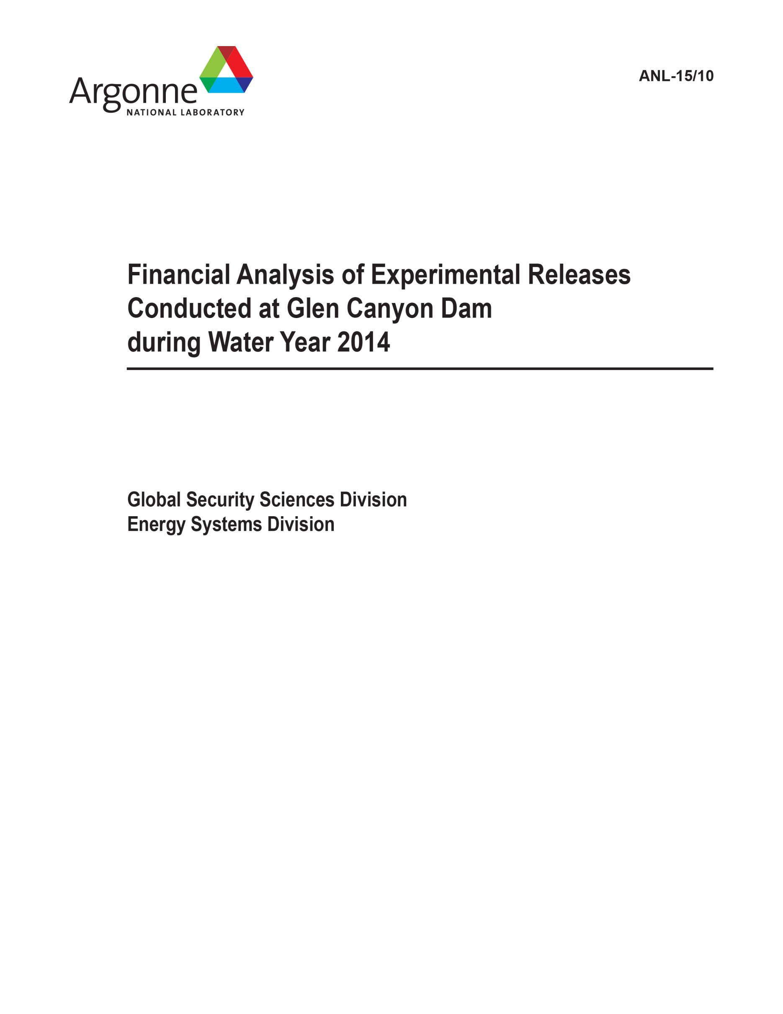

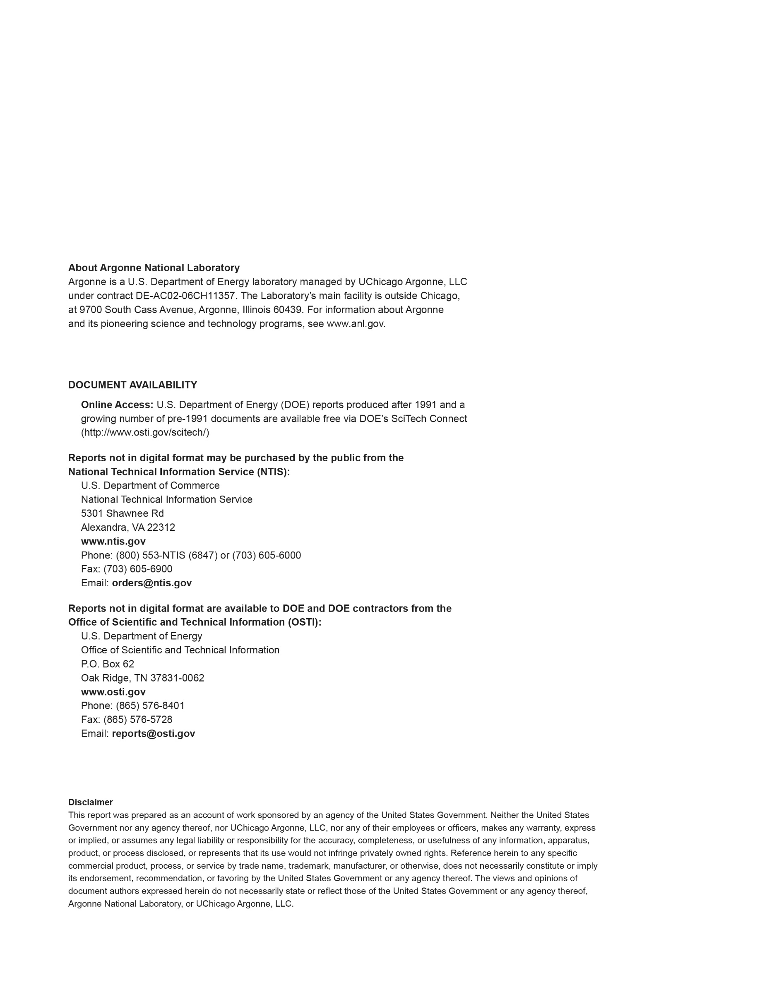

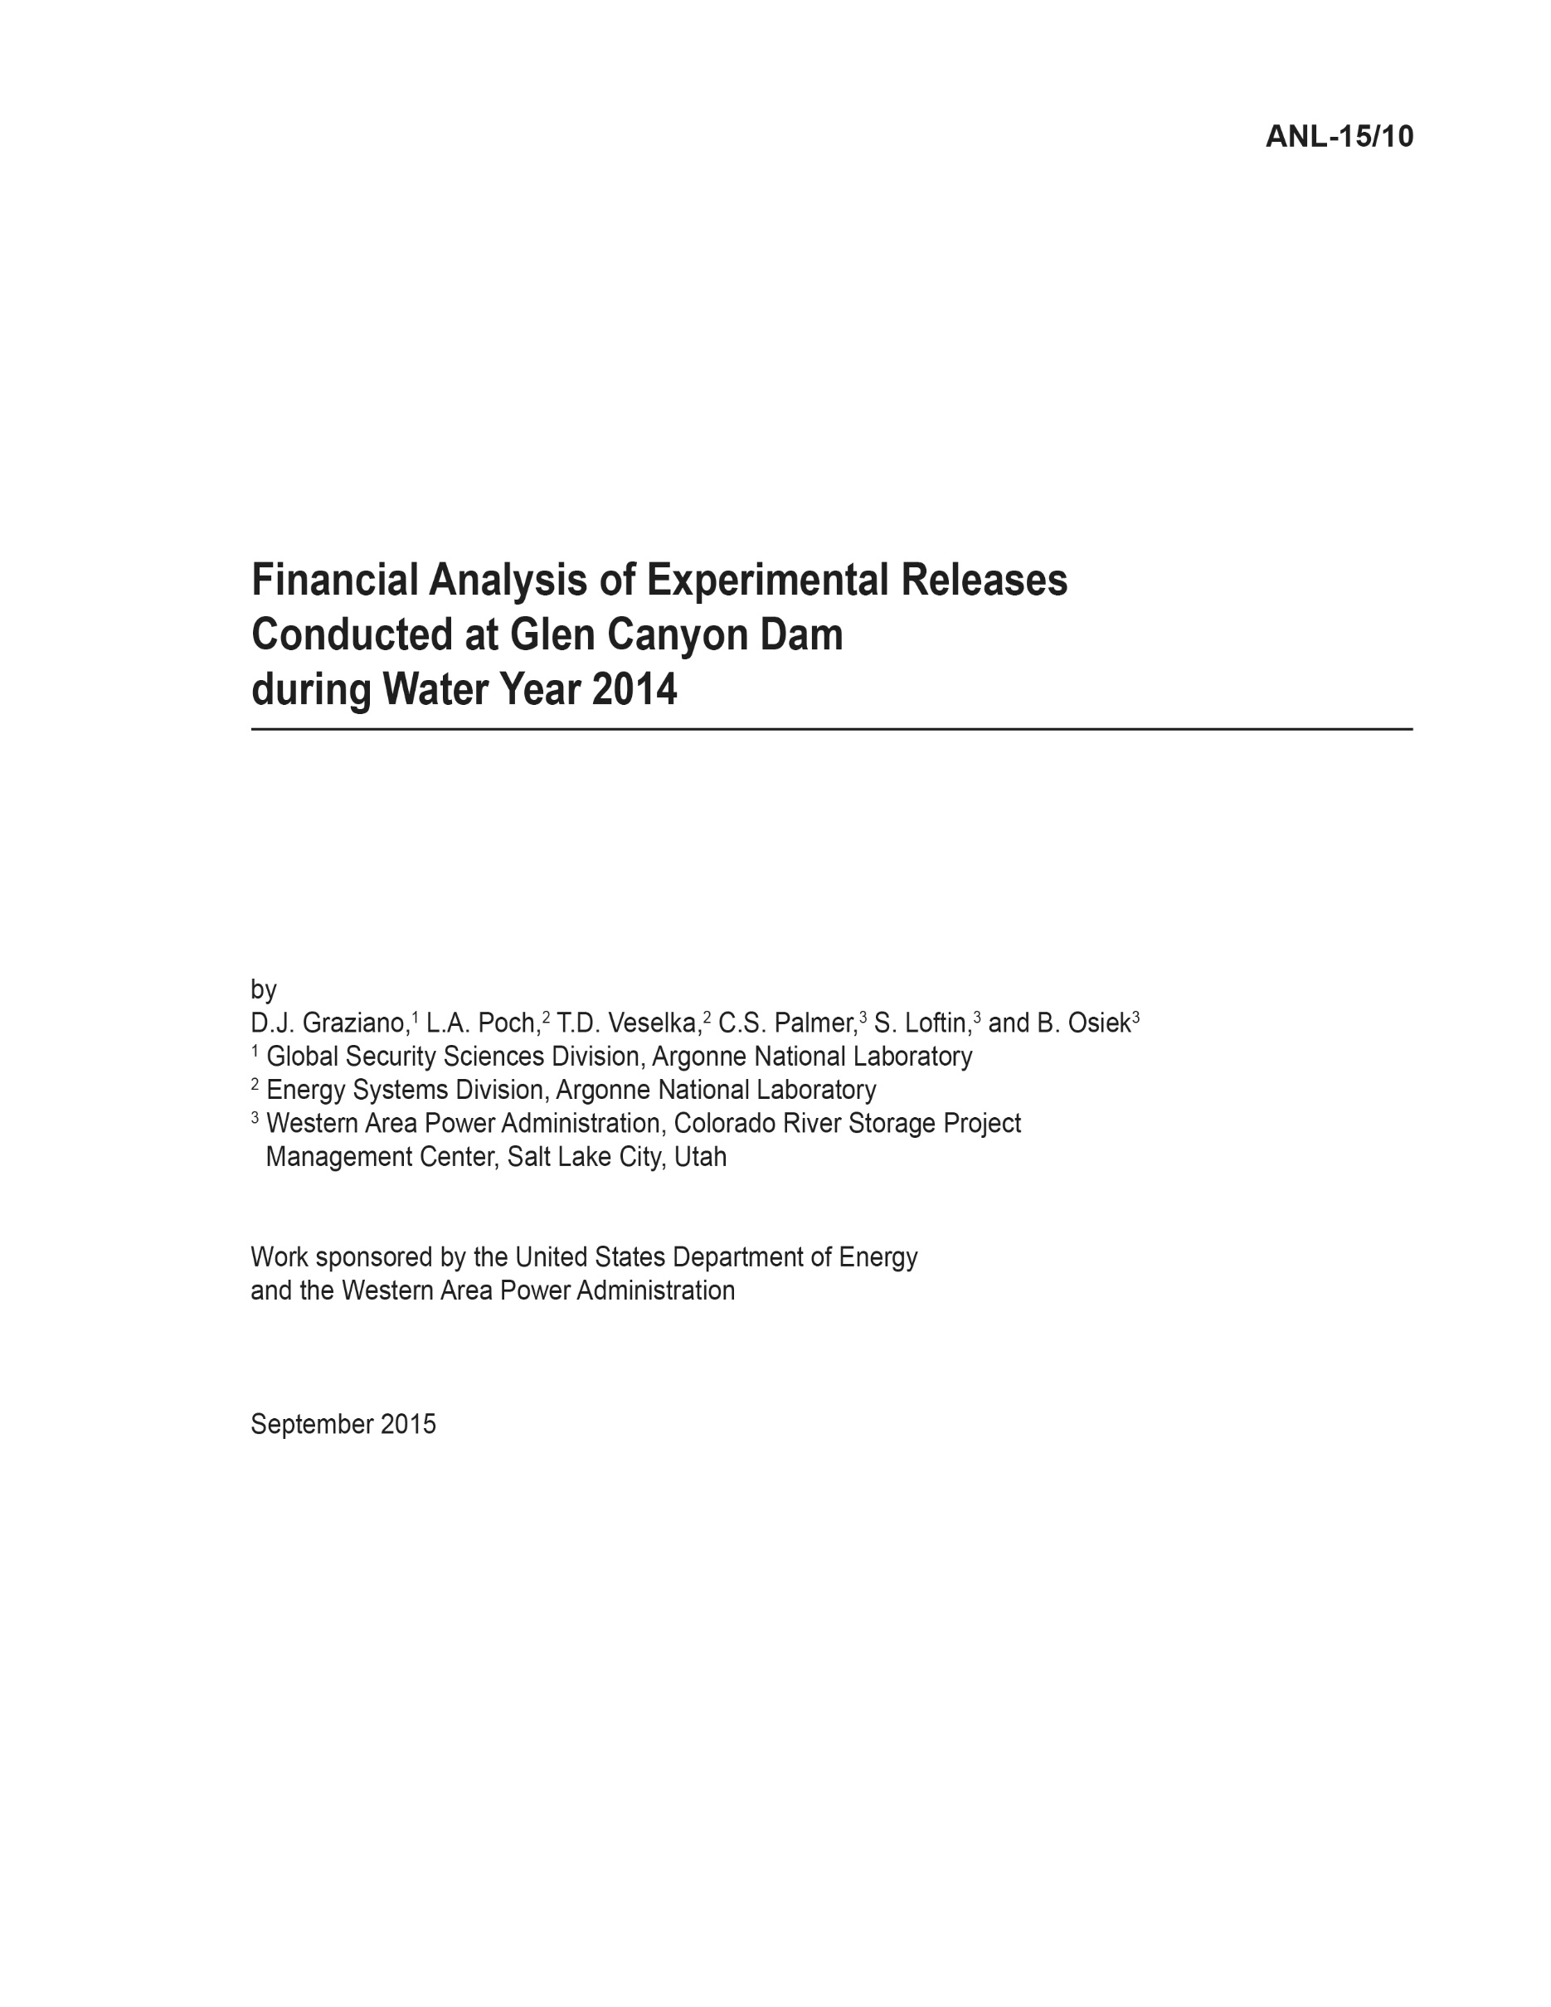

# Foreword

This report was prepared by Argonne National Laboratory (Argonne) in support of a financial analysis of experimental releases from the Glen Canyon Dam (GCD) conducted for the U.S. Department of Energy’s Western Area Power Administration (Western). Western markets electricity produced at hydroelectric facilities operated by the Bureau of Reclamation. The facilities known collectively as the Salt Lake City Area Integrated Projects include dams equipped for power generation on the Colorado, Green, Gunnison, and Rio Grande rivers and on Plateau Creek in the states of Arizona, Colorado, New Mexico, Utah, and Wyoming.

This report presents detailed findings of studies conducted by Argonne related to a financial analysis of experimental releases conducted at the GCD during water year 2014. Previous reports issued in January 2011 (ANL/DIS-11-1), August 2011 (ANL/DIS-11-4), June 2012 (ANL/DIS‑12-4), April 2013 (ANL/DIS-13-2), and June 2014 (ANL/DIS-14/9) performed financial analyses of experimental releases conducted in water years 1997 to 2005, 2006 to 2010, 2011, 2012, and 2013, respectively. Staff members in Argonne’s Global Security Sciences Division and Energy Systems Division prepared this technical memorandum with assistance from staff members of Western’s Colorado River Storage Project Management Center and Energy Marketing and Management Office.

This page is intentionally left blank.

# 

Contents

Foreword iii

Acronyms and Abbreviations vii

Units of Measure vii

Abstract 1

1 Introduction 3

2 ROD Criteria and Western’s Operating Practices 5

2.1 ROD Operating Criteria and Exceptions 5

2.2 Monthly Water Release Volumes 6

2.3 Montrose Scheduling Guidelines 7

3 Description of Experimental Releases 11

3.1 High Flow Experiment 11

4 Methods and Models 13

5 Cost of Experiments in WY 2014 15

6 References 19

[Appendix A: GTMax Simulations for Water Year 2014: Actual Hourly Energy Prices   
and Loads and Financial Cost of Net Energy Purchases A-1](#_Toc428780859)

[Appendix B: Financial Cost of the Experimental Release in Water Year 2014   
on the Basis of Energy Generation B-1](#_Toc428780860)

Figures

2.1 Illustration of the Firm-Load-Driven Dispatch Guideline under the 1996 ROD Operating Criteria When SLCA/IP Resources Are Short of Load 8

3.1 Release Pattern of the High Flow Experiment Conducted in November 2013 12

5.1 Monthly Water Releases in WY 2014 15

5.2 Cost of Experimental Releases in WY 2014 16

5.3 On-Peak and Off-Peak Prescheduled Sales and Purchase Prices — Weighted Averages for Experimental Release Days Compared to Other Days in November 17

5.4 Comparison of Lake Powell Elevations and Power Conversion Factors in WY 2014 18

A.1 SLCA/IP Topology Used for Power Plant Dispatch Simulations A-1

A.2 GTMax Results of Block Energy Purchases and Sales GTMax Simulation Results for November 11–16, 2013 A-7

B.1 Cost of Experimental Releases in WY 2014 – Basis of Energy Generation Value B-1

Tables

2.1 Operating Constraints Prior to 1991 and under the ROD 6

2.2 Water Releases and Lake Powell Elevation by Scenario and Month in WY 2014 7

3.1 Characteristics of GCD Powerplant Experimental Release 11

A.1 Weighted Average Monthly On- and Off-Peak Electricity Prices for WY 2014 A-2

A.2 Weighted Average Hourly Prices for WY 2014 A-4

A.3 GTMax Simulation Results - Monthly Value of Energy Purchases and Sales A-6

B.1 Weighted Average Monthly On- and Off-Peak Electricity Prices for Water Year 2014 B-1

B.2 Comparative Financial Costs Derived from Net Energy Purchases and Net Energy Generation B-2

# Acronyms and Abbreviations

The following is a list of the acronyms and abbreviations (including units of measure) used in this document.

AHP available hydropower

Argonne Argonne National Laboratory

EMMO Energy Management and Marketing Office (Western)

GCD Glen Canyon Dam

GCDEIS Glen Canyon Dam Environmental Impact Statement

GTMax Generation and Transmission Maximization

HFE High Flow Experiment

MSR Minimum Schedule Requirement

PO&M-59 Power Operations and Maintenance, Form 59 (a Bureau of Reclamation form entitled, *Monthly Report of Power Operations – Powerplants*)

Reclamation Bureau of Reclamation

ROD Record of Decision

SHP sustainable hydropower

SLCA/IP Salt Lake City Area Integrated Projects

Western Western Area Power Administration

WY water year

# Units of Measure

cfs cubic feet per second

ft feet

hr hour

MW megawatt(s)

MWh megawatt-hour(s)

pf power factor

TAF thousand acre-feet

This page is intentionally left blank.

Financial Analysis of Experimental Releases Conducted   
at Glen Canyon Dam during Water Year 2014

by

D.J. Graziano, L.A. Poch, T.D. Veselka, C.S. Palmer,[1] S. Loftin,* and B. Osiek*

# Abstract

This report examines the financial implications of experimental flows conducted at the Glen Canyon Dam (GCD) in water year (WY) 2014. It is the sixth report in a series examining the financial implications of experimental flows conducted since the Record of Decision (ROD) was adopted in February 1997 (Reclamation 1996). A report released in January 2011 examined water years 1997 to 2005 (Veselka et al. 2011), a report released in August 2011 examined water years 2006 to 2010 (Poch et al. 2011), a report released June 2012 examined water year 2011 (Poch et al. 2012), a report released April 2013 examined water year 2012 (Poch et al. 2013), and a report released June 2014 examined water year 2013 (Graziano et al. 2014).

An experimental release may have either a positive or negative impact on the financial value of energy production. Only one experimental release was conducted at GCD in WY 2014, specifically, a high flow experimental (HFE) release conducted in November 2013. For this experimental release, financial costs of approximately $2.6 million were incurred because the HFE required sustained water releases that exceeded the power plant’s maximum flow rate. In addition, during the month of the experiment, operators were not allowed to shape GCD power production to either follow firm power customer loads or to respond to market prices.

This study identifies the main factors that contribute to HFE costs and examines the interdependencies among these factors. It applies an integrated set of tools to estimate financial impacts by simulating the GCD operations under two scenarios, namely, (1) a baseline scenario that mimics both HFE operations during the experiment and during the rest of the year when it complies with the 1996 ROD operating criteria, and (2) a “without experiments” scenario that is identical to the baseline except it assumes that the HFE did not occur.

The Generation and Transmission Maximization (GTMax) model was the main simulation tool used to simulate the dispatch of hydropower plants at GCD and other plants that comprise the Salt Lake City Area Integrated Projects (SLCA/IP). The research team used extensive data sets and historical information on SLCA/IP powerplant characteristics, hydrologic conditions, and Western Area Power Administration’s (Western’s) power purchase prices in the modeling process. In addition to estimating the financial impact of the HFE, the team used the GTMax model to gain insights into the interplay among ROD operating criteria, exceptions that were made to criteria to accommodate the experimental releases, and Western operating practices.

This page is intentionally left blank.

# 1 Introduction

The Glen Canyon Dam (GCD) (also known as the Powerplant) consists of eight generating units with a continuous operating capacity of 1,320 megawatts (MW) at unity power factor (pf). It is one component of a larger system known as the Salt Lake City Area Integrated Projects (SLCA/IP). Electricity produced by the Powerplant serves the demand of 5.8 million consumers in 10 western states that are located in the Western Interconnection (WI). In the early days of its operation, the Powerplant had few restrictions. Except for a minimum water release requirement, the daily and hourly operations of the Powerplant were initially constrained only by the physical limitations of the dam structures; the Powerplant; and its storage reservoir, Lake Powell. This approach—of adjusting the Powerplant’s output principally in response to market price signals—often resulted in large fluctuations in the plant’s power output and associated water releases.

Concerns about the impact of GCD operations on downstream ecosystems and endangered species, including those in Grand Canyon National Park, prompted the Bureau of Reclamation (Reclamation) to conduct a series of research releases from June 1990 to July 1991 as part of an environmental studies program. On the basis of an analysis of these releases, Reclamation imposed operational flow constraints on August 1, 1991 (Western 2010). These constraints were in effect until February 1997, when new operational rules and management goals specified in the Glen Canyon Dam Environmental Impact Statement (GCDEIS) Record of Decision (ROD) were adopted (Reclamation 1996). The ROD operating criteria limits hourly maximum and minimum water release volumes from the dam. The ROD criteria also constrain the change in the water release between consecutive hours and restrict the range of hourly releases on a rolling 24-hour basis.

The Glen Canyon Dam Adaptive Management Program, established by the GCDEIS ROD (Reclamation 1996), conducts scientific studies on the relationship between Powerplant operations and downstream resources. Experimental water releases are performed periodically to monitor river conditions, conduct specific studies, enhance native fish habitat, and conserve fine sediment in the Colorado River corridor in Grand Canyon National Park.

Beginning in 1997, various types of experiments have been performed at GCD. The financial costs of experiments conducted from 1997 through 2005 were reported in the document, *Revised Financial Analysis of Experimental Releases Conducted at Glen Canyon Dam during Water Years 1997 through 2005* (Veselka et al. 2011). The financial costs of experiments conducted from 2006 through 2010 were reported in the document, *Financial Analysis of Experimental Releases Conducted at Glen Canyon Dam during Water Years 2006 through 2010* (Poch et al. 2011). The financial costs of experiments conducted in water year 2011 were reported in the document, *Financial Analysis of Experimental Releases Conducted at Glen Canyon Dam during Water Year 2011* (Poch et al. 2012). The financial costs of experiments conducted in water year 2012 were reported in the document, *Financial Analysis of Experimental Releases Conducted at Glen Canyon Dam during Water Year 2012* (Poch et al. 2013). The financial costs of experiments conducted in water year 2013 were reported in the document, *Financial Analysis of Experimental Releases Conducted at Glen Canyon Dam during Water Year 2013* (Graziano et al. 2014). Costs are assessed on the basis of a water year (WY). A WY is defined as a 12-month period from October 1 to September 30; for example, WY 2014 runs from October 1, 2013, to September 30, 2014.

One experiment, referred to as a high flow experiment (HFE), was conducted during WY 2014. Occurring in November 2013, the HFE prescribed a fixed pattern of GCD water releases over a 6‑day period. During 113 hours of the HFE, prescribed releases exceeded the Powerplant’s maximum flow rate by up to 17,000 cubic feet per hour (cfs). This “spilled” water does not produce energy and thus results in a financial cost to the Western Area Power Administration (Western). This report describes the method that was used to model the SLCA/IP, which includes GCD and discusses the financial costs of conducting this experiment.

During normal operations, GCD is governed by stringent operating rules as specified in the 1996 ROD. Although these rules yield environmental benefits, they also have financial and economic implications. These criteria reduce the flexibility of operations, diminish dispatchers’ ability to respond to market price signals, and lower the economic and financial benefits of power production. Power benefits are affected by the ROD in two ways. First, the loss of operable capability must eventually be replaced by other power generation resources. Second, the hydropower energy cannot be used to its fullest extent during hours of peak electricity demand when the market price and economic benefits are relatively high.

During the HFE, operational flexibility was essentially eliminated—water had to be released according to a fixed and pre-specified schedule. An integrated set of tools was used to estimate the financial impacts of the HFE by simulating GCD operations under two scenarios, namely, (1) a baseline scenario that mimics both HFE operations during the experiment and during the rest of the year and that complies with 1996 ROD operating criteria, and (2) a “without experiments” scenario that is identical to the baseline except it assumes that the HFE did not occur.

The Generation and Transmission Maximization (GTMax) model simulates the SLCA/IP powerplant dispatch from which Western’s financial revenues are computed. This tool uses an integrated systems modeling approach to dispatch power plants in the system while recognizing interactions among supply resources over time. Retrospective simulation for WY 2014 made use of extensive sets of data and historical information on SLCA/IP powerplants’ characteristics and hydrologic conditions and Western’s power purchase prices. The GTMax model simulated two scenarios. Under the “Baseline” scenario GTMax mimics the HFE as documented by Western and Reclamation and, for the rest of the year, simulates operations that comply with 1996 ROD operating criteria. The second scenario, “Without Experiments,” is identical to the first one, except it assumes that the experimental release did not occur. Differences in the value of GCD energy production between the two scenarios represent the change in financial value of power attributed to experimental releases. In addition to estimating the financial impact of experimental releases, the GTMax model was also used to gain insights into the interplay among ROD operating criteria, exceptions that are made to criteria to accommodate the experimental releases, and Western operating practices. Details on the methodology and data sources are more thoroughly described in Section 4 of the report, *Revised Financial Analysis of Experimental Releases Conducted at Glen Canyon Dam during Water Years 1997 through 2005* (Veselka et al. 2011).

# 2 ROD Criteria and Western’s Operating Practices

Important factors that explain the financial impacts of experimental releases include the following:

1. ROD operating criteria,
2. Exceptions to the ROD made to accommodate the experimental releases,
3. Monthly and annual water release distribution of annual volumes, and
4. Western’s scheduling guidelines that were adapted in response to ROD restrictions.

This section provides background information on each of these factors.

## 2.1 ROD Operating Criteria and Exceptions

Operating criteria specified in the ROD are intended to temper the rate of change in hourly and daily water releases. The criteria selected were based on the Modified Low Fluctuating Flow Alternative as described in the final GCDEIS. These criteria were put into practice by Western beginning in February 1997.

Flow restrictions under the ROD are shown in Table 2.1, along with operational limits in effect prior to June 1, 1991, for comparison. The ROD criteria require water release rates to be 8,000 cfs or greater between the hours of 7:00 a.m. and 7:00 p.m., and at least 5,000 cfs at night. The criteria also limit how quickly the release rate can increase and decrease in consecutive hours. The maximum hourly increase (i.e., the up-ramp rate) is 4,000 cfs/hour (hr), and the maximum hourly decrease (i.e., the down-ramp rate) is 1,500 cfs/hr. ROD operating criteria also restrict how much the releases can fluctuate during rolling 24-hour periods. This change constraint varies between 5,000 cfs and 8,000 cfs per day, depending on the monthly volume of water releases. Daily fluctuation is limited to 5,000 cfs in months when less than 600 thousand acre-feet (TAF) are released. The limit increases to 6,000 cfs when monthly release volumes are between 600 TAF and 800 TAF. When the monthly water release volume is 800 TAF or higher, the daily allowable fluctuation is 8,000 cfs.

The maximum flow rate is limited to 25,000 cfs under the ROD operating criteria. Maximum flow rate exceptions are allowed to avoid spills or flood releases during high runoff periods. Under very wet hydrological conditions, defined as when the average monthly release rate is greater than 25,000 cfs, the flow rate may be exceeded; however, water must be released at a constant rate. Exceptions to the operating criteria are also made to accommodate experimental releases. For the experiment discussed in this report, maximum flow rates above 25,000 cfs were allowed during the HFE conducted in November 2013.

Table 2.1: Operating Constraints Prior to 1991 and under the ROD (Post 1997)

|  |  |  |
| --- | --- | --- |
| Operational Constraint | Historic Flows (Pre 1991) | ROD Flows (Post 1997) |
|  |  |  |
| Minimum release (cfs) | 3,000 during the summer  1,000 during the rest of the year | 8,000 from 7:00 am–7:00 pm  5,000 at night |
|  |  |  |
| Maximum release (cfs) | 31,500 | 25,000 |
|  |  |  |
| Daily fluctuations (cfs/24 hr) | 28,500 during the summer  30,500 during the rest  of the year | 5,000; 6,000; or 8,000  depending on release  volume1 |
|  |  |  |
| Ramp rate (cfs/hr) | Unrestricted | 4,000 up 1,500 down |

1 Limited to 5,000 cfs/day when monthly water release is less than 600 TAF; 6,000 cfs/day when monthly water release is 600 TAF to 800 TAF; and 8,000 cfs/day when monthly water release is greater than 800 TAF.

Source: Reclamation (1996).

## 2.2 Monthly Water Release Volumes

Monthly water releases in the Upper and Lower Colorado River Basin are set by Reclamation to be consistent with various operating rules and guidelines, acts, international water treaties, consumption use requirements, State agreements, and the “Law of the River” (Reclamation 2008). In addition to power production, monthly release volumes are set considering other uses of the reservoirs, such as for flood control, river regulation, consumptive uses, water quality control, recreation, and fish and wildlife enhancement and to address other environmental factors.

Release decisions are made by using current runoff projections provided by the National Weather Service’s Colorado Basin River Forecast Center. Because future hydrologic conditions in the Colorado River Basin are not known with certainty and because events do not unfold as previously projected, adjustments are periodically made to its annual operating plan. Reclamation adjusts its release decisions on a monthly basis to reflect projections made by rolling 24-month studies that are updated monthly.

For the Baseline and Without Experiment scenarios, historical SLCA/IP monthly water releases as recorded in Reclamation’s Form PO&M-59 (Reclamation undated) and provided by Western for WY 2014 (Loftin 2015) were used for all hydropower plants except for GCD. Reclamation provided the GCD monthly water release input data for both scenarios and the hourly water releases during the HFE (Grantz 2015). These data included corrected values for the bypass flows during the HFE.

Table 2.2 shows the monthly water release volumes and the end-of-month elevations of the Lake Powell reservoir for each scenario during the study period. The HFE conducted in November 2013 required water to be reallocated among months; specifically, flows were reduced in March and May (Grantz 2015). This reallocation is seen in monthly water releases between the With (i.e., Baseline) and Without Experiments scenarios.

Table 2.2: Water Releases and Lake Powell Elevation by Scenario and Month in WY 2014

|  |  |  |  |  |  |  |  |  |  |  |  |
| --- | --- | --- | --- | --- | --- | --- | --- | --- | --- | --- | --- |
|  |  | Baseline  (With Experiments) | | |  | | Without  Experiments | |  | Difference  (With−Without) | |
| Calendar Year | Month | Water Release (TAF) | Lake Powell Elevation (feet [ft]) |  | | Water Release (TAF) | | Lake Powell Elevation (feet [ft]) |  | Water Release (TAF) | Lake Powell Elevation (feet [ft]) |
|  |  |  |  |  | |  | |  |  |  |  |
| 2013 | Oct. | 480 | 3,590.9 |  | | 480 | | 3,590.9 |  | 0 | 0.0 |
| 2013 | Nov. | 696 | 3,587.9 |  | | 500 | | 3,590.2 |  | 196 | −2.3 |
| 2013 | Dec. | 600 | 3,584.5 |  | | 600 | | 3,586.8 |  | 0 | −2.3 |
| 2014 | Jan. | 800 | 3,578.8 |  | | 800 | | 3,581.2 |  | 0 | −2.4 |
| 2014 | Feb. | 600 | 3,575.6 |  | | 600 | | 3,578.0 |  | 0 | −2.4 |
| 2014 | Mar. | 502 | 3,574.8 |  | | 600 | | 3,576.0 |  | −98 | −1.2 |
| 2014 | Apr. | 500 | 3,577.5 |  | | 500 | | 3,578.7 |  | 0 | −1.2 |
| 2014 | May | 502 | 3,589.2 |  | | 600 | | 3,589.2 |  | −98 | 0.0 |
| 2014 | June | 600 | 3,609.0 |  | | 600 | | 3,609.0 |  | 0 | 0.0 |
| 2014 | July | 800 | 3,608.1 |  | | 800 | | 3,608.1 |  | 0 | 0.0 |
| 2014 | Aug. | 800 | 3,605.8 |  | | 800 | | 3,605.8 |  | 0 | 0.0 |
| 2014 | Sep. | 600 | 3,605.5 |  | | 600 | | 3,605.5 |  | 0 | 0.0 |

## 2.3 Montrose Scheduling Guidelines

The actual hourly scheduling of SLCA/IP hydropower plant operations is performed by Western’s Energy Management and Marketing Office (EMMO) located in Montrose, Colorado. Schedulers make decisions based on a set of scheduling priorities and guidelines, including a directive to comply with environmental operating criteria. The GCD restrictions shown in Table 2.1 describe operational boundaries; however, within these limitations are innumerable hourly release patterns and dispatch drivers that comply with a given set of operating criteria. Thus, although the operational range was significantly wider prior to the 1996 ROD, a wide range of GCD ROD-compliant operational regimes still exists. Other SLCA/IP power plants must also comply with various operational limitations. For example, Flaming Gorge releases are patterned such that downstream flow rates are within Jensen Gage flow limits. In addition, releases from the Wayne N. Aspinall Dams cannot result in reservoir elevations that are outside of (1) a specified range of forebay elevation levels, and (2) limits on decreases in reservoir elevations over time.

As operational constraints were imposed on SLCA/IP resources, including those at the GCD, Powerplant scheduling guidelines and goals shifted from a model driven primarily by market prices to a new model driven by customer loads. Within the boundaries of these operating constraints, SLCA/IP power resources are used to serve firm load. Western also places a high priority on purchasing and selling power in 16-hour, on-peak blocks and 8-hour, off-peak blocks in the day-ahead market.

As illustrated in Figure 2.1, when hydropower resources are short of load, SLCA/IP generation resources are typically “stacked” on top of the block purchases as a means of following firm customer load. Because of operational limitations, Western staff may need either to purchase or sell varying amounts of energy on an hourly basis on either the day-ahead and/or real-time market. The volumes of these variable market purchases and sales are relatively small under the vast majority of conditions. The GTMax model topology and inputs are designed to mimic these guidelines. In other situations, however, market sales can sometimes be significant when SLCA/IP resource generation exceeds firm load. For example, during off-peak-load hours of the HFE, the GCD Powerplant was operating at full available capacity, while at the same time, firm customer requests for power were relatively low. During this period, day-ahead sales during off-peak hours were as high as 350 megawatt-hours (MWh).



Figure 2.1: Illustration of the Firm-Load-Driven Dispatch Guideline under the 1996 ROD Operating Criteria When SLCA/IP Resources Are Short of Load

The load-following objective facilitates a strong link between Western’s contractual obligations and SLCA/IP operations, requiring dispatch among SLCA/IP power plants to be closely coordinated. This interdependency exists because loads and hydropower resources are balanced whenever feasible. Western is able to affect the shape of customer firm load requests indirectly through specifications in its contract amendments. In turn, these customer loads affect both SCLA/IP power plant operations and hourly reservoir releases. Contract terms that indirectly affect load and power plant operations include sustainable hydropower (SHP) and available hydropower (AHP) capacity and energy sales, as well as Minimum Schedule Requirement (MSR) specifications. The MSR is the minimum amount of energy that a customer must schedule from Western in each hour. The load-following dispatch directive minimizes scheduling problems and helps Western avoid noncompliant water releases.

In addition to load following, dispatchers follow other practices that are specific to GCD Powerplant operations. These practices fall within ROD operational boundaries but are not ROD requirements. Therefore, these institutional practices may be altered or abandoned by Western at any time. One practice involves reducing generation at GCD to the same minimum level every day during low-price, off-peak hours. Western also avoids drastic changes to total water volume releases when they occur over successive days. In this analysis, therefore, it was assumed that the same volume of water was released each weekday.

Another Western scheduling practice that was observed when examining water releases occurring on both Saturdays and Sundays is that weekend releases are generally not less than 85% of the average weekday release (Patno 2008). In addition, during the summer season, operations allow one cycle of raising and lowering GCD Powerplant output per day. This practice increases to a maximum of two cycles during other seasons of the year as dictated by the hourly load pattern.

Changes in Western’s scheduling guidelines did not occur abruptly but subtly and over a period of months. These changes were not only the result of the operational constraints imposed by the ROD but also attributable to changing market conditions, such as persistent drought, electricity market disruptions in 2000 and 2001, and extended experimental releases that had large fluctuations in daily flow rate. Western found that by instituting load-following dispatch, it could better control its exposure and risk to market price fluctuations (Palmer 2010). New scheduling guidelines were implemented during WY 2001.

As in the case of operational constraints, the other SLCA/IP power plants (besides Glen Canyon) must also follow scheduling guidelines*.* For example,the Collbran Project’s daily generation produced by the Upper and Lower Molina power plants is scheduled at or near power plant maximum capability for continuous blocks of time, the lengths of which are based on the amount of water that is available for release during a 24-hour period.

This page is intentionally left blank.

# 3 Description of Experimental Releases

One experimental release was conducted during WY 2014: namely, an HFE in November 2013. This section describes this experimental release, its characteristics, and when it occurred. Table 3.1 summarizes the operational characteristics of GCD releases during the experimental release, such as maximum and minimum flows, maximum daily fluctuation, and maximum and minimum ramp rates.

Table 3.1: Characteristics of GCD Powerplant Experimental Release

| **Event** | **Date** | **Maxi-mum Flow (cfs)** | **Mini-mum Flow (cfs)** | **Maximum Hourly Up-Ramp Rate (cfs/hr)** | **Maximum Hourly Down-Ramp Rate (cfs/hr)** | **Maximum Daily Fluctuation (cfs/day)** | **Water Reallocated within Year** | **Exception to ROD Criteria** |
| --- | --- | --- | --- | --- | --- | --- | --- | --- |
|  |  |  |  |  |  |  |  |  |
| HFE | 11/11/2013– 11/16/2013 | 37,148 | 5,143 | 4,193 | 3,199 | 31,855 | Yes | Yes |

## 3.1 High Flow Experiment (HFE)

The November 2013 HFE was conducted per the 10-year (2011–2020) protocol for short-duration, high-volume controlled releases from GCD during sediment-enriched conditions (Reclamation 2011). The objective of this multi-year plan is to investigate how multiple events could be more effective in building sandbars and conserving sand over long periods. As a sediment conservation measure, HFEs rebuild sandbars and beaches; improve the riparian resources and protect archaeological resources by building up sandbars and redepositing sand at higher elevations; preserve and restore camping beaches; reduce near-shore vegetation; and rejuvenate backwaters, which can be important rearing habitat for native fish.

The November 2013 HFE ran from November 11 to November 16. The total duration at high flow was 5 days and 2 hours, with 3 days and 22 hours at a nominal peak release of 37,000 cfs. The flow rate exceeded the capability of the turbines for 113 hours, with water released through the dam’s hollow jet tubes (river outlet works or bypass) reaching 17,000 cfs. No electricity was generated by the water released through the hollow jet tubes. So that sufficient water was available to perform this experiment, water that would otherwise have been used in months after this experiment was redistributed for use during the HFE. Specifically, the redistribution for this HFE was imparted by reducing water releases in March and May of 2014 (Grantz 2015). The flow pattern for the November 2013 HFE is shown graphically in Figure 3.1.

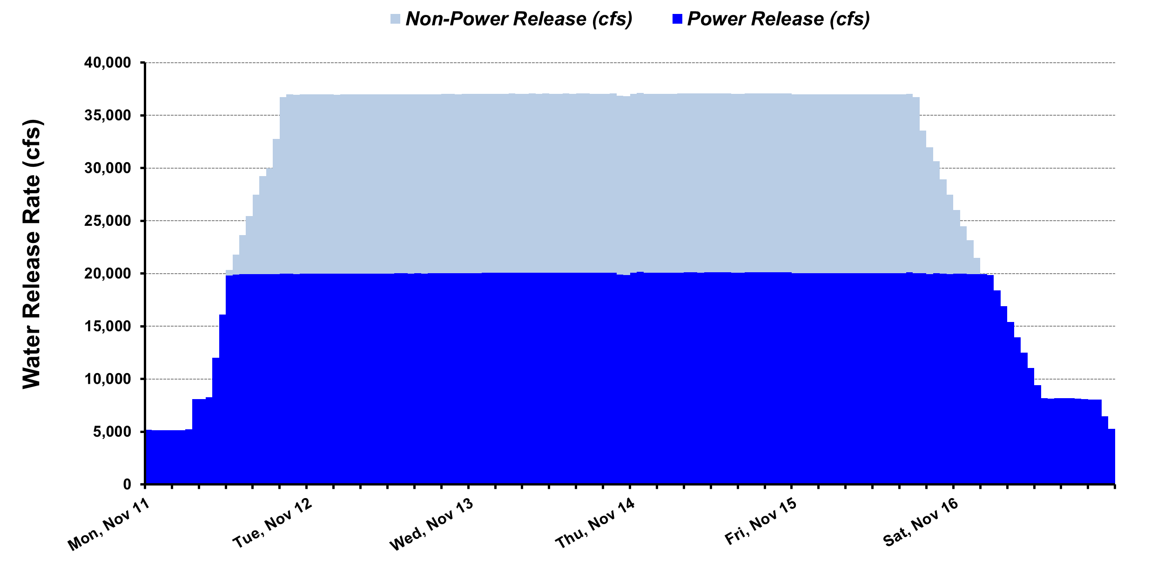

Figure 3.1: Release Pattern of the High Flow Experiment Conducted in November 2013

# 4 Methods and Models

For the WY 2014 analysis, financial impacts were computed by comparing simulated results between two operating scenarios:

1. The **Baseline scenario,** which assumes 1996 ROD operating criteria, the occurrence of the November 2013 HFE release, exceptions to the 1996 ROD criteria to accommodate the experimental releases, and historical monthly release volumes; and
2. The **Without Experiments scenario,** which assumes 1996 ROD operating criteria, the absence of any experimental releases, and monthly release volumes that differ from historical levels.

In prior financial analyses of experimental releases, the impacts were derived from the difference in the *value of GCD energy* production between the two simulated operating scenarios. For WY 2014, the financial impact is assessed from the difference in *net energy purchase costs*. Normally both methods yield very similar if not identical results. This revised analytic approach was undertaken at the request of Western to better capture financial losses associated with the effect of Western selling excess energy production at very low energy prices during the HFE release. During the experiment, Western sold more prescheduled energy (day-ahead bilateral market) than would have been sold if the experiment had not been conducted. This excess power was sold at an exceptionally low hourly price because EMMO staff could not find buyers that were willing to pay more. Hence, these transactions incurred an additional financial penalty.

The GTMax model is the main simulation tool used to dispatch SLCA/IP hydropower plants, including GCD. It not only simulates GCD operations, but it also provides insights into the interplay among the following: the ROD operating criteria, exceptions to the criteria to accommodate experimental releases, modifications to monthly water volumes, and Western’s scheduling guidelines and goals. The GTMax model is supported by several other tools and databases. These support tools include: the SLCA/IP Contracts spreadsheet, Customer Scheduling algorithm, Market Price spreadsheet, Experimental Release spreadsheet, and a Financial Value Calculation spreadsheet.

The GTMax model is supported by an input spreadsheet that contains ROD operating criteria, historical hydropower operations data, and parameters for Western scheduling guidelines. The input spreadsheet also performs various computations and prepares input data for GTMax. GTMax results are transferred to another spreadsheet to summarize simulation results, perform cost calculations, extrapolate weekly results to a monthly total, and produce a variety of tables and graphs.

The methods, models, and data used in this analysis were discussed in detail in Section 4 of the earlier report, *Revised Financial Analysis of Experimental Releases Conducted at Glen Canyon Dam during Water Years 1997 through 2005* (Veselka et al. 2011). The financial cost estimates based on net energy generation and net purchases of energy were derived from the same GTMax simulations for WY 2014. Deviating from prior analyses, actual hourly energy prices and loads were used in these GTMax simulations. Appendix A provides details on the data used in the simulations, as well as on the method used for estimating the financial costs of the experimental release.

# 5 Cost of Experiments in WY 2014

WY 2014 had one experiment: namely, an HFE in November 2013. The HFE in November 2013 had a nominal peak flow of 37,000 cfs. Supporting these high flows required reallocations of almost 200 TAF of water from the months of March and May in 2014 to November 2013.

Figure 5.1 shows the monthly water releases in WY 2014 for the two scenarios. The amounts of water released in the Baseline and Without Experiment scenarios differed in the months of November, March, and May. For November, water releases were higher in the Baseline scenario to accommodate the HFE. This higher water release was balanced with releases that were approximately 98 TAF lower during each of the months of March and May.

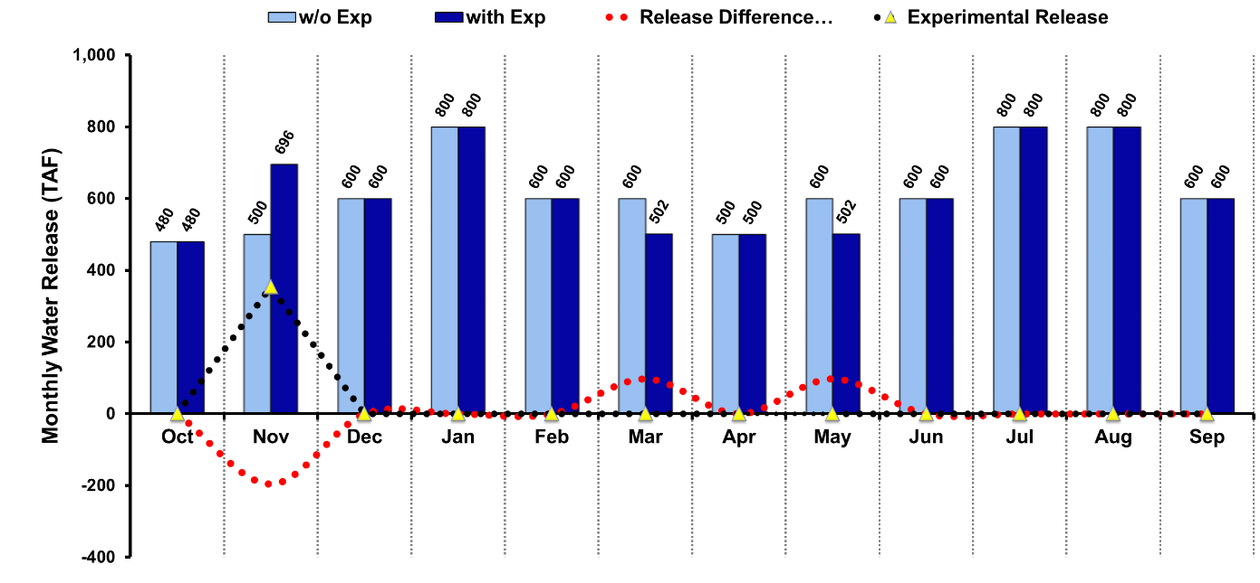

Figure 5.1: Monthly Water Releases in WY 2014

The financial analysis for the WY 2014 HFE considers the difference in net energy purchases between the Baseline and Without Experiment scenarios. This analytic method, which differs from prior financial analyses of experimental releases, is detailed in Appendix A. Results are shown in Figure 5.2.

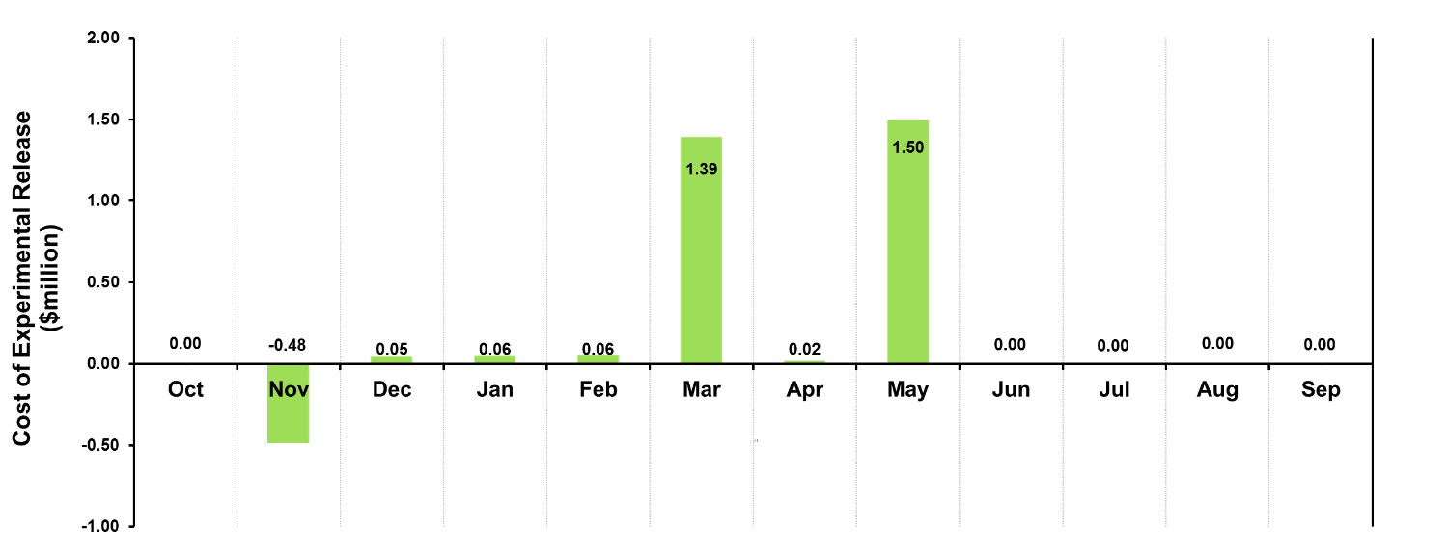

Figure 5.2: Cost of Experimental Releases in WY 2014

The financial implications of the HFE occurred over several months, with a financial gain in November of about $482,000 and a financial loss in December through April of about $3,075,000, for a net cost of about $2,593,000. The financial gain in November resulted from the higher water releases to accommodate the HFE and hence higher energy production. This gain would have been higher except that it was tempered by the following set of circumstances:

1. Several units were off-line during the HFE, resulting in higher spills and lower energy production;
2. Releases during non-experimental days in the month were very low, essentially forcing dam releases to nighttime and daytime minimums (see Table 2.1); and
3. Prices of off-peak energy sales during the HFE were abnormally low.

Figure 5.3 illustrates the third point. Both the on-peak and off-peak prescheduled sales prices are lower during the experimental release period than during other days in November. Furthermore, during the experimental release days, both the on-peak and off-peak prescheduled sales prices are actually lower than their counterpart prescheduled purchase prices, accentuating the financial losses associated with net purchases during the 6-day experiment.

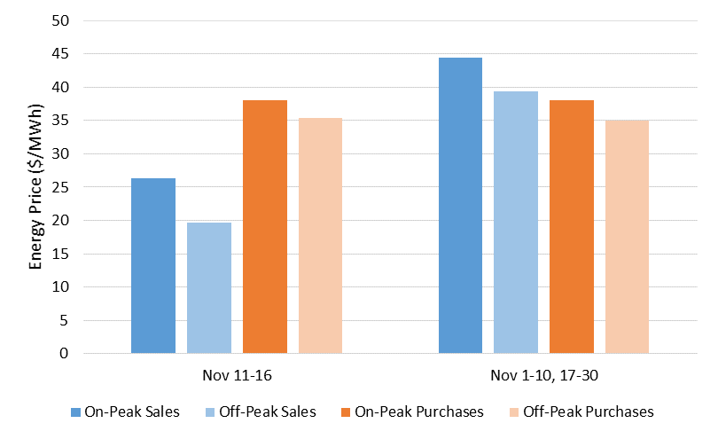

Figure 5.3: On-Peak and Off-Peak Prescheduled Sales and Purchase Prices — Weighted Averages for Experimental Release Days Compared to Other Days in November

The largest financial losses from the HFE occurred in March (about $1,393,000) and May (about $1,495,000) because water was reallocated from these months to November. Although water releases in the months of December, January, February, and April were the same for both scenarios, these months had a combined financial loss of about $188,000. This loss was attributable to a lower Lake Powell elevation in the Baseline Scenario, as shown in Figure 5.4. The large HFE release in November lowered Lake Powell’s forebay elevation, which reduced the GCD Powerplant’s power conversion factor. Therefore, less energy is produced in the Baseline scenario for each unit of water passing through the turbines than is produced in the Without Experiments scenario, resulting in higher net energy purchase costs for Western.

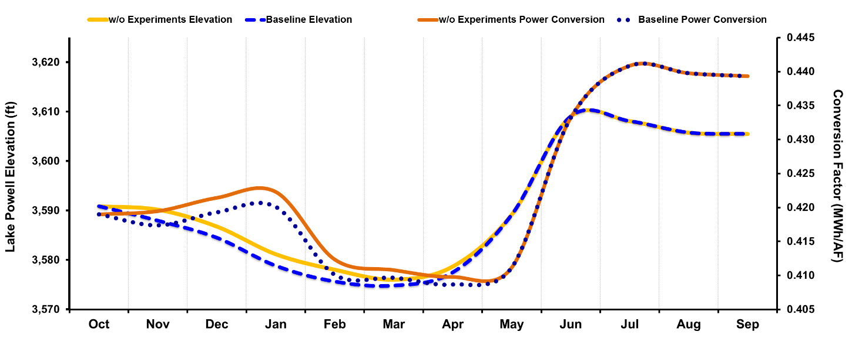

Figure 5.4: Comparison of Lake Powell Elevations and Power Conversion Factors in WY 2014

A sensitivity analysis was conducted to assess the impact of the revised methodology on model results. Details of this analysis are provided in Appendix B. Using the previous methodology, the financial cost of the November 2013 HFE is estimated to be about $2,440,000, which is $153,000 less than the cost estimated by using the revised methodology. This difference arises primarily because of the fact that Western sold energy in the day-ahead (preschedule) market during the HFE at a very low price. This pricing impact is accurately captured under the revised methodology. However, it is not fully accounted for using the previous methodology, which did not explicitly model the energy sales and purchases during the HFE or account for the very low price of energy sold during off-peak hours of the HFE. Results presented in Appendix B show that the estimated costs of the HFE are very similar using both methodologies except for the month of November when the HFE took place.

# 6 References

Grantz, K., 2015, personal communication to D.J. Graziano, Mar.

Graziano, D.J., L.A. Poch, D.J. Graziano, T.D. Veselka, C.S. Palmer, S. Loftin, and B. Osiek, 2014, *Financial Analysis of Experimental Releases Conducted at Glen Canyon Dam during Water Year 2013,* ANL/DIS-14/9, Argonne National Laboratory, June.

Loftin, S., 2015, personal communication to D.J. Graziano, Feb.

Palmer, C., 2010, personal communication to T. Veselka, Jan.

Patno, H., 2008, personal communication to T. Veselka, Apr.

Poch, L.A., T.D. Veselka, C.S. Palmer, S. Loftin, and B. Osiek, 2011, *Financial Analysis of Experimental Releases Conducted at Glen Canyon Dam during Water Years 2006 through 2010*, ANL/DIS-11-4, Argonne National Laboratory, Aug.

Poch, L.A., T.D. Veselka, C.S. Palmer, S. Loftin, and B. Osiek, 2012, *Financial Analysis of Experimental Releases Conducted at Glen Canyon Dam during Water Year 2011*, ANL/DIS‑12‑4, Argonne National Laboratory, June.

Poch, L.A., D.J. Graziano, T.D. Veselka, C.S. Palmer, S. Loftin, and B. Osiek, 2013, *Financial Analysis of Experimental Releases Conducted at Glen Canyon Dam during Water Year 2012*, ANL/DIS-13-2, Argonne National Laboratory, April.

Reclamation, 1996, *Record of Decision: Operation of Glen Canyon Dam Final Environmental Impact Statement, Appendix G*, U.S. Department of the Interior, Oct. [http://www.usbr.gov/uc/  
rm/amp/pdfs/sp_appndxG_ROD.pdf], accessed April 1, 2010.

Reclamation, 2008, *The Law of the River*, U.S. Department of the Interior, Lower Colorado Region [http://www.usbr.gov/lc/region/g1000/lawofrvr.html], accessed April 2010.

Reclamation, undated*, Monthly Report of Power Operations – Powerplants*, Form PO&M-59, U.S. Department of the Interior.

Reclamation, 2011, *Environmental Assessment: Development and Implementation of a Protocol   
for High-flow Experimental Releases from Glen Canyon Dam, Arizona, 2011–2020*, U.S. Department of the Interior, Bureau of Reclamation, Upper Colorado Region, Salt Lake City, Utah, December 30.

Scheid, N., 2015, personal communication to D.J. Graziano, March.

Veselka, T.D., L.A. Poch, C.S. Palmer, S. Loftin, and B. Osiek, 2011, *Revised Financial Analysis of Experimental Releases Conducted at Glen Canyon Dam during Water Years 1997 through 2005*, ANL/DIS-11-1, Argonne National Laboratory, Jan.

Western (Western Area Power Administration), 2010, *Operations of Glen Canyon Dam under the ROD*, CRSP Management Center [http://www.wapa.gov/CRSP/planprojectscrsp/  
gcopswhite.html], accessed April 1, 2010.

# Appendix A: GTMax Simulations for Water Year 2014: Actual Hourly Energy Prices and Loads and Financial Cost of Net Energy Purchases

The price that Western Area Power Administration (Western) paid to purchase power is one of the main factors in the financial cost of experiments and a key input to the Generation and Transmission Maximization (GTMax) model. As Figure A.1 shows, the Salt Lake City Area Integrated Projects (SLCA/IP) topology used for the power plant dispatch simulations considers market purchases and sales of energy. The BLOCK PURCHASE node represents prescheduled transactions (purchases and sales) to serve SLCA/IP customer loads and requires input data for on-peak and off-peak prices for Sunday-Holiday, Saturday, and Weekdays. Despite its label, the Western prescheduled block sales are also made at the node. As opposed to the real-time market, these prescheduled transactions (to cover long and short positions) are preferred by Western’s Energy Management and Marketing Office (EMMO) to help manage risk.

The HOURLY PURCHASE node represents real-time purchases to serve SLCA/IP customer loads and requires input data for hourly prices for Sundays-Holidays, Weekdays, and Saturdays. The NON-FIRM SALES node represents real-time sales to non-firm markets.

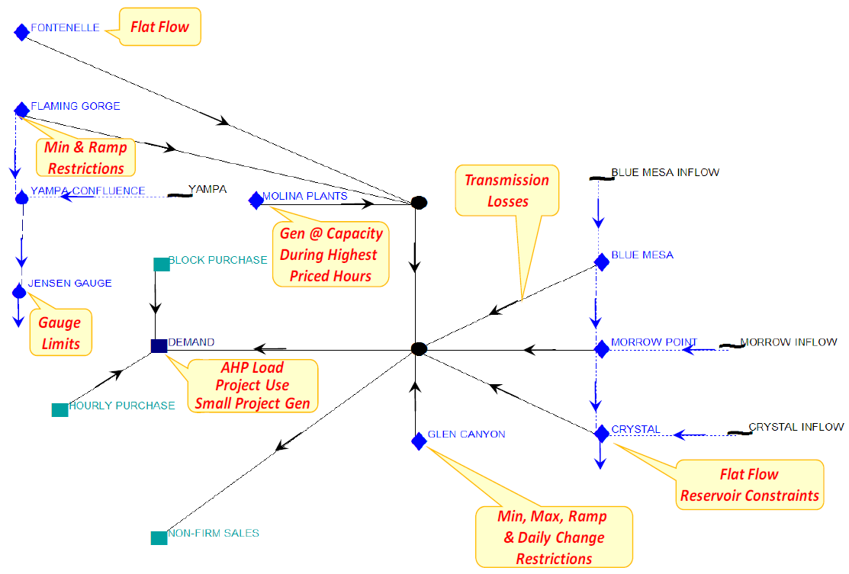

Figure A.1: SLCA/IP Topology Used for Power Plant Dispatch Simulations (the term “AHP Load” is used to be inclusive of periods when energy generation significantly exceeds sustainable hydropower [SHP] load)

The model input prices for block purchases, hourly purchases, and non-firm sales were derived from actual prescheduled and real-time energy sales and purchase data provided by Western (Scheid 2015). The block purchase prices used in the simulations are shown in Table A.1. These prices are energy-weighted averages of off-peak and on-peak prescheduled sale and purchase prices for all Sundays-Holidays, Weekdays, and Saturdays in the given month. To prevent errant simulation results, the hourly purchase prices and non-firm sales prices input to GTMax need to be the same. These prices, which are provided in Table A.2, were calculated as hourly energy weighted averages of all real-time purchases and sales reported for all Sundays-Holidays, Weekdays, and Saturdays by each month. For the month of November, the energy sales and purchases during the 6-day experimental release (i.e., November 11–16, 2013) were excluded from all energy-weighted averages.

Table A.1: Weighted Average Monthly On- and Off-Peak Electricity Prices for WY 2014 (GTMax Input – Block Purchases)

|  |  |  |  |  |  |  |
| --- | --- | --- | --- | --- | --- | --- |
| Calendar Year | Month | Sunday–Holiday Off-Peak ($/MWh) | Weekday Off-Peak ($/MWh) | Weekday On-Peak ($/MWh) | Saturday Off-Peak ($/MWh) | Saturday On-Peak ($MWh) |
|  |  |  |  |  |  |  |
| 2013 | Oct. | 32.02 | 28.85 | 37.38 | 27.88 | 37.13 |
| 2013 | Nov. | 36.72 | 34.02 | 38.41 | 33.79 | 38.07 |
| 2013 | Dec. | 46.82 | 39.75 | 44.76 | 39.10 | 43.50 |
| 2014 | Jan. | 34.36 | 31.82 | 38.68 | 30.91 | 37.79 |
| 2014 | Feb. | 49.35 | 40.94 | 49.57 | 43.24 | 51.65 |
| 2014 | Mar. | 36.59 | 30.98 | 39.48 | 29.60 | 38.74 |
| 2014 | Apr. | 37.57 | 33.44 | 44.33 | 32.74 | 43.93 |
| 2014 | May | 36.01 | 30.17 | 43.95 | 29.23 | 41.54 |
| 2014 | June | 29.22 | 26.35 | 38.35 | 26.74 | 40.96 |
| 2014 | July | 44.99 | 27.75 | 48.23 | 29.53 | 45.39 |
| 2014 | Aug. | 39.88 | 31.95 | 46.65 | 31.33 | 43.80 |
| 2014 | Sept. | 38.22 | 30.46 | 42.62 | 29.93 | 40.49 |

The GTMax model was run for the Baseline and Without Experiment scenarios using the prices shown in Tables A.1 and A.2 and actual hourly loads in lieu of generic shaped loads. Aside from these two changes, GTMax simulations were run as has been done in prior years. The financial analysis of the GTMax results, however, proceeded differently. In past analyses, the financial costs were determined by the difference in the value of energy generated during the water year (WY) between the two scenarios. In the revised method requested by Western, the financial cost was derived from the difference in the value of net energy purchased during the water year between the two scenarios.

Output results from the GTMax model include hourly values for block purchases or sales of energy, hourly purchases of energy on the spot market, and non-firm sales of energy. To assess the value of these energy transactions, actual hourly prescheduled and real-time energy sale and purchase data provided by Western (Scheid 2015) were again used. Specifically, the energy–weighted, average hourly prescheduled purchase and sales prices by day of the week (with Holidays considered to be Sundays) and by month were applied to the hourly block purchase and sale results, respectively. The energy–weighted, average hourly real-time purchase prices by day of the week and by month were applied to the hourly purchase results from GTMax. Likewise, the energy–weighted, average hourly real-time sales prices by day of the week and by month were applied to the non-firm sales results.

Table A.2: Weighted Average Hourly Prices for WY 2014 (GTMax Input – Hourly Purchases and Non-Firm Sales)

|  |  |  |  |  |  |  |  |  |  |  |  |  |  |  |  |  |  |  |  |  |  |  |  |  |  |  |
| --- | --- | --- | --- | --- | --- | --- | --- | --- | --- | --- | --- | --- | --- | --- | --- | --- | --- | --- | --- | --- | --- | --- | --- | --- | --- | --- |
| **Year** | **Month** | **Day** | **Hr 01** | **Hr 02** | **Hr 03** | **Hr 04** | **Hr 05** | **Hr 06** | **Hr 07** | **Hr 08** | **Hr 09** | **Hr 10** | **Hr 11** | **Hr 12** | **Hr 13** | **Hr 14** | **Hr 15** | **Hr 16** | **Hr 17** | **Hr 18** | **Hr 19** | **Hr 20** | **Hr 21** | **Hr 22** | **Hr 23** | **Hr 24** |
|  |  |  |  |  |  |  |  |  |  |  |  |  |  |  |  |  |  |  |  |  |  |  |  |  |  |  |
| 2013 | Oct. | Sunday-Holiday | 22.38 | 20.25 | 21.57 | 22.96 | 21.26 | 21.26 | 21.25 | 23.97 | 23.39 | 23.62 | 22.61 | 22.45 | 22.04 | 23.07 | 21.28 | 22.37 | 26.29 | 33.00 | 40.82 | 39.28 | 32.53 | 25.69 | 22.32 | 30.97 |
| 2013 | Oct. | Weekday | 21.61 | 21.66 | 21.53 | 24.44 | 29.08 | 33.35 | 37.05 | 38.41 | 36.41 | 34.70 | 34.46 | 33.03 | 33.03 | 32.45 | 31.94 | 33.62 | 34.38 | 35.83 | 38.93 | 37.94 | 33.31 | 30.06 | 27.82 | 36.68 |
| 2013 | Oct. | Saturday | 15.84 | 16.25 | 16.69 | 16.60 | 16.33 | 17.48 | 19.88 | 21.38 | 24.45 | 24.15 | 24.74 | 23.45 | 23.41 | 22.45 | 21.56 | 24.17 | 28.51 | 30.74 | 34.06 | 35.16 | 35.16 | 25.25 | 21.65 | 31.91 |
|  |  |  |  |  |  |  |  |  |  |  |  |  |  |  |  |  |  |  |  |  |  |  |  |  |  |  |
| 2013 | Nov. | Sunday-Holiday | 24.29 | 24.14 | 23.37 | 23.61 | 24.11 | 26.97 | 28.20 | 28.33 | 29.22 | 30.43 | 30.89 | 28.80 | 26.48 | 25.27 | 25.14 | 25.35 | 28.11 | 35.37 | 36.59 | 38.26 | 36.28 | 32.45 | 30.25 | 34.48 |
| 2013 | Nov. | Weekday | 27.07 | 25.24 | 25.51 | 25.42 | 28.76 | 35.23 | 41.19 | 42.43 | 40.03 | 35.94 | 34.85 | 33.26 | 31.84 | 31.46 | 30.03 | 31.03 | 34.68 | 40.92 | 46.86 | 45.90 | 39.68 | 35.98 | 33.43 | 40.68 |
| 2013 | Nov. | Saturday | 25.71 | 26.00 | 25.45 | 27.06 | 29.55 | 30.56 | 34.03 | 33.22 | 31.25 | 30.95 | 30.60 | 28.69 | 27.32 | 27.30 | 27.27 | 27.57 | 30.30 | 33.30 | 39.34 | 37.41 | 35.57 | 34.22 | 31.94 | 34.74 |
|  |  |  |  |  |  |  |  |  |  |  |  |  |  |  |  |  |  |  |  |  |  |  |  |  |  |  |
| 2013 | Dec. | Sunday-Holiday | 34.95 | 32.95 | 30.97 | 29.62 | 32.35 | 32.98 | 36.48 | 39.88 | 38.53 | 35.86 | 33.70 | 30.76 | 27.16 | 27.48 | 28.05 | 29.03 | 31.10 | 49.66 | 53.83 | 52.71 | 48.71 | 44.25 | 39.79 | 44.10 |
| 2013 | Dec. | Weekday | 33.30 | 31.59 | 30.27 | 30.31 | 34.70 | 43.18 | 55.13 | 54.90 | 55.82 | 49.78 | 45.66 | 42.56 | 40.82 | 38.08 | 36.74 | 36.24 | 41.71 | 58.05 | 58.82 | 57.32 | 51.16 | 46.24 | 42.15 | 52.16 |
| 2013 | Dec. | Saturday | 31.23 | 27.67 | 26.87 | 27.10 | 28.30 | 30.80 | 37.41 | 33.40 | 36.84 | 34.33 | 31.40 | 30.85 | 30.72 | 28.63 | 27.22 | 27.82 | 32.33 | 50.05 | 60.26 | 53.53 | 40.63 | 36.35 | 30.78 | 42.46 |
|  |  |  |  |  |  |  |  |  |  |  |  |  |  |  |  |  |  |  |  |  |  |  |  |  |  |  |
| 2014 | Jan. | Sunday-Holiday | 25.71 | 24.84 | 22.94 | 22.93 | 26.76 | 26.53 | 27.38 | 26.26 | 28.98 | 28.68 | 31.01 | 32.95 | 30.06 | 28.83 | 30.91 | 30.54 | 31.23 | 37.40 | 42.31 | 43.26 | 43.95 | 43.06 | 36.50 | 41.73 |
| 2014 | Jan. | Weekday | 27.82 | 25.36 | 25.15 | 25.39 | 29.34 | 34.46 | 42.22 | 46.46 | 45.15 | 42.98 | 40.82 | 38.93 | 36.81 | 34.84 | 34.41 | 34.57 | 35.33 | 43.13 | 47.18 | 45.80 | 40.03 | 35.39 | 35.59 | 43.06 |
| 2014 | Jan. | Saturday | 24.23 | 22.96 | 23.96 | 24.04 | 24.60 | 28.17 | 30.88 | 30.95 | 29.36 | 29.19 | 29.27 | 28.81 | 28.20 | 26.60 | 27.97 | 28.62 | 29.11 | 32.88 | 35.88 | 38.61 | 34.92 | 32.53 | 31.89 | 34.91 |
|  |  |  |  |  |  |  |  |  |  |  |  |  |  |  |  |  |  |  |  |  |  |  |  |  |  |  |
| 2014 | Feb. | Sunday-Holiday | 30.86 | 32.31 | 31.34 | 28.65 | 27.50 | 31.24 | 34.90 | 37.47 | 39.89 | 39.39 | 41.22 | 43.05 | 37.00 | 38.09 | 37.88 | 36.57 | 34.31 | 40.20 | 51.84 | 57.28 | 51.71 | 45.74 | 38.68 | 48.50 |
| 2014 | Feb. | Weekday | 36.75 | 36.44 | 38.01 | 40.38 | 46.29 | 52.08 | 66.96 | 68.49 | 63.26 | 69.20 | 70.88 | 55.51 | 50.85 | 49.46 | 46.53 | 43.72 | 41.79 | 56.26 | 69.88 | 68.76 | 62.72 | 60.26 | 47.71 | 61.88 |
| 2014 | Feb. | Saturday | 31.34 | 30.88 | 28.17 | 27.72 | 29.02 | 31.97 | 35.03 | 33.20 | 39.67 | 39.56 | 38.94 | 40.81 | 34.38 | 33.37 | 30.08 | 29.95 | 31.17 | 34.21 | 52.41 | 51.97 | 47.22 | 38.69 | 41.28 | 43.86 |
|  |  |  |  |  |  |  |  |  |  |  |  |  |  |  |  |  |  |  |  |  |  |  |  |  |  |  |
| 2014 | Mar. | Sunday-Holiday | 29.18 | 27.88 | 31.43 | 31.11 | 30.94 | 34.20 | 33.23 | 34.04 | 33.27 | 29.56 | 28.29 | 27.73 | 26.92 | 27.11 | 25.17 | 26.49 | 26.96 | 30.45 | 47.66 | 52.41 | 45.79 | 37.49 | 32.41 | 37.74 |
| 2014 | Mar. | Weekday | 24.00 | 21.83 | 22.34 | 24.15 | 30.90 | 41.90 | 46.06 | 49.31 | 44.91 | 40.65 | 36.83 | 34.89 | 32.44 | 32.36 | 30.57 | 29.53 | 31.39 | 33.88 | 44.30 | 41.94 | 39.74 | 33.26 | 33.02 | 38.84 |
| 2014 | Mar. | Saturday | 25.44 | 22.53 | 22.10 | 24.02 | 26.53 | 29.79 | 27.41 | 30.91 | 31.82 | 32.80 | 37.23 | 40.57 | 41.10 | 37.77 | 34.07 | 33.83 | 38.43 | 46.10 | 51.08 | 50.55 | 47.59 | 46.40 | 37.58 | 49.35 |
|  |  |  |  |  |  |  |  |  |  |  |  |  |  |  |  |  |  |  |  |  |  |  |  |  |  |  |
| 2014 | Apr. | Sunday-Holiday | 22.56 | 22.89 | 22.37 | 21.82 | 22.44 | 18.04 | 22.53 | 21.33 | 22.54 | 23.34 | 23.61 | 21.56 | 20.68 | 20.71 | 20.48 | 20.93 | 23.36 | 24.62 | 32.54 | 42.48 | 36.19 | 35.21 | 24.06 | 30.88 |
| 2014 | Apr. | Weekday | 29.60 | 28.86 | 27.68 | 27.12 | 29.95 | 36.02 | 40.95 | 40.98 | 37.46 | 35.87 | 33.17 | 31.87 | 31.54 | 31.64 | 30.93 | 32.37 | 33.29 | 34.30 | 40.86 | 50.69 | 40.64 | 35.06 | 31.28 | 38.58 |
| 2014 | Apr. | Saturday | 27.96 | 26.88 | 26.10 | 27.00 | 26.05 | 25.18 | 25.49 | 25.00 | 26.01 | 24.94 | 23.19 | 21.85 | 22.22 | 21.29 | 21.14 | 21.27 | 22.68 | 25.47 | 25.84 | 29.94 | 27.51 | 26.59 | 24.04 | 24.21 |
|  |  |  |  |  |  |  |  |  |  |  |  |  |  |  |  |  |  |  |  |  |  |  |  |  |  |  |
| 2014 | May | Sunday-Holiday | 26.15 | 23.75 | 22.45 | 22.59 | 23.78 | 19.32 | 20.92 | 20.08 | 20.91 | 21.79 | 26.60 | 31.51 | 31.64 | 33.68 | 36.10 | 37.42 | 45.46 | 47.94 | 53.06 | 54.36 | 50.70 | 43.41 | 32.58 | 49.27 |
| 2014 | May | Weekday | 27.80 | 25.54 | 25.44 | 25.29 | 30.45 | 32.45 | 35.57 | 37.12 | 40.29 | 39.93 | 40.61 | 40.82 | 41.88 | 45.13 | 48.60 | 49.65 | 52.19 | 57.47 | 57.86 | 51.86 | 44.45 | 38.76 | 35.19 | 53.34 |
| 2014 | May | Saturday | 25.68 | 24.45 | 21.92 | 24.15 | 25.18 | 21.49 | 25.73 | 23.25 | 24.35 | 26.17 | 26.78 | 26.89 | 26.26 | 26.84 | 27.11 | 27.45 | 31.76 | 37.10 | 37.40 | 40.21 | 33.50 | 33.96 | 31.57 | 35.67 |
|  |  |  |  |  |  |  |  |  |  |  |  |  |  |  |  |  |  |  |  |  |  |  |  |  |  |  |
| 2014 | June | Sunday-Holiday | 20.04 | 18.09 | 17.76 | 17.49 | 17.93 | 16.85 | 14.82 | 15.47 | 18.57 | 20.08 | 22.89 | 24.57 | 26.09 | 27.96 | 31.53 | 33.17 | 56.15 | 50.34 | 39.17 | 32.55 | 33.78 | 29.84 | 26.15 | 40.03 |
| 2014 | June | Weekday | 22.53 | 17.11 | 15.66 | 15.49 | 17.38 | 25.86 | 22.44 | 25.17 | 31.57 | 38.50 | 41.98 | 48.83 | 49.78 | 50.76 | 51.94 | 53.53 | 57.68 | 51.89 | 48.87 | 45.65 | 41.08 | 36.30 | 31.81 | 54.67 |
| 2014 | June | Saturday | 26.61 | 19.75 | 18.71 | 18.71 | 18.36 | 20.30 | 20.76 | 21.39 | 24.93 | 26.16 | 27.78 | 28.70 | 34.10 | 34.17 | 35.46 | 38.98 | 39.22 | 41.05 | 43.85 | 38.62 | 37.30 | 37.35 | 35.97 | 43.26 |
|  |  |  |  |  |  |  |  |  |  |  |  |  |  |  |  |  |  |  |  |  |  |  |  |  |  |  |
| 2014 | July | Sunday-Holiday | 28.94 | 27.43 | 21.75 | 21.15 | 20.26 | 18.76 | 19.59 | 22.40 | 28.01 | 32.48 | 38.07 | 43.38 | 44.36 | 48.06 | 49.26 | 52.27 | 54.87 | 52.83 | 50.91 | 43.99 | 39.87 | 38.58 | 37.82 | 52.56 |
| 2014 | July | Weekday | 28.98 | 27.44 | 26.28 | 26.82 | 29.10 | 29.53 | 31.59 | 33.16 | 35.15 | 39.14 | 41.32 | 43.28 | 44.21 | 47.09 | 50.33 | 54.90 | 58.08 | 54.03 | 50.38 | 44.09 | 42.99 | 37.87 | 40.40 | 52.85 |
| 2014 | July | Saturday | 29.05 | 26.60 | 23.79 | 22.66 | 26.35 | 22.15 | 28.19 | 27.18 | 27.19 | 31.76 | 33.40 | 40.90 | 39.95 | 44.52 | 50.55 | 55.26 | 59.91 | 54.38 | 48.76 | 43.44 | 38.81 | 35.89 | 43.87 | 52.34 |
|  |  |  |  |  |  |  |  |  |  |  |  |  |  |  |  |  |  |  |  |  |  |  |  |  |  |  |
| 2014 | Aug. | Sunday-Holiday | 28.83 | 25.97 | 24.08 | 22.86 | 22.64 | 20.78 | 20.36 | 20.43 | 19.33 | 25.83 | 30.37 | 32.19 | 31.03 | 37.60 | 42.75 | 46.10 | 52.61 | 52.65 | 43.21 | 34.81 | 35.01 | 36.34 | 32.51 | 44.33 |
| 2014 | Aug. | Weekday | 27.14 | 25.36 | 26.65 | 28.86 | 29.78 | 32.72 | 33.34 | 34.83 | 36.68 | 38.39 | 40.62 | 43.86 | 44.85 | 45.81 | 47.50 | 50.80 | 50.99 | 48.72 | 44.39 | 39.13 | 37.22 | 33.00 | 32.98 | 46.52 |
| 2014 | Aug. | Saturday | 25.50 | 25.69 | 26.08 | 26.05 | 28.62 | 29.88 | 26.32 | 27.73 | 28.17 | 28.06 | 30.40 | 32.30 | 37.78 | 40.22 | 40.81 | 48.38 | 51.21 | 47.31 | 43.68 | 39.84 | 36.69 | 29.91 | 32.46 | 43.66 |
|  |  |  |  |  |  |  |  |  |  |  |  |  |  |  |  |  |  |  |  |  |  |  |  |  |  |  |
| 2014 | Sep. | Sunday-Holiday | 27.81 | 25.70 | 25.07 | 26.00 | 26.22 | 24.87 | 25.33 | 25.82 | 26.40 | 26.63 | 33.52 | 37.51 | 36.90 | 41.42 | 43.93 | 45.07 | 50.15 | 50.60 | 56.74 | 43.63 | 41.49 | 38.03 | 35.66 | 49.09 |
| 2014 | Sep. | Weekday | 25.94 | 23.78 | 22.35 | 22.62 | 25.10 | 30.37 | 31.98 | 35.11 | 37.29 | 38.74 | 40.10 | 43.79 | 44.17 | 45.48 | 53.56 | 57.25 | 58.90 | 57.15 | 54.03 | 47.14 | 39.92 | 37.88 | 34.69 | 54.21 |
| 2014 | Sep. | Saturday | 30.80 | 28.84 | 27.50 | 28.05 | 30.14 | 28.42 | 29.55 | 29.96 | 30.96 | 31.41 | 35.00 | 36.99 | 38.51 | 38.35 | 45.49 | 49.63 | 51.18 | 44.48 | 47.19 | 36.46 | 33.63 | 32.84 | 32.22 | 43.16 |

Table A.3 presents the monthly financial costs for the block purchases/sales, hourly purchases, and non-firm sales calculated from GTMax results for the Baseline and Without Experiment scenarios. To complete the analysis, the cost associated with net purchases during the 6-day experimental release (i.e., November 11–16, 2013) was determined in a third GTMax simulation. In this simulation, the supervisory control and data acquisition (SCADA) data for the Glen Canyon Dam (GCD) power releases were used to predefine the hourly water release pattern that was input into GTMax. Other input data were the same as those for the Baseline simulation. A net energy purchase cost of $186,000 for the 6-day period of the experiment was estimated from the GTMax simulation (see the italicized “Exp” row in Table A.3). Although Western sold energy during off-peak hours, it was short on fulfilling energy loads during on-peak hours because of unit outages at GCD. These energy purchases were made at a significantly higher price than the price Western received for its off-peak energy sales, as illustrated in Figure A.2.

Table A.3: GTMax Simulation Results - Monthly Value of Energy Purchases and Sales

|  |  |  |  |  |  |  |  |  |  |  |  |  |  |
| --- | --- | --- | --- | --- | --- | --- | --- | --- | --- | --- | --- | --- | --- |
|  | | | Baseline (With Experiment) | | |  | Without Experiment | | |  | Differencea  (Baseline **minus** Without Experiment) | | |
| Calendar Year | Month | Hourly Purchases  ($) | | Block Purchases/Sales ($) | Non-Firm Sales  ($) |  | Hourly Purchases ($) | Block Purchases/Sales  ($) | Non-Firm Sales  ($) |  | Hourly Purchases ($) | Block Purchases  ($) | Non-Firm Sales  ($) |
|  |  |  | |  |  |  |  |  |  |  |  |  |  |
| 2013 | Oct. | 0 | | −6,637,404 | 94,211 |  | 0 | *−*6,637,692 | 94,363 |  | 0 | 288 | −153 |
| 2013 | Novb | −7,199 | | −7,920,928 | 1,280,312 |  | *−*3,908 | *−*7,672,441 | 360,452 |  | *−*3,291 | −248,487 | 919,860 |
| *2013* | *Expc* | *−10,844* | | *−721,336* | *546,136* |  | *–* | *–* | *–* |  | *−10,844* | −*721,336* | *546,136* |
| 2013 | Dec. | −1,053 | | *−*10,222,409 | 635,000 |  | *−*1,130 | *−*10,165,533 | 629,226 |  | 76 | −56,876 | 5,774 |
| 2014 | Jan. | 0 | | *−*5,332,152 | 114,657 |  | 0 | *−*5,271,799 | 111,787 |  | 0 | −60,353 | 2,871 |
| 2014 | Feb. | 0 | | *−*8,963,386 | 1,247,364 |  | 0 | *−*8,902,984 | 1,245,532 |  | 0 | −60,402 | 1,832 |
| 2014 | Mar. | −4,560 | | *−*8,712,351 | 172,950 |  | 0 | *−*7,209,067 | 58,157 |  | *−*4,560 | −1,503,284 | 114,793 |
| 2014 | Apr. | 0 | | *−*6,848,722 | 43,151 |  | 0 | *−*6,827,575 | 42,854 |  | 0 | −21,146 | 297 |
| 2014 | May | 0 | | *−*5,437,007 | 68,221 |  | 0 | *−*3,873,384 | 0 |  | 0 | −1,563,623 | 68,221 |
| 2014 | June | −153 | | 1,203,408 | 269,168 |  | *−*217 | 1,203,047 | 269,746 |  | 63 | 361 | −578 |
| 2014 | July | 0 | | *−*192,418 | 115 |  | 0 | *−*192,846 | 109 |  | 0 | 427 | 6 |
| 2014 | Aug. | 0 | | *−*913,999 | 0 |  | 0 | *−*914,324 | 0 |  | 0 | 325 | 0 |
| 2014 | Sep. | 0 | | *−*2,762,111 | 0 |  | 0 | *−*2,762,344 | 0 |  | 0 | 232 | 0 |

a  Differences calculated prior to rounding off.

b Results for November, Baseline scenario, exclude the six days (November 11–16, 2013) of the experimental release.

c Exp = GTMax simulation results are for the sales and purchases occurring during the 6-day experimental release.

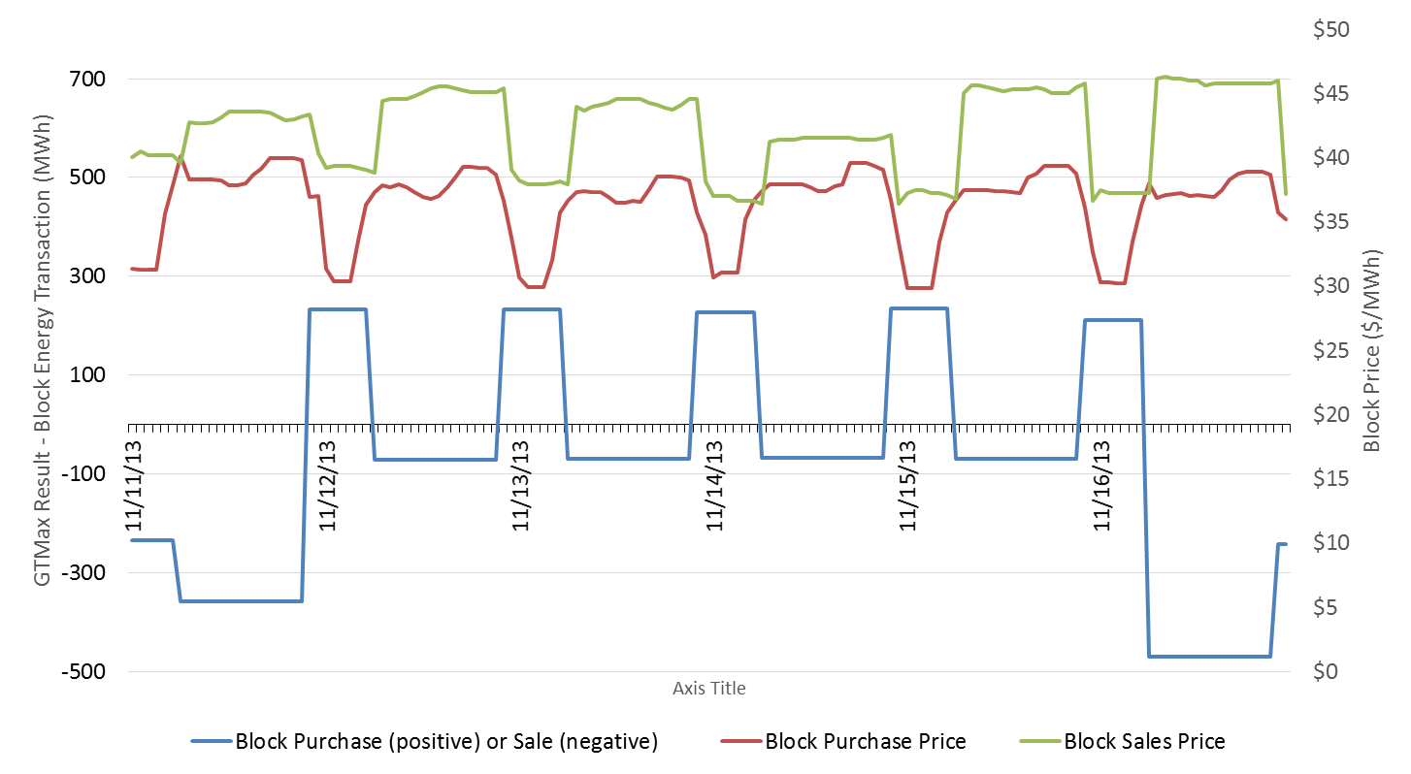

Figure A.2: GTMax Results of Block Energy Purchases and Sales GTMax Simulation Results for November 11–16, 2013

This page is intentionally left blank.

# Appendix B: Financial Cost of the Experimental Release in Water Year 2014 on the Basis of Energy Generation

Figure B.1 shows the monthly financial costs of the high flow experiment (HFE) that occurred in water year (WY) 2014, which are calculated on the basis of the value of Glen Canyon Dam (GCD) energy production. This figure also shows the monthly price spread between the on- and off-peak electricity prices that the Western Area Power Administration (Western) paid to purchase energy. The monthly on- and off-peak prices during WY 2014 are average firming energy prices provided by Western (Loftin 2015) and are shown in Table B.1.

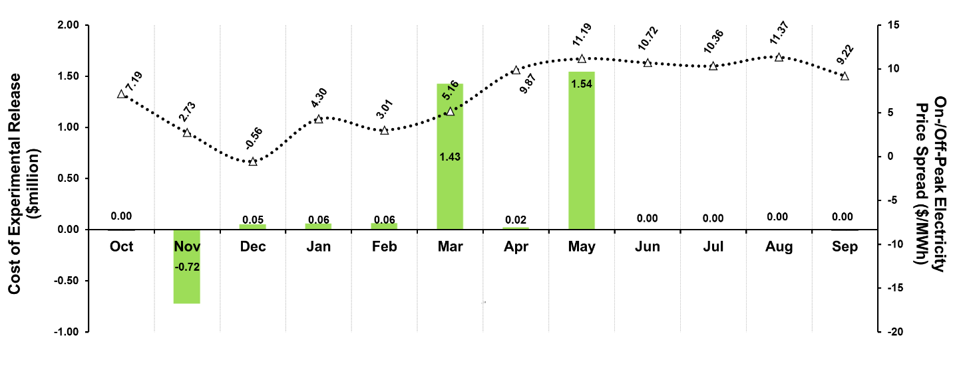

Figure B.1: Cost of Experimental Releases in WY 2014 – Basis of Energy Generation Value

Table B.1: Weighted Average Monthly On- and Off-Peak Electricity Prices for Water Year 2014

|  |  |  |  |  |
| --- | --- | --- | --- | --- |
| Calendar Year | Month | On-Peak ($/MWh) | Off-Peak ($/MWh) | Experiment Conducted |
|  |  |  |  |  |
| 2013 | Oct. | 36.91 | 29.72 |  |
| 2013 | Nov. | 38.45 | 35.72 | High Flow Experiment (HFE) |
| 2013 | Dec. | 45.13 | 45.69 |  |
| 2014 | Jan. | 38.76 | 34.46 |  |
| 2014 | Feb. | 51.59 | 48.58 |  |
| 2014 | Mar. | 39.71 | 34.55 |  |
| 2014 | Apr. | 44.02 | 34.15 |  |
| 2014 | May | 44.25 | 33.06 |  |
| 2014 | June | 44.50 | 33.79 |  |
| 2014 | July | 46.16 | 35.80 |  |
| 2014 | Aug. | 43.41 | 32.04 |  |
| 2014 | Sept. | 41.42 | 32.20 |  |

The financial implications of the HFE occurred over several months, with a financial gain in November of about $723,000 and a financial loss in December through May of about $3,163,000, for a net cost of about $2,440,000. Table B.2 provides a month-by-month comparison of the financial costs calculated by the different methods.

Table B.2: Comparative Financial Costs Derived from Net Energy Purchases and Net Energy Generation

|  |  |  |  |  |
| --- | --- | --- | --- | --- |
| Calendar Year | Month | Net Energy Purchase Basis (thousand $) | Net Energy Generation Basis (thousand $) | Experiment Conducted |
|  |  |  |  |  |
| 2013 | Oct. | 0 | 0 | – |
| 2013 | Nov. | 482 | 723 | High Flow Experiment (HFE) |
| 2013 | Dec. | −51 | −53 | – |
| 2014 | Jan. | −57 | −61 | – |
| 2014 | Feb. | −59 | −63 | – |
| 2014 | Mar. | −1,393 | −1,425 | – |
| 2014 | Apr. | −21 | −21 | – |
| 2014 | May | −1,495 | −1,539 | – |
| 2014 | June | 0 | 0 | – |
| 2014 | July | 0 | 0 | – |
| 2014 | Aug. | 0 | 0 | – |
| 2014 | Sept. | 0 | 0 | – |
| WY 2014 | Total | −2,593 | −2,440 |  |

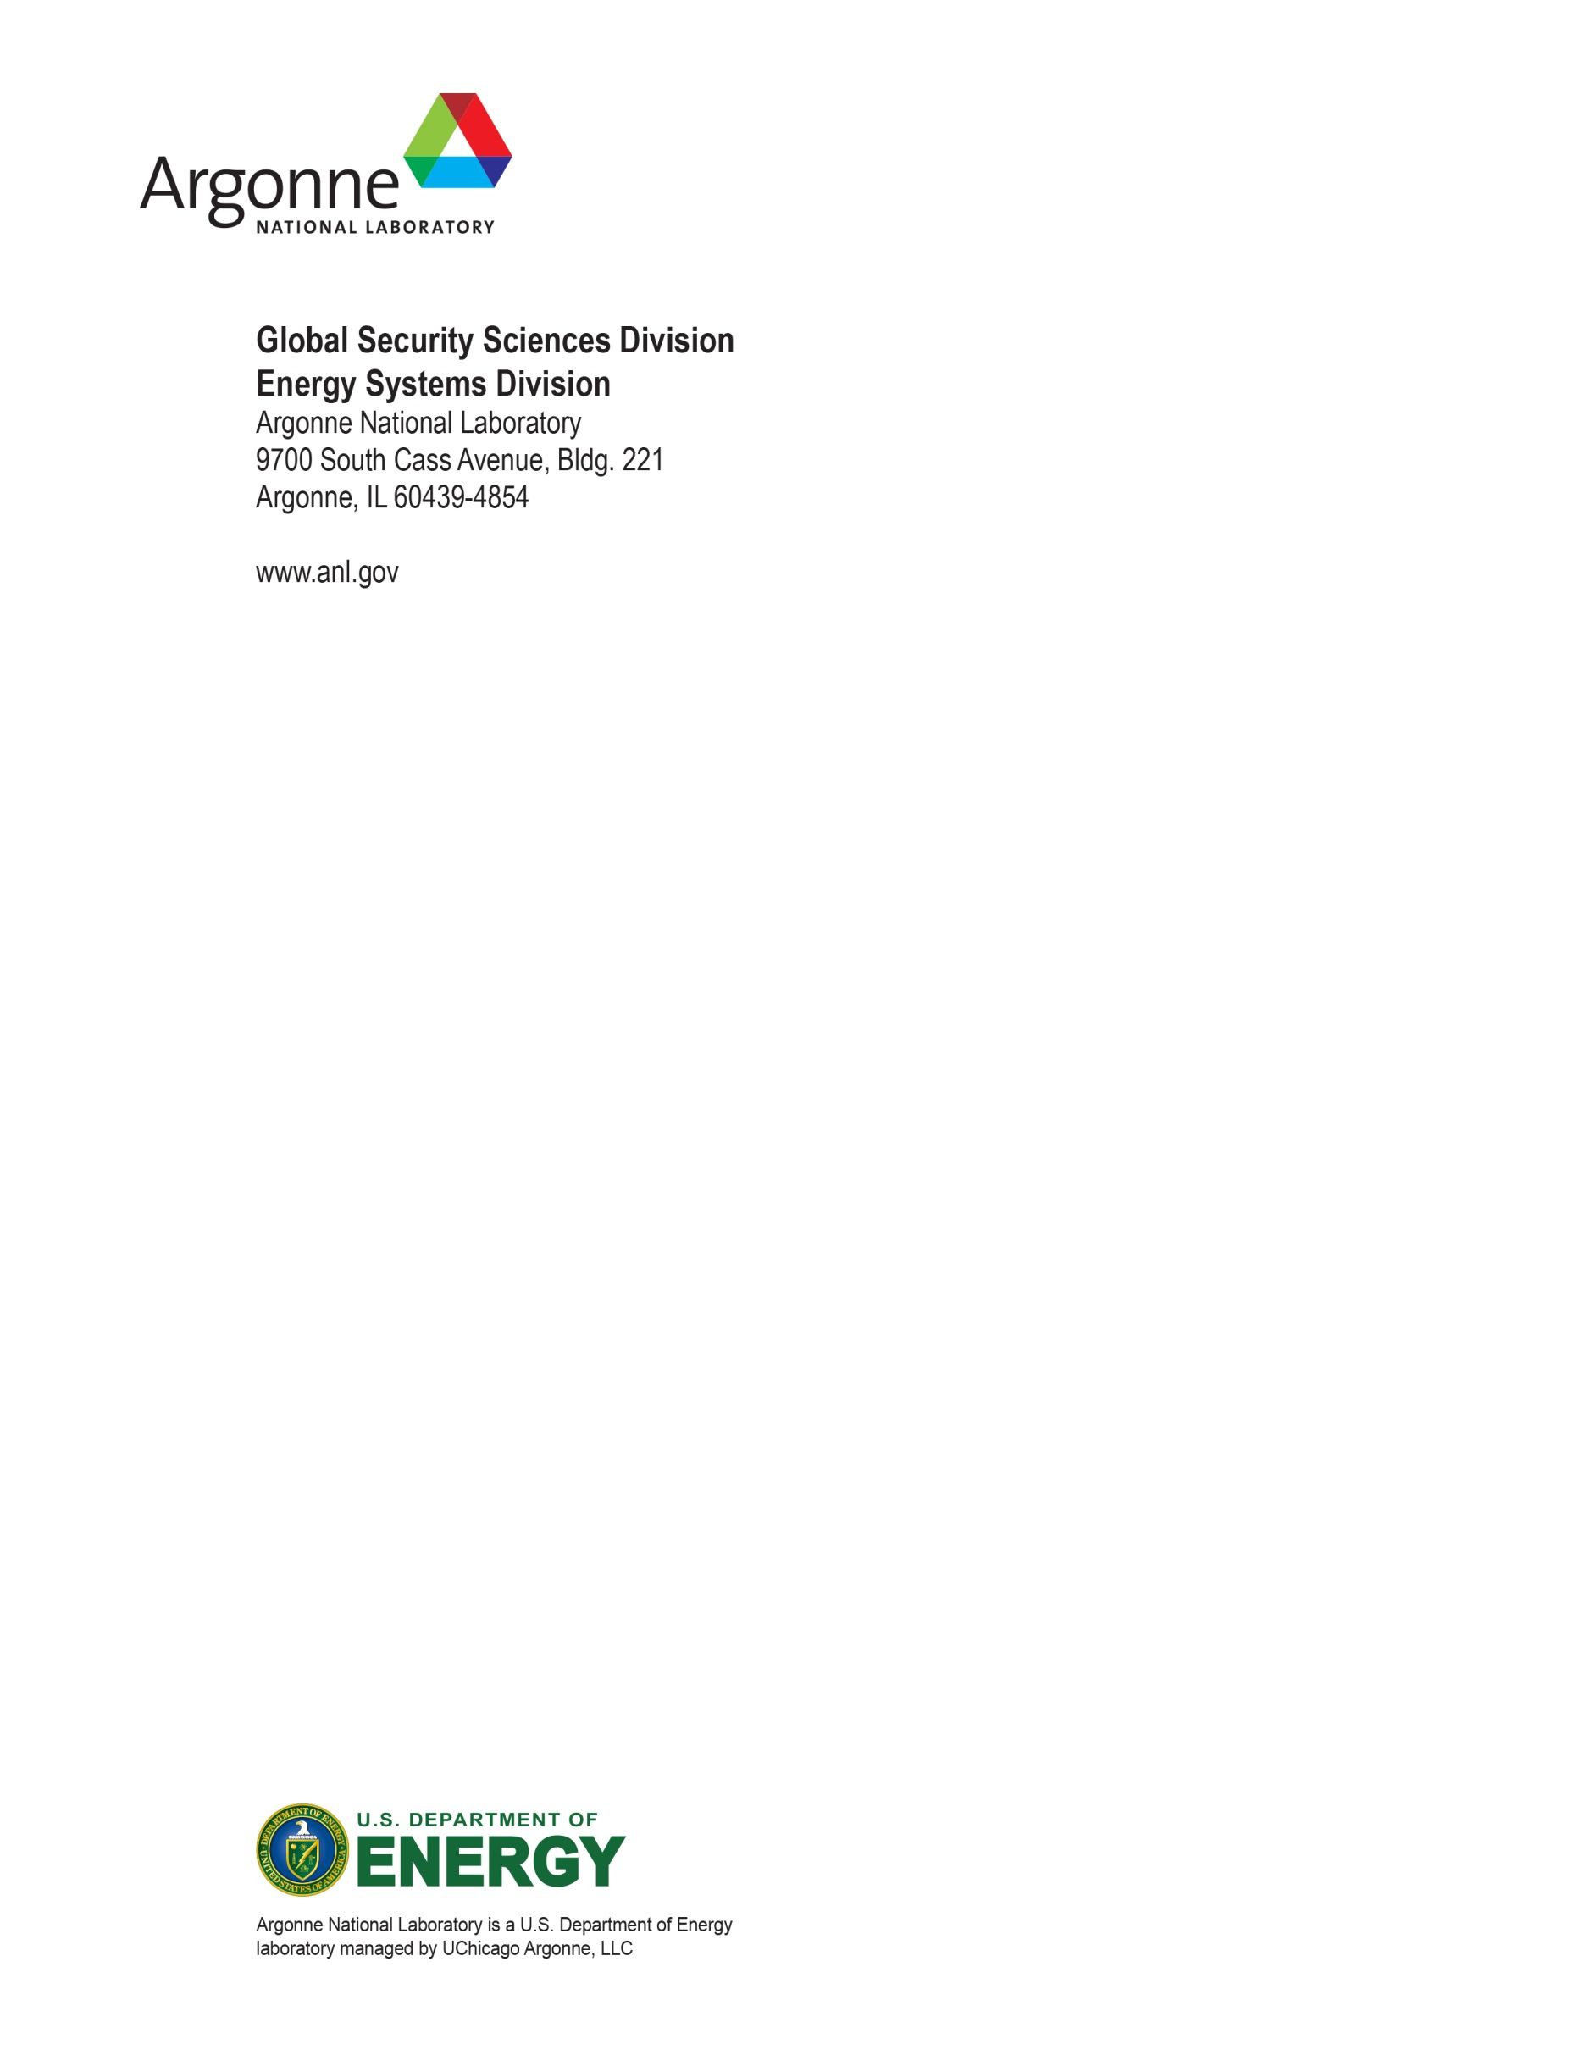

1. C.S. Palmer, S. Loftin, and B. Osiek are employed by the Western Area Power Administration Colorado River Storage Project Management Center, Salt Lake City, Utah.