- Overview of Proposed GCMRC Budget Adjustments
  - Q&A (10min)

- Project H & N (Brian Healy)
  - Note that Project N funds Brian and others’ salary
  - 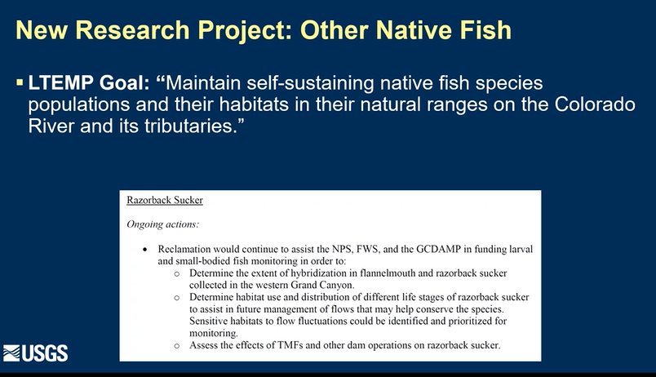
  - 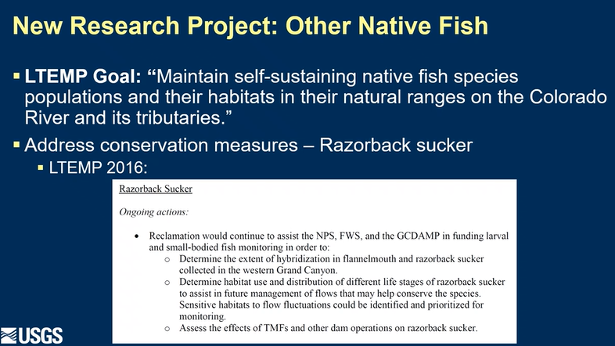
  - 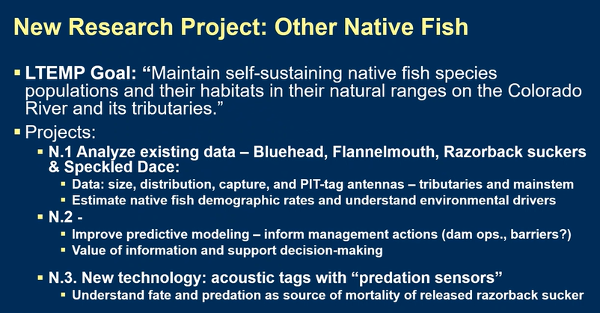
  - 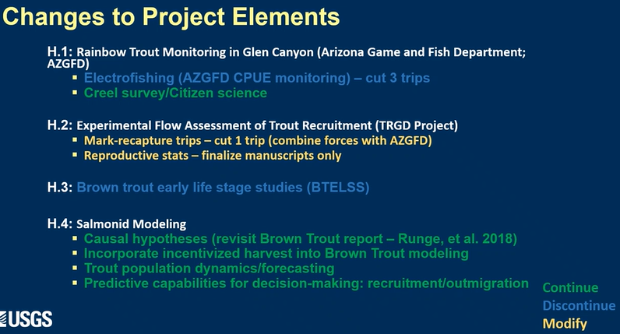
    - Had already cut down a lot for this project
      - Cut 4 of the 8 trips that had been going in the past
  - 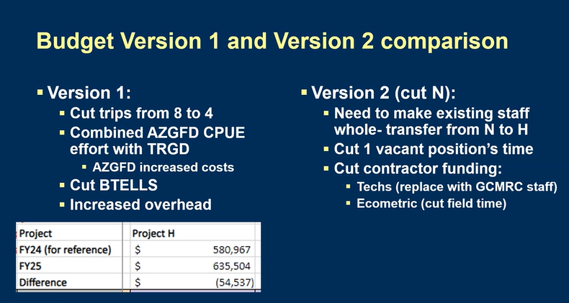
  - 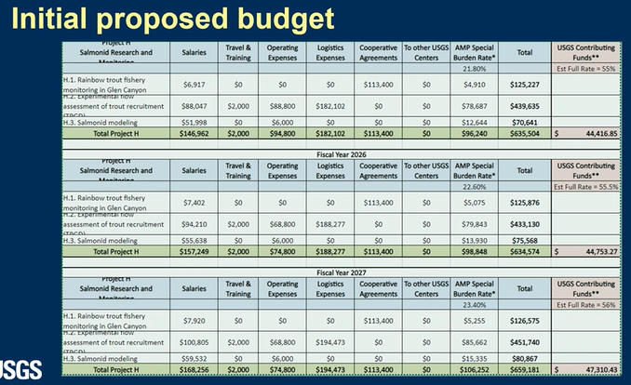
  - 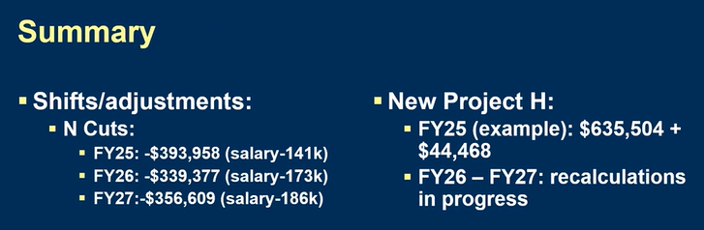
  - Q&A (10min)
    - Rob Billerbeck: I think for NPS we would hope that isn't yet final and we'd like to hear about project N
    - Bill Persons: don’t think the people we heard from Tuesday took the assignment quite the way
      - More interested in having a look at the full list and trying to prioritize in terms of information we need most right now
      - Not sure always agree with the cuts that were made
      - Brian Healy: choice would be to cut the third element of Project N, loss is knowing what happens to RZB suckers when released
        - RZB is ESA listed species, but could get to some of it w/ N.1 and using existing data
        - H project had a strong cut process prior to ARM. Would lose a lot more if we cut Project H.
        - Bill: Support N.1 and N.2
    - Emily Omana-Smith: support project N (particularly N.1 and N.2)
      - Your work to identify areas that could be cut is appreciated
      - Can you elaborate on areas that could be lost with budget cuts?
        - BH: presentation by USFWS using FlannelMouth as a surrogate for RZB
          - Using flannels might not be the best available science, could be something we could help to address
    - Ryan Mann: unable to attend Tuesday BAHG so trying to catch up on process
      - Concerned with the outlined proposed adjustments, particularly for these components
        - Support elements as outlined in N and H
        - Some cuts significantly affect the ability to analyze some of these cuts
        - Universal % cuts didn’t really work last TWP
    - Shana Rapoport: interested in Project N, would like to look at aspects we could include
      - Moving some N.3 into N.1
      - BH: can’t really combine w/ N.1, wouldn’t have the predation sensors that come w/ N.3
      - NSCP: there is a link there for sure
      - SR: wonder if there’s more cost saving from that collaboration
        - Up front equipment costs as long term investments?
        - BH: tags are annual costs

- Project C (Emily Palmquist)
  - 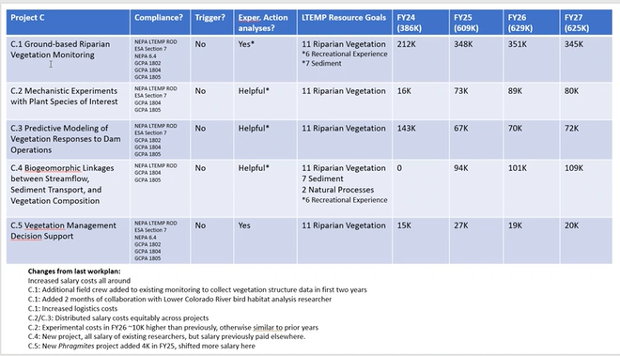
  - 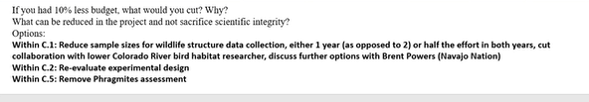
    - Hoping to get C? through external funding
  - 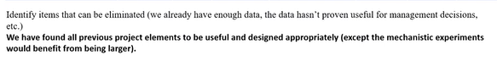
  - 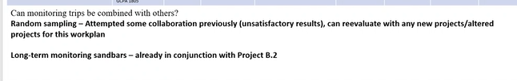
  - Q&A (10min)
    - Craig Elsworth: when we’re talking about compliance, we’re talking about “in a compliance document this project is stated”
      - Bill Stewart: not “need to know,” not really a black and white kind of thing
      - Brian Healy: I was involved in putting that spreadsheet together. DOI managers trying to relate the projects needs to the compliance requirements. Like all the compliance. Not just the BO and “thou shalts)
    - Bill Persons: concerned w/ large increase over FY24
      - EP: added some boats to monitoring which caused increase
        - Already don’t pay half the field crew, only pay for botanisits
        - Only have 2.75 staff paid for
          - Proposed TWP has .5 additional staff
    - Craig Ellsworth: appreciated the breakdown of staffing

- Project G (Charles Yackulic) (ends @ 3:50pm)
  - 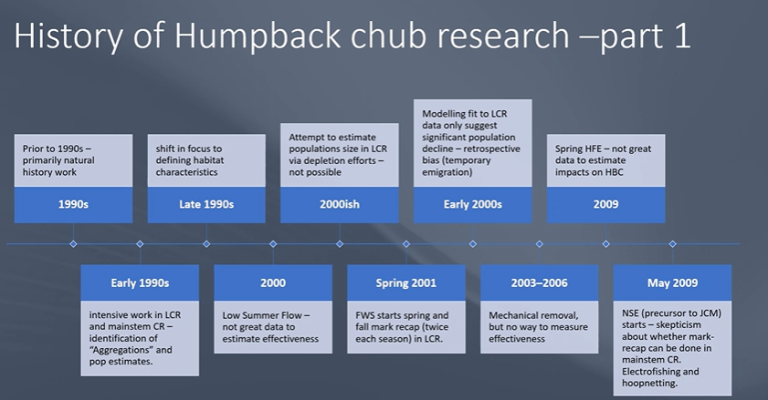
  - 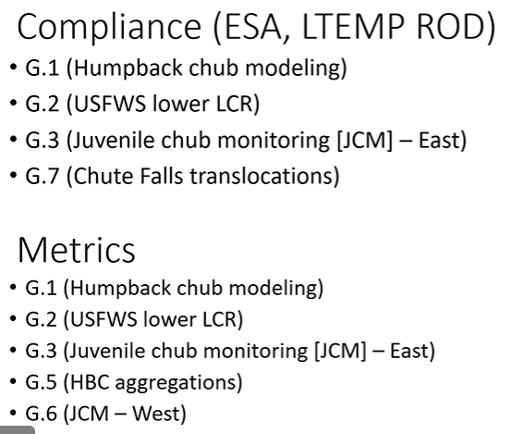
  - 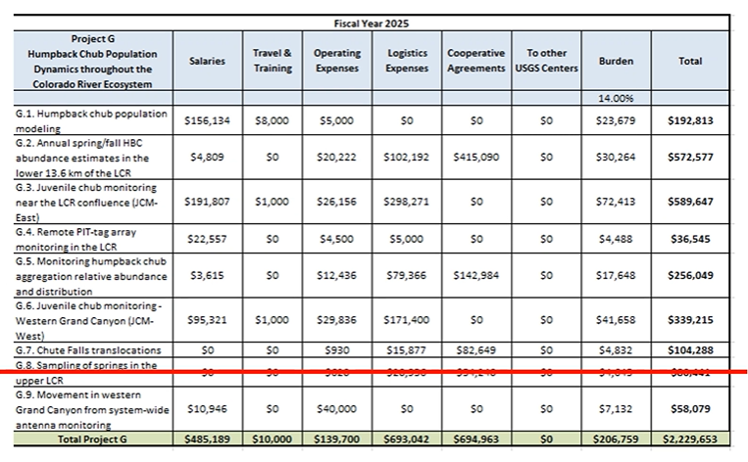

  - Q&A (10min)
    - Bill Persons: translocations are really a management activity, is there any way to shift those costs to a management agency?
      - Charles: some of it is monitoring the management activity, so some could go elsewhere
      - Andrew Schultz: looking at that across the board, it is on our mind
    - Kelly Burke – when you said you usually find outside funding, what does that look like when you’ve done it.
      - CY – yes, I do silvery minnow on the RG. But then people want me back for a crisis.
      - BH – not as easy for other PIs to get outside funding

- Project I (Kim Dibble) (10min) (Ends @ 4:10pm)
  - 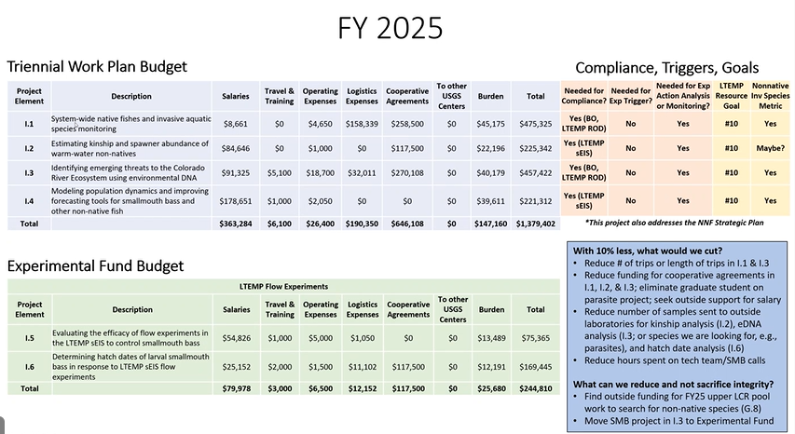
  - 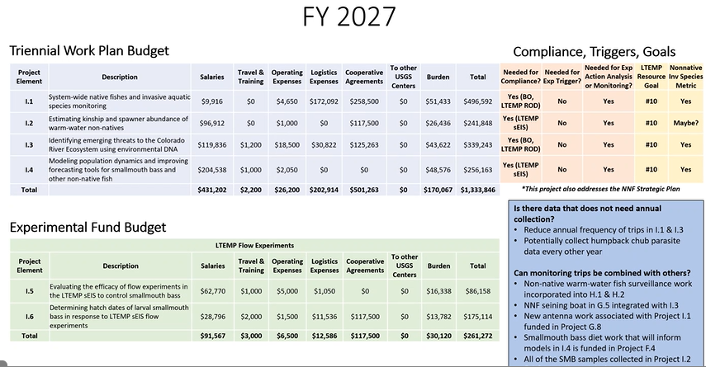
    - Flattening of Cooperative agreement and reduction in trips
      - Full system trip in the fall for invasives when water temp is highest
      - Some SMB related to experimental fund
    - IF budget reduced, could reduce trips
    - Could reduce samples sent to lab for eDNA
  - 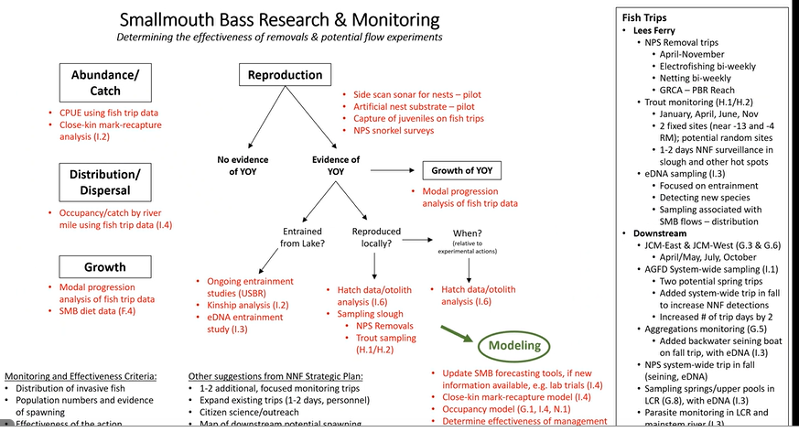

  - Q&A (10min)
    - What did we lose by not having 3 trips?
    - Not clear on all eDNA project relationships, does each project send in its own samples and have its own sampling trips? Can eDNA be combined across all projects?
    - Emily Omana-Smith: meeting next week to talk about eDNA
      - What efficiencies can we gain with folks doing all the eDNA work across the program
      - Did some backwater sampling last year and sent fecal samples to OSU, how does that compliment eDNA?
      - KD: I just got integrated into that group. Isaac Sherman (?) poster – where he presented some initial work on the eDNA from fecal (blue heads) and trout.
        - Looking at emerging threats, not microbiome and diet. They are having trouble teasing apart parasites from the items eaten. Stuck at the Order level.
    - Bill Persons: understanding is I.2 kinship analysis should help determine whether young SMB caught in Lee’s Ferry originate there or came through the dam. What’s the turn around on samples you’ve already submitted?
      - KD: 2022 kinship samples were sent in, prelim data came in, but has not been analyzed just yet
      - CY: admin snafoo caused delays, trying to set up new agreements for faster results
        - Kinship could be a little quicker, but requires more work
        - Have the 23 samples ready to go, waiting for funds to get in
    - Christina Noftsker: 10% less blue box reduces footprint of experimental fish lab
      - KD: lab at rocky mountain research station, so might make sense to reduce the footprint of that lab, though it doesn’t take a lot to run that lab
      - CY: USGS pays rent for RMRS as means to subsidize the program
    - Shana Rapoport: do we have a plan to develop combined reporting of non-native fish monitoring?
      - KD: those discussions haven’t happened yet, but we will provide someone to report out on those issues
        - Part of I.4 at this point

- Project M (Andrew Schultz, Mark Anderson) (10min) (ends @ 4:30PM)
  - 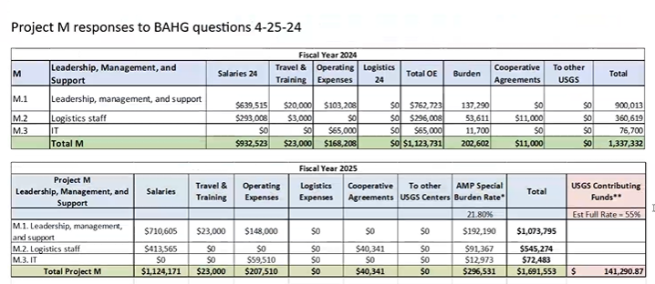
  - 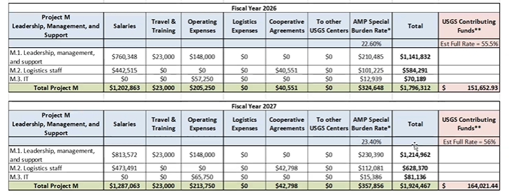
  - 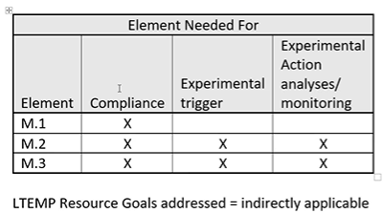
  - 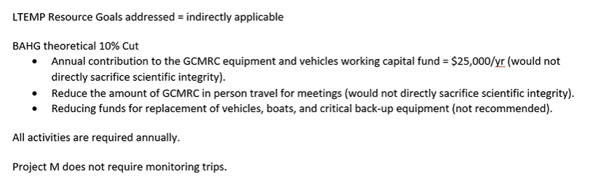
  - Q&A (10min)
    - Christina Noftsker: Estimate of what would be saved if TWG meeting went virtual instead of in person?
      - AS: Maybe 3% of total budget
    - David Ward: other people covered in Project M, data science, and other salaries
      - Wondering about the value added of those other individuals
      - .5 salary of PI, why not to specific project?
      - AS: not covering all of the salary, USGS is covering half as well
    - Rob Billerbeck: why is there an increase from $1.3 to $1.9, seems like a lot
      - AS: salary and logistics went up significantly, but didn’t have full staff until now
- Additional Discussion
  - Count of compliance weighs heavily in the Proposed Adjustment
  - Bill Persons
    - Some misunderstanding of how the budget spreadsheet was built and is being used, where do you think we should go next?
    - AS: Regarding the next draft of the TWP document due to BAHG/Science Advisors/DOI/tribes on 5/28…are the BAHG and TWG OK with submittal of a budget that is within 20% of the expected allocation ($10M) vs one that is under or close to budget? For what it’s worth, GCMRC leadership recommends the former, as it will allow for more back and forth as we work together to decide what science should be funded and what science the program can live without for now. Further, such a stepwise approach may allow the program to incorporate feedback from the Science Advisors in decisions on scope/budget (when applicable).
    - Want to make sure that this discussion continues
  - Erik Stanfield: consider ethics of certain monitoring practices
  - Shana: Curious how other agencies handle Adaptive Management Programs?
    - Bill Stewart: larger question and discussion to be had
- Next Steps
  - GCMRC Info Request
    - Copy of Slides from presentations for 4/23 and 4/25
    - Have GCMRC update Adjustment based on:
      - Where cuts can actually be made as presented to the BAHG 4/23 and 4/25
      - BAHG Comments during the 4/23 and 4/25 meetings, along with the written comments in the TWG Survey
      - Incorporate LTEMP Goal Results from TWG Survey
      - Include Experimental Fund Projects (as BAHG must still discuss BOR Initial Draft)
    - GCMRC should identify what projects are eligible to/currently receive outside funding
    - If possible, it would be helpful to receive information on who is funded by which projects, and what % of their time goes to each project/program
      - Full time vs. term
    - Compliance should site specific BA/BO/NHPA/LTEMP Environmental Commitments requirement
  - BAHG Survey Due May 1st, same questions as TWG Survey
  - 5/7/24 to Discuss BOR TWP & BAHG Survey
  - Think of what we want the SA to look for in the 2nd Draft

