- Quick Intro (5min)

- Overview of Proposed GCMRC Budget Adjustments (10min)
  - Q&A (10min)
    - Can you share compliance metrics?
      - AS: yes
    - Bill Persons: how did you convert those indexes to $/need and cost/compliance. Have you talked with staff, or is this an engineering exercise?
      - AS: told them not to work off any numbers, but they are aware and you will be hearing of how these cuts affect the science
        - Staff has not had chance to work any of this proposal through at the moment
    - Shana Rappaport: how does GCMRC check projects for cost effectiveness, don’t want PIs to pad budgets knowing that this is coming?
      - AS: we assume people aren’t padding their budgets, we will still need to do a deep dive and figure out what needs to be cut

- D & L: (Joel Sankey, Helen Fairley) (10min)
  - 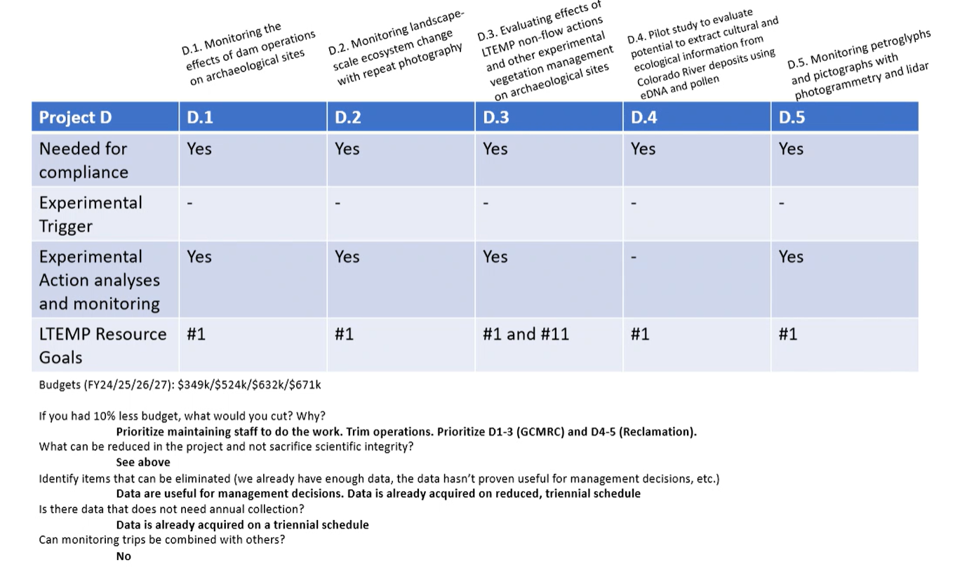
  - 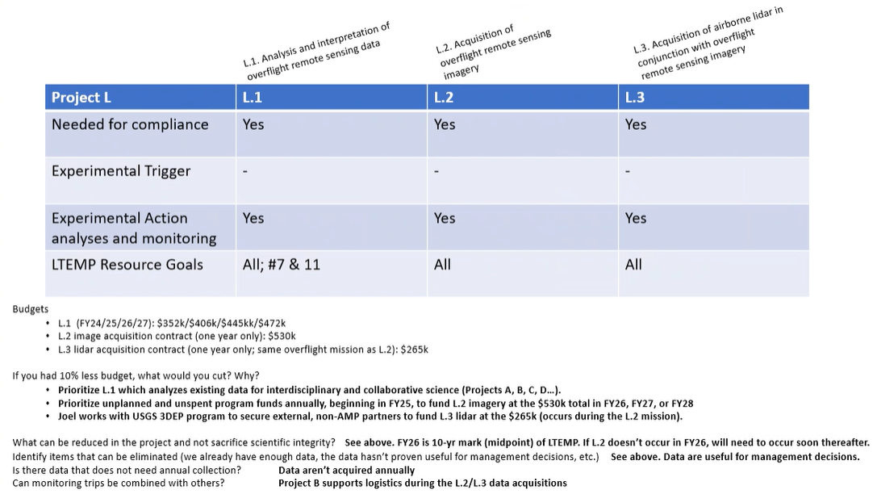
  - Q&A (10min)
    - Bill Persons: did you take a look at the comments in the TWG surveys, maybe take a look and see if you can address them (ask for all of the PIs)
      - Shana: echoes this request
      - In all of these projects there are some drastic cost increases, can you identify the major source of those increases?
        - JS: staff are shared positions (listen to recording)
          - No new staff
          - 2 permanent staff

- E (10min) (Charles Yackulic/Ian Bishop)
  - 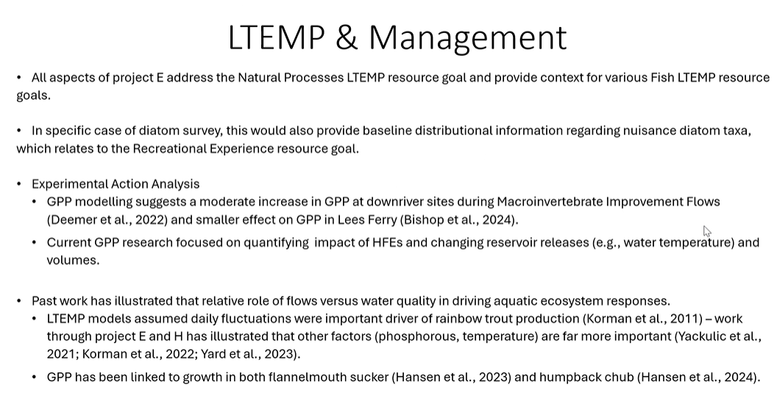
  - 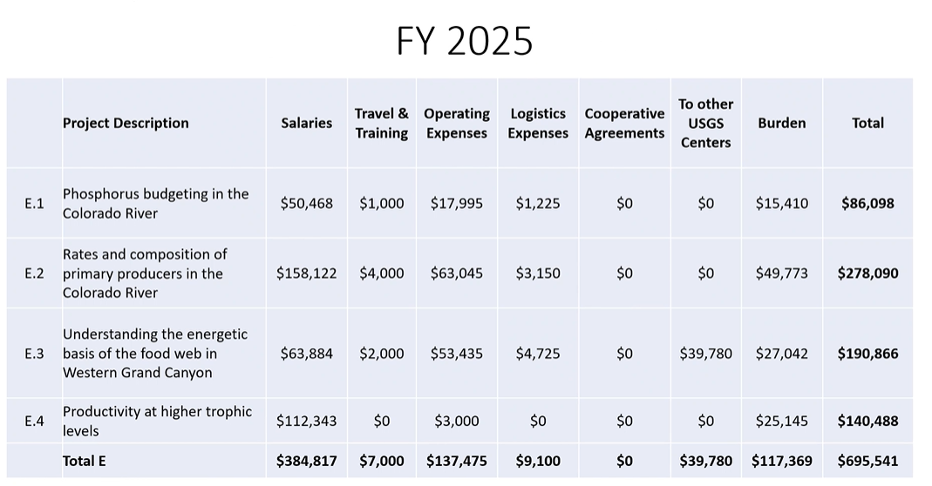
  - 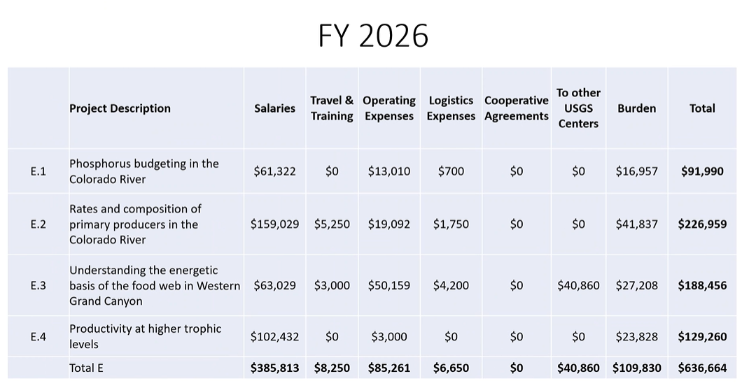
  - 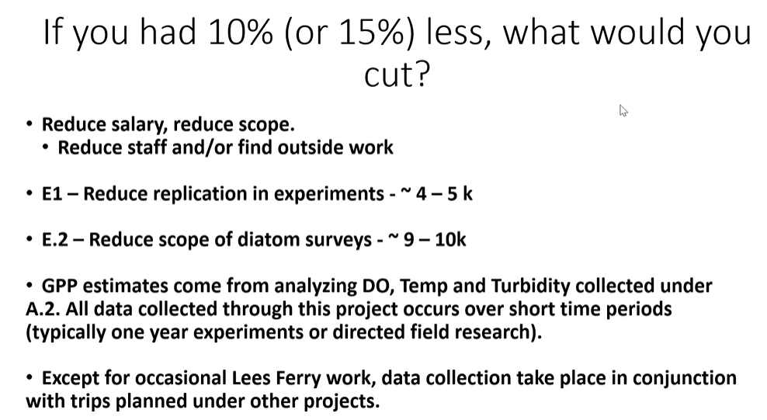

  - Q&A (10min)
    - Bill Persons: surprised at “nice to know” not “need to know”
      - Key driver for aquatic ecosystem
      - Primary production
    - Charles Yackulic: redirected to work on DO, temps, SMB, haven’t been reminding folks as much about GPP links as much as in the past
    - Jim Strogen: think there is a great need for folks to learn more about phosphorous
    - Christina Noftsker: do we have many tools to increase P, is it something we can get our arms around?
      - Charles: WAPA funded a study of whether you could do fertilization
        - Do know it is higher at lower reservoir elevations, and may change dynamics when lower elevations are considered moving forward (post 2026 considerations may have a large influence)
        - One of the reason we want to get a handle on P, if you don’t measure the major driver you end up ascribing results to something else
          - (RBT recruitment assumed to be influenced by things other than P, which was the major driver)
    - Shana Rapoport: can you talk more about what we’d lose if E.3 is cut?
      - CY: how many fish are now in WGC compared to how many there used to be?
        - Provide some context on RZB sucker population declines, and whether we could expect the same for HBC based on carrying capacity
      - SR: what would it be to scale effort back rather than $0 out?

- F (10min) (Morgan Ford)
  - 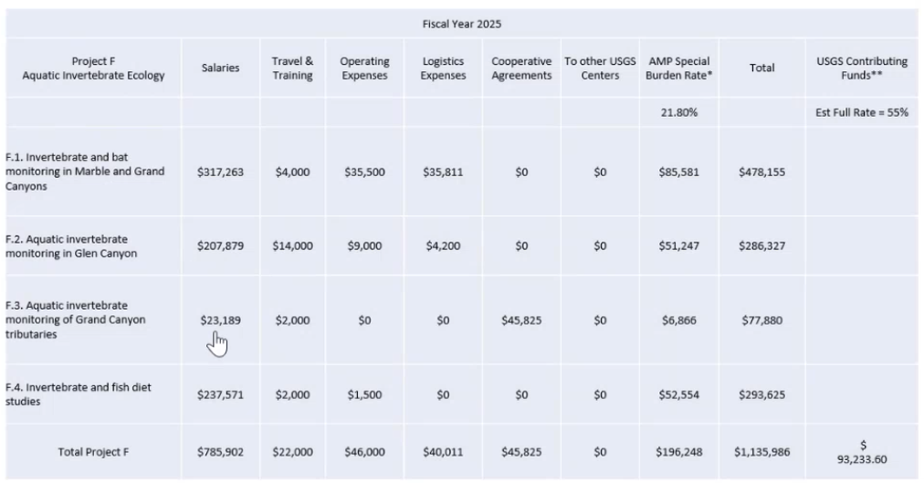
  - Potentially invertebrate drift trips & GC tributaries
    - Might be a way to cut some of those dollars
  - Aquatic invertebrate is monthly
    - Pairing with TRGD best indication of fish condition
    - In the Tributaries can be put towards the back burner
  - Cooperative agreements in F.3 may also provide some space to cut dollars
  - Fish diet important
  - Q&A (10min)
    - Why is bat monitoring important to continue and how does it help us make management decisions in the system?
      - Morgan: the emergent stage provides food to birds, bats, and lizards. Bat component shows us how river impacts terrestrial species
        - Bat pads in community science program
          - Relatively inexpensive part of the monitoring
          - Low hanging fruit
    - Bill Person’s: gammarus drift?
      - Morgan Ford: we have started seeing lower numbers in glen canyon/lee’s ferry (stable by the dam)
    - Erik Stanfield: importance of these projects is that expand us out into the whole ecosystem approach (tribal preference)
      - Community science are good models as they are lower cost and show community learning
        - Basing a bird study off of bat process
    - Jim Strogen: how long does it typically take to process stuff?
      - Morgan: 4 hours/sample for lee’s ferry reach, lower reach takes longer due to additional “coffee grounds” suspended in the sample
        - 6-11hours for lower reach samples
      - JS: if data collected 2024, do you have the data to analyze in 2025 or 2026?
        - MF: good question, it varies
    - David Ward: what would be lost if you were to not send the $45k to Oregon State?
      - MF: big thing would be eDNA work (this is the 4th year)
    - Kim Dibble: eDNA from fecal samples of fish
    - Rob Billerbeck: Are there and results from 2 years of eDNA research yet?
      - MF: yes, they have been providing some compelling evidence

- A (David Topping) (10min)
  - Project is Salary heavy
    - 15% across the board Reduction would not work for this project.
  - Would start decommissioning gaging stations
  - WQ Specialist was rehired for FY24, so the jump from FY23 to 25 is that staff member
  - Not so much change in work
  - Some permanent salaries moved out to other projects
  - Could maybe cut $50k from budget by decommissioning gages
  - Need USGS (not GCMRC) to step up and provide salary outside of this program
  - Database and website moved to project K
  - Could maybe save a few 10s of thousands
  - Convince someone at the Main USGS to fund salaries instead of having the GCDAMP pay salary

  - Q&A (10min)
    - Colleen Cunningham: don’t quite understand the reasoning this program pays entire salaries
      - Going forward, is that something we need to think about?
        - What % should be paid by the program, and what should be paid straight through USGS or other project work?
      - David Topping: real problem that USGS doesn’t cover salary
        - CC: big problem moving forward as administrations may not deem certain things unimportant moving forward
        - DT: every center director has tried, might be worth coming from the stakeholders themselves
        - CC: agree, but there also shouldn’t be the assumption that things in this program will go on forever
    - Andrew Schlutz: continuing to try to secure funds for staff as much as possible
      - Term heavy, not all permanent staff
      - Doesn’t take away from previous points, just wanted to point that out
    - Charles Yackulic: historical context: original idea was that USGS would kick in permanent salary, but the burden and overhead rate would have been increased

- B (Paul Grams) (10min)
  - 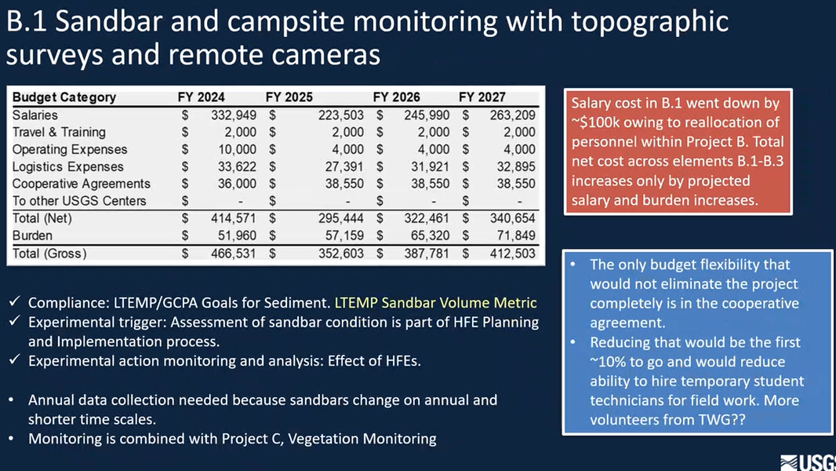
  - 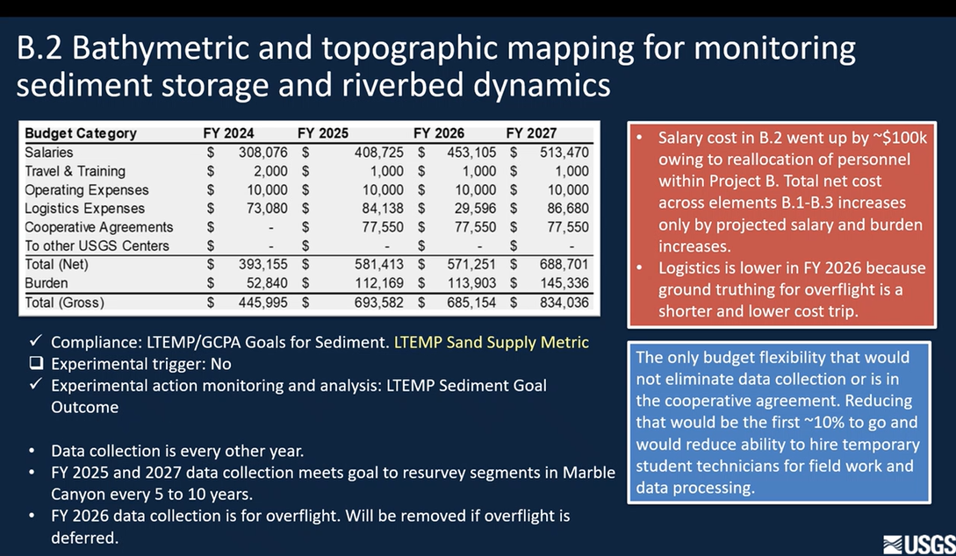
  - 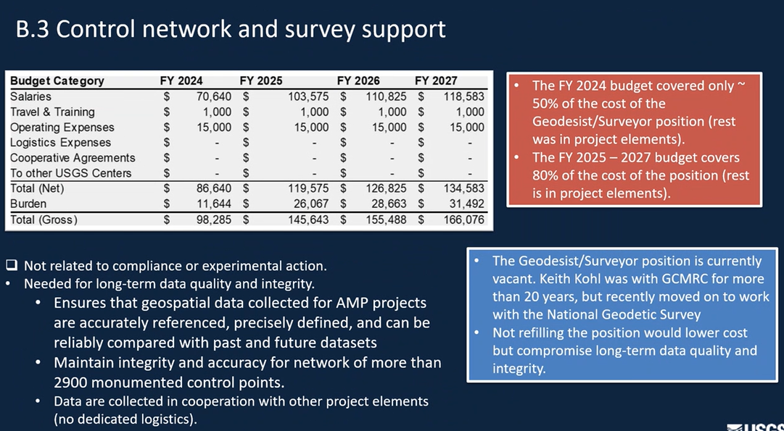
  - 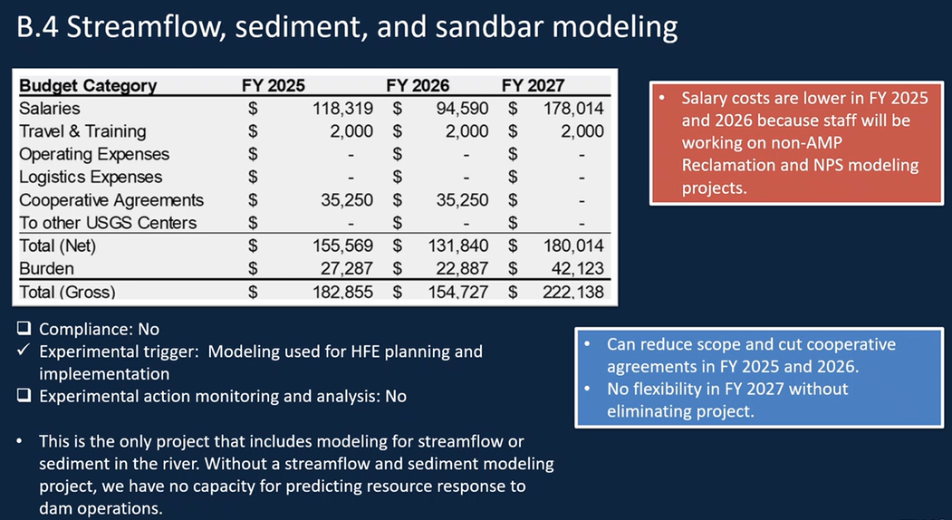
  - Q&A (10min)
    - Cooperative agreements are effectively contracting out the work
    - Bill Persons: bathymetric mapping
      - Don’t understand the need other than we need to know how much sand is in the system
      - If we knew there was unlikely an HFE in a given year, what would happen if we didn’t collect bathymetry?
      - PG: Bathymetry not tied to HFEs, not done annually. More tied to scale of LTEMP, have 1 trip in this new TWP
        - Annual sandbar modeling is due to the rapidly changing system
      - BP: Maybe question of how much precision we need?
        - Paul: what we’re doing is one rowing trip a year, annual data collection is a central part. Don’t think it’s overkill.
    - Erik Stanfield: made some mention of TWG volunteers
      - Can we think more broadly of TWG volunteers for all projects?
        - Do we need to devote additional effort to recruiting volunteers?

- J (Lucas Bair) (10min)
  - 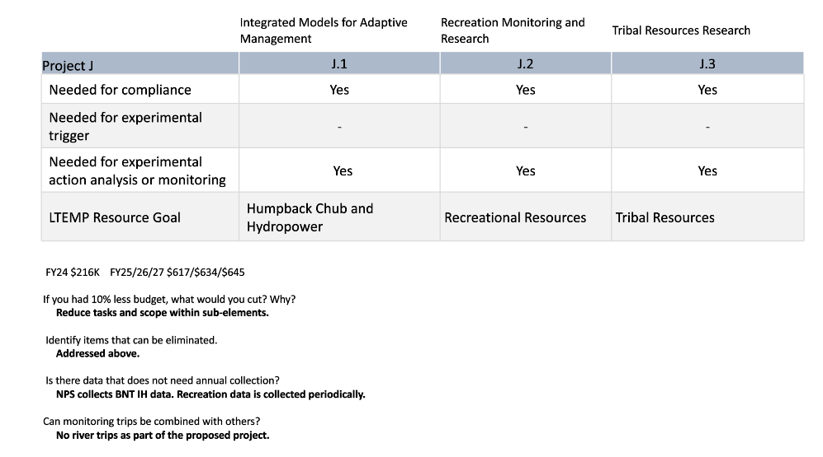
  - Only one permanent employee

  - Q&A (10min)
    - David Ward: money going to other USGS centers, what is that for?
      - LB: would hire out other USGS centers that have expertise as this project only has one full time staff
    - Leslie James: identify $ for hydropower and VoI?
      - $40k for the hydropower component
      - $120k for VoI
    - Bill Persons: There are other tools available to evaluate value of information to the program - the LTEMP work by Runge seemed to greatly help that effort. Jerry (Western) mentioned looking at decision support under conditions of high uncertainty which seems to be the situation we are in. I think this program could benefit from a more structured decision support program within the Adaptive Management framework.
    - Clarification on metric requirement: is it required or something that AMWG asked?
      - LB: not entirely sure

- K (Thomas Gushue) (10min)
  - 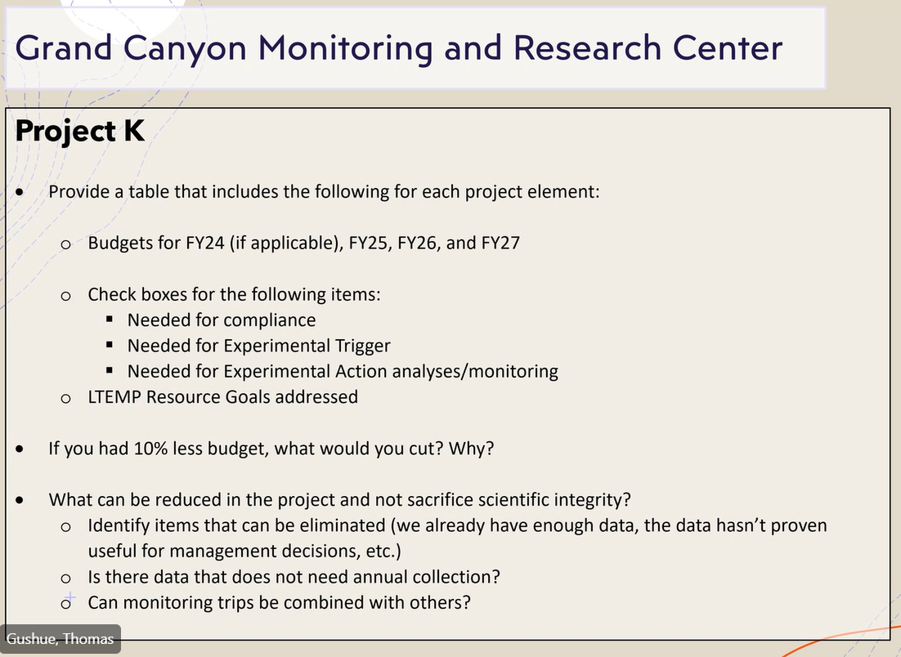
  - 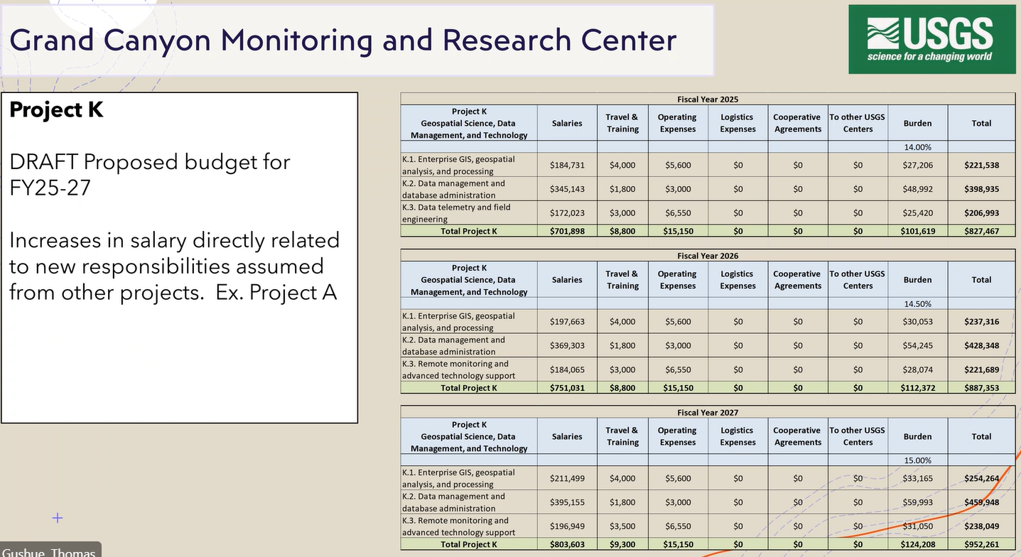
  - 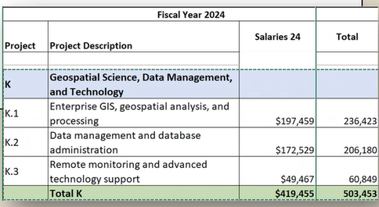
  - 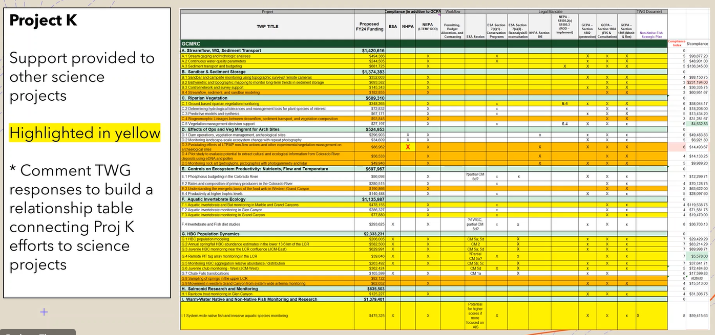
  - 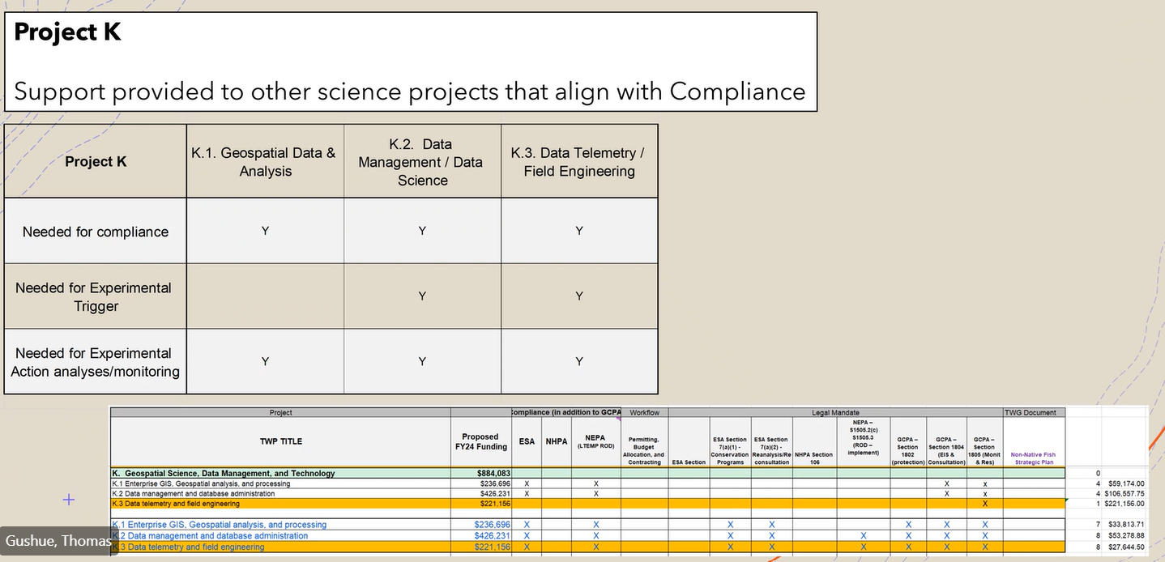
  - 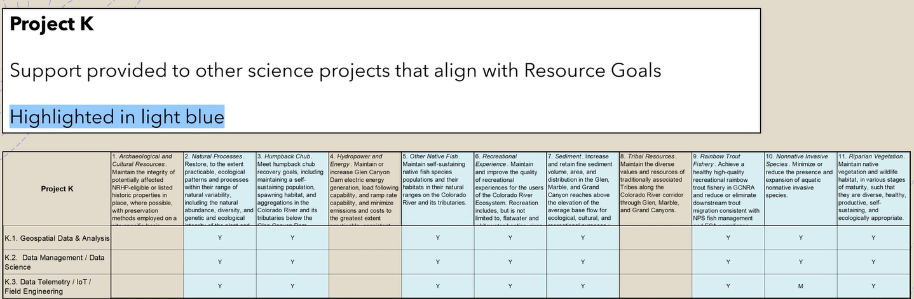
  - 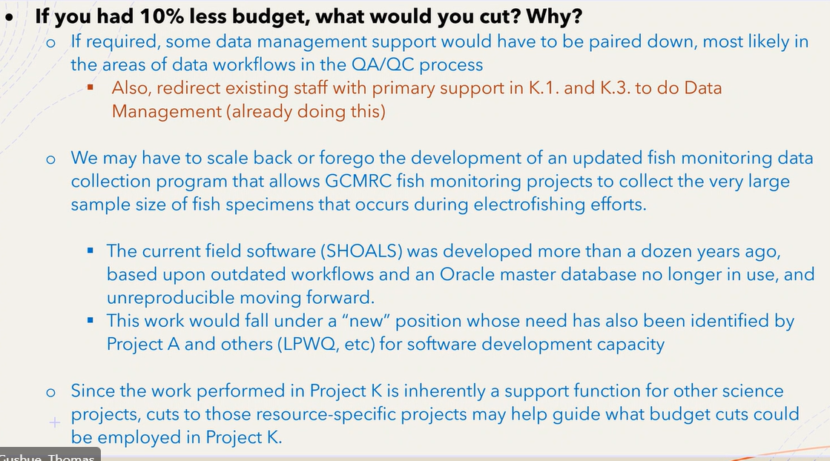

  - Q&A (10min)
    - Andrew Schultz: position that was supporting A also supports the rest of the center
    - Christina Nofstker: is burden rate different?
      - AS: typo in the slide, that was prior to DOI adjustment in 2024

- Additional Discussion (15min)
  - Leslie: When the question of "compliance" is addressed, please distinguish between a specific BA/BO/NHPA, etc. requirement. Of course this entire program is intended to be compliance with overarching "authority" laws such as GCPA, CRSPA, Law of River, etc.
  - Leslie: what is the metrics project being required by, for, or who?
    - Charles: going to hazard a guess, as part of LTEMP it said shall develop metrics that will be tracked going forward to provide input on how well management is meeting its goals
- The GCDAMP priorities are set by the GCPA of 1992, the LTEMP FEIS, and ROD, and related mitigation requirements for endangered species and cultural resources. The GCDAMP priorities include the management and experimental actions; mitigation and environmental commitments; and research and monitoring identified in the LTEMP FEIS and ROD, and these will be the highest priorities for the GCDAMP over the term of the LTEMP. The GCDAMP activities that are eligible for funding from power revenues are those actions related to dam operations or the mitigation of dam operations within the CRE. These will be funded in compliance with Section 204 of Public Law (PL) 106-377. Appropriated funds or other sources of funding may also be used for GCDAMP activities as specified in Section 1808 of the GCPA and Section 204 of PL 106-377.
  - Bill Persons: if we have objectives, we must have a way to measure those objectives
  - Craig: RE: SA: you get out of something what you put into it
    - Hopes BOR picks good people
  - Charles: with the PEPS, some of them are worthwhile regardless of their experience
  - David Topping: PEPs process won’t help due to the salary problem with permanents
    - Instead of forcing the PEP process upon everyone, has to be a conversation b/w stakeholders and USGS/Center leadership
- [4:54 PM] Billerbeck, Rob P
  - i think Charles makes a good point that the projects all probably have great scientific value and are well designed studies, but maybe the question we have to wrestle with is how applied is that info for management or mitigation related to dam ops under GCPA?
- [4:55 PM] Bill Persons (Unverified)
  - Would it be appropriate to include a few Protocol Evaluation Projects in the FY25 workplan?
- Deb Williams: Another thought may be a Structured Decision Making approach

- Does the BAHG want to put forward the proposed GCMRC Budget (presented to the BAHG 4/23 and 4/25) to the Science advisors to let them help us pair it down?
- Is there anything that stands out that needs to be tweaked prior to the draft going to the Science Advisors?
- What specifically do you want the Science Advisors to look for?

