BAHG Call #3: Humpback Chub/Native Fish, Rainbow Trout, & Vegetation (Projects C, G, H) 02/13/24
NOTE: All dollar values are from the FY24 Budget
- Project C: Riparian Vegetation Monitoring and Research ($339,147) Emily Palmquist
  - The purpose of this project is to monitor the status and trends of riparian vegetation, examine mechanisms behind trends in riparian vegetation change as they relate to LTEMP flows, and apply existing and new knowledge to LTEMP vegetation management. The four elements of this project assess riparian vegetation status in the Colorado River Ecosystem (CRe), test mechanisms by which flow regime impacts species of interest, synthesize data to anticipate changes to vegetation, and assist nonflow management actions directed by the LTEMP. Full Description on page 135 of the FY21-23 TWP.
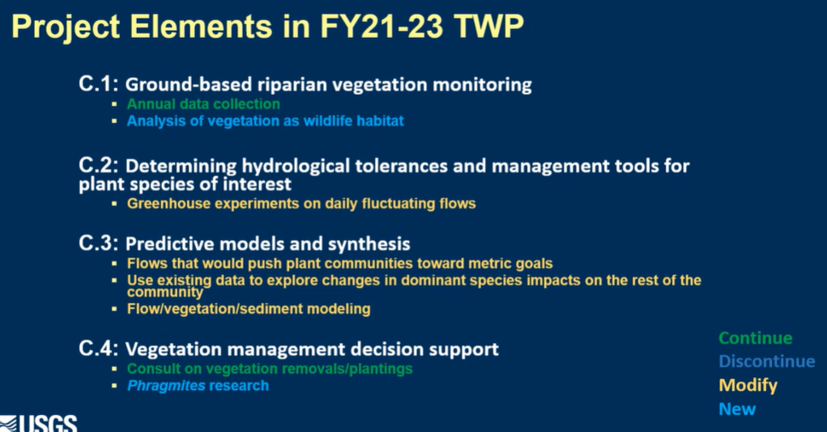
    - C.1 Ground-based riparian vegetation monitoring ($169,062)
      - Adding analysis of vegetation as wildlife habitat
      - In response to not addressing wildlife habitat part of LTEMP goal
        - Using first part of workplan to develop monitoring and research/questions

    - C.2 Determining hydrological tolerances and management tools for plant species of interest ($12,012)
      - Anticipating first year as growing the plants and acquiring needed equipment
      - Considering if there is a way to combine this with field experiments
    - C.3 Predictive models and synthesis ($143,022)
      - Want to dig into what change in bacarus and tamarisk will do to broader vegetation diversity
      - Half a page and a half of workshopping for ideas for flow/veg/sediment modeling, trying to figure out where to put this in the workplan (interdisciplinary studies)
    - C.4 Vegetation management decision support ($15,051)
      - Adding Phragmites research
        - Genotype for invasive vs. native phragmites
        - Would need to talk about what the broader group would like to do IF the non-native lineage is present in the canyon

  - Discussion
    - Larry Stevens: historical perspective: vegetation has transitioned from tamarisk dominated to wasteland of habitat
      - All in favor of habitat approach
      - Challenge in this system is NPS “conserve natural state”
        - No consensus on what exactly that means
        - Need NPS fully on board for any management actions recommended from GCDAMP
      - EP: would it be useful in habitat studies to think of questions along the lines of “What will the habitat be if we leave things the way they are vs. what would it be if plant communities are altered?”
        - LS: imagery might be a way to broach that subject, status quo, invasive species, non-native phramgites

    - Seth Shanahan: don’t see aerial mapping, is that because ground is more useful?
      - EP: imagery still important, ground based gives info in the interim
        - Aerial is good at looking at landscape changes in large areas
        - Ground based better @ shorter term scale changes
        - Aerial in imagery project
      - SS: focus on wildlife and partnering w/ Navajo, will that be BOR of GCMRC?
        - Bird data on BOR side
        - Coordinating efforts for bird data with BOR
      - SS: should be a metric for wildlife habitat
        - EP: can add that component
    - Dan Leavitt: wildlife habitat is a large concept: would challenge to think of it like native veg and look at functional groups
      - Leverage data to further our current understanding
      - Value in answering questions
      - EP: discussed a lot of concepts at this point, haven’t gone into how wildlife side is being handled right now
        - Do like the idea of thinking about functional groups
      - DL: it’ll be a long iterative process
    - Christina Noftsker: were cottonwoods present pre-dam?
      - EP: yes, there were in pockets, goodings willow was more common than Fremont cottonwood

- Project G: Humpback Chub Population Dynamics throughout the Colorado River Ecosystem ($1,594,535) Maria Dzul (Jewell)
  - This project is mandated by the 2016 Biological Opinion associated with the LTEMP, while focusing research on improving our understanding of abundance and the drivers of humpback chub population dynamics throughout the lower CRe. Full Description on page 231 of the FY21-23 TWP.
    - G.1 Humpback chub population modeling ($150,929)
    - 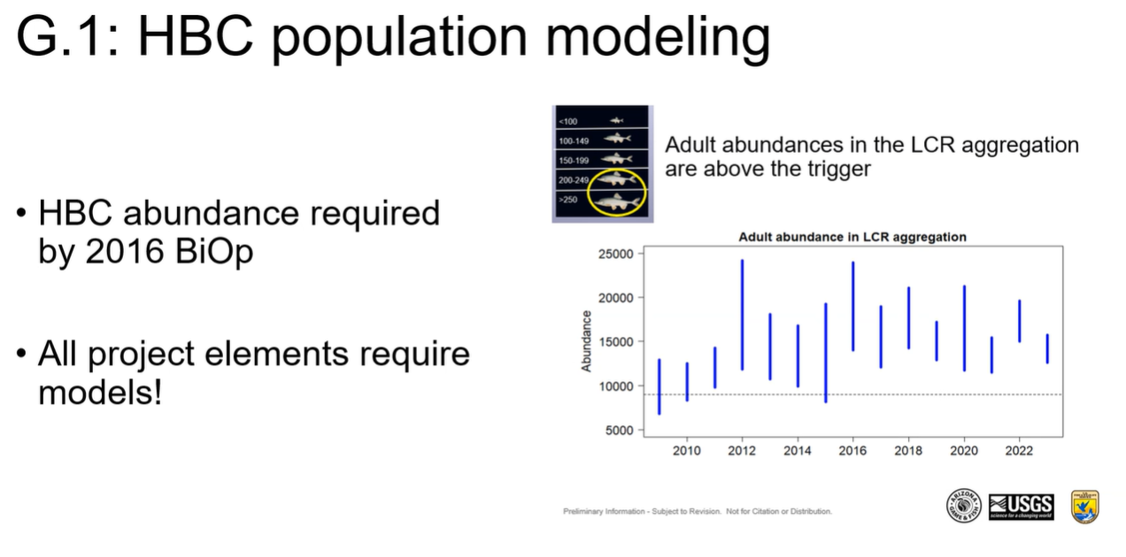
    - G.2 Annual spring/fall HBC abundance estimates in the lower 13.6 km of the LCR ($526,083)
    - 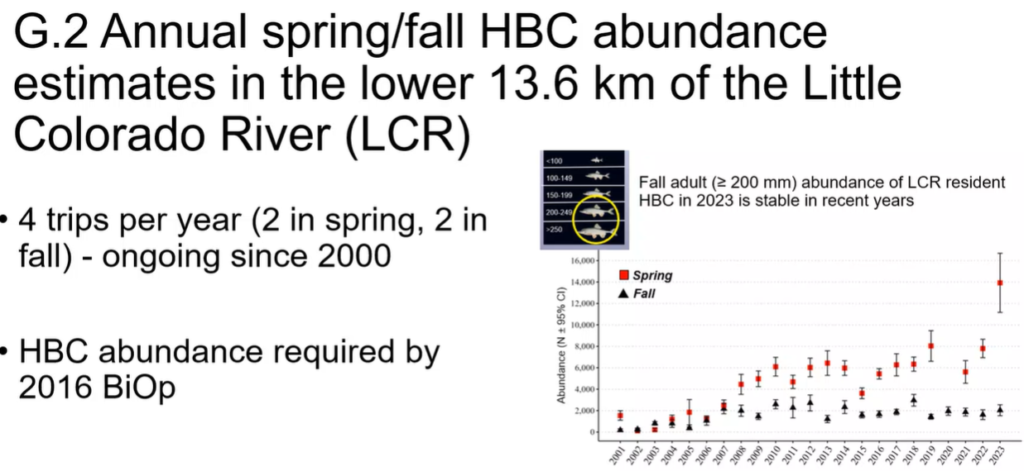
    - G.3 Juvenile chub monitoring near the LCR confluence (JCM-East) ($530,907)
    - 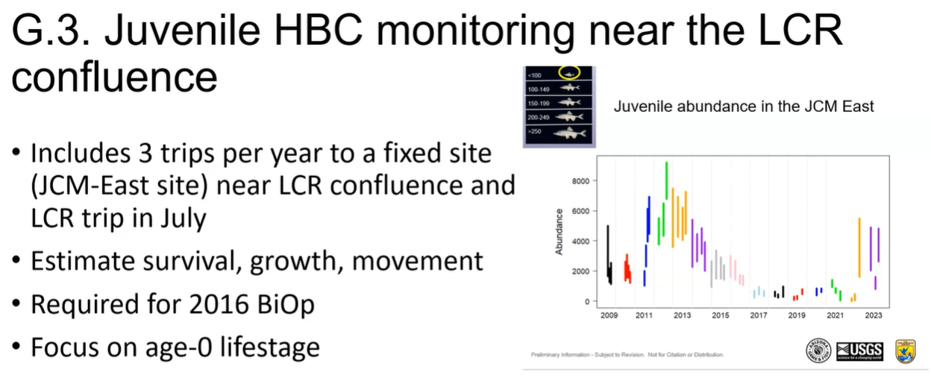
    - G.4 Remote PIT-tag array monitoring in the LCR ($75,569)
    - 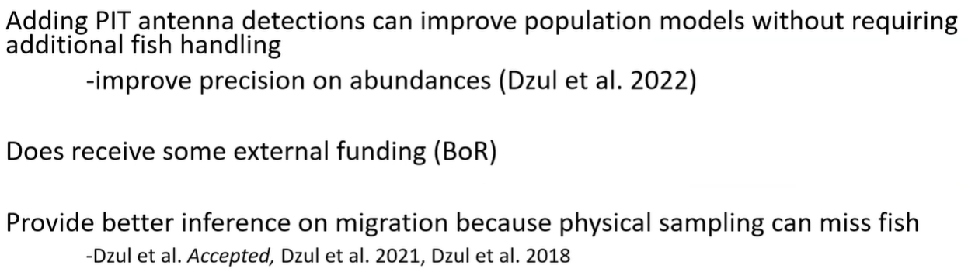
    - G.5 Monitoring humpback chub aggregation relative abundance and distribution ($210,348)
    - 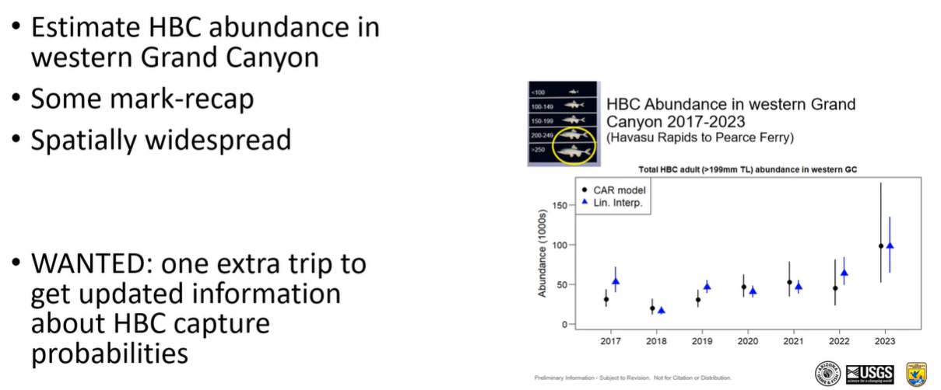
    - G.6 Juvenile chub monitoring - West (JCM-West) ($0)
    - 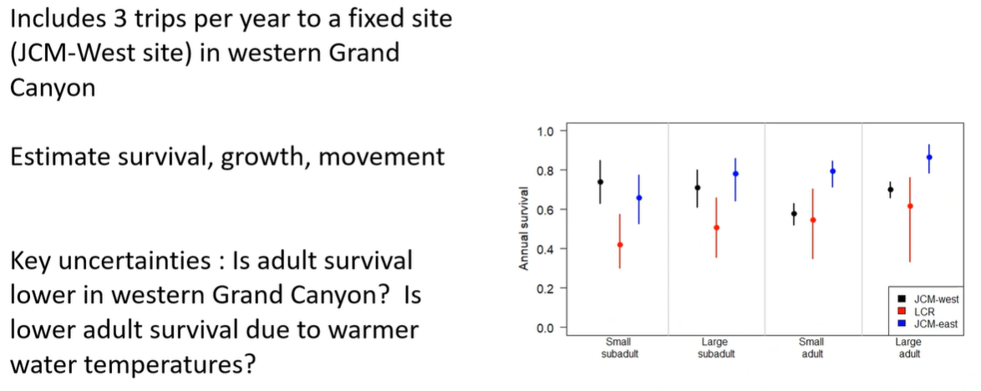
    - G.7 Chute Falls translocations ($100,699)

    - Not seeing elimination of any project elements
    - 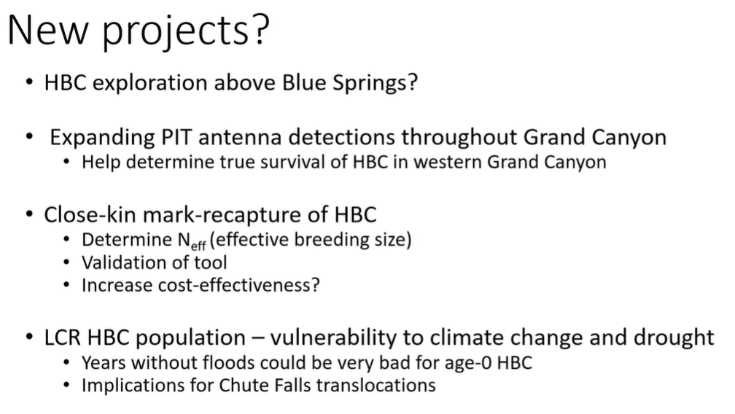

  - Discussion
    - Brian Hines: for new pit tag detection, are you looking at mobile or more self contained methods?
      - MD: looking at something more portable, especially if they are going on other projects
        - Something to deploy overnight
        - Hoping to add to trips that are already going out
    - Seth Shanahan: with submission of SEIS, are there components that reflect on Maria’s workplan that we should know about?
      - Bill Stewart: what is being proposed is covered in terms of triggers
      - SS: would be good to know what needs to be done vs. what we want to be done
    - Larry Stevens: is Paria suitable for HBC, if so, how?
      - Do we have enough data?
      - MD: if river continues to warm, HBC could expand and get to Paria on their own
        - Could try to analyze translocation more formally if people are interested
      - LS: in WGC, how much attention are you paying to tributary miles?
        - MD: USFWS might know better for tribs
          - Not specifically looking for spawning activity
      - LS: Big increase in WGC has happened in low lake levels, if lake were to refill, what are issues surrounding that? Or is that population kind of sacrificial?
        - KD: Haven’t walked through that scenario before
        - DL: BOR Separated Glen Canyon Dam portion from Hoover Dam under SEIS, little premature to talk about end results as nothing is signed
          - Larry’s point is a good one, could that be significant to the overall population?
      - LS: other comment was about handling, statistically strange things happen when you sample more than 5% of a population
    - Rob Billerbeck: NPS supportive overall
      - Concern: are we thinking about possibility of LTEMP SEIS with large fluctuations
        - Can we pick up potential effects of how those fluctuations would have on young of year HBC
        - Do we have enough precision to pick up affects should it happen?
        - MD: would have to look more closely, key is timing for dam operations
    - Helen Fairley: tags were to reduce handling of fish in LCR, also response to issue raised by the tribes
      - If there is a way to make good on the idea of reducing amount of fish handling?
      - MD: there was a reduction by cutting LCR Lower 1200 meter sampling
        - Some fish are resident in LCR
      - HF: would ask that be a consideration moving forward
        - At what level can we live with less precision to lower direct handling
    - Brian Hines: Could we use project E to look at carrying capacity? Maybe get bioenergetics model to look at HBC in lower WGC
      - KD: part of last workplan was to develop better estimates of how much food HBC need to eat to maintain body weight, part of that is look at what they need in EGC vs. WGC
        - MD: would be able to assess that so long as there are no complicating factors
- Project H: Salmonid Research and Monitoring ($511,247) Brian Healy
  - Rainbow trout were an important component in the development of LTEMP for GCD operations, and thus were a major consideration in the flow decisions in the selected alternative in the LTEMP ROD. This study focuses on how experimental flows will influence recruitment, growth, survival, and dispersal of rainbow trout in Glen and Marble canyons. Full Description on page 257 of the FY21-23 TWP.
  - 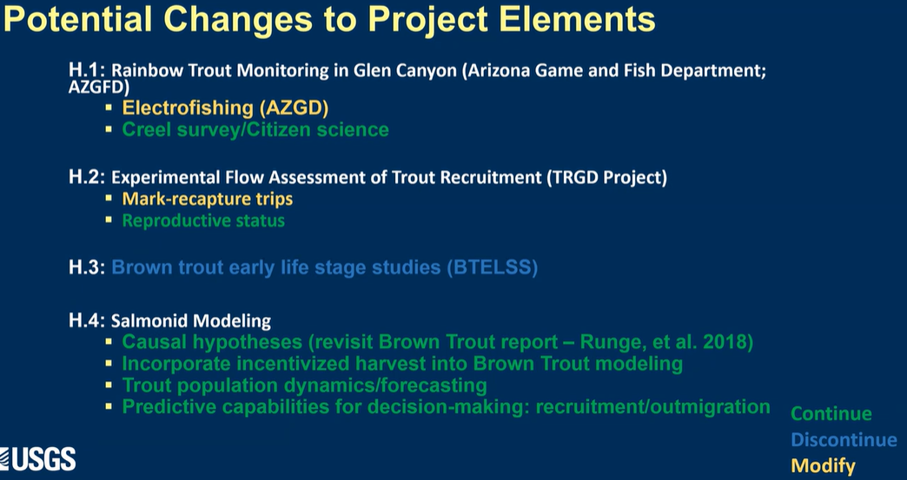
    - Rainbow trout monitoring in Glen Canyon ($123,760)
    - 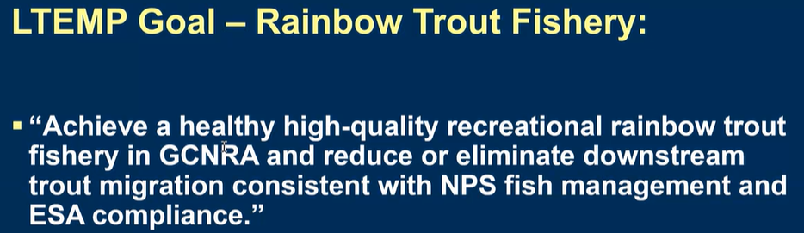
    - Experimental flow assessment of trout recruitment ($267,705)
    - Brown Trout Early Life Stage Survey in Glen Canyon ($0)
    - Salmonid modeling ($119,782)
  - 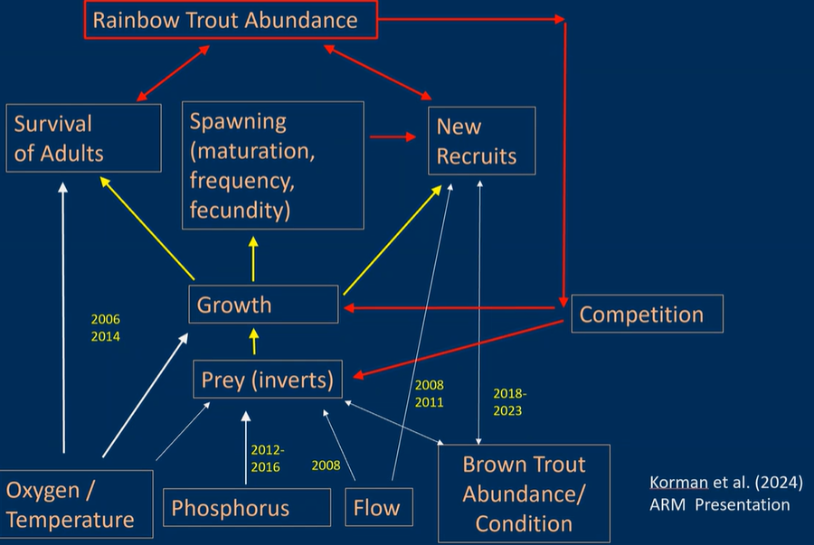
  - Discussion
    - Emily Omana-Smith: in support
      - Happy to see flow options
- NEW PROJECT Other Native Fish
  - 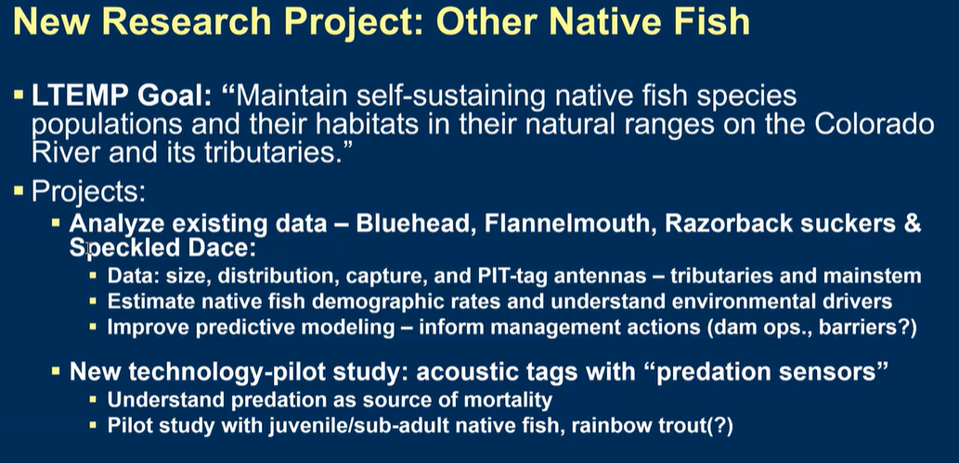
  - Discussion:
    - Would the Native Fish Element of Project I be moved into this New Project?
      - BH: it could be moved into this new project
      - Kim Dibble: that was the thought, try to separate native vs. non-native, trying to disentangle the species
        - Taking the data that would be collected in the other projects for modeling in this one to address the LTEMP Goal
    - Larry Stevens: will life history models require additional sampling?
      - BH: speckled dace respond rapidly to management actions
        - Little more difficult to monitor in a quantitative way as they’re so small
      - BH: I realized I might not have answered all of Larry's questions: as far as additional sampling for "other native fish", I wouldn't plan much additional field work, but use data that is already being collected on the other trips. I plan to think more about this. Sorry about that Larry

