Making a Section 508 Compliant Document
From an Already Created Document

Open the document you will be working in (ex. Word, Excel, PowerPoint)

Click on Review and then Check Accessibility

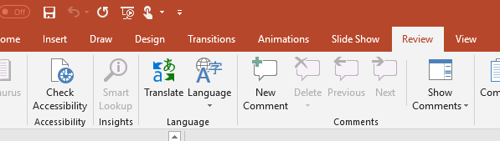

A column will open on the right side of your screen with errors and warnings.

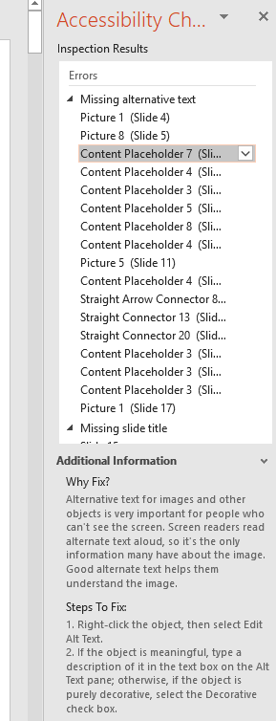
At the bottom of the tab is additional information and steps to fix (add) what needs to be done to make the document 508 compliant.

When you click on one of the lines, the system will jump to that slide and put a mark around what it is looking for.

This p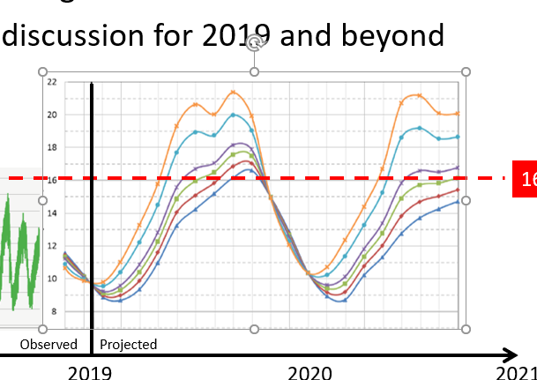

The steps to fix are
- Right click the object and select Edit Alt Text

- Type a description of the object in the box.

  - This graph shows….
  - Use enough detail so a blind person will clearly understand what is being shown

Once the item has been resolved, it will be removed from the list.

Check Reading Order

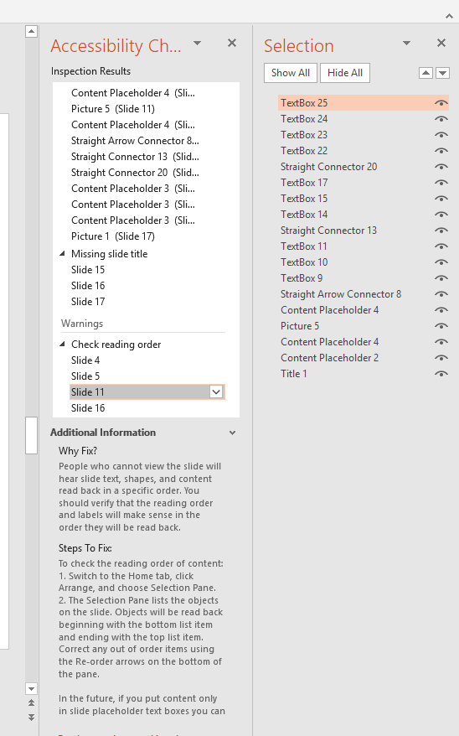
Follow the instruction under “Steps to Fix” to pull up the Selection pane.

What you will need to do here is start from the bottom and say how the slide should be read…

Title 1
Picture 5
Text box 9
Text box 10, etc.

Make sure the flow is in a way that will make sense to a blind person.

As you click on each line the cursor will jump to what it is talking about.

When everything is set for the 508 compliance requirements, checklist will be empty.

