Call 4: Riparian Vegetation, Cultural Resources, Tribal Resources, Socioeconomics, Recreation, Hydropower, Overflight Remote Sensing and GIS, 2/28/20

Attendees: Craig Ellsworth, Peggy Roefer, Shane Capron, Jakob Maase, Steve Wolff, John S., Eric Sky, Paul Harms, Lonnie, Scott VanderKooi, Lucas Bair, Brad Butterfield, Emily Palmquist, Helen Fairley, Joel Sankey, Mike, Peter Bungart, Lee Traynham, Leslie James, Cliff Barrett, Craig McGinnis, Jan Balsom, Larry Stevens, Theresa Pasqual, Kim Yazzie, Vineetha Kartha,

BAHG Members MIA: Richard Begay, Charley Bulletts, Rob Billerbeck, Winkie Crook, Kurt Dongoske, Michelle Garrison, Brian Healy, Ken Hyde, John Jordan, Ryan Mann, Jessica Neuwerth, Bill Persons, Ben Reeder, Seth Shanahan, Jim Strogen, Kirk Young

- Riparian vegetation
  - Lead researcher: Emily Palmquist (GCMRC), Brad Butterfield (NAU)
  - Resource goal:
- Riparian vegetation: Maintain native vegetation and wildlife habitat, in various stages of maturity, such that they are diverse, healthy, productive, self-sustaining, and ecologically appropriate.
- Natural processes: Restore, to the extent practicable, ecological patterns and processes within their range of natural variability, including the natural abundance, diversity, and genetic and ecological integrity of the plant and animal species native to those ecosystems.
- 2019 DOI guidance:
  - Future research should be tied directly to LTEMP resource goals and objectives
  - Explore vegetation management to benefit high value recreational beaches and protect vulnerable archaeological sites
- BO Conservation Measures: none
- LTEMP experiment:
  - Experimental riparian vegetation treatments
    - Non-native/invasive native species removals on camping beaches
    - Native species replantings
  - Status and Trends:
    - 2017: Moderate concern and unchanged with medium confidence
    - We no longer think this is unchanged. Our status and trends suggest that riparian vegetation is changing and more rapidly than expected.
  - Knowledge Assessment recommendations:

- Data being collected:
    - Project A.1. Stage and discharge data at stations throughout the CRE
  - Project Element C.1. Ground-based riparian vegetation monitoring
    - Assessment of the status and trends of vegetation composition, cover, richness, and native to nonnative species dominance through time across the three main geomorphic features along the river; sandbars, debris fans, and channel margins.
  - Project Element C.2. Mechanistic experiments with plant species of interest
    - Greenhouse experiments regarding Goodding’s willow, arrowweed, and seepwillow responses to flows to understand growth and persistence.
  - Project Element C.3. Vegetation responses to LTEMP flow scenarios
    - Model the influence of flow scenarios on species distributions and potential community change
  - Project Element C.4. Vegetation management decision support
    - Assist with planning and coordination of experimental vegetation actions: control of nonnative plant species, development of native plant materials, replanting native plant species, removal of vegetation encroaching on campsites, and management to assist with cultural site preservation.
    - Project L. Remote Sensing Overflight in Support of Longterm Monitoring and LTEMP (May 2021)
      - Multispectral Imagery
      - Digital Topography
    - Website content and virtual online maps
    - Cartographic products
      - River map books
      - Publication maps
    - Colorado River centerline and river mile system
    - Flowlines
      - Extracted from low-flow water's edge (~8,000 CFS) in overflight imagery
      - Modelled from overflight topography and water surface elevation data
    - Land cover and landform mapping and change detection
      - water, sand, vegetation
      - geomorphic basemap
    - Vegetation species classification
    - Campsite delineation
      - Campsite atlas
    - Topography data
      - Topographic change detection
      - Hydrologic flow modeling

- Metrics used:
  - Measurement and analysis of plant cover and species presence
  - Changes in woody vegetation
  - Vegetation response-guilds for integrated research of sandbars and riparian vegetation
  - Assessment of nonnative plant control and native plant restoration efforts
  - Projections of future changes in riparian vegetation species distribution and cover relative to LTEMP flow scenarios
- How is this being used to adaptively manage the CRE?
  - Providing basic knowledge of the plant species cover and composition and the environmental factors controlling them (including flows)
  - Providing mechanisms behind key species growth and survival related to different flow scenarios
  - Provides information to assist in LTEMP vegetation removals and plantings
- Stakeholder questions or discussion?
  - Hydropeaking: means something different than how the term is being used in the Program. Ought to use term more like regular or normal operations or daily fluctuating flow. Need to use a term that accurately reflects the flow in the industry it occurs. Tidal flows
  - Integrate changes of vegetation type or structure on wildlife (feed, habitat). Change of veg over time and effects of wildlife, longer than just the last few years, pre-dam to present. Beaver, bighorn, mule deer. Look for collaboration with NPS wildlife unit. Remote sensing changes in veg published 2015 (data sets go to pre-dam), now looking at species level changes, also repeat photography to look at changes in veg, shift from telling us what happened in the past to modeling what might happen in the future, look at more recent repeat photography opportunities (see Larry),
  - Need a consistent plan for ecosystem monitoring implemented over the 20-year LTEMP
  - Any soil sampling to identify changes in vegetation? Nutrients, salinity, etc moving from the river to the terrestrial environment. Foodbase: monitoring bugs to bats and birds.

- Archaeological and cultural resources
  - Lead researchers: Joel Sankey, Helen Fairley
  - Resource goal:
    - Maintain the integrity of potentially affected NRHP-eligible or listed historic properties in place, where possible, with preservation methods employed on a site-specific basis.
  - 2019 DOI guidance:
    - Petty guidance memo:
      - Future research should be tied directly to LTEMP resource goals and objectives
      - The memo also specifically calls out Exploring vegetation management to protect vulnerable archaeological sites.
    - NHPA: TWP and budget should focus on compliance priorities including actions necessary for compliance with the National Historic Preservation Act. Long-term lidar monitoring of archaeological sites is identified as a required monitoring activity within the new HPP; results of this monitoring will inform future treatment decisions under the HPP.
    - GCPA: Research and monitoring as required by the Grand Canyon Protection Act – cultural resources are specifically mentioned in GCPA.
    - LTEMP: Explore vegetation management to benefit high value recreational beaches and protect vulnerable archaeological sites
    - LTEMP: Explore the feasibility of conducting a spring HFE, along with modeling for improvements and efficiencies that benefit natural, cultural, recreational, and hydropower resources
  - BO Conservation Measures: none
  - NHPA, GCPA: Monitoring plan for the geomorphic condition of archaeological sites is identified as a monitoring activity in the approved and final historic preservation plan. The monitoring program was developed at the request of Reclamation to provide quantitative measurements of the effects of dam operations on archaeological sites and is being used to inform treatment decisions.
  - LTEMP experiment:
    - Experimental riparian vegetation treatments to increase aeolian sand transport to cultural resource sites.
    - Spring and fall HFEs
  - Status and Trends:
    - 2017: Moderate concern and declining with high confidence
  - Knowledge Assessment recommendations:

  - Data being collected:
    - Project A.1. Stage and discharge data at stations throughout the CRE
    - Project A.3. Sediment-transport and sand-budgeting data throughout the CRE to inform sediment conditions
    - Project Element D.1. Geomorphic effects of dam operations and vegetation management
      - Quantify changes in the physical condition of river corridor archaeological sites in Grand Canyon, surrounding landscapes, and site-scale sediment connectivity as a function of; (i) dam operations, (ii) natural processes, and (iii) vegetation management
    - Project element D.2 Cultural resources synthesis to inform Historic Preservation Plan
    - Project L. Remote Sensing Overflight in Support of Longterm Monitoring and LTEMP (May 2021)
      - Multispectral Imagery
      - Digital Topography
    - Website content and virtual online maps
    - Cartographic products
      - River map books
      - Publication maps
    - Colorado River centerline and river mile system
    - Land cover and landform mapping and change detection
      - water, sand, vegetation
      - geomorphic basemap
    - Vegetation species classification
    - Topography data
      - Topographic change detection
      - Hydrologic flow modeling
  - Metrics used:
    - Measurement of geomorphic condition of all river corridor archaeological sites using drainage and aeolian classification systems as a framework for measuring large changes in site condition
    - Measurement of geomorphic condition of a sample of river corridor archaeological sites using ground-based lidar (sample size currently = 24; final sample size = ~30) to measure changes in condition tied to annual dam operations and LTEMP vegetation management
  - How is this being used to adaptively manage the CRE?
    - Determine whether increasing the frequency of HFEs increases the resupply of river sand to archaeological sites in the river corridor and offsets erosion, thus achieving the LTEMP resource goal.
    - Determine if removal of riparian vegetation located between HFE-sediment supplied sand bars and aeolian dunefields containing archaeologic sites increases the probability of "preservation in place" and thus achieving the LTEMP resource goal.
    - Provides data for determining future treatment types and effectiveness
  - Data and Knowledge Gaps – Proposed future research directions
    - Completing research in relation to vegetation removal experiments
    - NPS checkdam treatment: appropriate settings and measuring success
    - Mapping river deposits as cultural landscape
    - Sediment supply-biological soil crust-exotic annual grass invasions
    - Administrative history for the cultural program
  - Stakeholder discussion
    - Veg work + aeolian transport: tool to address system wide effect of what management actions like HFEs are doing for arch sites.
    - Address immediate needs, synthesis and admin history may be a lower priority.
    - Needs to be a long-term project because effects may take multiple years / multiple HFE cycles to manifest.
    - Aeolian transport of sand deposited following an HFE has the potential to benefit only 21% of archaeological sites in the river corridor. What is being done to protect the remaining sites?
      - Response: First, there is a potential for changes in dam operations, combined with vegetation management, to benefit 197 archaeological sites; 197 is far more than 21% of the 350+ river corridor sites. So we are not sure where the 21% estimate stated here comes from? Second, for those sites which cannot be improved through managing the dam and sediment supply, the Historic Preservation Plan has defined other mitigation measures that may be considered; however, some of these proposed measures, such as data recovery (i.e., archaeological excavations) are last-resort measures that will not fulfill the LTEMP goal of in situ preservation, while other possible mitigation measures, such as check dam installation, appear to work better if sediment supply is restored to some degree through rebuilding near shore sand bars and facilitating inland transport of sediment by wind.
    - 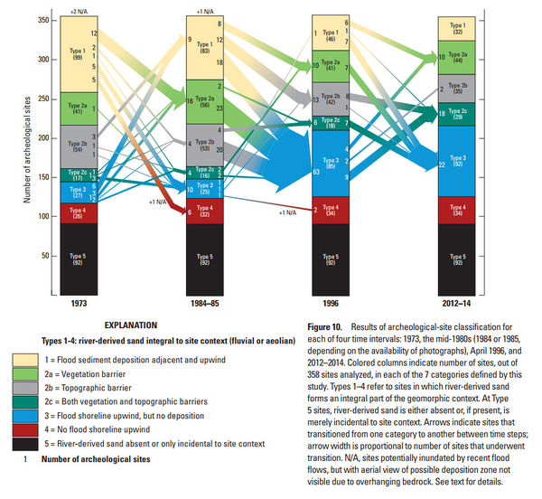
https://pubs.er.usgs.gov/publication/pp1825

    - Is studying aeolian sand transport the best use of time and resources in our effort to protect archaeological sites in the CRE?
      - Response: This question mischaracterizes the focus of recent work, which is on improving understanding of how to most effectively retain cultural resources in place through testing and refining a conceptual model that links river-derived sediment with site preservation potential. As noted above, restoring sediment transport connectivity between near shore-sand deposits and archaeological sites through the medium of wind transport currently offers the only mechanism for stabilizing and potentially reversing ongoing erosion of river corridor archaeological sites. Check dams can, in some cases, help to slow rates of erosion, but they appear to be most effective when implemented in conjunction with active aeolian sediment re-supply. Other mitigation measures that are proposed in the new HPP will not help to preserve sites in place; instead, they attempt to compensate tribes and the American public for the ongoing loss of irreplaceable, non-renewal cultural sites that serve as a tangible testament to the historical presence and cultural legacy of native American people in this landscape.
    - Can removing vegetation increase erosion at arch site via blowing sediment off the arch site? The veg removal isn’t removing veg on the arch site, just between sand source dune and the arch site. How long does it take for veg to reestablish?

LTEMP Vegetation Project Proposal for BAHG - NPS
This project involves paired work between NPS and GCMRC – two projects tied together
  - Leads
    - NPS Leads: Lonnie Pilkington (GRCA) and John Spence (GLCA) – Reclamation Project C.7
    - GCMRC Lead: Emily Palmquist/Brad Butterfield – was GCMRC Project C – Veg Decision Support (one component)
    - GCMRC Lead researchers: Brad Butterfield and Emily Palmquist – GCMRC Project C (one element) ; Joel Sankey and Helen Fairley– GCMRC Project D (one element)
  - Review of 2018-20 TWP
    - How is work being done to help us meet:
      - LTEMP Goals
1. Archaeological and Cultural Resources. Maintain the integrity of potentially affected NRHP-eligible or listed historic properties in place, where possible, with preservation methods employed on a site-specific basis.
2. Natural Processes. Restore, to the extent practicable, ecological patterns and processes within their range of natural variability, including the natural abundance, diversity, and genetic and ecological integrity of the plant and animal species native to those ecosystems.
6. Recreational Experience. Maintain and improve the quality of recreational experiences for the users of the Colorado River Ecosystem. Recreation includes, but is not limited to, flatwater and whitewater boating, river corridor camping, and angling in Glen Canyon.
7. Sediment. Increase and retain fine sediment volume, area, and distribution in the Glen, Marble, and Grand Canyon reaches above the elevation of the average base flow for ecological, cultural, and recreational purposes.
8. Tribal Resources. Maintain the diverse values and resources of traditionally associated Tribes along the Colorado River corridor through Glen, Marble, and Grand Canyons.
11. Riparian Vegetation. Maintain native vegetation and wildlife habitat, in various stages of maturity, such that they are diverse, healthy, productive, self-sustaining, and ecologically appropriate.
      - Guidance from DOI in 2019 Petty memo
        - “The priorities identified in the LTEMP ROD for the GCDAMP are as follows:
          - Management and Experimental Actions
          - Mitigation and Environmental Commitments
          - Research and Monitoring
        - This vegetation project is all three of those.
        - The memo also specifically calls out three areas of research for particular consideration of which the vegetation project is one of the three: “Exploring vegetation management to benefit high value recreational beaches and protect vulnerable archaeological sites”.
      - BO or ROD environmental compliance requirements
        - ROD 4.2 – “Experimental non-flow vegetation treatments mitigate impacts from dam operations within the CRE”
        - ROD 4.3 – “Alternative D also includes experimental non-flow vegetation treatments that are expected to improve vegetation through the removal of nonnative plants and replanting of native plants in select areas along the river.”
        - ROD 6 – Environmental Commitments – “The following mitigation, monitoring, and enforcement commitments will be implemented as integral parts of the decision as a means of avoiding or minimizing adverse effects.”
        - ROD 6.4 – “Experimental Vegetation Treatment and Mitigation: As part of the LTEMP, experimental riparian vegetation treatment was included as mitigation for dam operations within the CRE.”
      - LTEMP Experimentation
        - ROD 7 – “Implementation: LTEMP experimental flows and non-flow experiments shall be implemented after September 30, 2017.”
        - LTEMP EIS – Experiments section – ES.8.3.3 – Experimental Vegetation Treatment. “NPS will work with Tribal partners and GCMRC to experimentally implement and evaluate a number of vegetation control and native replanting activities on the riparian vegetation within the Colorado River Ecosystem in GCNP and GCNRA.”
    - What work has been done – what are accomplishments?
      - Areas Experimentally Treated in 2018-2019 and planned in 2020
      - GRCA – In 2019, invasive non-native plant species affected by dam operations were treated at 6 sites covering 3.29 acres. In order to increase campable areas, vegetation treatments occurred at 16 campsites covering 3.25 acres (see Figure 1. Surprise Canyon Camp and Photo 1.). Cultural resource protection through removal of vegetation blocking geomorphic processes occurred at 4 sites. Native plant restoration actions were implemented at 2 sites.
      - GRCA – In 2020, invasive non-native plant treatments will occur at 16 or more sites (including revisits). Vegetation treatments to increase campable areas will occur at 18 sites (including revisits). Cultural resource protection will occur at 6 sites (including revisits). In support of native plant restoration actions, native seed and cuttings will be collected at 3 or more sites. Native plant materials will be propagated in the GRCA Greenhouse in support of out-planting efforts planned for 2021 and 2022.

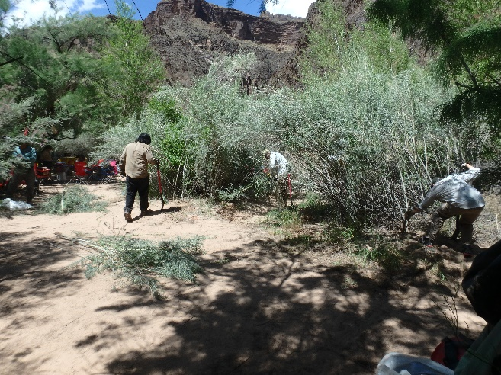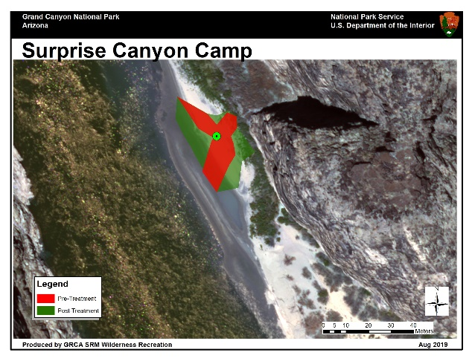
Ancestral Lands Crew removing arroweed to expand recreation Aerial view at Surprise Canyon camp showing expanded recreation area

      - GLCA – Two sites have been treated, with -7.0L RM of ca. 8 acres cleared and replanted with native species; and the 2nd site (-12L RM) of ca. 20 acres to be cleared this year. The -7 mile site had large amounts of downed and dead tamarisk which was cleared out, creating ca. 30 cords of wood that were moved to Lees Ferry and distributed to local Navajo communities as firewood. All the firewood was gone within 24 hrs. Propagation is ongoing including a suite of riparian woody species as well as an upland herbaceous forb/grass/shrub seed mix.
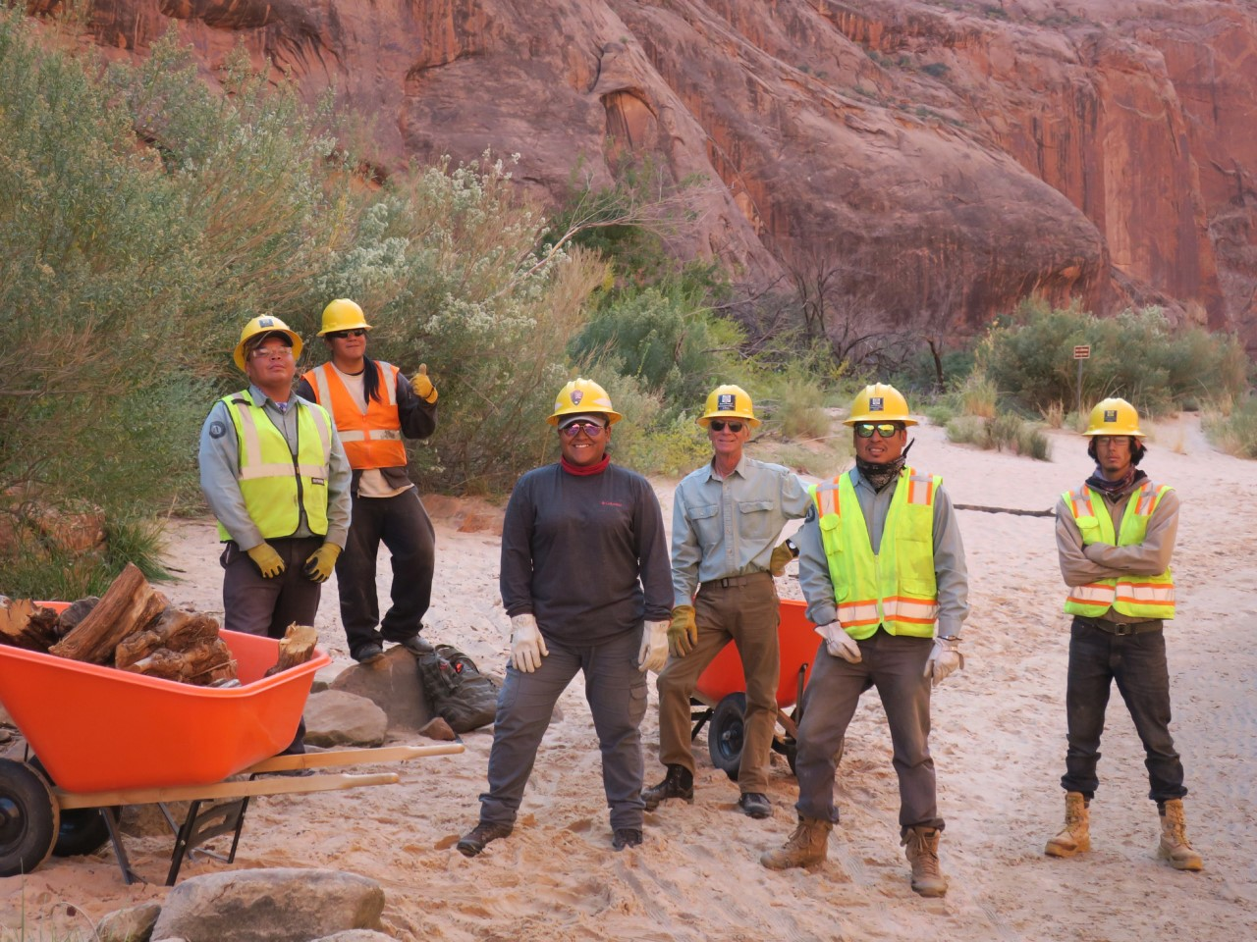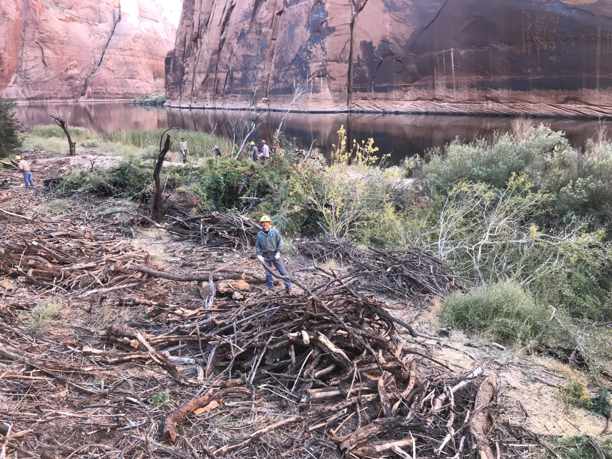
Ancestral Lands Navajo Crew on the beach SWCC crew doing tamarisk removal - includes tribal members
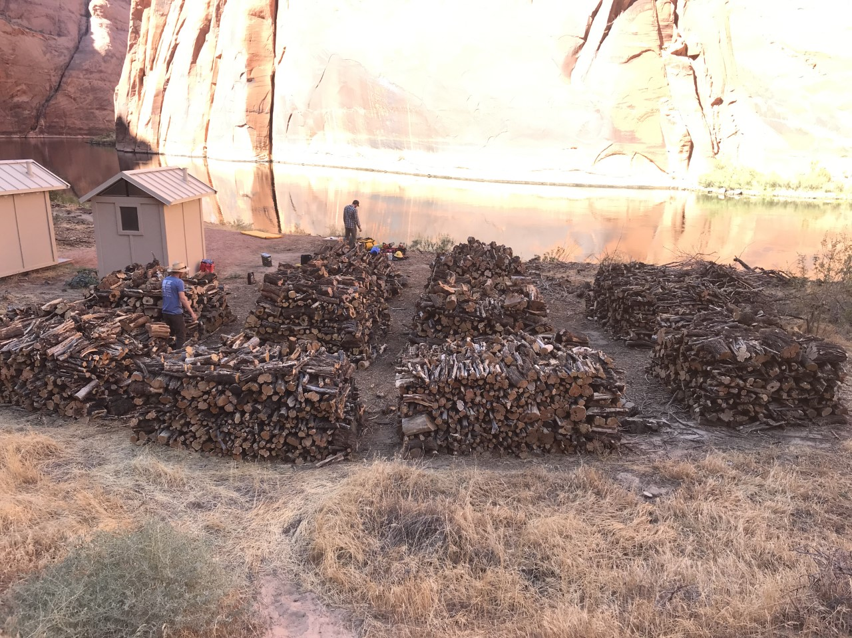
Cords of wood removed packaged for distribution to local communities
      - Involvement of tribes:
        - Meetings and input – Tribal input is important and written into the ROD – NPS held meetings with Tribes in 2017(1), 2018(4), 2019(1).
        - Ancestral Lands Corps – GLCA used two Ancestral Land Corps crews, one Navajo and one Hopi. These crews helped clear out woody debris and helped revegetate the -7.0L RM site. In 2020 funding is available for 1-2 additional AL crews, plus funding to support travel to the newly restored sites for tribal representatives.
        - Between 04/16/19 and 05/01/19, GRCA partnered with AZCC and the SCC Ancestral Lands Programs to engage 7 tribal youth (Zuni, Navajo) in a river mission to complete LTEMP actions. Between 04/01/2020 and 04/16/2020, GRCA will partner with the AZCC Ancestral Lands Program to engage 7 tribal youth in a river mission to complete LTEMP actions. AZCC, Peter Bungart, and GRCA are exploring ways to engage Hualapai youth in this project.
        - We plan to meet with Tribal Representatives and GCMRC March 5 to discuss past and future work sites, including more opportunities for work crews and elder guidance for youth.

    - What has been learned in evaluating the project?
      - Experiments were designed to address management for multiple resources: riparian vegetation, cultural resources, recreation, sediment
      - Vegetation removal experiments to benefit high value recreational beaches and protect vulnerable archaeological sites.
      - Implemented in 2019 to evaluate whether removal of riparian vegetation between HFE-sediment supplied sand bars and archaeologic sites increases the probability of achieving the LTEMP resource goal for archaeological sites of "preservation in place".
      - We propose to add a research element in the FY21-23TWP to assess whether and to what degree riparian vegetation removal improves campsite quality and recreation experience, per the LTEMP goal for recreation.
      - A pilot experiment implemented in 2019 with arrowweed grown in a greenhouse demonstrated significant decreases in growth with greater flood depth, though arrowweed was less impacted by flooding than expected. Additionally, this greenhouse experiment showed that arrowweed from different locations along the river differ in overall plant vigor (size and growth).
    - Propagation & genetics – GCMRC population genetic research demonstrated genetic differentiation among populations of Fremont cottonwood, providing guidance on suitable sources for localized restoration treatments. Other desirable species (Goodding’s willow, coyote willow, and honey mesquite) did not exhibit genetic differentiation, indicating that the most convenient or vigorous sources may be selected. Source population will be a factor included in proposed ex situ experiments to identify variation in plant growth and performance associated with genetic variation.

Planning for 2021-23 TWP
    - What needs to continue (sketch out next triennial plan roughly)
      - GRCA - For 2021 – 2023, invasive non-native plant treatments will continue at 20 or more sites per year, vegetation treatments to increase campable areas will occur at 20 or more sites per year, cultural resource protection will occur at 6 or more sites per year, and native plant restoration actions at 3 sites per year. On 03/05/2020, we will be meeting with tribes to discuss treatment site selection and culturally significant plant species for native plant restoration efforts. We will continue to engage tribal youth in project implementation.
    - GCMRC and GRCA joint vegetation removal sites – We are currently partway into the vegetation removal experiments, but since there was no HFE in 2019, we will continue the experimentation and monitoring to evaluate combined effects of vegetation removal and HFEs.
      - GLCA continued vegetation project for 2021-2023, the 2nd site (-12L) will have ongoing replanting of native species and maintenance work, with initial planning and preparations to initiate restoration at a 3rd site at -14.5R RM (Ropes Trail), which is a popular camping site; this site will be cleared in 2022 with initiation of native plantings, which will continue through 2023; final report will be prepared for 2nd Triennial Project and lessons learned developed in detail. There will be an increased effort to plant species that provide shade and are culturally significant, especially Gooddings willow and cottonwood. The Ropes Trail site will also include a joint project with BOR on terrace stabilization, which is a concern in the Glen Canyon reach. GLCA has seen greatly increased recreation impacts on the river corridor and will be initiating planning for additional camping sites including a potential overnight camp site at Lunch Beach. Currently this is a day-use only beach.
    - Expanding the greenhouse experiments to study the impacts of flow (hydrological conditions and burial by sediment) as well as non-flow (cutting) actions on arrowweed and seepwillow would provide valuable information on arrowweed’s growth and performance under these conditions (as in the LTEMP treatments).
    - GLCA FY2021-2023 funding: $42K in 2021, $84K in 2022, $66K in 2023
    - GRCA FY2021-2023 funding: $206.5k in 2021, $208.2k in 2022, and $209.8k in 2023

    - Identify any Knowledge Assessment recommendations
      - Including an interconnections section that includes the vegetation and bare sand intersections as habitat with the rest of the system in terms of inverts, herps, birds, etc.

    - Describe how this data might be used to adaptively manage the CRE
      - We can apply what have learned in these first few years to improve the native planting, invasive removals and beach encroachment efforts.
      - We can continue the vegetation removals to test the effectiveness for aeolian processes to protect cultural areas in the appropriate sites.
  - Stakeholder discussion
    - Importance of using culturally important plants in restoration projects.

- Tribal Cultural Values
  - Lead researchers:
  - Resource goal:
    - Maintain the diverse values and resources of traditionally associated Tribes along the Colorado River corridor through Glen, Marble, and Grand Canyons.
- 2019 DOI guidance:
  - Future research should be tied directly to LTEMP resource goals and objectives
  - TWP and budget should focus on compliance priorities including actions necessary for compliance with the National Historic Preservation Act
- BO Conservation Measures: none
- LTEMP experiment: none
  - Status and Trends:

  - Knowledge Assessment recommendations:

- Data collected in the last workplan:
  - Project Element J.1. Tribal perspectives for and values of resources downstream of Glen Canyon Dam: Tribal member population survey
    - Assess tribal preference relationships among resource attributes (e.g., hydropower, native fish)
  - Changes in the distribution and abundance of culturally-important plants (see Riparian Vegetation)
  - Southern Paiute Vegetation and Cultural Resource Monitoring Program
  - Zuni Monitoring Program in Grand Canyon
  - Hopi Long-term Monitoring Program for Öngtupqa
  - Hualapai Monitoring Program
  - Navajo Nation River Monitoring Program
- Metrics used:

- How is this being used to adaptively manage the CRE?

- Stakeholder discussion
  - Kim Yazzie (Navaho): Trying to find proposals from Melinda and Richard.
  - Hopi river trip, ethnographic work including interviews by female leaders that can’t attend the river trips,
  - Encourage opportunities to integrate tribal perspectives and participation in work being done on other resource topics,
  - Investigate how gardening occurred along the river corridor, how do modern cultigens compare to what was been grown historically?
  - How did the tribes interact with each other? Cross canyon routes, political alliances,
  - New beaches forming below Diamond Creek that weren’t there pre-HFEs? Were there beaches here pre-dam?
  - Hualapai river running and increase in in-river sandbars. How are operations/HFEs effecting in-river sandbars? Erosion of the Lake Mead deltaic deposits.
  - LIDAR: how often? Not consistently acquired in this program. Was collected in Sept 2019: lower canyon near National and in the BA/south rim area. Topographic data collected photogramically via overflight. Drone/UAS: grounded.

- Socioeconomics (see Hydropower and Tribal Resources)
  - Lead researcher: Lucas Bair
  - Resource goal
  - 2019 DOI guidance
  - BO Conservation Measures
  - LTEMP experiments
  - Status and Trends
  - Knowledge Assessment recommendations
  - Data collected in the last workplan
  - Economic Values of Recreational Resources along the Colorado River
  - Applied Decision and Scenario Analysis
    - Project Element J.2. Applied decision and scenario analysis
      - Development and integration of decision support models, using economic metrics, to evaluate and prioritize monitoring of, and research on, resources downstream of GCD, including the anticipated success (or lack thereof) of proposed experiments in the LTEMP EIS.
        - Rainbow trout mechanical removal model
  - Tribal Perspectives for and Values of Resources Downstream of Glen Canyon Dam
  - Metrics used
  - How is this being used to adaptively manage the CRE?
  - Stakeholder discussion

- Recreational experience
  - Lead researcher: Lucas Bair
  - Resource goal:
    - Maintain and improve the quality of recreational experiences for the users of the Colorado River Ecosystem. Recreation includes, but is not limited to, flatwater and whitewater boating, river corridor camping, and angling in Glen Canyon.
- 2019 DOI guidance:
  - Future research should be tied directly to LTEMP resource goals and objectives
  - Explore vegetation management to benefit high value recreational beaches and protect vulnerable archaeological sites
  - Explore the feasibility of conducting a spring HFE, along with modeling for improvements and efficiencies that benefit natural, cultural, recreational, and hydropower resources
- BO Conservation Measures: none
- LTEMP experiment:
  - Spring and Fall HFEs (2012, 2013, 2014, 2016, 2018)
  - Experimental riparian vegetation treatments
    - Non-native/invasive native species removals on camping beaches
    - Native species replantings
  - Status and Trends:
    - 2017: Significant concern and declining with strong confidence
  - Knowledge Assessment recommendations:

- Data being collected:
  - Project Element B.1. Sandbar monitoring using topographic surveys and remote cameras
    - Track the individual and cumulative effects of HFEs and intervening dam operations on sandbars and campsites in the CRe
- Metrics used:
  - Sandbar campsite area
  - Rainbow trout abundance and condition
  - Annual flow, minimum flow, fluctuation range
  - Crowding
- How is this being used to adaptively manage the CRE?
  - Understanding how operations and experiments effect recreation
- Stakeholder discussion
  - Take advantage of flow experiments to describe tradeoffs

- Hydropower and energy
  - Lead researchers: Lucas Bair (working with WAPA?)
  - Resource goal:
    - Maintain or increase Glen Canyon Dam electric energy generation, load following capability, and ramp rate capability, and minimize emissions and costs to the greatest extent practicable, consistent with improvement and long-term sustainability of downstream resources.
  - 2019 DOI guidance:
    - Future research should be tied directly to LTEMP resource goals and objectives
    - The Department of Interior has recently prioritized the responsible development and production of renewable energy on federal lands. The GCDAMP is encouraged to work within the LTEMP framework to seek ways to improve the value of the hydropower resource.
    - Maintaining dam releases consistent with applicable laws
    - Consider impact to hydropower as part of the development of LTEMP experiments and study plans
    - Continue to utilize operational flexibility in response to varying hydrological and other resource-related conditions
  - BO Conservation Measures: none
  - LTEMP experiment: none
  - Status and Trends:
    - 2017: Moderate concern and declining with high confidence
  - Knowledge Assessment recommendations:

  - Data being collected:
  - Hydropower Monitoring and Research
    - Project N: Identify ways of reducing the impact of experimentation to hydropower.
  - Metrics used:
    - Minimize emissions and costs to hydropower to the greatest extent possible, consistent with improvement and long-term stability of downstream resources.
    - Cost of experimentation
    - Basin Fund balance
  - How is this being used to adaptively manage the CRE?

  - Stakeholder discussion
    - Leslie has issues with methods used in some of the past and proposed hydropower work. Requests side call on the development of additional hydropower research. Doesn’t feel that the current research is accurately reflecting how the hydropower contracting works. Should this be a discussion for the SEAHG?

Remote Sensing Overflight in Support of Long-term Monitoring and LTEMP

Lead researchers: Joel Sankey and Tom Gushue

Why?
- Data sets derived from remote sensing overflights are essential to most of the past and present research projects conducted by GCMRC (Table 1).
- LTEMP planning was based on research which relied heavily on data from previous overflights.
- LTEMP ROD implementation will rely on data from past and future overflights.
- GCMRC’s Scientific Monitoring Plan: LTEMP ROD “calls for a comprehensive, decadal-scale assessment of the impact of dam operations” on multiple resources.
- LTEMP Resource Goals: Imagery and derivative data products from overflight remote sensing are used either directly or indirectly by nearly every GCDAMP TWP science project to address every resource goal.
- A scientific effort that has both an immediate and a longer-term payoff:
  - LTEMP implementation
  - Decadal-scale changes to resources system-wide

Table 1. Summary of primary datasets and examples of derived products from overflight missions used by GCDAMP science projects to achieve LTEMP resource goals
Primary datasets produced from overflight missions
Multispectral Imagery | Digital Topography
Products derived from primary datasets
Website content and online maps. | Cartographic products  - River map books  - Publication maps
Fish sampling unit system for mainstem CR | Humpback chub monitoring system for LCR
Colorado River centerline and river mile system | Flowlines  - Extracted from low-flow water's edge (~8,000 CFS) in overflight imagery  - Modelled from overflight topography and water surface elevation data
Land cover and landform mapping and change detection  - water, sand, vegetation land cover  - geomorphic basemap | Vegetation species classification
Campsite delineation  - Campsite atlas | Topography data  - Topographic change detection  - Hydrologic flow modeling

What?
- Historical overflights
  - Analog air photos since the 1960s (and even earlier)
- Modern overflights
  - Multispectral digital image mosaics and topography
    - 2002, 2004, 2005, 2009, 2013, 2021
- 2021-2024 Work plan
  - Timeframe
    - 2021 - 1 year for managing contract and acquiring data
      - Mission scheduled for May 2021
    - 2022 - 1 year for building image mosaic
    - 2023 - Image mosaic served online and image analysis and product generation begin
  - Approximately $0.6 million to contract the acquisition
  - GCMRC staff support and funding required
    - to plan and manage the acquisition
    - to process, serve, and analyze the data

Geospatial Science, Data Management and Technology Project BAHG Resource Notes & TWP21-23 Conference call [02.28.2020]
Lead researcher: Thomas Gushue
Resource goal:
- Data management, including geographic information systems (GIS), has been a part of GCMRC’s role in GCDAMP since its inception, and was also supported in the 1995 ROD – specifically in GCDAMP Goal 12, to maintain a high-quality monitoring, research and adaptive management program.
- Subsequent documents, including the most recent LTEMP EIS, have reaffirmed this important aspect of the Center and Program.
2019 DOI guidance
- Project is designed to support the other proposed science projects that are aligned with resource goals identified in the LTEMP EIS and in more recent DOI guidance (2019 memo),
- Document calls for continuity in resource monitoring and consistency in providing high-quality monitoring and research to the Adaptive Management Program. This project provides the support to make this happen.
BO Conservation Measures
LTEMP experiments
Status and Trends
Knowledge Assessment recommendations
Data being collected
- Geospatial project work elements will be planned in coordination with the proposed science projects, and with direct involvement in the remote sensing overflight project that is proposed for FY2021.
- Most work performed in the realm of data management and GIS is focused on workflows and processing data after it has been collected.
- This project will continue to support project-specific data collection efforts through maintaining existing data entry programs and developing new ones, where applicable.
- This project will also continue to support field efforts with mapping products, and in some cases staff involvement in the data collection efforts.
Metrics used
How is this being used to adaptively manage the CRE?
- This Project is instrumental in sharing important information about trends in resources of the Colorado River ecosystem through web-based, interactive tools, online mapping products, updated website presence, and other GIS-related support
- Products developed allow for the ability to make better informed, time-sensitive decisions on experimental and management actions under the 2016 LTEMP and the associated ROD
Stakeholder discussion
- Request for web-based data applications on online mapping products
- https://www.usgs.gov/centers/sbsc/science/gcmrc-data-and-tools

Geospatial Science, Data Management, and Technology Project

- Lead researcher(s): Thomas Gushue
- Co-PIs: James Hensleigh, Timothy Andrews

BAHG Resource Notes

Documents and Comments considered / addressed in this document

LTEMP ROD (page 12):

6.1.b. Priorities and Funding of the GCDAMP. The GCDAMP priorities are set by the GCPA of 1992, the LTEMP FEIS, and ROD, and related mitigation requirements for endangered species and cultural resources. The GCDAMP priorities include the management and experimental actions; mitigation and environmental commitments; and research and monitoring identified in the LTEMP FEIS and ROD, and these will be the highest priorities for GCDAMP over the term of the LTEMP. The GCDAMP activities that are eligible for funding from power revenues are those actions related to dam operations or the mitigation of dam operations within the CRE. These will be funded in compliance with Section 204 of Public Law (PL) 106-377. Appropriated funds or other sources of funding may also be used for GCDAMP activities as specified in Section 1808 of the GCPA and Section 204 of PL 106-377.

FROM SCIENCE PLAN:
p. 13. To keep managers and stakeholders informed, GCMRC instead plans to establish a Web-based “living document” on its homepage—similar in structure to data presently served on GCMRC’s maps and data portal concerning stream flow, sediment transport, water quality, and sandbar characteristics—where status of resource data are available for review by the public. These provisional data will, at a minimum, include time series of changes in sandbar area and volume based on annual sandbar surveys and time-lapse photographs of various sandbar monitoring sites that specifically highlight changes in sandbar characteristics associated with particular experiments. These data will be accompanied by an annual interpretative statement of the trends of sandbars that will be updated at the time of each year’s annual reporting meeting. Similar data will be provided regarding humpback chub populations, rainbow trout populations and the associated fishery, the aquatic food base, and other resources of interest, as appropriate, for addressing conservation measures and triggered actions consistent with the ROD.
FROM SECRETARY DESIGNEE MEMO, 2019:
The primary guiding documents for the GCDAMP will continue to be the LTEMP FEIS and ROD, which provide the framework for adaptively managing Glen Canyon Dam operations and management actions associated with downstream resources through 203 7. This program guidance document will help ensure continuity and continued successes within the GCDAMP under the current administration and in the years to come. The priorities identified in the LTEMP ROD for the GCDAMP are as follows:
• Management and Experimental Actions
• Mitigation and Environmental Commitments
• Research and Monitoring

Identify the resource goal as described in LTEMP
- Data management, including geographic information systems, has been a part of GCMRC’s role in GCDAMP since its inception, and was also supported in the 1995 ROD – specifically in GCDAMP Goal 12, to maintain a high-quality monitoring, research and adaptive management program.
- Subsequent documents, including the most recent LTEMP EIS, have reaffirmed this important aspect of the Center and Program.

Identify any guidance from DOI in the 2019 Petty memo that applies to the resource
- Project is designed to support the other proposed science projects that are aligned with resource goals identified in the LTEMP EIS and in more recent DOI guidance (2019 memo),
- Document calls for continuity in resource monitoring and consistency in providing high-quality monitoring and research to the Adaptive Management Program (LTEMP, ROD).

Brief description of data being collected in the new workplan
- Geospatial project work elements will be planned in coordination with the proposed science projects, and with direct involvement in the remote sensing overflight project that is proposed for FY2021.
- Most work performed in the realm of data management and GIS is focused on workflows and processing data after it has been collected.
- This project will continue to support project-specific data collection efforts through maintaining existing data entry programs and developing new ones, where applicable.
- This project will also continue to support field efforts with mapping products, and in some cases staff involvement in the data collection efforts.

How is this being used to adaptively manage the CRE?
- This Project is instrumental in sharing important information about trends in resources of the Colorado River ecosystem through web-based, interactive tools and mapping products
- Products developed allow for the ability to make better informed, time-sensitive decisions on experimental and management actions under the 2016 LTEMP and the associated ROD

Proposed Work Elements, FY21-23

Geospatial Science
- Geospatial data processing and analysis of large, complex data sets
- GIS and mapping support provided to GCDAMP-funded science and related activities
- Enterprise GIS platform for serving data online
  - Built upon ESRI ArcGIS Portal and Server applications
  - Maintaining existing online data resources and upgrading, where appropriate
  - Expanding on content that is available
  - Improving functionality and web-based analytical tools
- Development of custom web applications and other online geospatial content in support of GCDAMP-funded science efforts.
- Assistance in data review and metadata development of final data sets that have geospatial components
- Action Items for FY21-23:
- Migration of GIS processing, geospatial analysis tools, and production mapping ArcGIS Pro [64-bit] software
- Design and implementation of an internal geospatial data content system using ESRI ArcGIS Server and Portal

Data Management and Database Administration
- Focused on data integrity, preservation, and improved accessibility to data resources
- Continued maintenance of relational databases in support of LTEMP related science efforts
  - Provide consistent, stable platform for conducting much of the monitoring and research activities
  - Development and implementation of new enterprise, relational databases in support of resource goals
  - Geospatial and tabular data stored and served from same/similar relational database platforms
- Coordination with USGS & SBSC IT staff on data and database needs, IT infrastructure, software, high-performance computing, source control for programming code, and other emerging technologies
- Lead role in adoption of hybrid-cloud strategy for future data management and application development
- Action Items for FY21-23:
- Fish database redesign and workflow modernization
- Potentially other resource-specific databases
- Riparian Vegetation Survey database and data entry application
- Geodetic Control Network database and application
- Sandbar Area & Volume Database and Application [Live application hosted on AWS]

Remote Monitoring Technologies and Engineering
- Electrical engineering in support of resource-specific science projects
  - Sediment monitoring, sand storage, fish monitoring, water quality, cultural resources

- Advancements in Connected Sensors and Internet of Things (IoT) Technology
  - Lees Ferry Weather Station, River Mile 0 water quality sensor
  - Data streaming to Amazon Web Services (AWS) cloud from field-based sensors
  - Using less expensive cellular data transmission (versus satellite comm.)
  - Ability to interact with sensors, modify data collection parameters or frequency
  - Greater data accessibility with subscriptions to alerts for sensors and advanced data visualization tools available through AWS.
- Action Items for FY21-23:
- Goal is to develop a connected network of sensors through Glen Canyon reach
- Would provide scientists, stakeholders and managers near real-time access to important resource conditions (e.g. water quality parameters) for stretch of Colorado River immediately downstream of GCD.
- System of connected sensors could be expanded to include Lake Powell and downstream
- Online dashboard(s) of near real-time sensor data
- Expand IoT to other monitoring efforts: LCR fish antenna and water quality data

