2017 SOUTHERN PAIUTE CONSORTIUM
Colorado River Corridor Resource Evaluation Program
Annual Report of Activities

Prepared by:

Charley Bulletts
Megan Sheehan
Misty Snow
Marisa Ybarra
Travis Durant
Kevin Bulletts

Southern Paiute Consortium
Pipe Spring, Arizona
and
Bureau of Applied Research in Anthropology
University of Arizona
Tucson, Arizona

October 26, 2017

Report of work carried out under Southern Paiute Consortium Cooperative Agreement with the Bureau of Reclamation, #R11AP40007-R10PC40021

Introduction

The traditional lands of the Southern Paiute people are bounded by more than 600 miles of the Colorado River from the Kaiparowits Plateau in the north to Blythe, California in the south. According to Southern Paiute traditional knowledge, Southern Paiutes were the first inhabitants of this region and are responsible for protecting and managing this land along with the water and all that is upon and within it.

Today, the Colorado River flows through Grand Canyon National Park and Glen Canyon National Recreation Area, as well as the Navajo and Hualapai reservations. The Bureau of Reclamation (BOR) completed the construction Glen Canyon Dam on the Colorado River in 1963 and became responsible for management of the Dam. U.S. federal law requires that Glen Canyon Dam be operated with minimal impact to the natural, recreational, and cultural resources of the Colorado River Corridor, the region of the Colorado River between Glen Canyon Dam and Lake Mead that is potentially impacted by flows from the Dam. The National Historic Preservation Act mandates that the impacts of any federal undertaking that will negatively affect historic and traditional cultural properties be evaluated, and the Southern Paiute monitoring program is designed to address this mandate. The Grand Canyon Protection Act and the Environmental Impact Statement for the Operation of the Glen Canyon Dam (GCDEIS) established a program of long-term research and monitoring of the effects of the Dam on these resources.

In 1991, three Southern Paiute tribes – the Kaibab Band of Paiute Indians, the Paiute Indian Tribe of Utah (representing the Shivwits Band of Paiute Indians), and the San Juan Southern Paiute Tribe – agreed to participate in studies to identify cultural resources impacted by Glen Canyon Dam and to recommend strategies for their protection. In 1993, the Kaibab Band of Paiute Indians and the Paiute Indian Tribe of Utah created the Southern Paiute Consortium (SPC) to ensure more effective government-to-government interactions between the tribes and the BOR. The SPC took over the cultural resource studies being conducted under the GCDEIS.

The BOR and National Park Service (NPS) developed a Programmatic Agreement (PA) on Cultural Resources for Glen Canyon Dam Operations. On February 9, 1994, the PA was signed by the Advisory Council on Historic Preservation, the Arizona State Historic Preservation Office, the BOR, the NPS, the Hopi Tribe, the Hualapai Tribe, the Navajo Nation, the Paiute Indian Tribe of Utah, the Kaibab Band of Paiute Indians, the San Juan Southern Paiute Tribe, and Zuni Pueblo. The PA laid out a plan for agency compliance with Section 106 of the National Historic Preservation Act through the development of monitoring and management protocols for cultural resources in the Colorado River Corridor. It directed the BOR and NPS to develop and implement a plan for monitoring the remedial actions and to develop a Historic Preservation Plan (HPP) for long-term monitoring and management.

In 1995, the GCDEIS was completed and transition to the Adaptive Management Program called for in the Grand Canyon Protection Act was begun. At that time, the SPC expanded the research activities it began under the GCDEIS to include assessing potential environmental impacts, developing monitoring procedures, and interacting with the BOR and other PA signatories. It established the Colorado River Monitoring and Environmental Education program. The basis for the program and the results of its initial development and implementation are fully discussed in the report, Itus, Auv, Te’ek (Past, Present, Future): Managing Southern Paiute Resources in the Colorado River Corridor (Stoffle, Austin, Fulfrost, Phillips, and Drye 1995). The results of each succeeding year’s activities are reported in annual reports to the BOR.

In 2007, the SPC and Bureau of Applied Research in Anthropology (BARA) at the University of Arizona completed a ten year review of Southern Paiute participation in the Glen Canyon Dam Adaptive Management Program (Austin, Phillips, Seibert, and Bulletts 2007). Following that review, the SPC modified its Colorado River Monitoring and Environmental Education program to better meet the needs of its member tribes and the Adaptive Management Program.

In 2011, the Bureau of Reclamation (BOR) and the National Park Service (NPS) initiated the Long Term Experimental and Management Plan Environmental Impact Statement (LTEMP EIS); the Record of Decision was published in December 2016. The goal of the LTEMP EIS was to evaluate dam operations and identify management actions and experimental options that would provide a framework for the operation of the Glen Canyon Dam over the subsequent 20 years, superseding the above-mentioned GCDEIS. The LTEMP will implement regular high flow experiments (HFEs) as an integral part of the management plan. HFEs release large volumes of water from the dam in an effort to increase the size and number of sandbars in the canyon. This important change and the passage of the 20-year anniversary of its Colorado River Monitoring and Environmental Education program prompted the SPC to focus its 2016 activities on assessing its monitoring program, evaluating in particular how the program could be adjusted to best address the effects of the changing operation of Glen Canyon Dam on places and resources of special concern to Southern Paiutes (Bulletts 2017).

The initial assessment of the SPC monitoring program identified three challenges that guided the program redesign: (1) the lack of availability of a botanist knowledgeable about the flora and environmental history of the Colorado River Corridor, experienced in monitoring, and knowledgeable about Southern Paiute history and culture; (2) the need to strengthen communication between the SPC and tribal councils, consultants, tribal members, and members of the GCAMP; and (3) the need to improve access to the information collected under the monitoring program.

The 2017 program continued the work begun in 2016 and had four goals: (1) ongoing assessment and adaptation of the SPC’s monitoring program in response to current conditions; (2) training and education of Southern Paiute monitors; (3) education of Southern Paiute tribal members and the general public; and (4) discussion of traditional cultural properties protection and management. These four goals were accomplished during 2017. This report summarizes the activities of the SPC undertaken as part of its responsibilities to protect and manage the land, water, and resources within Southern Paiute traditional territory and as a PA signatory.

The structure of this annual report reflects the integration of the program’s monitoring and educational components. Chapter 1 addresses all of the activities realized on this year’s river trip, detailing site-by-site what was observed, documented, and discussed by participants. Chapter 2 details other activities that the SPC director and Consortium representatives engaged in throughout the year to advance the programmatic goals.

Chapter 1

Cultural Resource Evaluation and Educational Program

The SPC cultural resource monitoring program was developed to evaluate the effects of the operation of Glen Canyon Dam on cultural resources that have been identified by Southern Paiute consultants within the Colorado River Corridor. The FY2017 Southern Paiute Consortium (SPC) Colorado River Corridor cultural resource monitoring program operated between September 2016 and September 2017 and marks the program’s twenty-first year. Given the program’s longevity, significant changes in the availability of consultants, and anticipated changes to the programmatic agreement on cultural resources for Glen Canyon Dam operations, the SPC focused its 2017 activities on (1) assessing the monitoring program; (2) holding conversations about updating and adjusting the monitoring program to address current tribal needs and interests, resource availability, and changing adaptive management and program priorities; and (3) revising the program. In addition, through meetings and events, tribal members were informed about the impacts of Glen Canyon Dam that had been noted in prior years, the recently concluded LTEMP process, and the role of the SPC in the Glen Canyon Dam Adaptive Management Program.

Integrated with the monitoring program, the SPC Colorado River Corridor Education and Training Program was specifically designed to provide opportunities for Southern Paiutes to learn directly from elders and cultural resource specialists as well as from scientists and others participating in the Glen Canyon Dam Adaptive Management Program. The program includes activities that take place along the Colorado River and elsewhere. This aspect of the overall SPC program is necessary to inform and educate future tribal leaders and train tribal monitors (see Austin, Fulfrost, Osife, Drye, and Rogers 1996). Additionally, a second purpose of the program is to provide education and outreach to non-tribal members about Southern Paiutes, their history in and perspectives of the Colorado River Corridor, and the importance of the broader cultural landscape stretching from rim to rim. This is achieved through outreach programs to the Colorado River Guides, schools, and civic organizations, as well as through interactions with other canyon visitors during the annual river trip.

Upriver Assessment

During FY2017, the SPC worked with researchers from the Bureau of Applied Research in Anthropology (BARA) at the University of Arizona, through a contract from the National Park Service to Archaeological Research, LLC, to gather data on Southern Paiute tribal values that could assist with the protection and mitigation of the portion of the Glen Canyon National Recreation Area (GLCA) between Glen Canyon Dam and Lees Ferry (the Glen Canyon Reach). The study treated the Glen Canyon Reach holistically as part of a broader cultural landscape (Stoffle, Halmo, and Austin 1997:230-231) or Traditional Cultural Property (TCP) and aimed to document the connections between the Reach and the area surrounding it, particularly the stretches of the river, its tributaries, and the canyons both upstream of the dam and downstream of Lees Ferry. The primary goals of the study were: (1) to review prior research relevant to the study; (2) to discuss tribal values related to the Glen Canyon Reach and surrounding areas, paying attention to both the vertical and horizontal importance of the broader landscape or TCP; (3) to identify potential mitigative measures, treatments, and other management actions that could be taken to compensate for the potential adverse effects of dam operations; and (4) to ascertain the reasons for a hiatus in SPC monitoring in the Reach. The results will be shared in a report to the National Park Service (Austin, Borgias, and Bulletts forthcoming).

The 2017 upriver assessment prompted discussions with tribal members about the Reach, and revealed strong interest in renewing regular monitoring of the upriver sites (between Lees Ferry and the Glen Canyon Dam). The sites along the Glen Canyon Reach had not been visited by the SPC or tribal members during the last ten years. In this time, important changes to the sites were observed. Tribal members voiced particular concern about the notable erosion of the beaches, the fish removal efforts, and the dramatic changes wrought by visitor impacts (Austin, Borgias, and Bulletts forthcoming).

Downriver Assessment

This year’s program also included one downriver river trip between Lees Ferry and Diamond Creek (June 6th – June 16th), incorporating the assessment and implementation of tribal monitoring as well as education and outreach. Trip participants included the SPC Director; two tribal elders; four SPC monitors; one Southern Paiute cultural consultant; one SPC consultant; one registered nurse from the Kaibab Band of Paiute Indians; five participants from the Paiute Indian Tribe of Utah; five participants from the Kaibab Band of Paiute Indians; and two educational and research specialists from the University of Arizona.

The education component of the trip included (1) specialized training in monitoring skills and techniques; (2) direct information about Paiute culture provided by the Southern Paiute elders and cultural resource specialists; (3) learning through participation in Southern Paiute traditional practices and in monitoring activities; (4) information about policy and management related to Glen Canyon Dam, especially the LTEMP; (5) education about how cultural resources along the Colorado River are being protected, and what policies exist and requirements are needed for receiving protective designation of cultural resources; and (6) expert consultation about relevant political and scientific issues in the Grand Canyon. As in past years, tribal educators were an integral component of the education program, sharing information about past as well as present connections between Southern Paiutes and the Colorado River Corridor. The sharing of ethnobotanical knowledge, including information about traditional plant uses, was an important component of the 2017 downriver trip.

Table 1.1. Downriver Trip Schedule and Activities, 2017
Site # | Site name | Date monitored | Activities Completed
- | Lees Ferry | June 6, 2017 | - River safety orientation and monitor training
5 | South Canyon | June 7, 2017 | - Southern Paiute interpretation and cultural activities  - Monitoring of archaeology, rock writing, and the beach, and assessment of monitoring program
6 | Nankoweap | June 8, 2017 | - Southern Paiute interpretation and cultural activities  - Monitoring of archaeology and assessment of monitoring program
8 | Tanner | June 9, 2017 | - Southern Paiute interpretation and cultural activities  - Monitoring of archaeological site and assessment of monitoring program
 | Salt Mines | June 9, 2017 | - Southern Paiute interpretation and cultural activities
 | Blacktail Canyon | June 11, 2017 | - Discussion of LTEMP, AMWG participation, non-native fish management, and gathering of information to inform potential changes in SPC monitoring program
10 | Deer Creek | June 12, 2017 | - Southern Paiute interpretation and cultural activities  - Monitoring of plants, archaeology, and visitors, and assessment of monitoring program  - Cultural hike featuring ethnobotany and history
11 | Kanab Creek | June 13, 2017 | - Southern Paiute interpretation and cultural activities  - Monitoring of beach and assessment of monitoring program  - Cultural hike featuring ethnobotany and history
12 | Vulcan’s Anvil | June 14, 2017 | - Southern Paiute cultural activities
13 | Whitmore | June 14, 2017 | - Southern Paiute interpretation and cultural transmission  - Monitoring of rock writing and assessment of monitoring program
15 | Ompi Cave | June 14, 2017 | - Southern Paiute cultural activities
16 | Spring Canyon | June 15, 2017 | - Southern Paiute interpretation
17 | Indian Canyon | June 15, 2017 | - Southern Paiute interpretation and cultural transmission
18 | Pumpkin Spring | June 15, 2017 | - Southern Paiute interpretation and cultural transmission  - Monitoring of spring and beach, and assessment of monitoring program

Lees Ferry

A pre-river orientation and training of participants took place at Lees Ferry the day prior to the start of the downriver trip (June 5, 2017). Technical training was conducted during the orientation day at Lees Ferry. Participants were taught skills including photo matching and compass reading. Other topics covered included the history and development of the Southern Paiute Consortium and the monitoring program, as well as the goals, importance, and cultural significance of the river trips. River safety training was also conducted pre-departure.

South Canyon – Site # 5

South Canyon was the first site visited by the 2017 trip participants. At South Canyon, the elders and cultural consultant shared their knowledge about how to respectfully move through the canyon. Elders, the cultural consultant, and monitors also discussed with trip participants the significance of the site and the rock writing. The SPC director spoke with participants about the tamarisk trees in the area, the effects of the tamarisk beetle, and the impacts of the high flow experiments (HFEs) on the beach at South Canyon. No significant change in the beach was observed since the last monitoring in 2016.
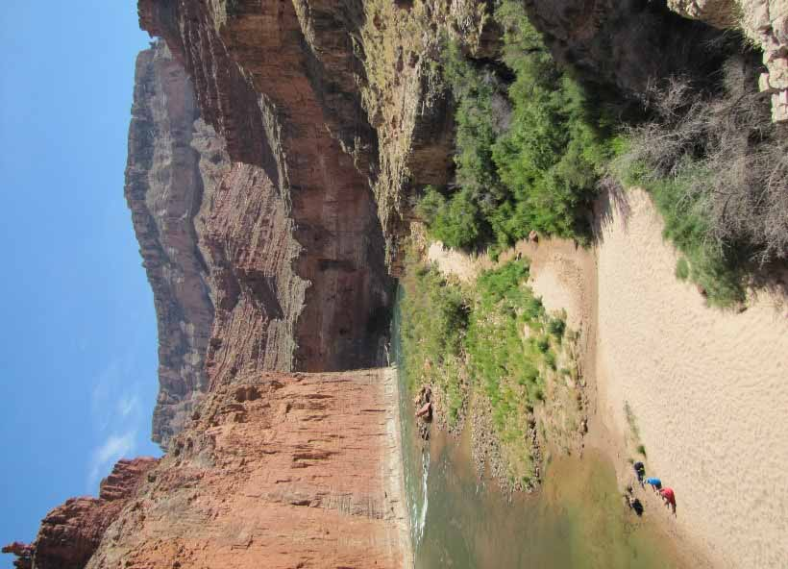
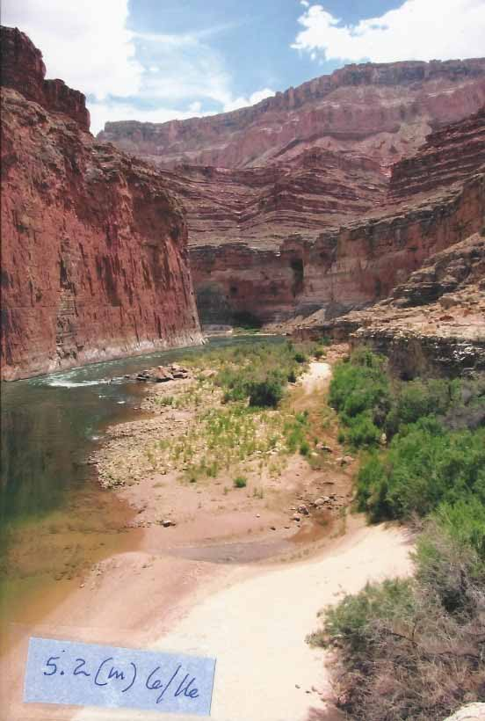
5.2 (m) 6/17
Figure 1.1. Beach at South Canyon, photos from 2016 on the left and from 2017 on the right.

Participants and monitors also visited and monitored the rock structure at South Canyon. The SPC cultural consultant spoke about the significance of sites such as these. It was observed that one wall of the rock structure had collapsed (See Figure 1.2). Trailing was noted alongside the exterior of the collapsed wall.

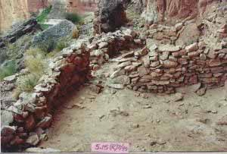
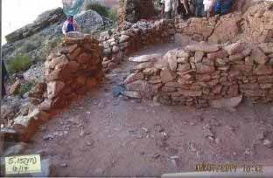
Figure 1.2. Photo of rock structure at South Canyon taken in 2017 (above left) and 1999 (above right). Note the collapse of the wall featured in the lower left-hand side of each photo.

Recommendation

The Consortium recommends that NPS evaluate the rock structure and the increased trailing around the structure. The SPC would like to see efforts made to discourage visitors from entering the structure.

Nankoweap – Site # 6

Nankoweap was visited in 2017. Tribal elders spoke with trip participants about the plants located at the site, their importance, and their ethnobotanical use. Tribal elders and the cultural consultant shared their knowledge of the bench and granary sites, including the importance of the living area at the confluence of Nankoweap Creek and the Colorado River and the impact of the loss of sediments and continued widening of the Creek channel at this site due to the operations of Glen Canyon Dam. As the monitors and cultural consultant visited the bench and granary sites, they observed two human impacts on the sites. At the bench site, the metate artifact had been moved, although it was still present at the rock shelter. At the granary, the SPC cultural consultant discovered a falsified artifact consisting of rope fibers hidden behind a rock.

The SPC director, monitors, and research specialists discussed how to best monitor the beach and vegetation near the confluence of Nankoweap Creek and the Colorado River. Two new photo points were established from high vantage points. However, in assessing the photos taken from these points, it was determined that they did not adequately document the area of concern.

Recommendation

The SPC director will renew outreach efforts to river guides in order to encourage guides not to hide real or fabricated artifacts within the canyon. The SPC remains concerned about the impacts of the HFEs on this site and will continue to assess how to best monitor this site. In this effort, the Consortium will coordinate with GCMRC to obtain aerial photos of the Nankoweap beach just above the entry of Nankoweap Creek, both recent photos as well as photos that pre-date the regular HFEs. In 2018, the Consortium will assess the possibility of establishing a beach overlook photo point on river left.

Tanner – Site # 8

The Tanner site was monitored in 2017. Trip participants were informed about the monitoring program at this site and were encouraged to practice their technical skills of photo matching. The SPC director, monitors, and research specialists noted no significant increase in erosion from the side canyon channel. Monitors observed that some rocks have been moved or piled near the rock panels. Two distinct trails were noted by monitors (see Figure 1.3). Monitors also noticed that trailing is occurring all around this site (see Figure 1.4). This trailing has happened in the past, as documented in SPC’s 2014 report (Bulletts et al. 2014)
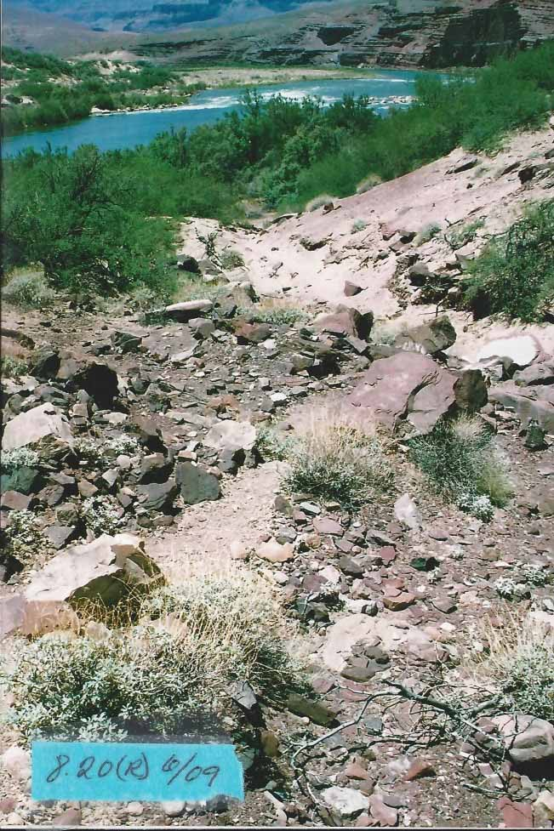
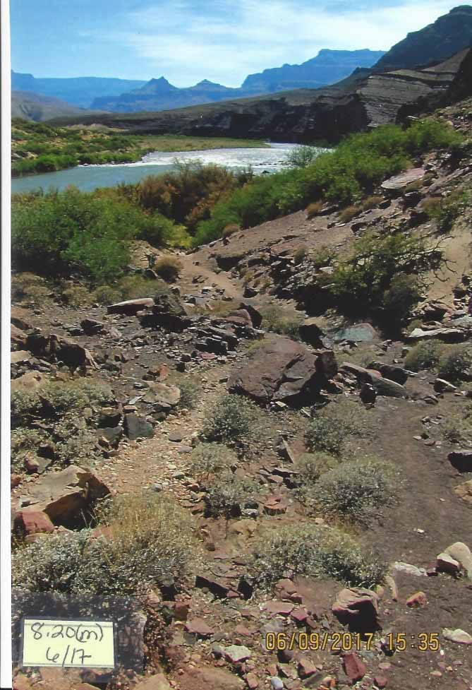
Figure 1.3. Photo on left is from 2009, and the dominant trail is observed cutting through the center of the photo. The photo on the right is from 2017. In it, two trails can be observed, one along the same trail from 2009 and the other along the right side of the photo.
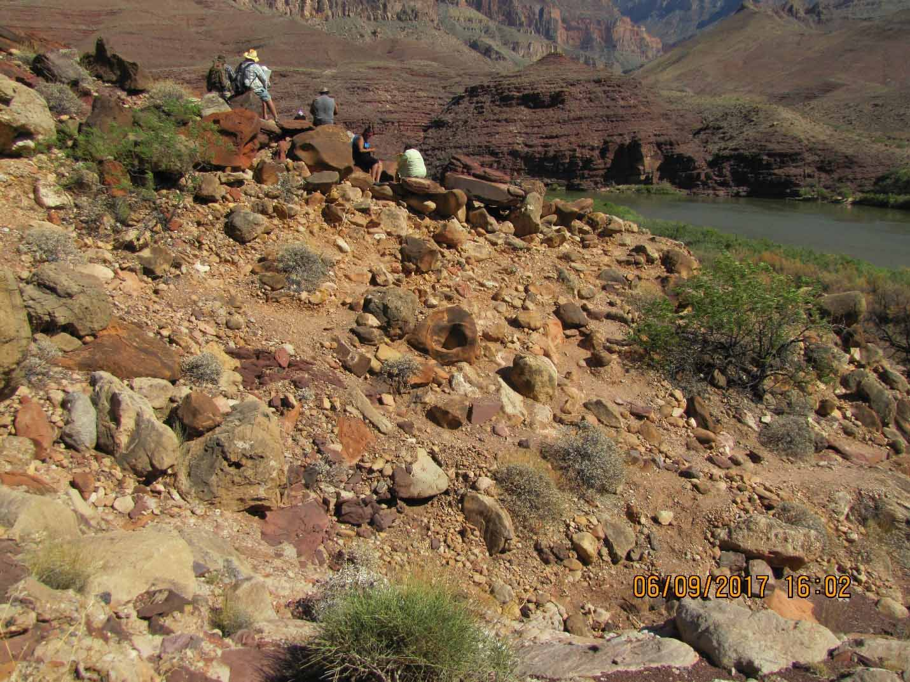
Figure 1.4. Photo shows trailing all around this site. The main tail is obscured.

Recommendation

The SPC recommends that NPS evaluate trailing at this site. The SPC would like to see efforts made to discourage visitors from creating their own trails.

Deer Creek – Site # 10

Cultural and spiritual activities were conducted at Deer Creek as well as monitoring of the rock writing panels and agave. The cultural consultant and tribal elders helped prepare trip participants for their visit, imparting important cultural knowledge linked to the site. SPC monitors, the director, cultural consultant, and tribal elders led trip participants in the monitoring.

At the rock writing panels, monitors reported slight erosion and evidence of mineral deposits on the prints. At one panel, the edge of the rock was shiny, suggesting that visitors are using it as a handhold (See Figure 1.5).
Figure 1.5. Panel at Deer Creek Narrows where the impacts of hand holding were observed in 2017, seen in the photo on the right. Photo on the left shows what used to be present.

The agave plots at Deer Creek were monitored in 2017. Monitors observed continued growth of agave plants as well as an increase in the number of pups at both agave sites. Trailing continues to be a concern at the secondary agave plot, where disturbance of the vegetation, including trampling of pups, was observed (See Figure 1.6).

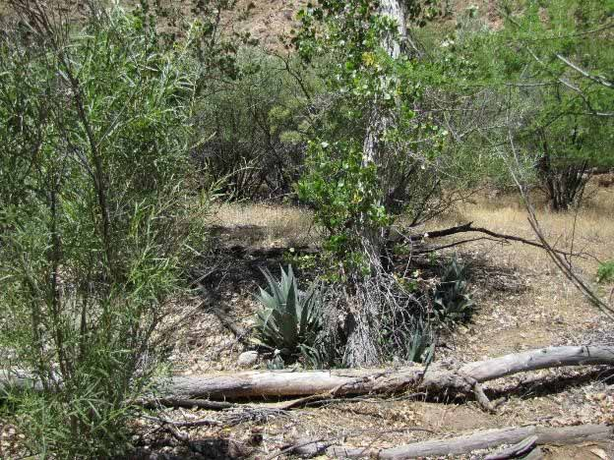
Figure 1.6. Trailing at the second agave plot at Deer Creek.

The Consortium conducted visitor monitoring at this site. SPC monitors noted the presence of 123 visitors to the lower site—Deer Creek falls between 9:00AM to 2:30PM. Forty visitors hiked to the narrows and visited the upper site.

Recommendation

SPC should identify and evaluate photo enhancement software in 2018 to better document changes to rock writing panels. The Consortium recommends that NPS address the increased trailing at the second agave plot.

Kanab Creek – Site #11

Kanab Creek was visited and monitored in 2017. Participants accompanied the Southern Paiute cultural consultant on a hike up the creek. Monitors, the SPC director, and research specialists discussed changes in monitoring. Two potential new photo points were established overlooking the beach.

Recommendation

SPC will take photos from the newly-established photo points in 2018, and should assess whether to continue taking photos from the additional photo points.

Vulcan’s Anvil – Site #12

Vulcan’s Anvil was visited for spiritual and ceremonial reasons in 2017. Six objects were removed from the Anvil. These included two piles of salt and four rocks, a decrease from the previous year in which twenty objects were removed from the Anvil.

Whitmore Wash - Site #13

In 2017, trip participants visited the Whitmore Wash site, holding discussions about its cultural significance. Tribal elders and the Southern Paiute cultural consultant spoke about the significance and interpretations of the rock writing panels. Participants were able to ask questions, engage in discussion with tribal experts, and inspect the rock writing panels. SPC monitors noted some fading of the rock writing, although they were unable to determine if the difference was caused by lighting conditions. A new trail leading from the end of the panels downriver was noted and photographed (See Figure 1.7).

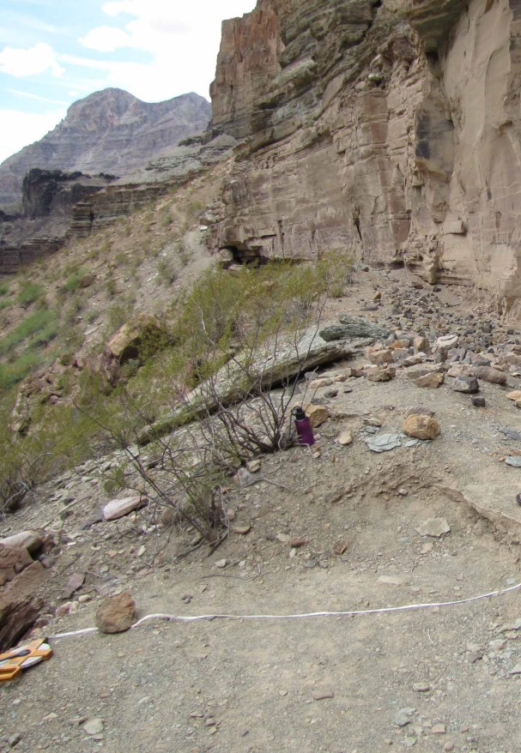

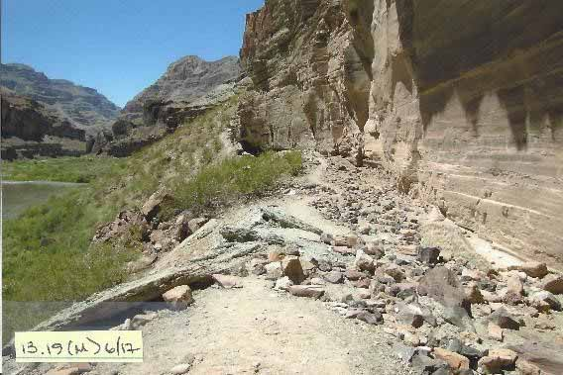

Figure 1.7. New trail leading downriver along rock writing panel at Whitmore, seen in the photo on the right from 2017. Photo on left was taken in 2014, and no trail is visible.

Recommendation

The SPC will continue to monitor trailing and any fading of the panel with new photo software. The SPC will identify and evaluate photo enhancement software in 2018 to better document changes to rock writing panels. The Consortium also recommends that NPS continue to add more vegetation so that tourists cannot approach the rock writing panel in an effort to mitigate new trailing in the area.

Ompi Cave – Site #15

This site was visited for spiritual and ceremonial reasons.

Spring Canyon – Site #16

Spring Canyon was not monitored in 2017. While some flooding has opened a small gap at the mouth of the canyon, the site remains protected by thick vegetation, so monitors did not approach the site in order to avoid creating a trail there.

Recommendation

The SPC will renew monitoring at the site when a flash flood scours the canyon, enabling access to the site and reducing the protection it receives from the vegetation.

Indian Canyon – Site #17

This site was monitored in 2017. Monitors noted that vegetation in the roasting pit has increased, but no other changes were noted.

Pumpkin Spring – Site #18

Pumpkin Spring was visited and monitored in 2017. It remains a site of active erosion and deposition. The SPC monitors and director explained the site’s monitoring program to trip participants and a discussion was held about future monitoring at the site. No significant changes in the spring were observed.

Other Activities during the River Trip

Throughout the trip, participants gathered every other evening in a circle to share thoughts and feelings about the day’s experiences and prepare for the following day’s activities. Information shared during these group meetings included stories about the places and the culturally appropriate behaviors expected there. All participants discussed what they knew about the places and shared their feelings about visiting them, often in relation to their past experiences and contemporary lives “up on top,” outside the river corridor. The participants also provided additional information about other groups and historical/political events related to places that were visited. The evenings ended with time for prayer and reflection after everyone had a chance to be heard, and to speak as much as they liked regarding the issues that affected them.

Revision of The Monitoring Program and Updated Four-Year Plan

Initial Assessment and Suggestions

Throughout the 2017 river trip and in ongoing discussions, the SPC engaged in an assessment of the monitoring program. This year’s initial assessment identified three main challenges. These include: the lack of availability of a botanist knowledgeable about the flora and environmental history of the Colorado River Corridor, experienced in monitoring, and knowledgeable about Southern Paiute history and culture; the need to strengthen communication between the SPC and tribal councils, consultants, and tribal members; and the lack of easy access to the information collected under the monitoring program. These challenges will be addressed in the program redesign which will be completed in FY2018.

Given limitations in both financial and human resources, the SPC has decided to suspend recording of plant observations based on plant transects—a process that necessitated hiring a trained botanist. The flora of the Colorado River Corridor remains highly important for Southern Paiutes. In order to continue to monitor plant species along the corridor and any possible impacts associated with the changing operation of the dam, Southern Paiutes will continue to visit sites where plant resources of special concern are found, engaging in a series of ethnobotanical discussions. Additional efforts will be made to record elders knowledgeable about culturally important plants as they lead these ethnobotanical discussions. Finally, the Consortium will explore other options for monitoring the areas where plant transects had been done. In 2017, monitors sought to establish new photo points overlooking the Nankoweap site where plant transects had been done. It was later determined that the new photo points did not adequately capture the area of concern. In 2018, the Consortium will seek to establish a photo point overlooking the site from river left, continuing the SPC’s effort to evaluate options for monitoring the impact of the dam on the beach and vegetation at the Nankoweap site.

The assessment also revealed the integral nature of communication in maintaining a well-run program and in addressing programmatic goals. Initial steps are being implemented to improve communication between the SPC and tribal councils, tribal members, and GCDAMP members. In 2017, the SPC Director began working with the tribal council of the Kaibab Band of Paiute Indians to select river trip participants. This change directly involves the tribal council in the monitoring and education program and provides increased transparency in the participant selection process. Steps to improve communication between the SPC and GCDAMP are addressed in Chapter 2.

Easier access to more information about culturally important places and resources is an important goal of the newly designed program. Discussions were held during the 2017 river trip to solicit input about how to make the information collected during river trips more accessible both to trip participants and to all tribal members. One initial effort to address this concern included the sharing of previous ethnographic research related to the monitoring sites. The reports, Piapaxa ‘Uipi (Big River Canyon): Southern Paiute Ethnographic Resource Inventory and Assessment (Stoffle, Halmo, Evans, and Austin 1994) and Tumpituxwinap (Storied Rocks): Southern Paiute Rock Art in the Colorado River Corridor (Stoffle, Loendorf, Austin, Halmo, Bulletts, and Fulfrost 1995) were circulated in the morning and evening so that trip participants could learn about the sites visited and the stories linked to each site. In particular, participants reported that they valued the quotes, stories, and information shared by elders that were highlighted in the reports.

As was the case in 2017, participants on river trips frequently request more information about monitoring sites, plants, rock writing panels, archaeological sites, place names, and the impacts wrought by visitors and the operation of the dam. To provide trip participants and other tribal members with more information, the SPC will synthesize the data collected over the past twenty years, compiling interviews, reports, photos, and other relevant data. This information will be presented in an accessible format, one that is easy to regularly update in light of new findings and changing adaptive management strategies. The Consortium will take advantage of new technologies, using collected data and information to ensure that river trip participants have at their disposal important information related to the sites visited. For example, this information may include maps, short video clips of elders sharing ethnobotanical information, and excerpts from interviews relaying stories connected to selected sites. Key themes (ethnobotany, language, traditional cultural property, sediment deposition) will be presented to further contribute to Southern Paiute and non-Paiute understandings of the region.

The compilation of collected information is an important way to connect each year’s river trip participants with previous participants as well as with the history of Southern Paiutes in the Colorado River Corridor. The elders who had experiential knowledge of the Colorado River Corridor before the dam was constructed were crucial in establishing the program, but few individuals of that generation remain. In light of having fewer elders who can continue to participate in the river trips, the Consortium is committed to increasing the educational conversations and activities that occur during the river trips.

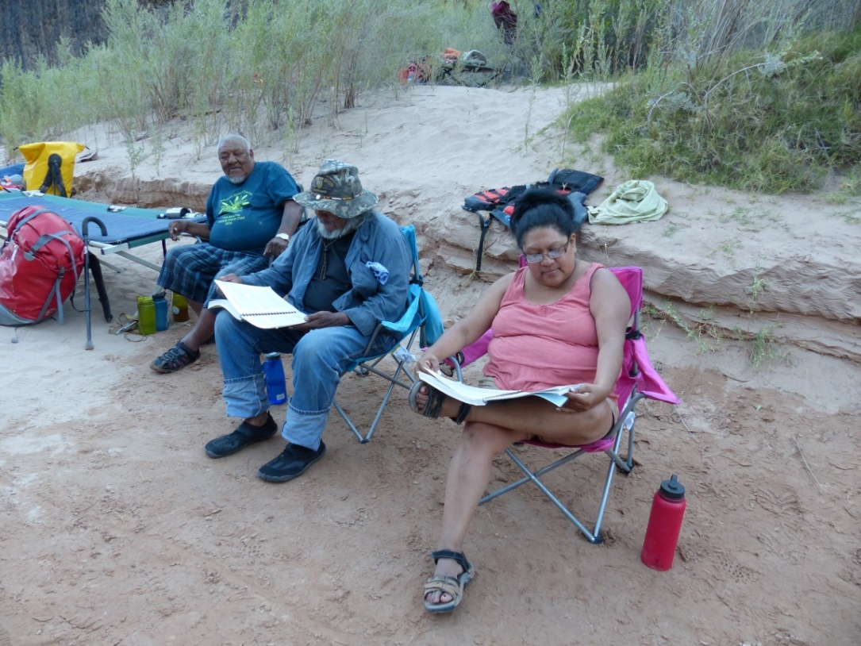
Figure 1.8. Trip participants review ethnographic studies detailing Southern Paiute understandings of the monitoring sites visited along the Colorado River corridor.

Finally, the upriver assessment yielded important insights that will be incorporated in the program redesign. The ten-year gap in monitoring of the sites located between Lees Ferry and the Glen Canyon Dam paired with the significant changes observed at those sites demonstrate the importance of regular monitoring of frequently visited sites. The observed impacts of visitors at the upriver sites prompted conversations about incorporating visitor monitoring as a daily aspect of the SPC monitoring and education program. In the redesigned program, monitoring will include more dispersed observations of visitor behavior and the related physical conditions of the sites (“public interference”). The role of trip participants will broaden, with participants taking on increased responsibilities in the monitoring process. Regular monitoring paired with effective communication of observations has the potential to mitigate negative impacts from visitor presence at sites or from the changing operations of the dam.

Updated Four-Year Plan

The Consortium’s four-year plan was updated based on the assessment done in 2017.
Notably, the sites where plant monitoring was done by taking transect readings are no longer listed on the four-year plan. The Consortium will continue to monitor the archaeology and beaches at these sites and will incorporate site-specific discussions of ethnobotanical knowledge. However, in instances where the presence of visitors would damage the area, the sites will not be visited (i.e. river right at Vulcan’s Anvil). The revised four-year plan is included below in Table 1.2.

Table 1.2. Southern Paiute Consortium – 4 year plan
Site | 2018 | 2019 | 2020 | 2021
South Canyon | beach, archaeology | beach, cultural* | beach, archaeology | beach, cultural
Nankoweap | archaeology | cultural | archaeology | cultural
Lava/Chuar | archaeology |  | archaeology
Tanner | archaeology |  |  | archaeology
Bedrock |  | cultural
Deer Creek | beach, archaeology, plants | beach, archaeology, plants | beach, archaeology, plants | beach, archaeology, plants
Kanab Creek | beach | beach | beach | beach
Vulcan’s Anvil | cultural | cultural | cultural | cultural
Whitmore | beach, archaeology | beach, archaeology | beach, archaeology | beach, archaeology
Pre-Parashant |  |  |  | archaeology
Ompi | cultural | cultural | cultural | cultural
Spring Canyon | archaeology, plants | cultural | archaeology, plants | cultural
Indian Canyon | archaeology | cultural | archaeology | cultural
Pumpkin Spring | spring, cultural | spring, cultural | spring, cultural | spring, cultural
Ledges | archaeology, spring |  |  | archaeology, spring
Granite Park | cultural | cultural | cultural | cultural
*Southern Paiutes recognize sites with archaeology, plant gathering areas, springs, and many other features as cultural sites. Terminology used in this table reflects designations commonly used by scientists and resource managers and is used to aid in communication. Sites indicated as “cultural” in this table are those which do not fit into the other categories.

Chapter Two
Meetings and Conferences

Much of the work conducted under the PA during FY2017 was done in committees and meetings. This chapter summarizes the interactions between the Southern Paiute Consortium (SPC) and others with an interest in cultural resources in the Colorado River Corridor.

Meetings and Conferences

The Southern Paiute Consortium was represented at meetings of the Adaptive Management Work Group (AMWG), the Technical Work Group (TWG), the Programmatic Agreement (PA) related to the Long Term Experimental and Management Plan (LTEMP), and the Grand Canyon Monitoring and Research Center (GCMRC). All of these activities are informed by the information that the SPC gathers during its annual Colorado River trips. The SPC Director is responsible for ensuring that the information is passed between the Southern Paiutes and the federal managers responsible for operations of the Glen Canyon Dam and the resources within the Colorado River Corridor.

Long Term Experimental and Management Plan

The SPC Director met with representatives of the Long-Term Experimental and Management Plan (LTEMP), and participated in conference calls and meetings related to the EIS. The SPC Director also met with Consortium and tribal representatives, including past directors, tribal government officials, and cultural experts, to discuss feedback on the LTEMP process. The Record of Decision for the LTEMP was signed in December 2016, and the Kaibab Band of Paiute Indians and the Shivwits Band of Paiute Indians are signatories of the LTEMP.

Adaptive Management Work Group and Technical Work Group

On behalf of the Consortium, the SPC Director participated in two AMWG meetings (January and August), three AMWG conference calls (February, May and July), and four TWG meetings (October, December, April, and June). At these meetings, the SPC Director conveyed to the work groups the Consortium’s position that the Colorado River Corridor is a significant cultural landscape and is vital to the physical and spiritual well-being of Southern Paiute people (see Stoffle, Halmo, and Austin 1997).

Meetings and Interaction with Federal Agencies, Tribal Leaders, and Members

The SPC Director met with Glen and Grand Canyon National Park Service representatives to discuss projects and activities that could potentially impact the Colorado River Corridor. The SPC Director participated in numerous conference calls with federal agencies that are PA Signatories. Additionally, the SPC Director presented reports to the Paiute Indian Tribe of Utah, the Shivwits Band of Paiute Indians, and the Kaibab Band of Paiute Indians explaining and outlining the LTEMP process.

Finally, strong communication is needed between the Consortium and the other members of the GCDAMP so that information might be productively exchanged. High turnover among members of the adaptive management program necessitates continual education of fellow AMP members regarding Southern Paiute values and perspectives attached to sites within the Colorado River corridor. The SPC is committed to sharing relevant information about culturally important places and resources to all members and to educating incoming members about Southern Paiute perspectives on resource management in the canyon.

References

Austin, Diane, Sophia Borgias, and Kevin Bulletts
Forthcoming Report on the Ethnographic Research by the Southern Paiute Consortium to Inform Management of the Traditional Cultural Property and Other Tribal Historic Properties in the Colorado River Corridor Below Glen Canyon Dam to Lees Ferry, Arizona. Prepared for the National Park Service. Prepared by the Bureau of Applied Research in Anthropology, University of Arizona and Anthropological Research LLC on behalf of the Southern Paiute Consortium, Tucson, AZ.

Austin, Diane, Arthur Phillips III, David Seibert, and Kevin Bulletts.
2007 Southern Paiute Participation in the Glen Canyon Adaptive Management Program: A Ten Year Review. Prepared by the Bureau of Applied Research in Anthropology, University of Arizona, Tucson, Arizona and the Southern Paiute Consortium, Kaibab, Arizona. Prepared for the Bureau of Reclamation. June 29.

Austin, Diane E., Brian K. Fulfrost, Cynthia Osife, Tricia F. Drye, and Glenn Rogers
- 1996 Southern Paiute Consortium Colorado River Corridor Monitoring and Education Program: Summary. Prepared for the Glen Canyon Environmental Studies, Bureau of Reclamation. Prepared by the Southern Paiute Consortium, Pipe Spring, Arizona and Bureau of Applied Research in Anthropology, University of Arizona, Tucson, Arizona. September.

Bulletts, Charley.
2017 2016 Southern Paiute Consortium Colorado River Corridor Resource Evaluation Program: Annual Report of Activities. Prepared by the Southern Paiute Consortium, Pipe Spring, Arizona and the Bureau of Applied Research in Anthropology, University of Arizona, Tucson, Arizona. February 21.

Bulletts, Charley, Shanan Anderson, Mike Osife, Kevin Bulletts, Megan Sheehan, Amanda Hilton, and Diane Austin
2014 2014 Southern Paiute Consortium Colorado River Corridor Resource Evaluations Program Annual Report of Activities. Prepared for the Glen Canyon Environmental Studies, Bureau of Reclamation. Prepared by the Southern Paiute Consortium, Pipe Spring, Arizona and Bureau of Applied Research in Anthropology, University of Arizona, Tucson, Arizona. September.

Stoffle, Richard W., Diane E. Austin, Brian K. Fulfrost, Arthur M. Phillips, III, and Tricia F.
Drye
1995 Itus, Auv, Te'ek (Past, Present, Future): Managing Southern Paiute Resources in the Colorado River Corridor. Prepared for the Glen Canyon Environmental Studies, Bureau of Reclamation. Prepared by the Bureau of Applied Research in Anthropology, University of Arizona, Tucson, Arizona. September.

Stoffle, Richard W., David B. Halmo, and Diane E. Austin
- Cultural Landscapes and Traditional Cultural Properties: A Southern Paiute View of the Grand Canyon and Colorado River. American Indian Quarterly 21(2): 229-249.

Stoffle, Richard W., David B. Halmo, Michael J. Evans and Diane E. Austin
1994 Piapaxa ‘Uipi (Big River Canyon): Southern Paiute Ethnographic Resource Inventory and Assessment. Prepared for the National Park Service, Rocky Mountain Regional Office and for the Glen Canyon Environmental Studies, Bureau of Reclamation. Prepared by Bureau of Applied Research in Anthropology, University of Arizona, Tucson, Arizona. June.

Stoffle, Richard W., Lawrence L. Loendorf, Diane E. Austin, David B. Halmo,
Angelita S. Bulletts, and Brian K. Fulfrost
1995 Tumpituxwinap (Storied Rocks): Southern Paiute Rock Art in the Colorado River Corridor. Prepared for the Glen Canyon Environmental Studies, Bureau of Reclamation. Prepared by the Southern Paiute Consortium, Pipe Spring, Arizona and Bureau of Applied Research in Anthropology, University of Arizona, Tucson, Arizona. September.

