Photos of Shoreline Habitats used by Juvenile
Trout and Humpback Chub
Rich Valdez
February 12, 2014

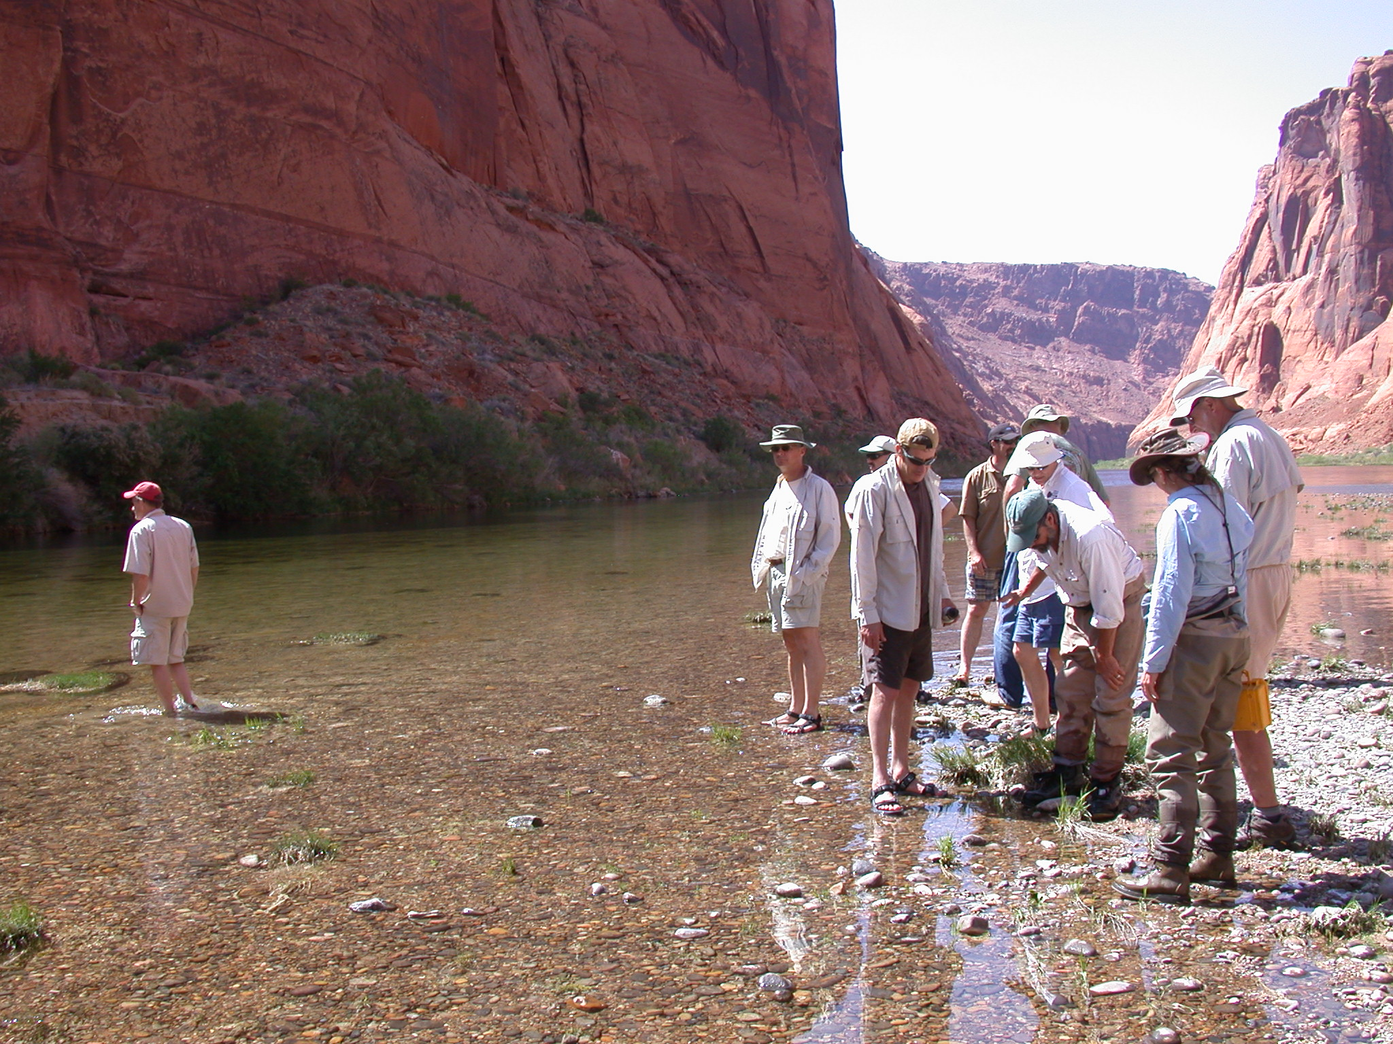
Glen Canyon about 5 miles downstream of Glen Canyon Dam. Low-angle shorelines used by small juvenile trout, May-August.

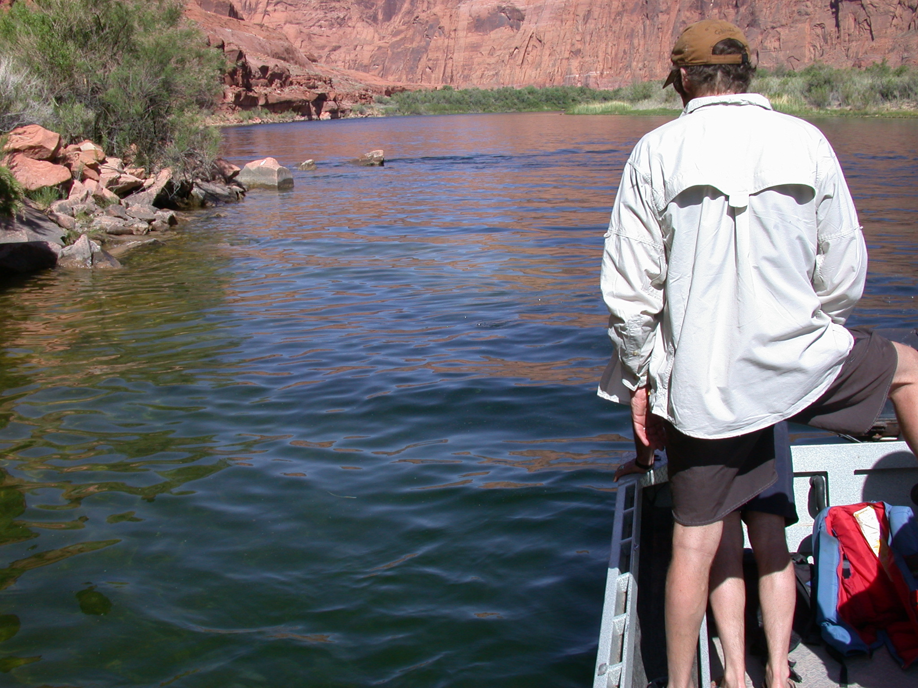
Glen Canyon about 7 miles downstream of Glen Canyon Dam. High-angle shorelines used by large juvenile trout, August +.
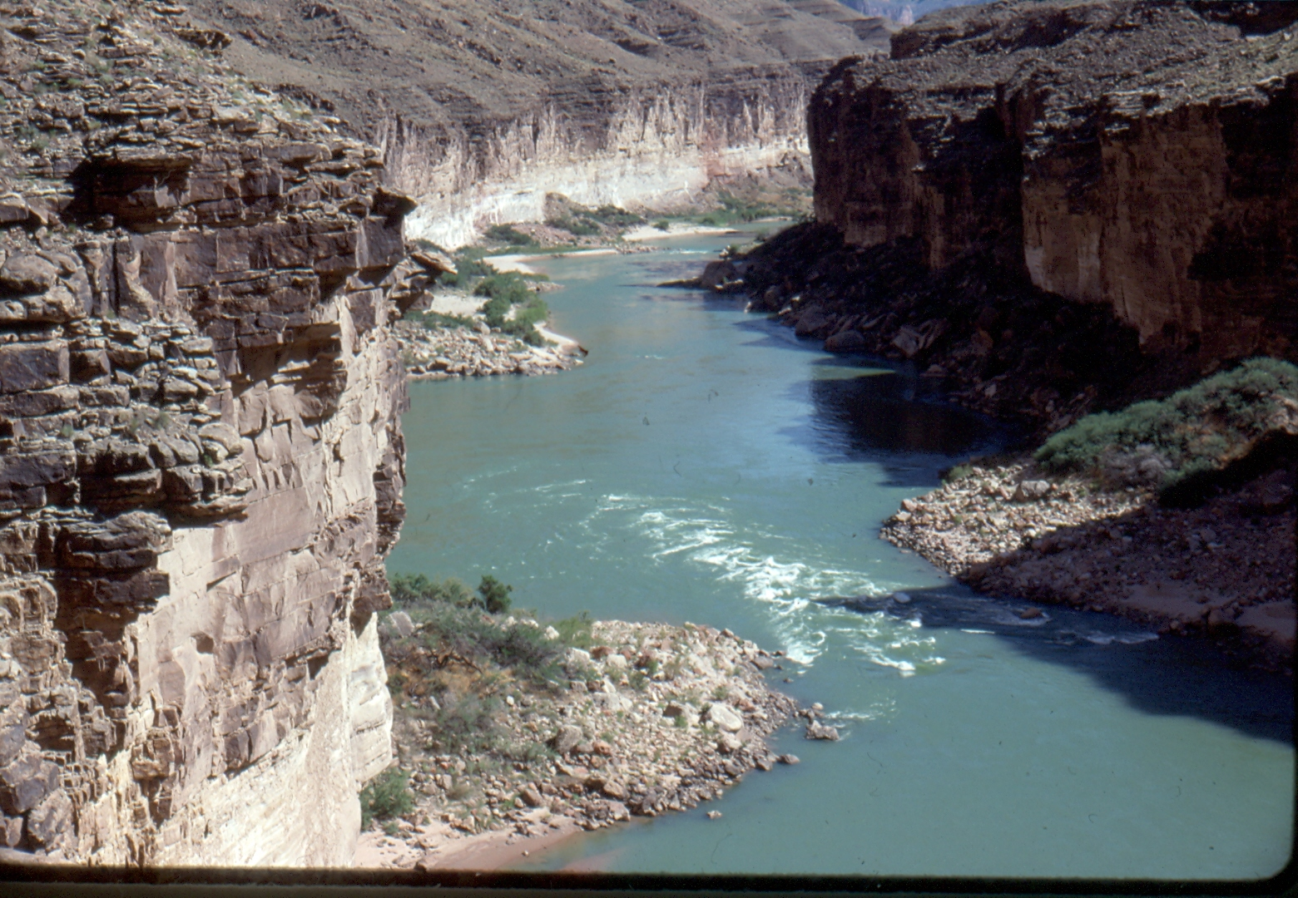
Colorado River 1 mile downstream of LCR confluence—Alluvial cobble fans and talus shoreline (in shade) used by juvenile HBC in Grand Canyon; adults use large recirculating eddies and may move to shorelines at night.

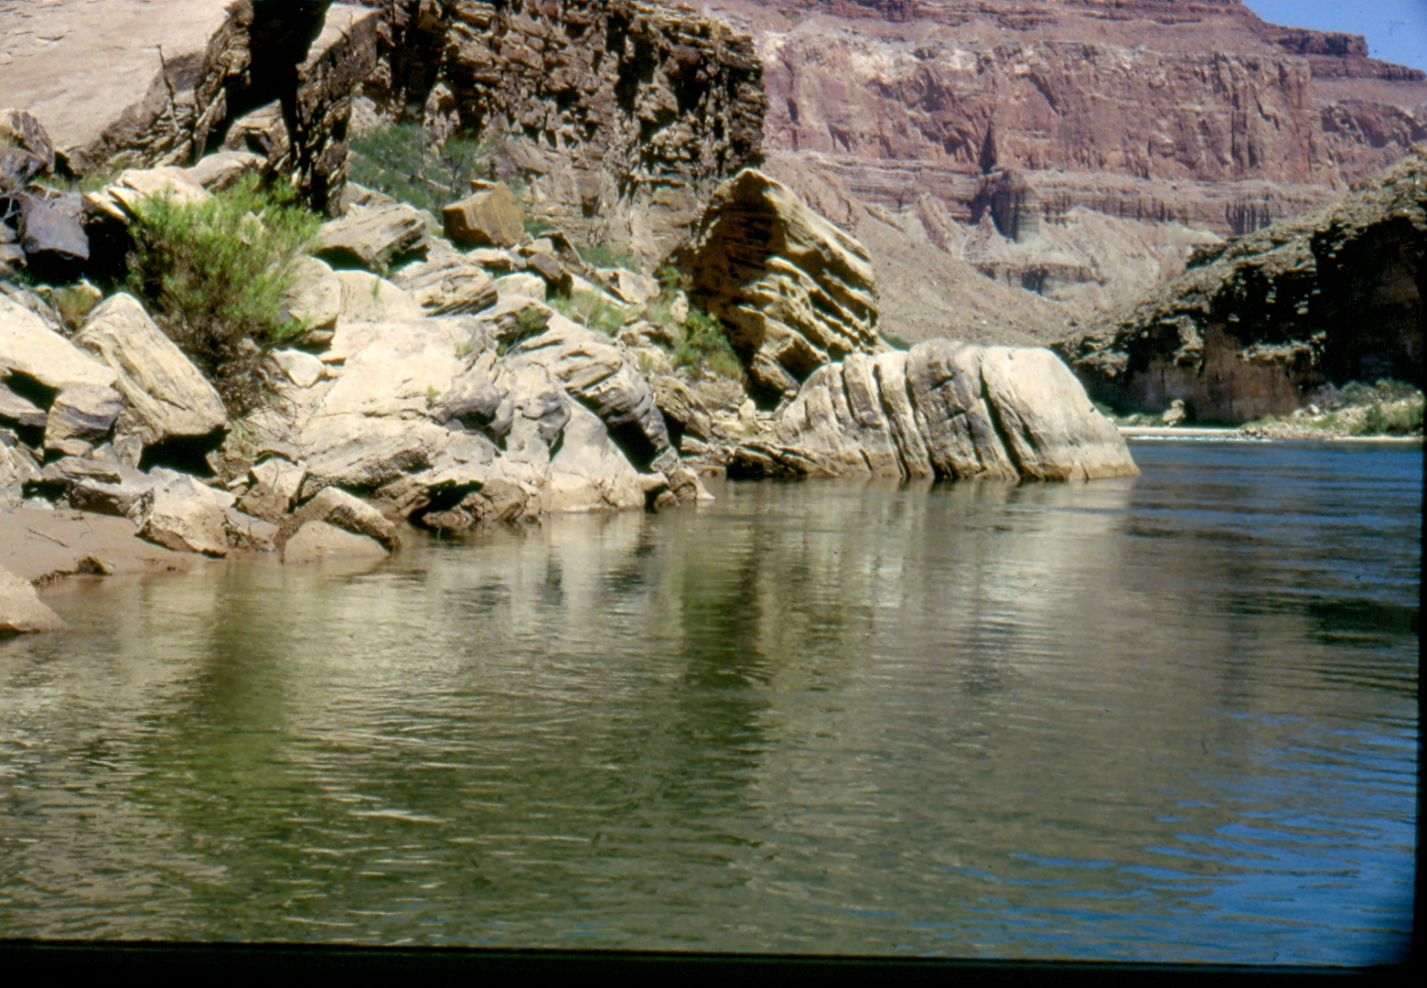
Colorado River 1.5 mile downstream of LCR confluence—Boulder shoreline used by juvenile HBC in Grand Canyon; adults use this habitat at night.
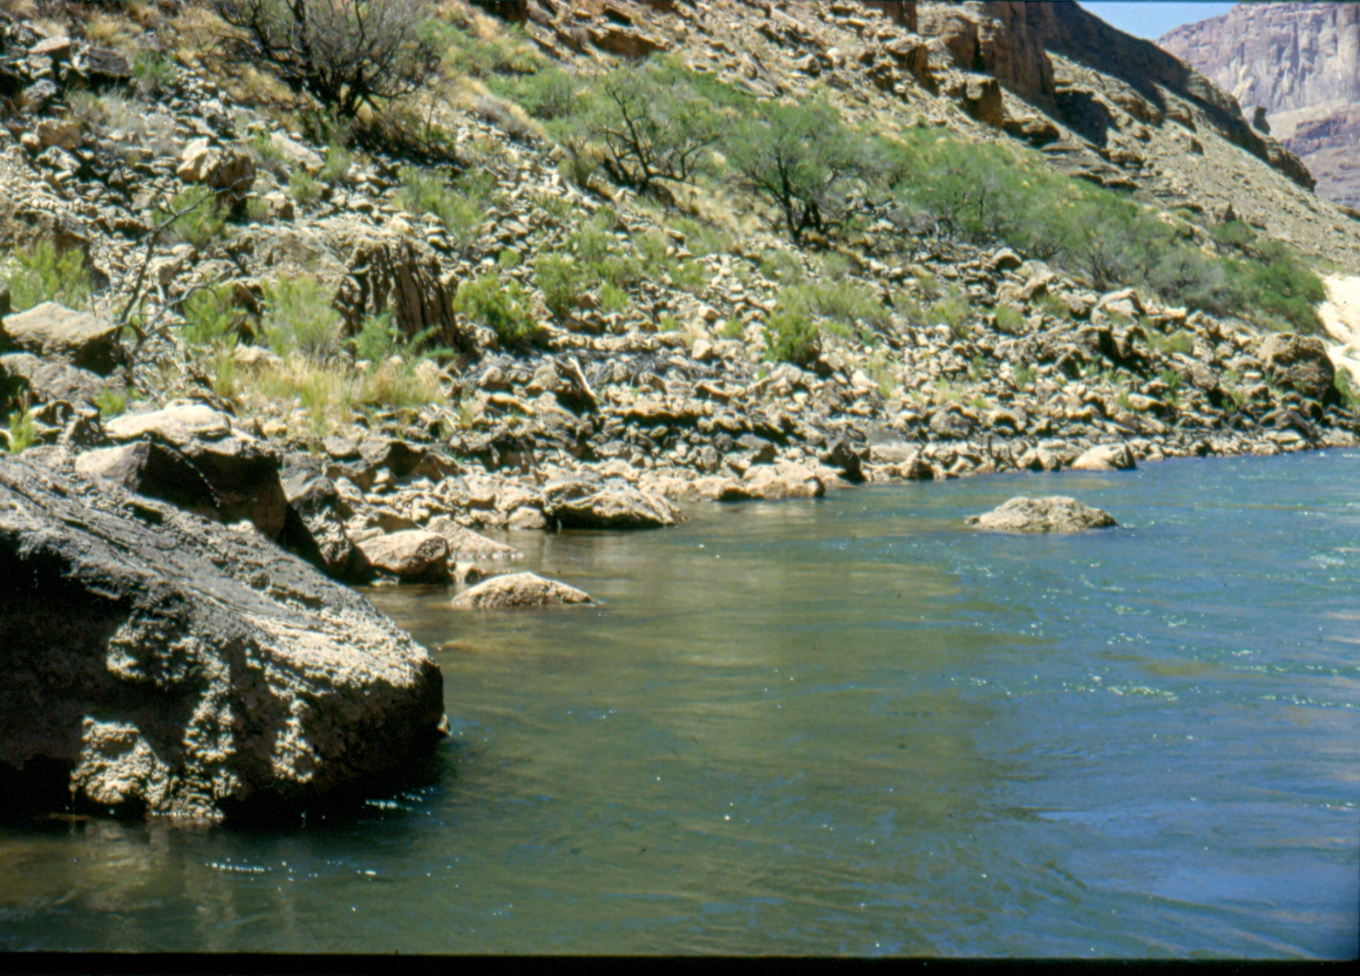
Colorado River 1.5 mile downstream of LCR confluence—Talus shoreline used by juvenile HBC in Grand Canyon.

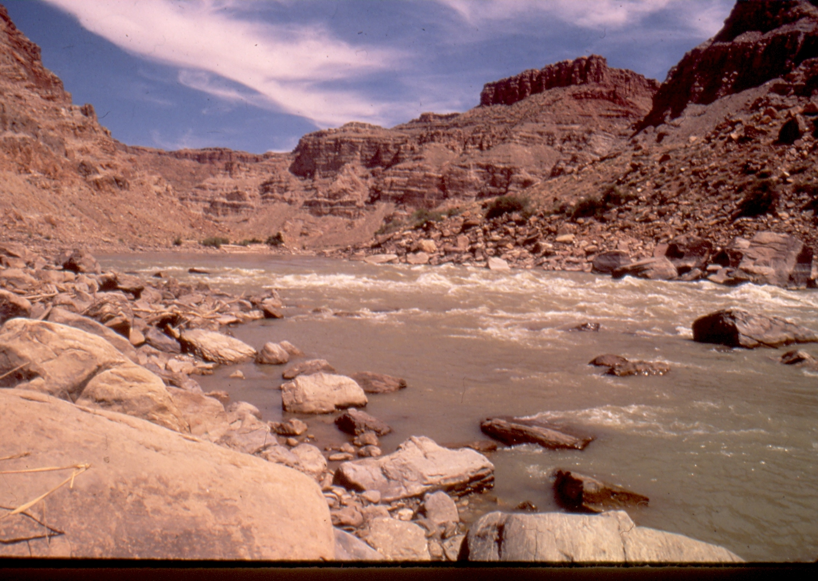
Cataract Canyon—Talus shoreline used by all life stages of HBC.

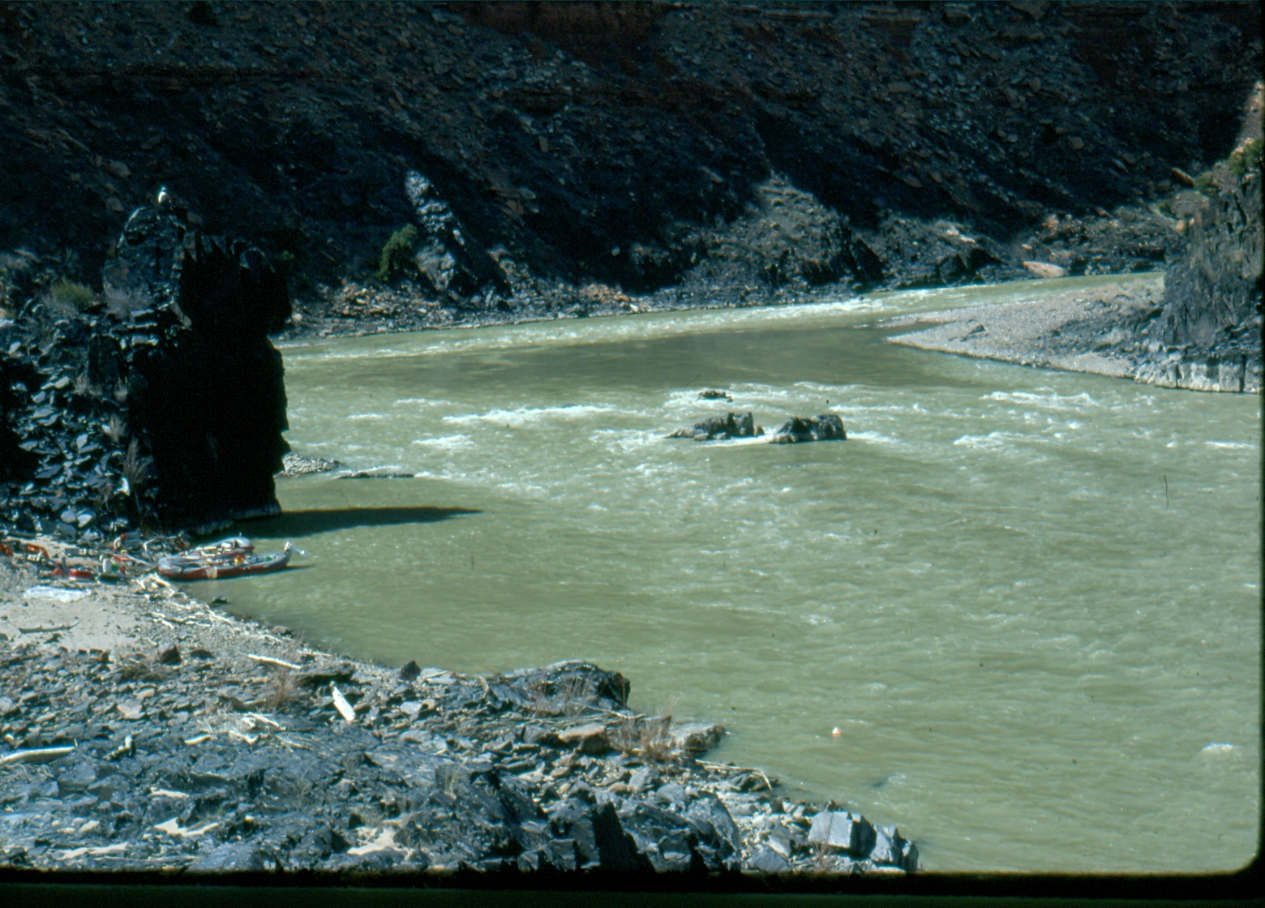
Westwater Canyon—Rock cliffs and shoreline cobble/boulders used by juveniles and adults.

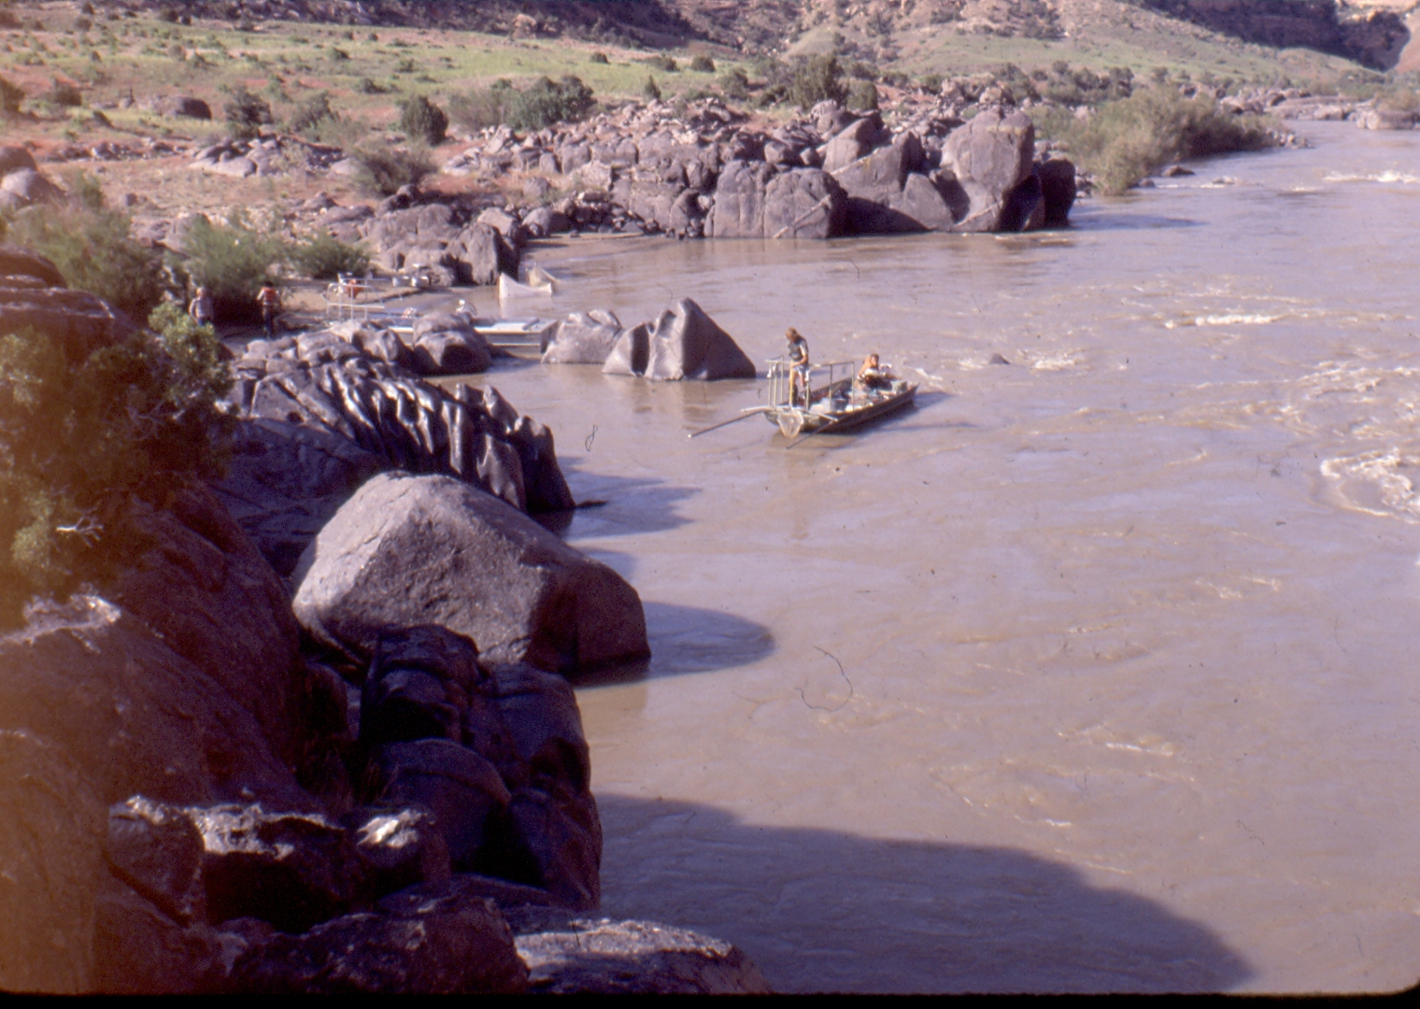
Black Rocks—Emergent Precambrian structure forms pocket and rooms used by juveniles and adults.

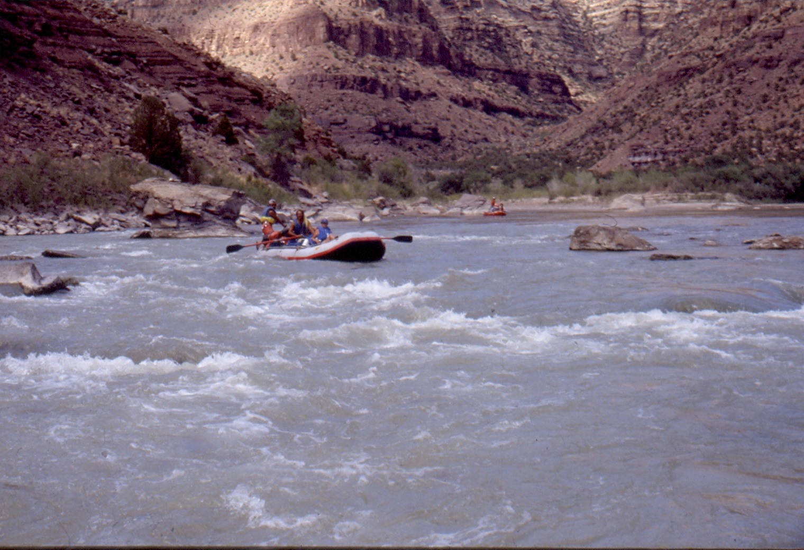
Desolation Canyon—Emergent mid-channel rocks and structure used by juveniles and adults.

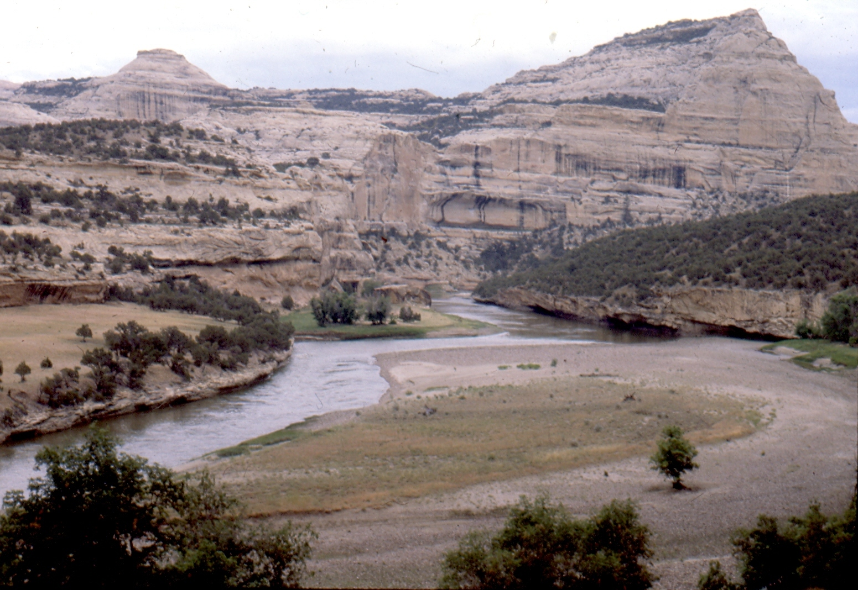
Yampa Canyon—HBC in Yampa Canyon rely more on pool-riffle sequence and vertical walls.

