2012 SOUTHERN PAIUTE CONSORTIUM
Colorado River Corridor Resource Evaluation Program
Annual Report of Activities

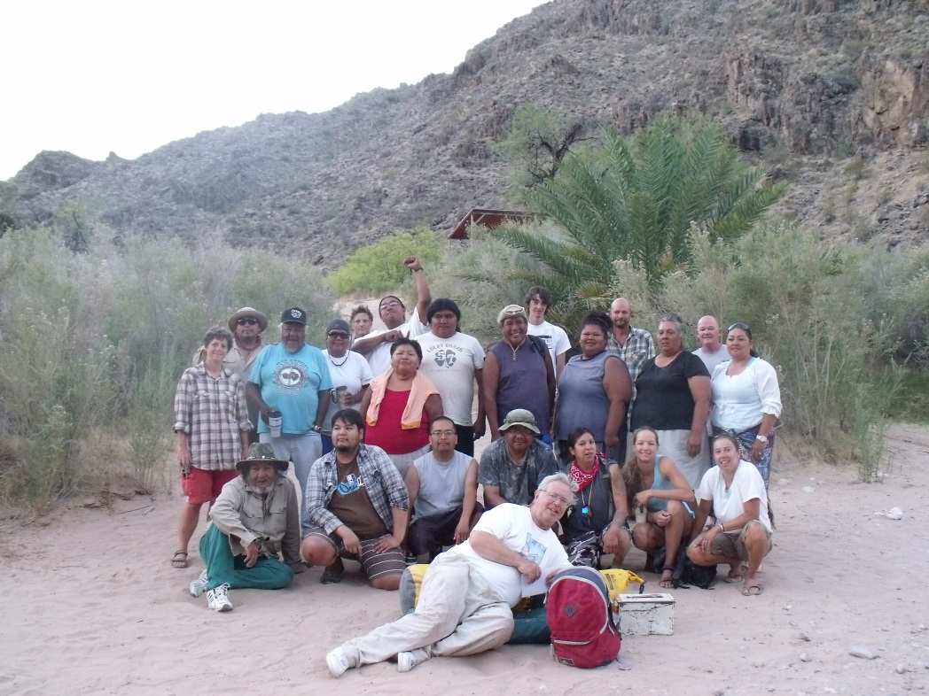

Prepared by:

Charley Bulletts
Michael Osife
Shanan Anderson
Arthur M. Phillips III
Carrie Cannon
Kevin Bulletts
Diane Austin

Southern Paiute Consortium

Pipe Spring, Arizona

and

Bureau of Applied Research in Anthropology

University of Arizona

Tucson, Arizona

October 24, 2012

Report of work carried out under Southern Paiute Consortium Cooperative Agreement with the Bureau of Reclamation, #R11AP40007-R10PC40021

Special Thanks

This report is dedicated to Dr. Arthur Phillips, good friend and ethnobotanist for the Southern Paiute Consortium’s Colorado River Monitoring and Education Program and the Kaibab Paiute Tribe’s Cultural Resource Program. For the past 20 years, Art has shared his knowledge and good nature with us. He has worked alongside us to help conduct research, develop and carry out our monitoring program, and create educational materials related to the Colorado River Corridor. Thanks, Art!

Introduction

The traditional lands of the Southern Paiute people are bounded by more than 600 miles of the Colorado River from the Kaiparowits Plateau in the north to Blythe, California in the south. According to Southern Paiute traditional knowledge, Southern Paiutes were the first inhabitants of this region and are responsible for protecting and managing this land along with the water and all that is upon and within it.

Today the Colorado River flows through Grand Canyon National Park and Glen Canyon National Recreation Area, as well as the Navajo and Hualapai reservations. The Bureau of Reclamation (BOR) completed the construction Glen Canyon Dam on the Colorado River in 1963 and became responsible for management of the Dam. U.S. federal law requires that Glen Canyon Dam be operated with minimal impact to the natural, recreational, and cultural resources of the Colorado River Corridor, the region of the Colorado River between Glen Canyon Dam and Lake Mead that is potentially impacted by flows from the dam. The National Historic Preservation Act mandates that the impacts of any federal undertaking that will negatively affect historic and traditional cultural properties be evaluated, and the Southern Paiute monitoring program is designed to address this mandate. The Grand Canyon Protection Act and the Environmental Impact Statement for the Operation of the Glen Canyon Dam (GCDEIS) establish a program of long-term research and monitoring of the effects of the dam on these resources.

In 1991, three Southern Paiute tribes – the Kaibab Band of Paiute Indians, the Paiute Indian Tribe of Utah (representing Shivwits Band of Paiute Indians), and the San Juan Southern Paiute Tribe – agreed to participate in studies to identify cultural resources impacted by Glen Canyon Dam and to recommend strategies for their protection. In 1993, the Kaibab Band of Paiute Indians and the Paiute Indian Tribe of Utah created the Southern Paiute Consortium (SPC) to ensure more effective government-to-government interactions between the tribes and the BOR. The SPC took over the cultural resource studies being conducted under the GCDEIS.

The BOR and National Park Service (NPS) developed a Programmatic Agreement (PA) on Cultural Resources for Glen Canyon Dam Operations. On February 9, 1994, the PA was signed by the Advisory Council on Historic Preservation, the Arizona State Historic Preservation Office, the BOR, the NPS and the Hopi Tribe, the Hualapai Tribe, the Navajo Nation, the Paiute Indian Tribe of Utah, the Kaibab Band of Paiute Indians, the San Juan Southern Paiute Tribe, and Zuni Pueblo.The PA lays out a plan for agency compliance with Section 106 of the National Historic Preservation Act through the development of monitoring and management protocols for cultural resources in the Colorado River Corridor. It directs the BOR and NPS to develop and implement a plan for monitoring the remedial actions and to develop a Historic Preservation Plan (HPP) for long-term monitoring and management.

In 1995, the GCDEIS was completed and transition to the Adaptive Management Program called for in the Grand Canyon Protection Act was begun. At that time, the SPC expanded the research activities it began under the GCDEIS to include assessing potential environmental impacts, developing monitoring procedures, and interacting with the BOR and other PA signatories. It established the Colorado River Monitoring and Environmental Education program. The basis for the program and the results of its initial development and implementation are fully discussed in the report, Itus, Auv, Te’ek (Past, Present, Future): Managing Southern Paiute Resources in the Colorado River Corridor (Stoffle, Austin, Fulfrost, Phillips, and Drye 1995). The results of each succeeding year’s activities are reported in annual reports to the BOR.

The 2012 program had eight goals: (1) implementation of the SPC’s monitoring program; (2) training and education of Southern Paiute monitors; (3) education of Southern Paiute tribal members and the general public; (4) discussion and evaluation of traditional cultural properties protection and management; (5) visitation of Grand Canyon Superintendent to provide input for tribal consultation with the National Park Service; (6) consultation among Southern Paiute tribal members to determine the future objectives of the SPC monitoring program on the Colorado River; (7) video documentation and archiving of the ethnobotanycomponent of the program; and (8) training of a new ethnobotanist. All of these goals were accomplished during 2012. Regular monitoring activities were conducted during a ten-day trip between Lees Ferry and Diamond Creek.

This report summarizes the activities of the SPC undertaken as part of its responsibilities to protect and manage the land, water, and resources within Southern Paiute traditional territory and as a PA signatory. Chapter One, “Cultural Resources Evaluation,” describes the results of the SPC’s 2012 river trip to monitor SPC cultural resources, gather information for tribal members and leaders, and otherwise conduct activities deemed necessary for fulfilling those responsibilities. Education and training are critical facets of the SPC program that ensure that the Southern Paiutes can continue to fulfill their responsibilities into the future. Chapter Two summarizes the results of the education and training components of the SPC program, including the planning and initial development of the video documentation and archiving of information about the ethnobotany component of the program. There are many groups with many diverse interests involved in the Adaptive Management Program, and much time is spent in meetings and conferences where information is shared. Chapter Three describes the SPC’s participation in those meetings and the other activities it undertakes to enhance its ability to successfully carry out its responsibilities.

Chapter One
Cultural Resource Evaluation

The SPC cultural resource monitoring program was developed to evaluate the effects of the operation of Glen Canyon Dam on cultural resources that have been identified by Southern Paiute consultants within the Colorado River Corridor. Indirect effects of dam operation on important cultural sites may extend well beyond the river’s edge, and variations in river level may affect site access, frequency of visitor use, and plant and animal communities well beyond the shoreline river (see Fig. 1.3, Itus, Auv, Te’ek [Past, Present, Future]: Managing Southern Paiute Resources in the Colorado River Corridor, [Stoffle, Austin, Fulfrost, Phillips, and Drye [1995]). Evaluating the effects of dam operation on the holistic integrity of river corridor cultural sites requires that some monitoring activities take place within portions of sites beyond the immediate influence of the dam.

Southern Paiutes have worked with the Bureau of Reclamation (BOR) to investigate cultural resource issues since 1992. In 1995, the SPC, on behalf of the Kaibab Band of Paiute Indians and the Paiute Indian Tribe of Utah (PITU), began the development and testing of a cultural resource monitoring program. The SPC designed the 2012 monitoring research efforts to advance the existing program.

The FY2012 Southern Paiute Consortium (SPC) Colorado River Corridor cultural resource monitoring program operated between September 2011 and September 2012. A major component of the monitoring program is the annual SPC monitoring river trip. This year’s program included one river trip between Lees Ferry and Diamond Creek, data entry and analysis, and report preparation. The purpose of the program was to continue tribal monitoring as recommended by the Glen Canyon Dam Environmental Impact Statement and Record of Decision (GCDEIS). The monitoring program included training and was conducted at the same time as the environmental education program (see Chapter Two). This chapter summarizes the activities of the trip into the Colorado River Corridor and provides recommendations for the FY2013 cultural resources monitoring program. Other SPC activities are detailed in Chapter Three.

Methodology

The SPC monitoring program developed in 1996 was utilized in 2012 (see Austin, Fulfrost, Osife, Drye, and Rogers 1996 for details). The program included the use of: (1) a composite cultural resource monitoring form; (2) site-specific monitoring checklists and data collection forms; (3) the SPC Monitoring Training Program; (4) an SPC plant reference guide; (5) standardized methodologies and forms for plant transect and plot monitoring; and (6) a monitoring program manager’s handbook. In addition, the Southern Paiute River Guide was shared with river trip participants. The SPC monitoring program is implemented in a one or three-year rotation; some sites are visited annually while other sites visited in 2012 were the same as those visited in 2009.Sites above Lees Ferry (in the Glen Canyon reach) are scheduled for visitation on a five-year rotation as well, though visitation requires a separate trip from the downriver trip. The SPC intends to visit those sites in 2013.

The focus of the 2012 monitoring program was a river trip through the Colorado River Corridor between Lees Ferry and Diamond Creek. Prior to the trip, the SPC monitoring team worked together to coordinate monitoring program plans. The trip began on June 13th and ended on June 22nd. One day prior to the trip (June 12th) monitoring training and orientation was carried out for all participants at the Lees Ferry Campground. Trip participants included the SPC Director; two tribal elders; two SPC monitors; two Southern Paiute cultural consultants; eight adult participants from the Paiute Indian Tribe of Utah, the Kaibab Band of Paiute Indians, and the Moapa Band; one SPC consulting ethnobotanist; one ethnobotanist-in-training; and two educational and research specialists from the University of Arizona, one of whom is a member of the Kaibab Band of Paiute Indians. Among their responsibilities, the university participants were responsible for creating educational and archival footage of the monitoring program and especially the ethnobotany component of the program (see also Chapter Two).

Site Discussions

In this section, site-by-site discussions describe findings at each site that was monitored during the 2012 river trip into the Colorado River Corridor. The summaries of the sites include descriptions of plants, rock writing, archaeology, and other cultural properties, plus any recommendations for revisions to the monitoring program or for actions to be taken by management agencies regarding the site. For detailed site descriptions, please refer to Stoffle, Austin, Fulfrost, Phillips, and Drye (1995). During 2012, the SPC monitors and consultants followed the revised six-year plan (which runs through 2016) for the twenty sites in the SPC monitoring program. Recommended changes to the monitoring program are discussed in each individual section.

Table 1.2. Downriver Sites Monitored During 2012
Site # | Site name | Date monitored | Features monitored | Next monitoring
- | Lees Ferry | June 12, 2012 | Training,Orientation | 2013 (Training, Orientation)
5 | South Canyon | June 13, 2012 | Beach, Cultural activities | 2013 (Beach, Cultural)*
6 | Nankoweap | June 14, 2012 | Plants, Archaeology, Cultural activities | 2013 (Plants, Cultural)
7 | Lava/Chuar | June 15, 2012 | Archaeology | 2015 (Archaeology)*
8 | Tanner | June 15, 2012 | Rock Writing | 2015 (Rock Writing)
10 | Deer Creek | June 18, 2012 | Plants, Rock Writing, Beach | 2013 (Plants, Rock Writing, Beach)*
11 | Kanab Creek | June 19, 2012 | Beach, Plants | 2013 (Beach)
12 | Vulcan’sAnvil | June 20, 2012 | Cultural activities | 2013 (Cultural)
13 | Whitmore | June 20, 2012 | Rock Writing, Beach | 2013 (Cultural, Beach)*
15 | OmpiCave | June 20, 2012 | Cultural activities | 2013 (Cultural)
18 | Pumpkin Spring | June 21, 2012 | Spring, Beach | 2013 (Spring, Beach)
*A new baseline ofmonitoringphotosof rock writing and archaeologicalfeatureswill be taken.

Lees Ferry

Orientation and monitor training were carried out at Lees Ferry campground the day before the river trip began. Exercises were conducted to train river trip participants in matching photos, using the compass, and running plant monitoringtransects. The training also included presentations by elders and others who were not participating in the river trip, but who had valuable perspectives on the monitoring program and cultural significance of the Grand Canyon to share with trip participants. The filmmakers recorded the training activities for the SPC archives and educational film. This practice will be continued in the future in order to allow for non-trip participants to share perspectives and save valuable time on the downriver trip.

South Canyon Site #5

Rock writing, archaeology, and the beach were monitored at this site in 2012.

Rock Writing

No changes in rock writing were noted during monitoring this year. Some reference monitoring photos need to be retaken. The site maps need to be updated to reflect changes in the site and make it easier to locate the monitoring photos.Concerns about trailing at this site remain and have been communicated to the NPS.

Archaeology

The monitors observed apparent animal burrowing which had caused some rocks to fall from the rock shelters located upstream of the trail to the bench (Fig. 1.1).

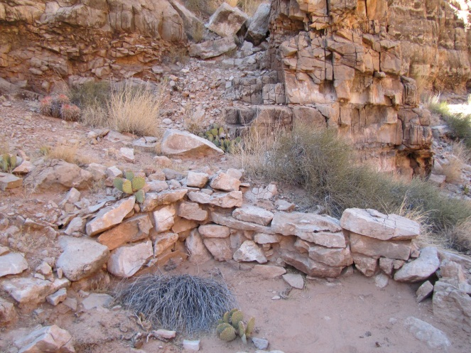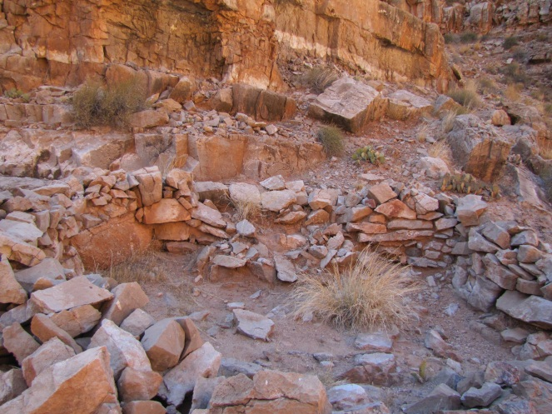

Figure 1.1. South Canyon rock shelters showing effects of animal burrowing

Beach

Beach photos were not taken in 2011 due to high water which flooded the canyon and made the photo sites inaccessible (Bulletts et al. 2011). The monitors used 2010 photos for matching this year.

There was more sediment in the bed of the canyon but it was mixed sand and gravel. Apparently South Canyon has flooded since the 2011 high water and possibly removed some of the sand and silt deposits the monitors expected to find as a result of the high river flows. Water level at the time of this year’s visit was 10,000-12,000 cfs, and river water was not entering the canyon.

One major change since the last visit is that tamarisk beetles have infested the tamarisk trees along both sides of the creek, and the trees are brown and dying (Fig. 1.2). While most of the Marble Canyon area from Lees Ferry on down has been affected by the beetles, it is notable that there are a couple of short reaches between Lees Ferry and South Canyon where the tamarisk is still healthy and apparently unaffected by the beetles.

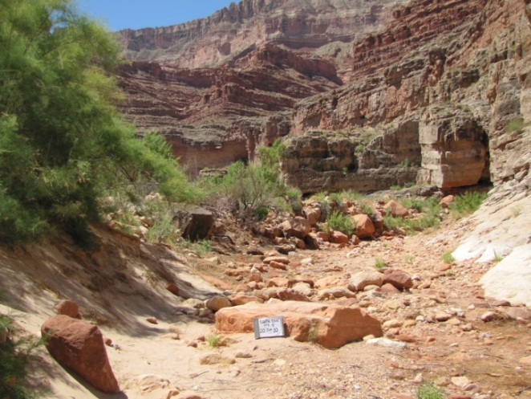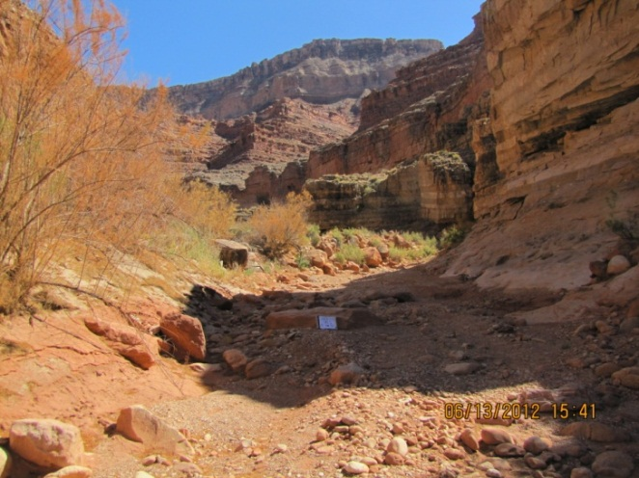
Figure 1.2. South Canyon: comparison of sediment on floor of creek, and tamarisk affected by tamarisk beetle. 2010 (left) to 2012 (right)

Recommendations

Visitation to this site remains high, so monitoring of this beach will continue annually. The SPCagain encourages the NPS to send a trail crew to visit the site and establish one clear trail in the area above the rock bouldersso the multiple trails there do not become further developed.Archeological structures at this site have experienced structural damage due to rodents. SPC recommends NPS visit the site for further analysis.

Nankoweap—Monitoring Site #6

Monitors monitored archaeology and plants at this site in 2012.

Archaeology

Some changes were observed at this monitoring site. There were no collection piles. However the grinding rock and grinding stones were moved about a foot compared to the 2009 photo and rocks were added onto the rock wall. The portion of the trail up to the site from Nankoweap Creek continues to be in very poor shape, having become a major runoff channel for water. Artifacts on the lower bench continue to be protected by cacti and mesquite.

Plants

A major side canyon flash flood in in Nankoweap Creek in September 2009 greatly widened the creek bed area at the mouth of the creek and destroyed all reference points used for locating Transect 1. The SPC monitors attempted to relocate the transect using old photos from 2009 but were unable to find it; neither the remnant “island” nor any identifiable rocks were present. The monitors were able to approximate its location using rocks across the river and features on the cliffs upstream and decided to establish a new transect called “Transect 4” (Fig. 1.3). Transect 1 will be terminated with the 2009 reading, and Transect 4 will document recovery of plants in the lower creek bed.

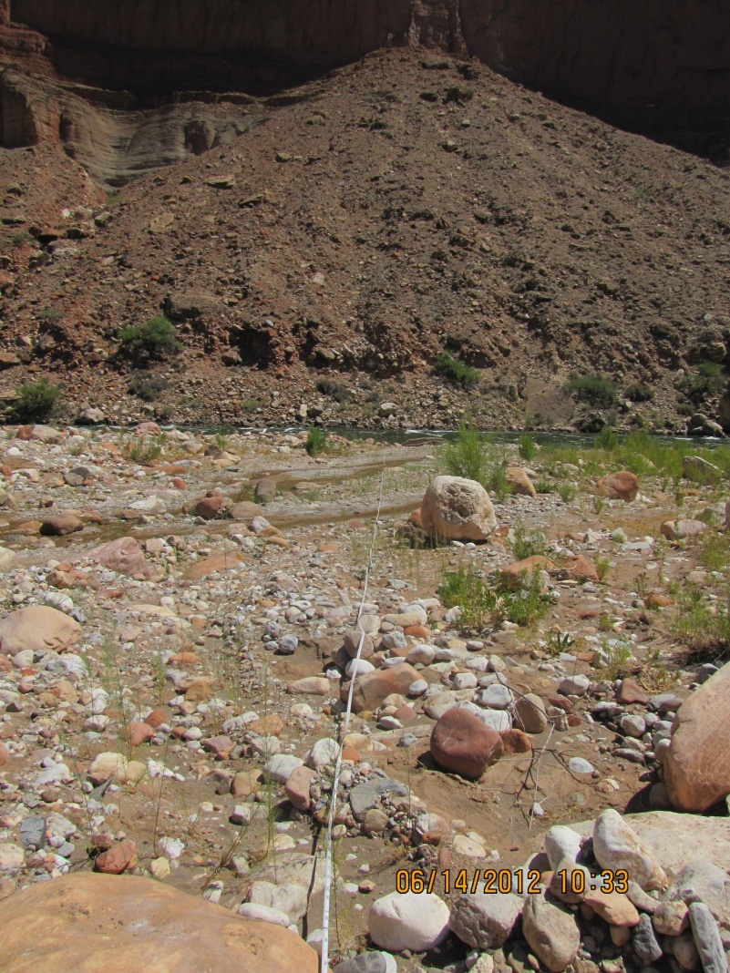
The 0 point of Transect 4 is within the drainage of Nankoweap Creek, on the downstream edge of a large flat rock. The transect crosses the creek diagonally twice running toward the river, and ends (at a water level of ca. 15,000cfs at the time of reading) 60 meters from the origin, at the river’s edge. The creek bed has been vegetated moderately densely by tamarisk seedlings 15-20 cm tall. These were recorded on field data sheets and in the database as “Tamarixchinensisseedlings” (Fig. 1.4). The tamarisk beetle has not yet affected tamarisk at this site or in the area.

The videographer filmed the new transect and interviewed the ethnobotanist about the new transect and the general monitoring program at Nankoweap. The monitors also set the lines for Transects 2 and 3 and talked about locating those and setting them, and what they are attempting to monitor with each transect. Transects 2 and 3 wereunaffectedbythe flash flood.

Figure 1.3.Overview of transect 4 established in 2012

Figure 1.4. Percent cover by species along Nankoweap Transect 4

Recommendations

The lower portion of the trail from Nankoweap Creek to the granaries is still in very bad shape, serving as a major runoff channel during rainstorms. The trail needs attention from a trail crew.

Lava/Chuar – Site # 7

The archaeology site was monitored from the creek bed. No major changes were observed, though some erosion had occurred. The monitors identified a new approach to monitoring that will better capture changes at the site caused by erosion from the creek.

Recommendations

The SPC director should consult with past consortium directors regarding the new approach, which will require re-mapping and establishing a new set of baseline photos.

Tanner – Site # 8

The rock writing was monitored at this site. The trail continues to need improvement. There are multiple trails being used at the site and the current trail has become a storm runoff channel in several places.

Recommendations

The SPC recommendations that the NPS trail crew visit the site to either relocate trail or establish a more structural trail that visitors will be able to see, eliminating the multiple trails.

Deer Creek – Site # 10

Plant and rock writing monitoring was conducted at this site in 2012. SPC monitors noted the newly-constructed Park Service trail between the Deer Creek narrows and the source. Most of the trail is higher above the creek bed than its previous location; this should alleviate problems of washout that occurred frequently in the past.

Plants

There are four adult-size Agaves in the main plot and only 2 offsets. No one of them appears larger than the others; all of them appear to be large enough to flower. The plant that flowered last summer is dead but the stalk is still standing.

The other Agave (7.1 meters away) is sending up a flowering stalk this year, now 2.4m tall and as of yet unbranched (Fig. 1.5). (Note: on a subsequent visit in early August the stalk was about 4 m tall and had branched, but the flowers were not yet open.) There are 47 offsets near this plant but no other adult plants (Fig. 1.6).

The site continues to show the effects of drought and lack of recharge by the creek. Both willows (Salix exigua) are now dead; the second one died this year and has fallen over (Fig. 1.7). Lower branches of the cottonwoods are dying and growth is now slow. Astragaluspraelongus is doing well this year; there are two large plants, one in front of the acacia and the other between the acacia and a cottonwood. The SPC monitors measured the latter. Graphic representation of the growth of four plants is shown in Fig. 1.8. There are faint trails to both agaves, probably made by hikers and river runners observing them.

`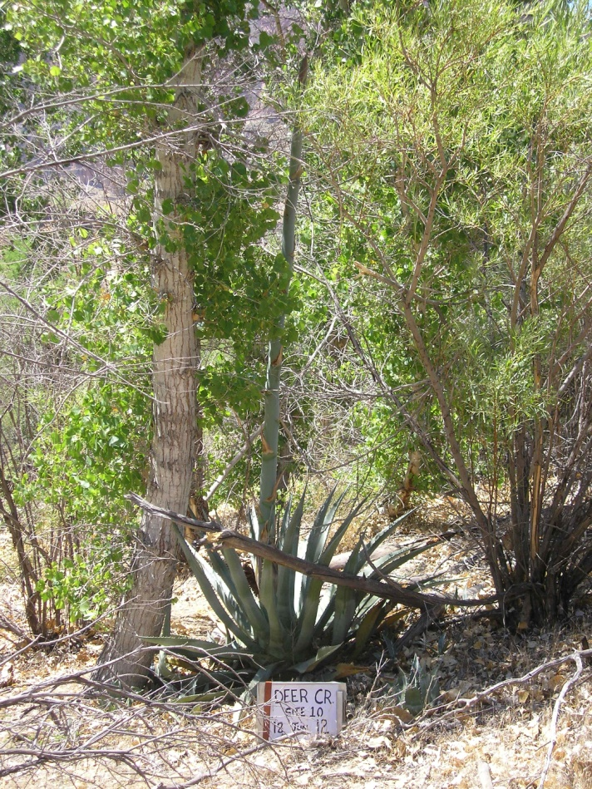

Figure 1.5. New inflorescence from the Deer Creek agave plant

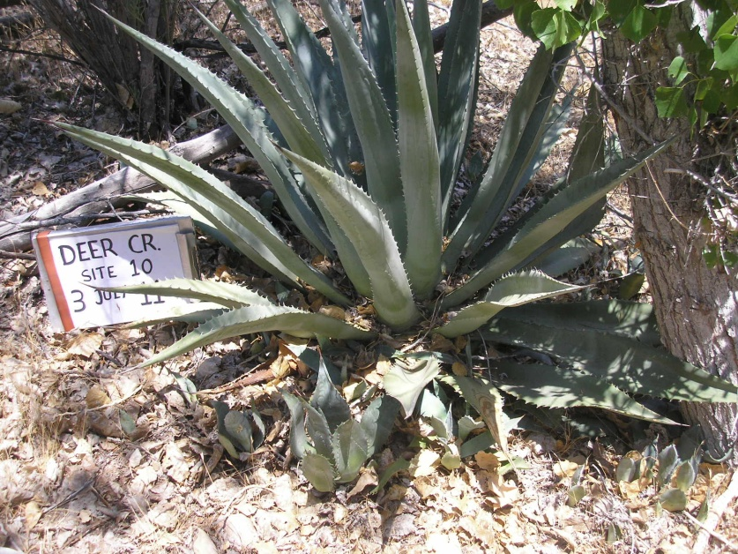

Figure 1.6. Offsets from Agave phillipsiana

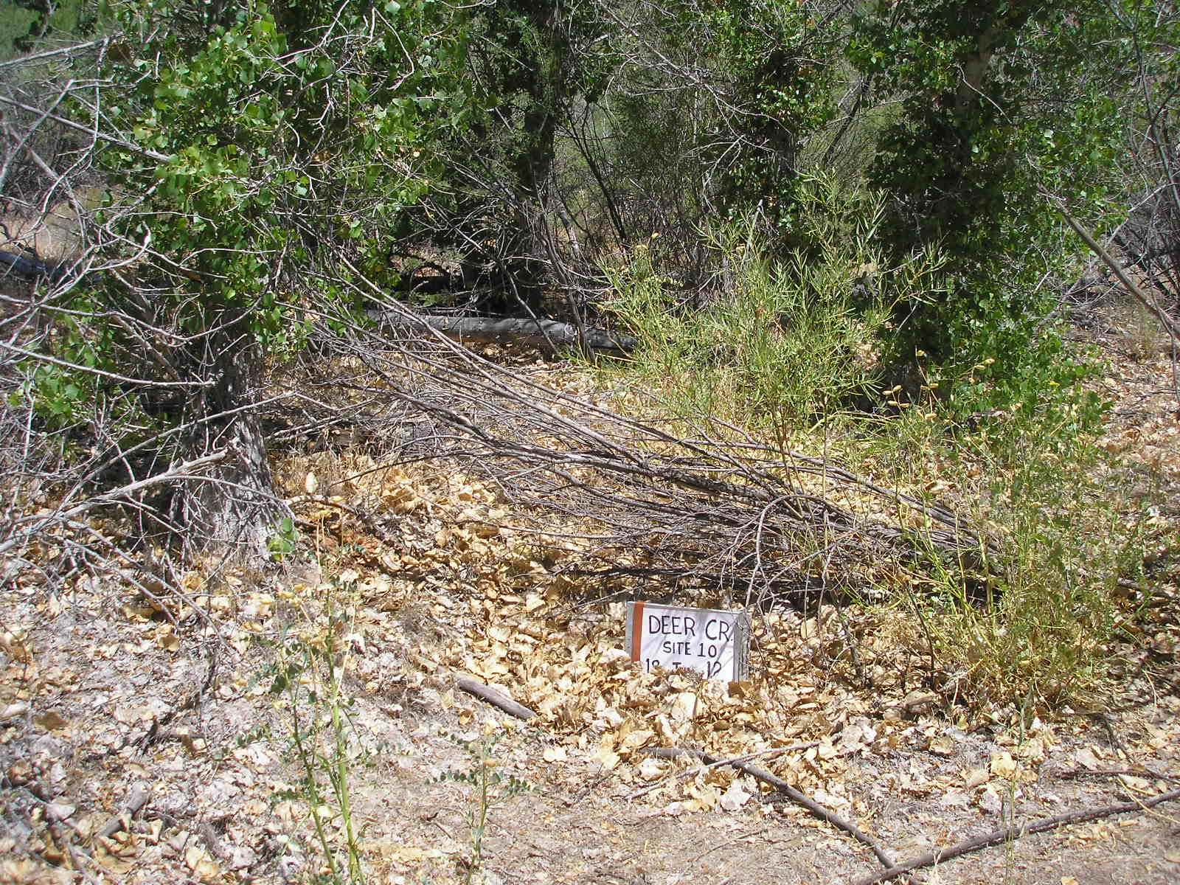

Figure 1.7. Dead Salix exigua (plant DC 4) in 2012

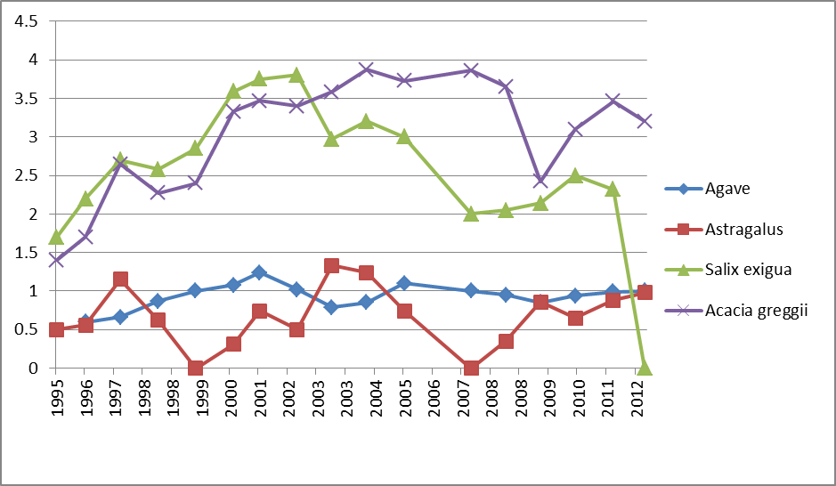

Figure 1.8. Height of plants in Deer Creek plot

Rock Writing

No major changes were observed to most sections of the panels at this site. There was no new graffiti noted at Deer Creek. However, some changes to the rock writing panels were noted. Sections of the panels are weakening, and some are sliding off. One panel continues to be impacted where human hands rub against the rocks that are being used as hand holds by visitors as they walk along the narrow trail. The trail through the narrows appears to be in the same condition as the previous year.

Recommendations

The baseline photography and mapping of the panels in the narrows should be re-done by the SPC to allow the monitors to better document changes to the rock writing panels. This will require more time at Deer Creek and is planned for 2013.

The gully that began to form below the plant plot in 2008 or early 2009 remains, but it does not appear to be actively increasing in size. While it is still shallow and its head is about 20m from the plot, it could be a potential threat to the agave, perhaps even in a single flood occurrence. The NPS should consider stabilization when a trail crew is next in the area to see if anything can be done to prevent headward erosion.

Kanab Creek Site # 11

Beach and plant monitoring was carried out at this site in 2012.

Beach

The site was flooded in 2011 due to high water releases. The major difference at the beach was an increase in vegetation.

Plants

Transect location, setting, and reading was accomplished using the 2009 set of photos. The transect shows definite effects of long-term drought on both the upper part and lower sandy portion. Globe-mallow (Spheralceagrossulariaefolia) was dead or dormant and none was recorded alive. In the sandy area on the lower portion of the transect there was no living blanket flower (Gaillardia pinnatifida) and prickly pear cacti were somewhat shriveled (Fig. 1.9). Other cacti in the area, mostly on the slope (claret cut, barrel), and Indian-tea (Ephedra nevadensis) were doing well (Fig. 1.10). Prolific fruits were present on prickly pear and barrels. The endpoint of the transect at the cliff edge was unchanged from the previous reading. Results of the transect reading are presented in Fig. 1.10. This shows a general decline in all species except catclaw acacia (Acacia greggii) and the loss of a number of species.

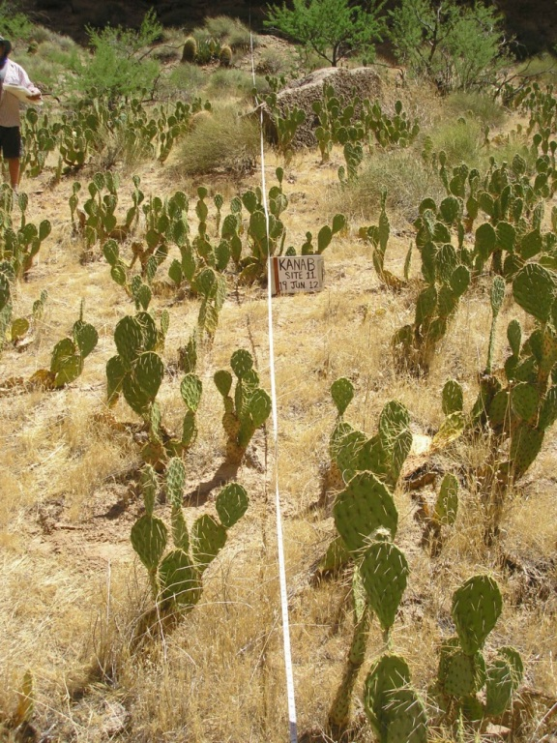

Figure 1.9. Lower portion of Kanab Creek, Transect 1, with desiccated Prickly Pear.

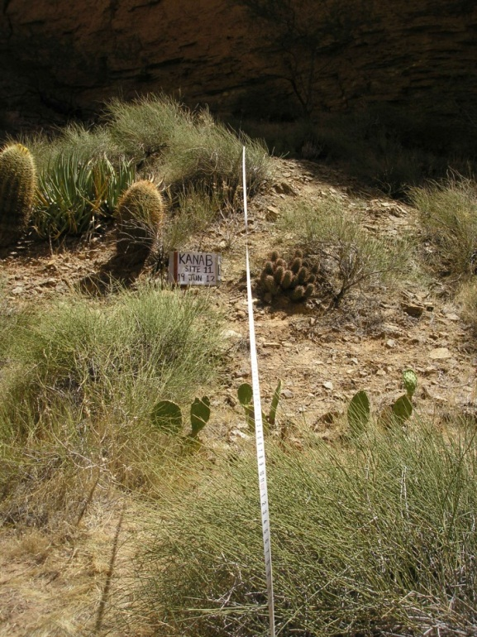

Figure 1.10. Upper portion of Kanab Creek Transect 1.

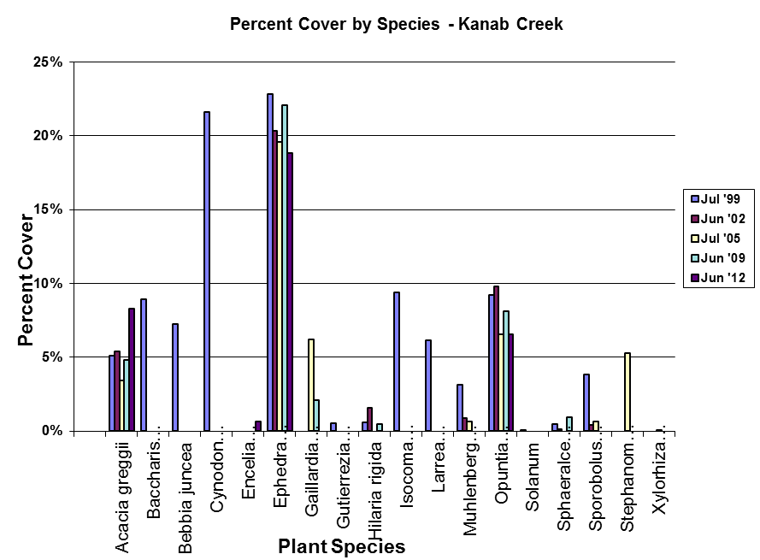

Figure 1.11. Percent cover by species along Kanab Creek Transect 1

Recommendations

The high water releases at this site benefitted the vegetation near the river due to the water that was available to the plants.The SPC can “retire” and archive all photos and photo logs prior to 2009. It is no longer necessary to take them in the field

Vulcan’s Anvil – Monitoring Site #12

Cultural monitoring was carried out at this site in 2012.

Cultural

This site was visited for spiritual and ceremonial reasons. Monitoring involved visual inspection and discussions of conditions among tribal members. Coins were retrieved off the Anvil.

There has been very little recent use of the river bank near the Anvil, and there was no evidence of human footprints or vegetation damage.

Recommendations

Minimal materials were retrieved this year from Vulcan’s Anvil. The SPC will continue its outreach and education to the river guides to encourage maintaining Vulcan’s Anvil free of trinkets left by visitors and guides.

WhitmoreWash—Monitoring Site #13

The rock writing and beach were monitored at this site in 2012.

Rock Writing

Monitoring of rock writing panels was completed.No major changes or new graffiti was observed. The SPC monitors identified a new approach to monitoring that will better capture changes at the site.

Beach

Photos from across river show that the trail to the panel continues to show effects of heavy use, and there is a well-developed trail along the top of the sand deposit probably reflecting alternate boat-parking areas and bathroom sites. SPC monitors noticed no additional erosion of the bank.

No large-scale changes were noted using photos taken from across the river.The sand bar just upstream from the boat parking area is currently inundated at high flow. Flow was not at a maximum at the time of this year’s visit, and the top of the bar was exposed and saturated. There was no vegetation growing on the bar.

Recommendations

The SPC should work with the river guides to educate their visitors about the cultural significance of this site. The baseline photography and mapping of the rock writing panel should be re-done by the SPC to allow the monitors to better document changes to the panel. This will require more time at Whitmore and is planned for 2013. At that time the SPC should re-consider its approach to monitoring bank erosion at this site.
.
Ompi Cave – Monitoring Site #15

This site was visited for spiritual and ceremonial reasons.Over the past several years SPC monitors have collected numerous tools and cups from within the cave. SPC has a huge concern with finding such collecting tools left behind and has expressed concerns to the NPS and other tribes participating in the Adaptive Management Program about finding materials left behind.

Recommendations
Contact Park Service on the situation with the Ompi Caves and discuss future recommendation with other Tribes. Maybe have a Government to Government meeting with Park Service and other Tribes who have a concern for the Desecration of the Cave.

SpringCanyon – Monitoring Site # 16

Monitoring at this site was not completed in 2012. Dense vegetation growth has made the usual landing place unusable, and while landing is possible at the mouth of the creek is feasible at certain water levels, the mouth itself is now closed by dense, vigorous growth of giant reed (Phragmitesaustralis). There has been no scouring flood in Spring Canyon in a number of years, causing vegetation density to continue to increase. As noted in 2010 and 2011, there is limited value in continuing to take the annual matching photos until the creek is scoured, as little change will occur and photos taken within the dense vegetation have little interpretive value due to poor visibility. Archeological monitoring is next scheduled at this site for 2013.

Recommendations

This site shows little human use in recent years, discouraged by difficult access. It is a good study of the relationship between access and visitation. Flash floods that scour out the canyon periodically make access easier, and visitation increases until vegetation grows back. The site should be left as-is to monitor the effects of naturally-influenced access. Photo monitoring of plants and the archaeological site should be suspended until a flash flood scours the canyon, as vegetation is currently too dense to allow for effective photo monitoring and access to the site.

Pumpkin Spring—Monitoring Site #18

Spring and beach monitoring were conducted at this site in 2012. High river flows for several months in 2011 allowed river water to enter and scour the pumpkin bowl, but the river was once again below the rim of the bowl in 2012 (Fig. 1.12).

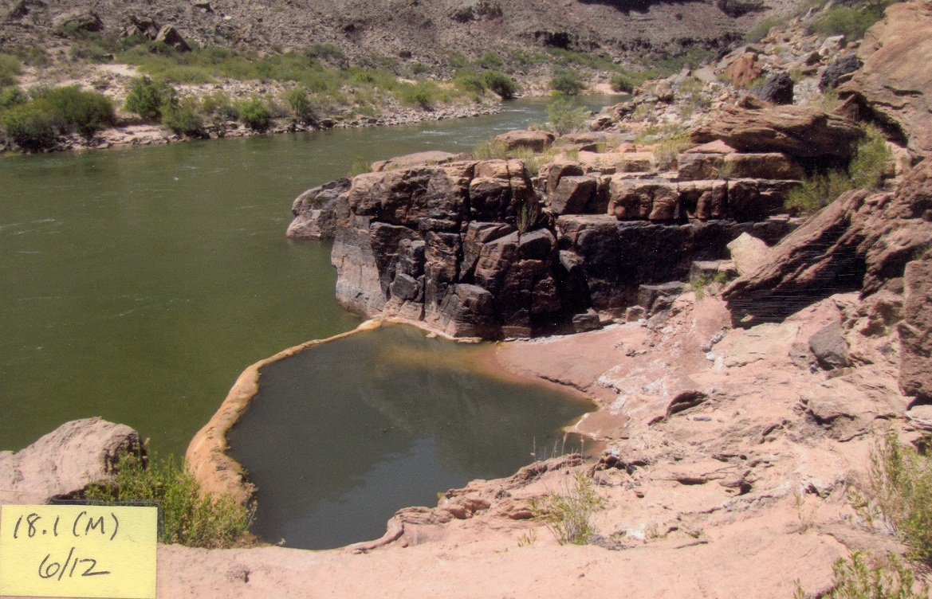
Figure 1.12. Pumpkin Spring in June, 2012

Recommendations
We will closely monitor the Spring, because of the HFE and the LTEMP that will happen. With the proposed floods we hope to help support the LTEMP. That shows the floods do help sacred springs with a good cleaning.

GranitePark—Monitoring Site #20

The SPC river trip was unable to stop at this site in 2012 because other groups were camping at the site. Of particular interest at the site is an ancient Goodding willow(Salix gooddingii) tree that has existed at the site for perhaps 200 years. Subsequent visits by the ethnobotanists in August and October revealed that the tree had further collapsed, and had not grown very vigorously this year. Dam releases of 20-25,000 cfs in 2011resulted in water reaching nearly to the base of the tree, and currents in the eddy were strong and potentially harmful in terms of eroding sediment around the roots. The SPC ethnobotanist visited the site during October 2012. Overall the tree appears to have declined somewhat this year (Fig. 1.13).

Stabilization of the tree, of historic and cultural interest to both Southern Paiute and Hualapai people, has been a priority for some years. Granite Park was a refuge site for people of both tribes when they were persecuted in the early 1900s. The tree is also of interest as a historical place featured in river trip photos as far back as the late 1800s. To date little progress has been made, and the tree continues to decline. There appear to be three major reasons for its condition:

- Erosion in the eddy which has created a steep bank and exposed the tree’s root system on the shoreline side of the tree. This is exacerbated by flows in the 12,000 – 25,000 cfs range, which have been the norm for many years.

- The tree is hollow, and subject to twisting in high wind. Without stabilization, it may fall during a major storm event.

- Beaver sometimes climb the tree and feed on younger branches. Generally they do not appear to disturb the older, thicker portions of the trunk.

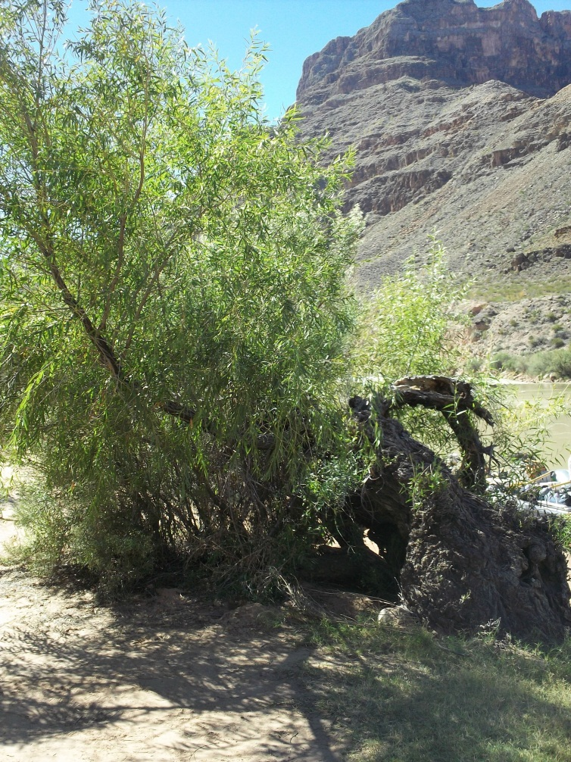

Figure 1.13 Gooddings Willow at Granite Park in October 2012.

Mitigating actions could include the following:

- The substrate at the base of the tree could be extended into the eddy by installing riprap fencing in a semicircle 10 feet from the base of the tree, and filling the space inside the fencing with cobbles and sand. This would allow additional habitat for the roots to grow and remain protected by currents in the eddy. Historic preservations funds could be available. The project could only be possible with a cooperative effort between the tribes and NPS.

- Stabilization would include filling the hollow and closing the open area on the lower side. This would have to be done by “tree surgeons” who are experienced in saving trees in landscaping situations.

- Beavers removing small branches in moderate numbers is not harmful, and stimulates growth of the tree. However, planting cuttings from the tree along the beach, as some have suggested, would probably not work unless they were protected from beavers for a number of years. Goodding willow trees were fairly common along the river until beaver increased in the late 1970s, after which they were quickly extirpated from all but a few sites, notably Cardenas marsh (mile 71L).

Recommendations

Efforts at creating support for a stabilization program should be brought before the Tribal Councils of the SPC member tribes and Hualapai Tribe, dialogue with NPS should be initiated, and funding should be sought. Information about the historic and cultural significance of the Goodding willow should continue to be included in the outreach materials developed by the SPC, and river guides should be discouraged from tying their boats to the tree. The SPC Director and Hualapai Cultural Resources office should discuss possible collaboration in taking steps to begin stabilization and mitigation efforts if the tree is to be preserved.

Chapter Two
Education and Training

The 2012 Southern Paiute Consortium Colorado River Corridor Education and Training Program was specifically designed to provide opportunities for Southern Paiutes to learn directly from elders and cultural resource specialists from the tribes of the Southern Paiute Consortium (SPC) – the Kaibab Band of Paiute Indians and the Paiute Indian Tribe of Utah (PITU) – and from the San Juan Southern Paiute Tribe and Moapa Band of Paiutes, as well as from scientists and others participating in the Glen Canyon Dam Adaptive Management Program. The program includes activities that take place along the Colorado River and elsewhere. This aspect of the overall SPC program is necessary to inform and educate future tribal leaders and train tribal monitors (see Austin, Fulfrost, Osife, Drye, and Rogers 1996). The educational component of the program continues to be supported within the University of Arizonaand is an important element of the overall program.

A second purpose of the program is to provide education and outreach to non-tribal members about the Southern Paiutes, their history in and perspectives of the Colorado River Corridor, and the importance of the broader cultural landscape stretching from rim to rim. This is achieved through outreach programs to the Colorado River Guides, schools and universities, civic organizations, and others. This purpose is also achieved through interactions with other canyon visitors through the annual presence of Southern Paiutes along the Colorado River. The recently-completed documentary, The Rivers and Canyons of the Colorado: Southern Paiute Monitoring and Education, also serves as a tool through which to educate non-tribal members about Southern Paiute monitoring program and the importance of the Colorado River Corridor for Southern Paiutes.

Program Activity Discussion

Meetings and River Trip Participants

Each year, the SPC prepares information about the annual monitoring trip and shares this information with the participating tribes. The tribes then select trip participants. Annual participation generally has alternated between adults and youth. The 2012 trip wasan adult trip and included the SPC Director; two tribal elders; two SPC monitors; two Southern Paiute cultural consultants; eight adult participants from the Paiute Indian Tribe of Utah, the Kaibab Band of Paiute Indians, and the Moapa Band;one SPC consulting ethnobotanist; one ethnobotanist-in-training; and two educational and research specialists from the University of Arizona, one of whom is a member of the Kaibab Band of Paiute Indians.

Prior to the trip, the SPC Director and the Shivwits Cultural Resource Manager made presentations about the trip to the leaders of the Kaibab Band of Paiute Indians, the Shivwits Band, the Cedar Band Council, the Koosharem Band Council, and the Indian Peaks Band Councilat their respective council meetings in early spring 2012. The SPC Director also attended a meeting of the Moapa Band of Paiute Indians. Individuals were also given the opportunity to sign up to be considered for the annual monitoring and education trip during Kaibab’s annual meeting. The Shivwits Cultural Resource Manager also informed all tribal members of the trip via the band newsletter. The PITU Cultural Resource Director also sent a letter to the chairpersons of the five PITU bands notifying them about the trip and the process by which tribal participants would be selected. Tribal leaders then submitted names of trip participants to the SPC Director. A final list of names was approved by the Tribal and Band Council representatives, and individuals were contacted by the SPC and sent information about the upcoming trip.

Summary of Activities

The SPC Director informed trip participants about the dates of the trip and the gear list, and provided information about the Colorado River Corridor, Southern Paiute history in the region, and the SPC cultural resources program. The SPC Director and Shivwits Cultural Resource Manager also met individually with many of the participants from both the Kaibab and Shivwits bands. During these meetings, participants were provided with information about the cultural significance of the Grand Canyon and the Colorado River Corridor and reminded of culturally appropriate behavior within this sacred place. Additionally, participants received training and instruction in the use of camping and rafting gear.

Following from the recommendations in the 2011 report, the pre-river orientation and training of participants took place at Lees Ferry on June 12, 2012, the day prior to the start of the downriver trip. By conducting the orientation and training prior to the downriver trip, tribal elders and other cultural specialists who did not go on the downriver trip were able to participate in the training of new participants. The pre-river orientation and training also maximized the time spent actively monitoring while on the downriver trip.

Recommendations

River trip preparation is a key component of the education and training program. Going into the Colorado River Corridor, Southern Paiutes are entering a place rich with historic and contemporary spiritual and cultural meaning. Although there is no way to fully prepare for the experience, through stories and discussions trip participants can gain the information they need to make themselves ready for the trip and gain the most out of their experiences. The SPC has developed a suite of educational materials, including the recently completed educational documentary, and should distribute them to potential participants prior to the trip so they can familiarize themselves with the nature and scope of the SPC’s educational and monitoring program. The SPC should continue to conduct the orientation and training at Lees Ferry before departing for the downriver monitoring trip.

Plant Reference Guide

The plant reference guide that was developed in 1997 includes over 125 pages of plants with photos; Paiute, scientific, and common plant names; and information about the significance of the plants in Southern Paiute culture. The guide was made available to trip participants during the 2012 trip.

Southern Paiute River Guide

The Southern Paiute River Guide includes overview maps of Southern Paiute territory and has a location finder on each page that shows the reader where s/he is along the river and within the larger territory. The guide also has space for note taking so participants can record information they wish to remember about places and events that occur along the river. The guide was updated in 2008, based on recommendations made during the 2007 downriver trip and was used on the 2012 trip. Based on recommendations from the SPC Director, monitors, and trip participants, the guide will be updated again in 2013.

Video Documentation and Archiving of Information about the Ethnobotany Program

During the 2010-11, with the assistance of the University of Arizona consultants, the SPC began to use video to document the ethnobotany program for the SPC archives. Drawing on the success of and interest in the recently-completed documentary, The Rivers and Canyons of the Colorado: Southern Paiute Monitoring and Education, the SPC adapted video documentary techniques to collect information about the plant monitoring program. During the 2012 trip, footage was shot at locations that were not visited in 2011; also, some footage was re-shot due to camera/microphone problems from the previous year. The footage shot consisted of two consulting ethnobotanists laying and reading transect lines and monitoring plants and beaches (Fig. 2.1). The ethnobotanist who designed the plant monitoring progam and has implemented it over the last eighteen years was interviewed multiple times during the 2012 trip at locations not stopped at in 2011. These interviews provide additional data and will be included in the archives

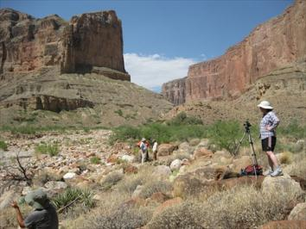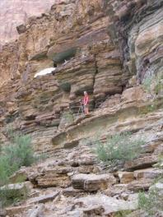

Figure 2.1. Video documentation of ethnobotany

The video footage was edited in the fall of 2011 and archived with both the Southern Paiute Consortium and with the University of Arizona’s Bureau of Applied Research in Anthropology. Topic transcripts were created for the video footage during 2012 to make it easier to access and use the footage. The video footage taken in 2012 will be edited and archived, and topic transcripts created during 2012-2013. The edited footage will be a resource for the Southern Paiute Consortium, particularly the current and future monitors and consulting ethnobotanists.

Recommendations

Video documentation of the SPC program and Southern Paiute concerns about sites along the river should continue. Additionally, continued video training should be made available for interested tribal members in an effort to develop videographers to aid in future video documentary projects.Since the monitoring program runs on three-year rotation, documentation of the plant monitoring program should be continued through 2012 and 2013.

The Downriver Trip

Summary of Activities

The downriver trip took place from June 13 to June 22, 2012, and the education and training component occurred on June 12 at Lees Ferry (see Chapter One). The education component of the trip included (1) specialized training in monitoring skills and techniques; (2) direct information about Paiute culture provided by Southern Paiute elders and cultural resource specialists; (3) learning through participation in Southern Paiute traditional practices and in monitoring activities; (4) information about policy and management related to Glen Canyon Dam; (5) education about how cultural resources along the Colorado River are being protected, and what policies exist and requirements are needed for receiving protective designation of cultural resources; and (6) expert consultation about relevant political and scientific issues in the Grand Canyon. The education program was also fully integrated into the monitoring program, and the trip schedule and activities are provided in Table 2.1.

As in past years, tribal educators were an integral component of the education program, sharing information about past as well as present connections between Southern Paiutes and the Colorado River Corridor. On the 2012 trip, the elders, cultural consultants, and ethnobotanists shared their knowledge with the adult participants. Ethnobotany, in particular the traditional uses of plants, was an important component of the 2012 river trip. Trip participants learned about traditional uses of plants found in the Colorado River Corridor, the types of places the plants grow, and the processes of gathering and processing plant materials.

Ethnobotanist Training

In 2011, in anticipation of a new ethnobotanist taking over the plant monitoring program in 2013, Dr. Arthur Phillips III, who has been carrying out the ethnobotanical monitoring program since 1993, began training Carrie Cannon, who has been designated as his replacement, in the monitoring program. This training continued in 2012. Carrie was trained in transect location, transect setting using photos, reading transects, data recording, and photography. Visits were also made to ethnobotanical monitoring sites not on this year’s schedule for monitoring to brief Carrie on the endpoint location and approximate positioning of each transect. Carrie also assisted in plant monitoring activities at sites that involved matching photography.

Table 2.1. Downriver Trip Schedule and Education Activities, 2012

Date | Site | ActivitiesCompleted
June 12 | Lee’s Ferry | River safety orientation, monitor training, video  training, and ethnobotany orientation
June 13 | South Canyon | Southern Paiute interpretation and cultural transmission  Assist monitors—beach, archaeology
June 14 | Nankoweap | Southern Paiute interpretation and cultural activities  Assist monitors—archaeology, plants
June 14 | Little Colorado River | Southern Paiute interpretation and cultural transmission  Water safety instruction
June 14 | Salt mines | Southern Paiute interpretation and cultural activities
June 15 | Lava Chuar | Southern Paiute interpretation and cultural activities
June 17 | Shinumo Creek | Southern Paiute interpretation and cultural activities
June 18 | Deer Creek | Southern Paiute interpretation and cultural activities  Assist monitors—rock art, plants, beach  Visitor behavior monitoring, interaction  Cultural hike
June 19 | Kanab Creek | Southern Paiute interpretation and cultural transmission
June 20 | Vulcan’s Anvil | Southern Paiute interpretation and cultural activities
June 20 | Whitmore Wash | Southern Paiute interpretation and cultural transmission  Assist monitors—rock art, beach
June 20 | Ompi Cave | Southern Paiute cultural transmission  Assist monitors – cultural activities
June 20 | 202 Mile Canyon | Southern Paiute interpretation and cultural transmission
June 21 | Spring Canyon | On-boat overview of site monitoring program
June 21 | Indian Canyon | Southern Paiute interpretation and cultural hike-Arch
June 21 | Pumpkin Spring | Southern Paiute interpretation and cultural transmission  Assist monitors—spring and beach
June 22 | Diamond Creek | Take out

Sharing of Daily Experience

Using the model developed in 1996, participants gathered each evening in a circle to share thoughts and feelings about the day’s experiences and prepare for the following day’s work. Information shared during these group meetings included stories about the places and the culturally appropriate behaviors expected there. All participants discussed what they knew about the places and shared their feelings about visiting them, often in relation to their past experiences and contemporary lives “up on top,” outside the river corridor. The participants also provided additional information about other groups and historical/political events related to places that were visited. The evenings ended with time for prayer and reflection after everyone had a chance to be heard, and to speak as much as they liked regarding the issues that affected them.

The downriver trip was a success. The educational experiences of all participants were enhanced by the presence of the elders, cultural specialists, ethnobotanists, and others with knowledge of the cultural sites, social and political history of the region, and the Adaptive Management Program and the Southern Paiutes’ role in that program.

Recommendations

The 2012 river trip and educational program was particularly successful because the participants were well prepared and knew what to expect. Each year, trip participants must be carefully selected and include, if possible, elders and other cultural specialists, at least two monitors, an individual responsible for the trip’s itinerary and logistics, and additional participants who are aware of the challenges of working on the Colorado River Corridor, and who have prepared for the experience through participation in pre-trip study and events.

In order maintain continuity in the planning and reporting of the downriver monitoring trip, it is recommended that both sets of monitors from alternating years participate in the pre-trip spring planning meeting and the post-trip report writing.

Participants on river trips bring a very wide variety of experiences and perspectives with them on the river, and they are usually willing to share those perspectives for the benefit of all participants. The space for dialogue about and incorporation of both Western scientific methods and Southern Paiute cultural practices should be maintained so that participants can learn how scientists and management agencies perceive and manage the resources of the Colorado River Corridor.
Chapter Three
Meetings, Conferences, and Other Activities

Much of the work conducted under the PA during 2012-2013 was done in committees and meetings. This chapter summarizes the interactions between the Southern Paiute Consortium (SPC) and others with an interest in cultural resources in the Colorado River Corridor.

Meetings and Conferences

The Southern Paiute Consortium was represented at meetings of Adaptive Management Work Group (AMWG), Technical Work Group (TWG), the Cultural Resources Ad Hoc Group (CRAHG), and the Grand Canyon Monitoring and Research Center (GCMRC). The SPC and its member tribes, the Kaibab Band of Paiute Indians and the Paiute Indian Tribe of Utah, participated in consultation with federal agencies that are PA Signatories. All of these activities are informed by the data and information that the SPC gathers during its annual Colorado River trips. The SPC Director is responsible for ensuring that the information is passed between the Southern Paiutes and the federal managers responsible for operations of the Glen Canyon Dam and the resources within the Colorado River Corridor.

Long Term Experimental and Management Plan

The SPC Director met with representatives of the Long-Term Experimental and Management Plan(LTEMP) proposal in February, 2012. Others that were there were Tribal representative and stake holders within federal agencies. The Kaibab Paiute Tribe signed the PA for the LTEMP. The LTEMP process is still being reviewed with all stakeholders submitting comments about finances and issues of AMWG and TWG involvement.The Tribes have expressed the need for increased funding to attend LTEMP meetings.

PA Signatories, Adaptive Management Work Group, and Technical Work Group

The SPC Director participated in AMWG and TWG meetings on behalf of the SPC.The SPC maintains its position that the Colorado River Corridor is a significant cultural landscape and is vital to the physical and spiritual well-being of Southern Paiute people (see Stoffle, Halmo, and Austin 1997).

(Note: that much of report for next year will change when the stake holders of the LTEMP decide if it falls under the AMP process)

Meetings and Interaction with Federal Agencies, Tribal Leaders and Members

The SPC Director met with representatives from the GCMRC, Fish and Wildlife Service, and National Park Service to discuss projects and activities that could potentially impact the Colorado River Corridor. The member tribes of the SPC worked with other PA Signatories to provide input for management activities. The SPC Director participated in a conference call with federal agencies that are PA Signatories. On the June NPS consultation trip, the Kaibab Band of Paiute Indians sent one representative. The SPC Director and the Hualapai THPO Office are working on ways to combine and collaborate on monitoring reports. This year the SPC Director went on a monitoring trip with the Hualapai Tribe. Much was learned and shared between both tribes. Officially SPC has taken Carrie Cannon, Hualapai’s Ethnobotanist, on its monitoring trips into the Grand Canyon.

Other Activities

The SPC has participated in activities that are beyond the scope of the PA but further the SPC’s efforts to protect Southern Paiute cultural resources in the Colorado River Corridor. These include continued development of the SPC Education and Outreach Program. The SPC Director made presentations to Bureau of Reclamations Denver office. SPC Director is currently working with Grand Canyon National Park Service Administrator on the closer of the narrows at Deer Creek. This should be an ongoing process while Back Country Management Plan (BCMP) is still accepting comments. The SPC, Director continues to hand out, The Rivers and Canyons of the Colorado: Southern Paiute Monitoring and Education to new employees of the AMP.

Colorado River Guides

The SPC Director met with River Guides and Superintendent of the Grand Canyon about the closure of the narrows at Deer Creek. The Grand Canyon River Guides and the SPC Director had a conference call with Grand Canyon National Park Superintendent. The SPC Director expressed the concerns of the Southern Paiute Nations with ongoing problems of hikers and river runners repelling into the narrows, and then the river guides expressed their concerns and thoughts about the closer of the Deer Creek narrows. SPC Director also responded to calls from river guides about the Deer Creeks Narrows closure. This issue has been accepted by most of the river guides although not many like the idea of it being closed. This will be an ongoing process of education and information sharing among the River Guides, SPC and the Grand Canyon Superintendent.

References

Austin, Diane E., Brian K. Fulfrost, Cynthia Osife, Tricia F. Drye, and Glenn Rogers
- 1996 Southern Paiute Consortium Colorado River Corridor Monitoring and Education Program: Summary. Prepared for the Glen Canyon Environmental Studies, Bureau of Reclamation. Prepared by the Southern Paiute Consortium, Pipe Spring, Arizona and Bureau of Applied Research in Anthropology, University of Arizona, Tucson, Arizona. September.

Bulletts, Charley, Michael Osife, IlaBulletts, Arthur Phillips III, Carrie Cannon, Kevin Bulletts, and Diane Austin
2011 2011 Southern Paiute Consortium Colorado River Corridor Resource Evaluation Program Annual Report of Activities. Prepared by the Southern Paiute Consortium, Pipe Spring, Arizona and Bureau of Applied Research in Anthropology, University of Arizona, Tucson, Arizona. August.

Stoffle, Richard W., Diane E. Austin, Brian K. Fulfrost, Arthur M. Phillips, III, and Tricia F.
Drye

Itus, Auv, Te'ek (Past, Present, Future): Managing Southern Paiute Resources in the Colorado River Corridor. Prepared for the Glen Canyon Environmental Studies, Bureau of Reclamation. Prepared by the Bureau of Applied Research in Anthropology, University of Arizona, Tucson, Arizona. September.

Stoffle, Richard W., David B. Halmo, and Diane E. Austin
- Cultural Landscapes and Traditional Cultural Properties: A Southern Paiute View of the Grand Canyon and Colorado River. American IndianQuarterly 21(2): 229-249.

